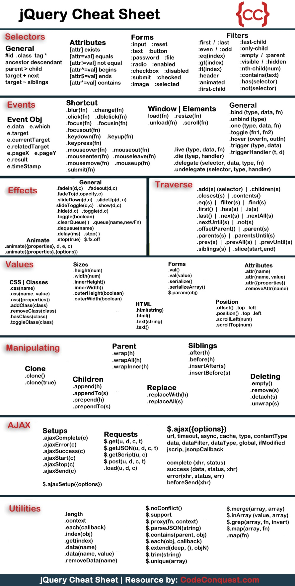

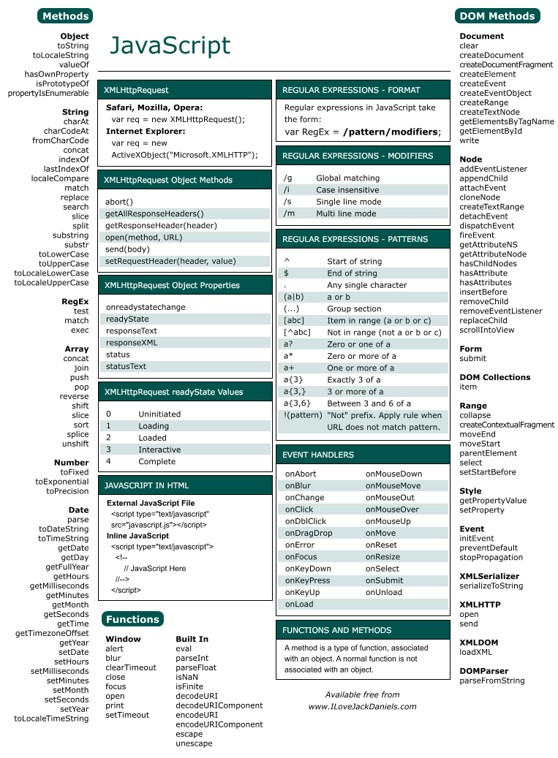

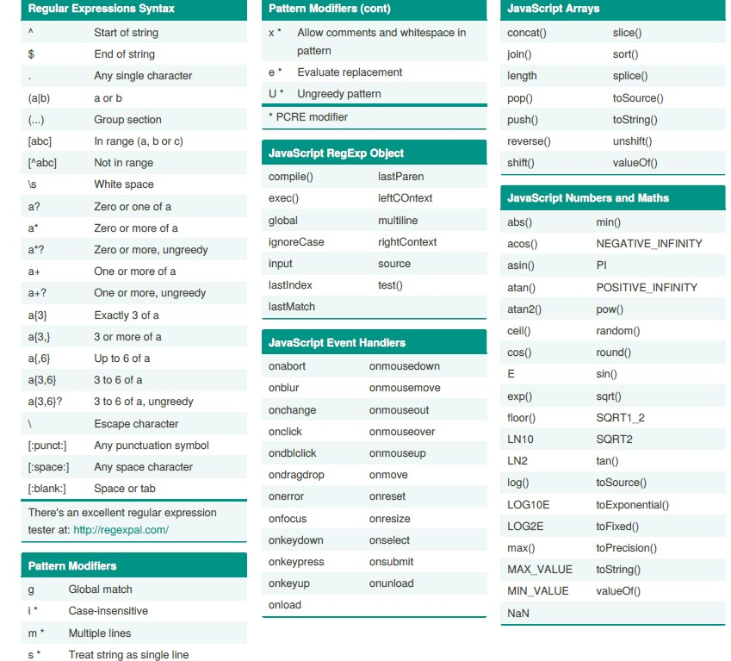

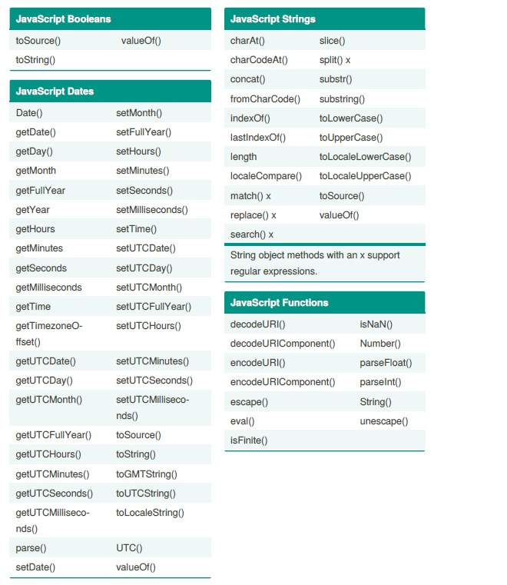

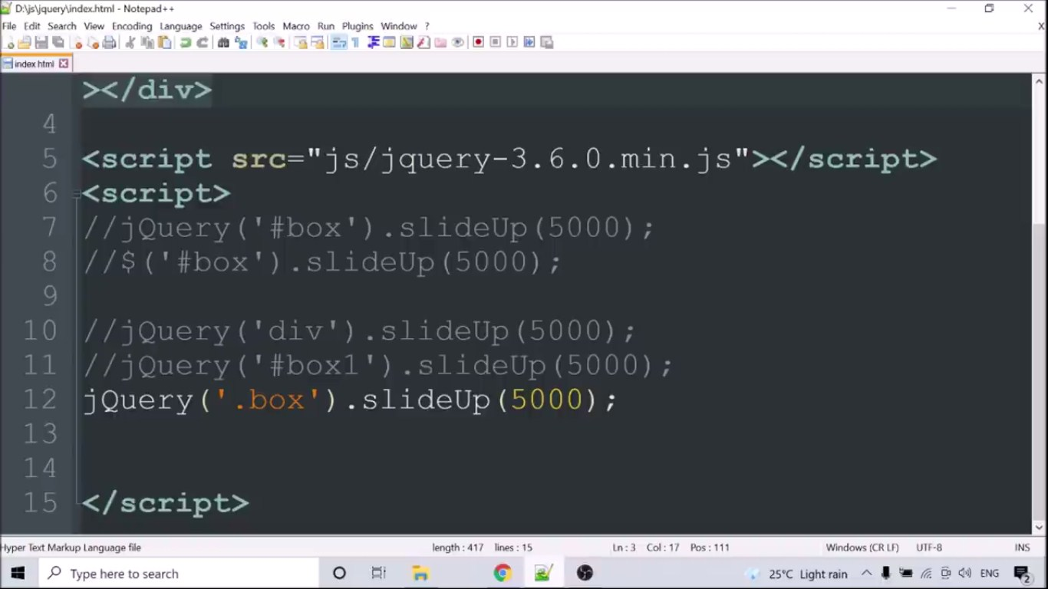

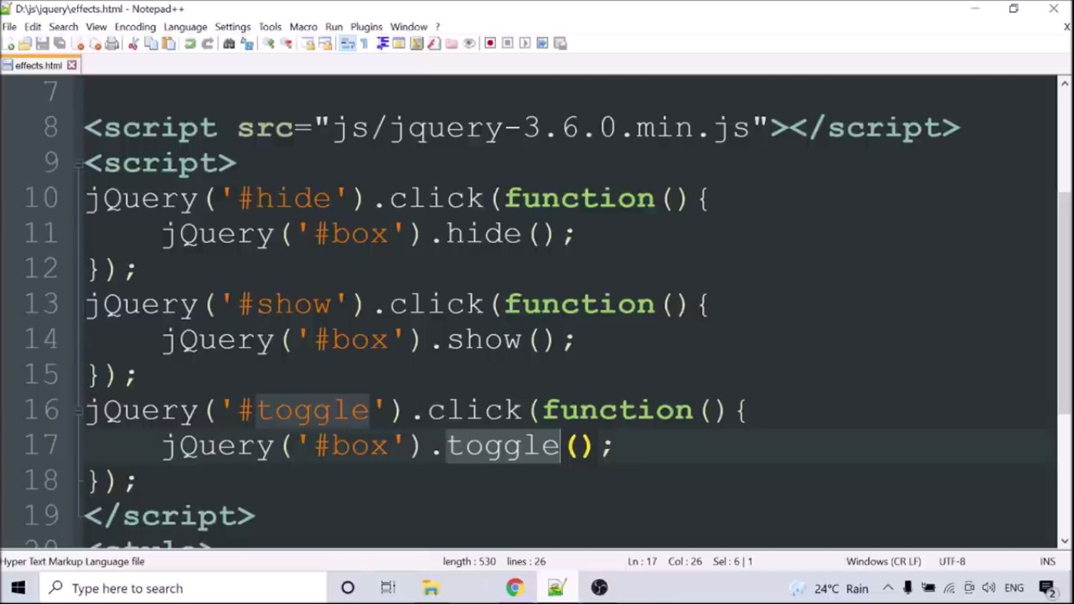

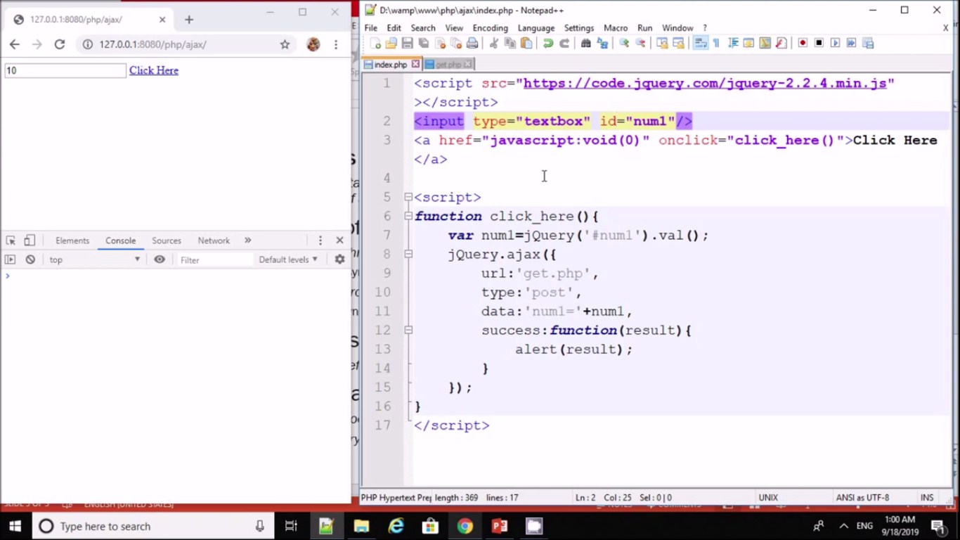

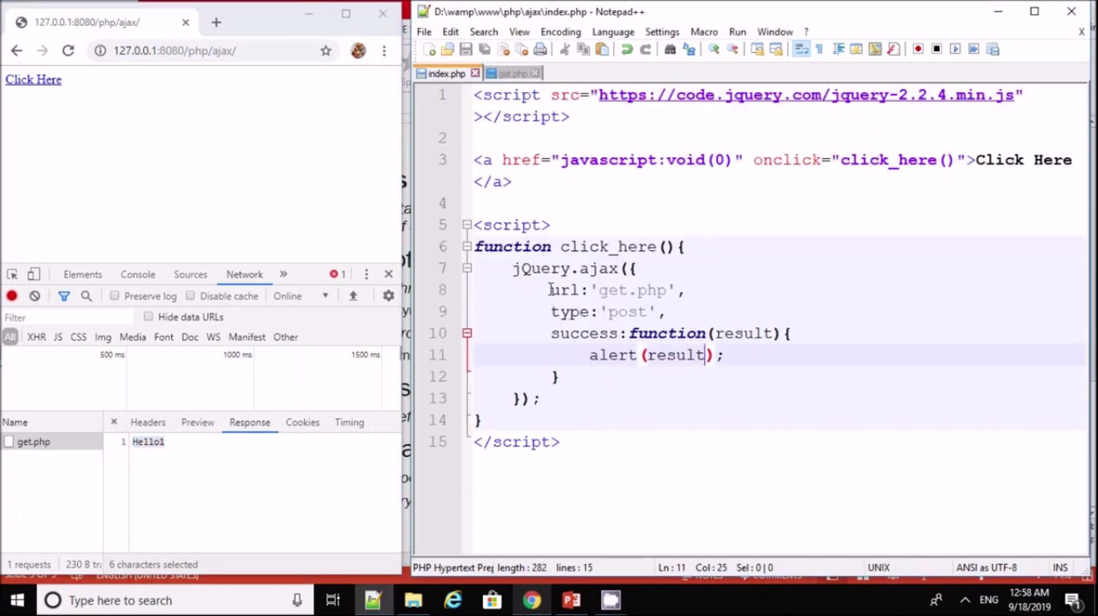

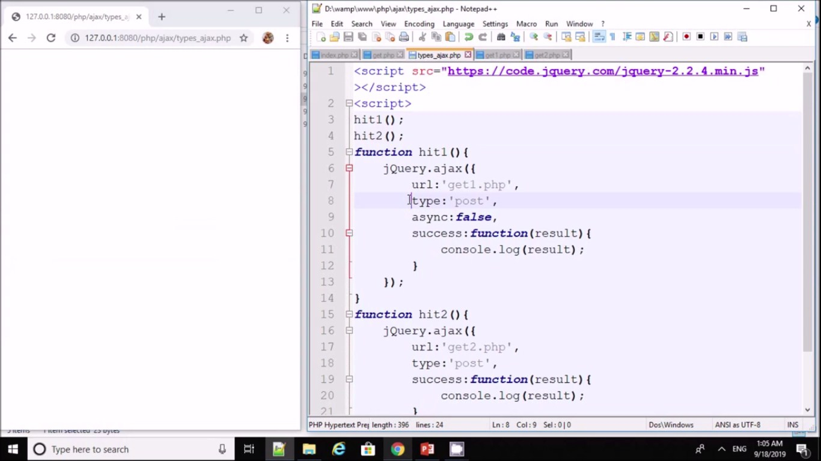

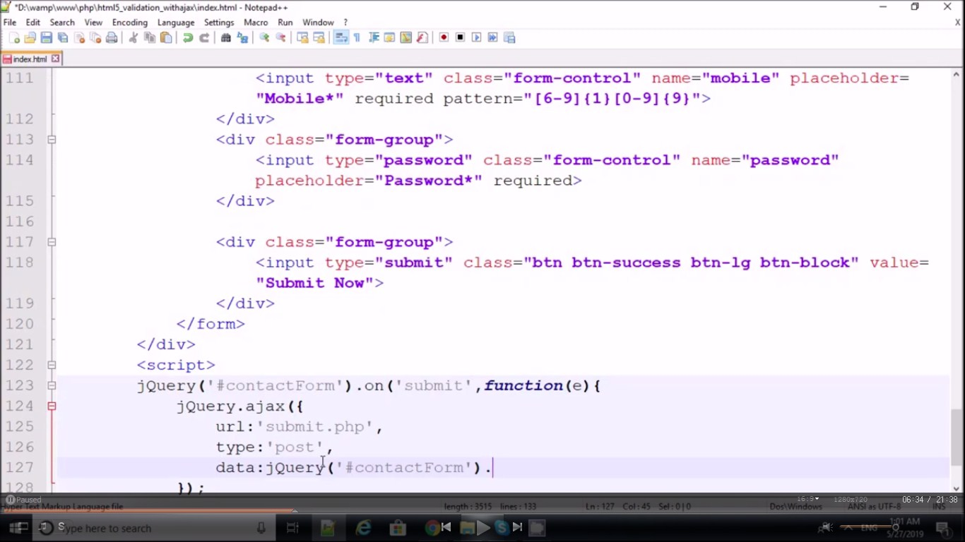

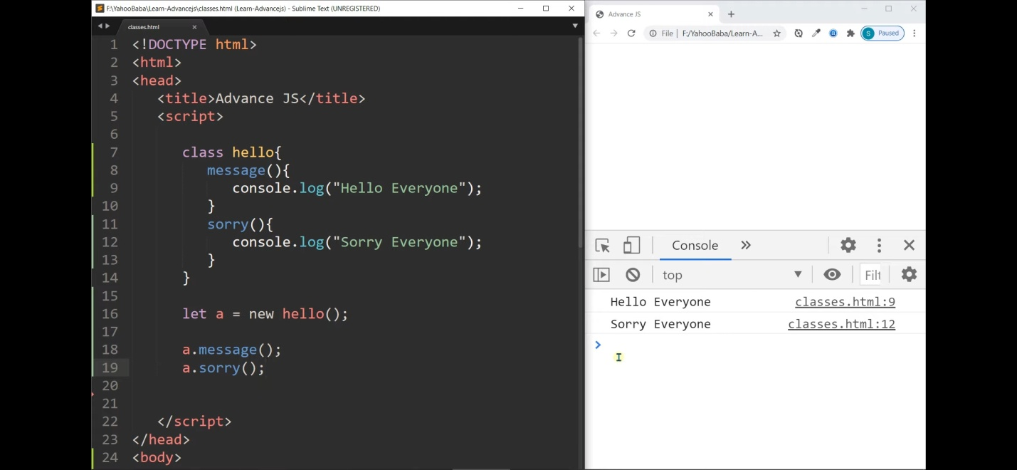

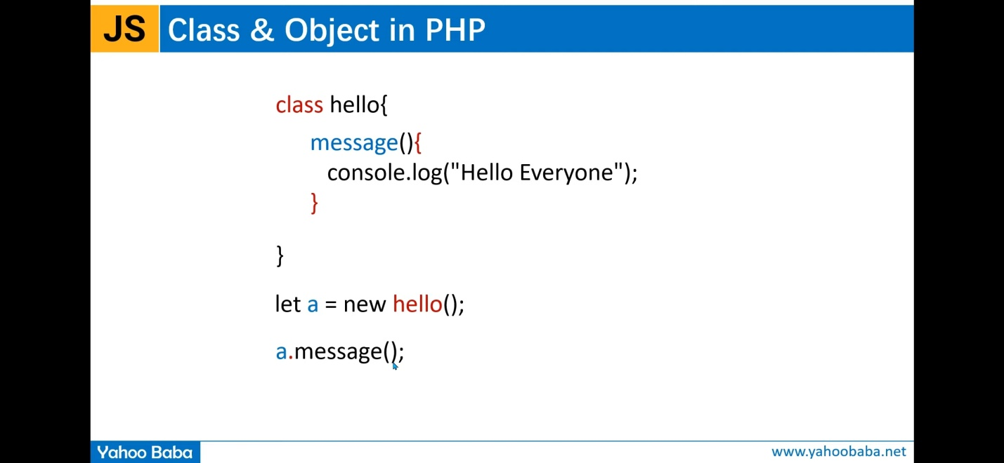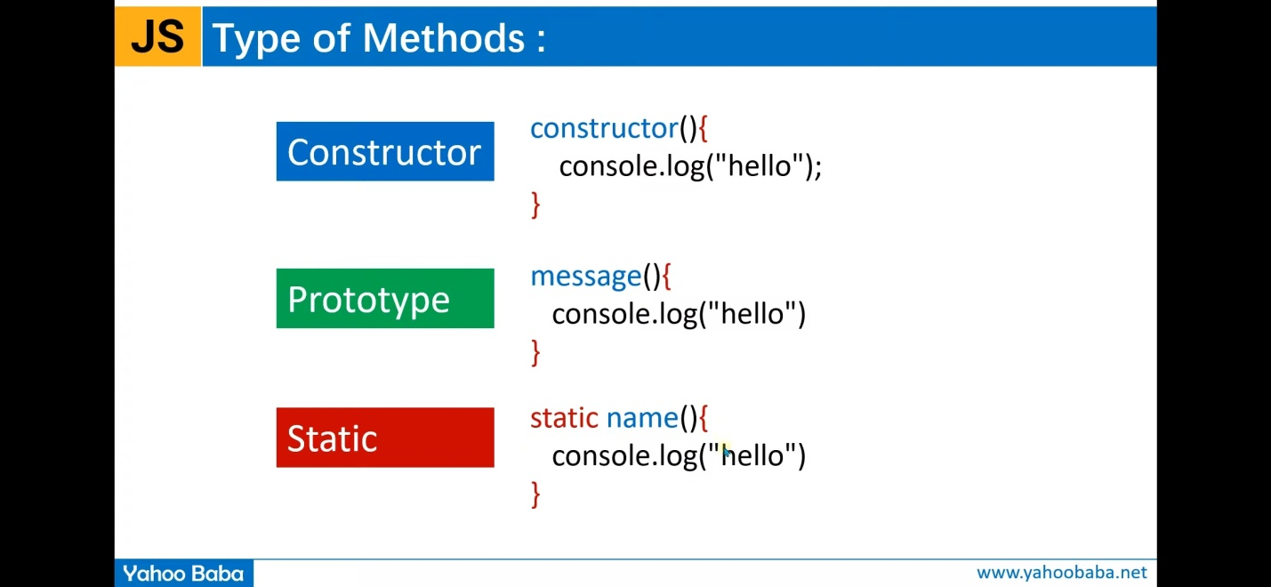



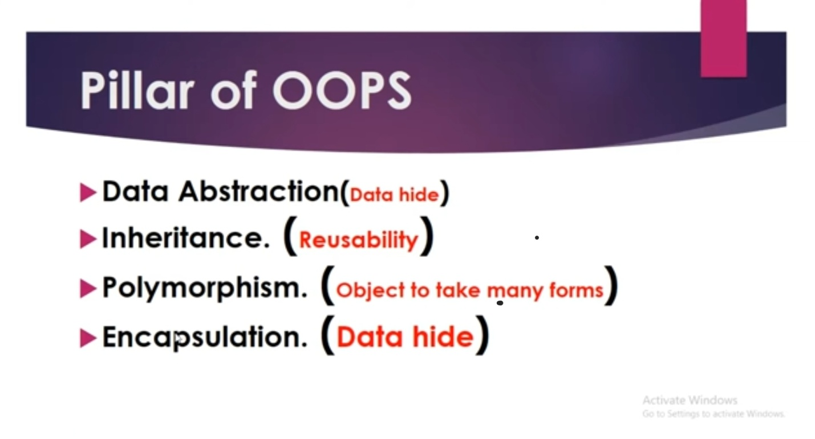

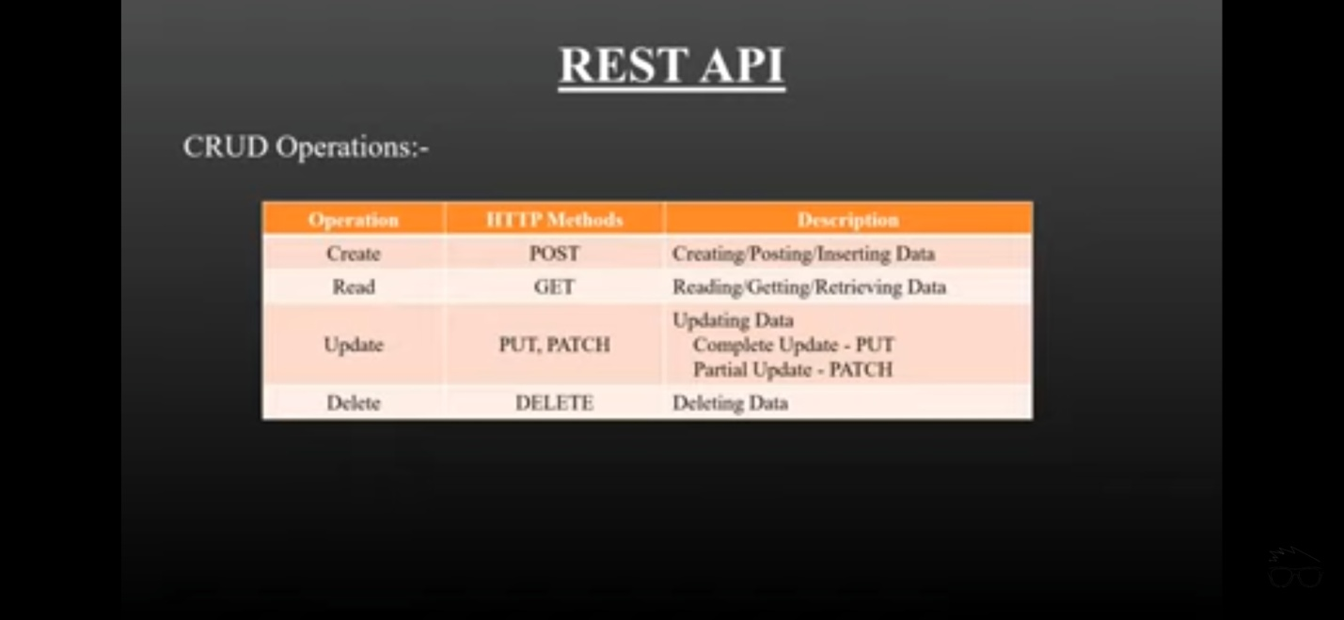

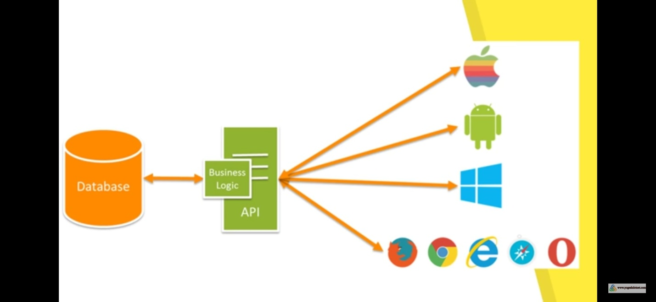

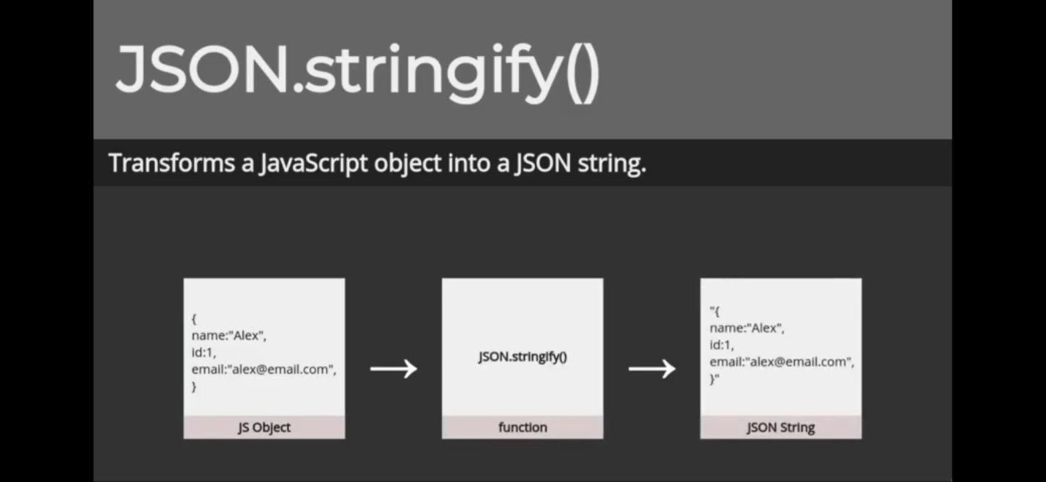

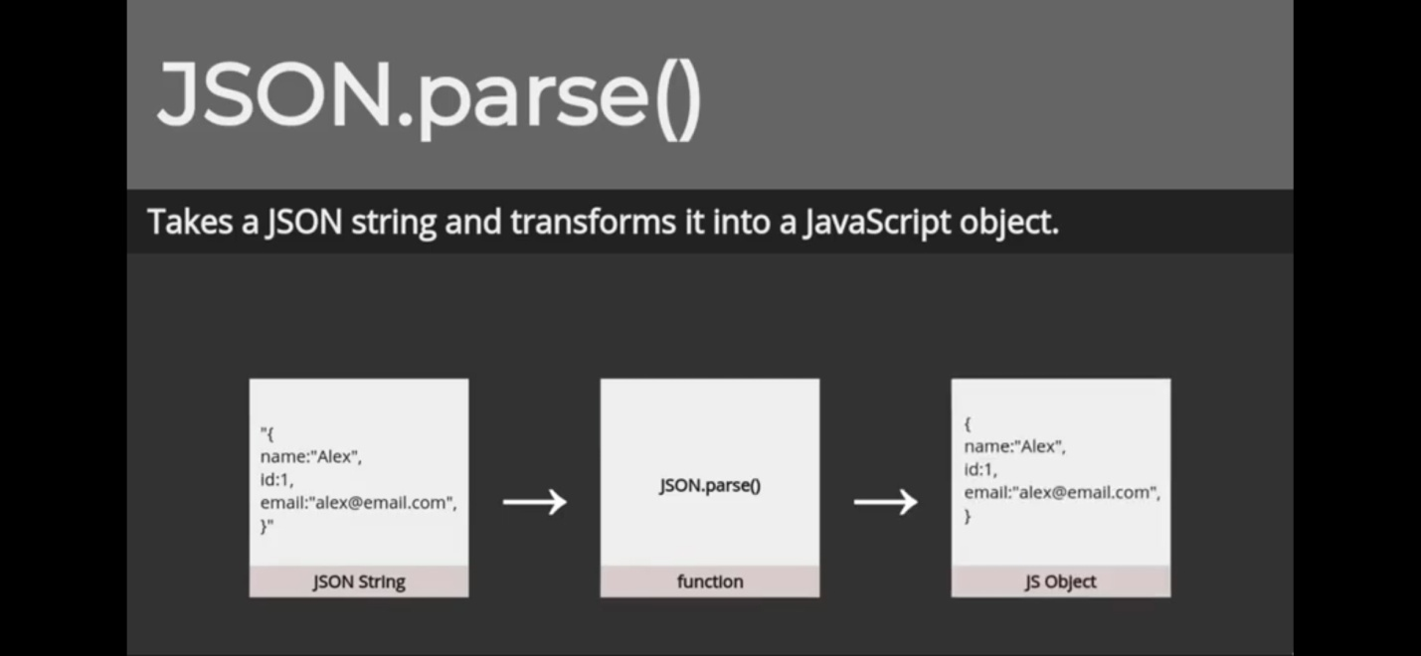

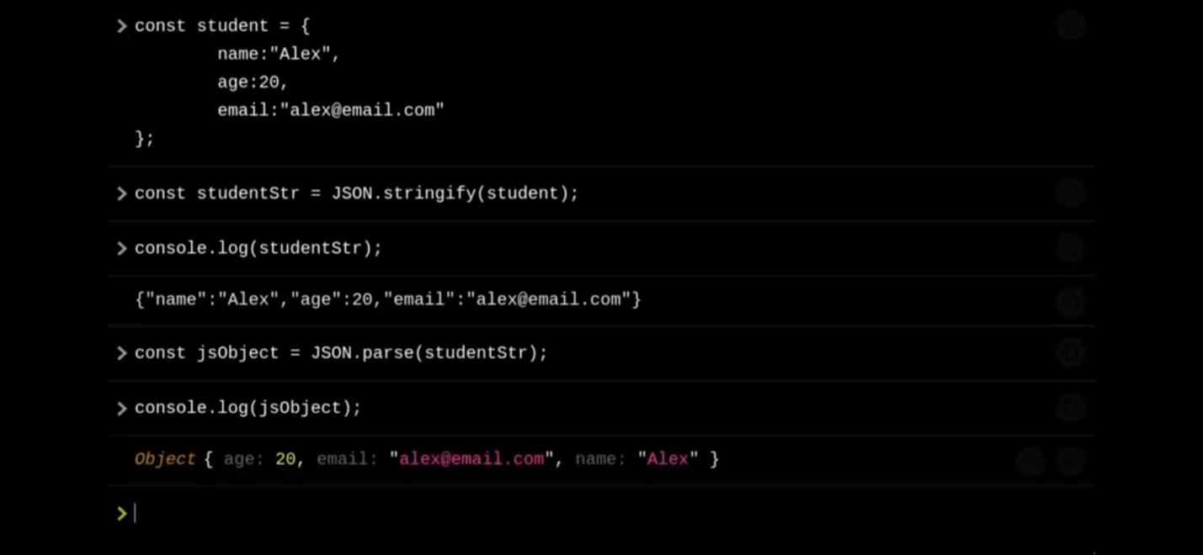

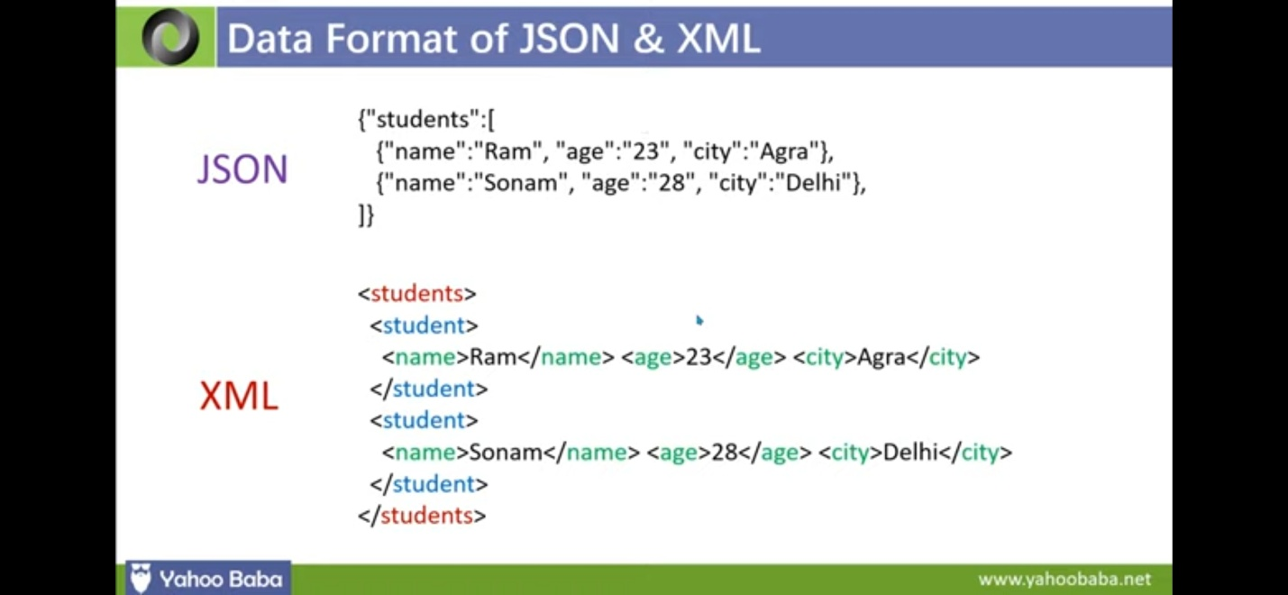

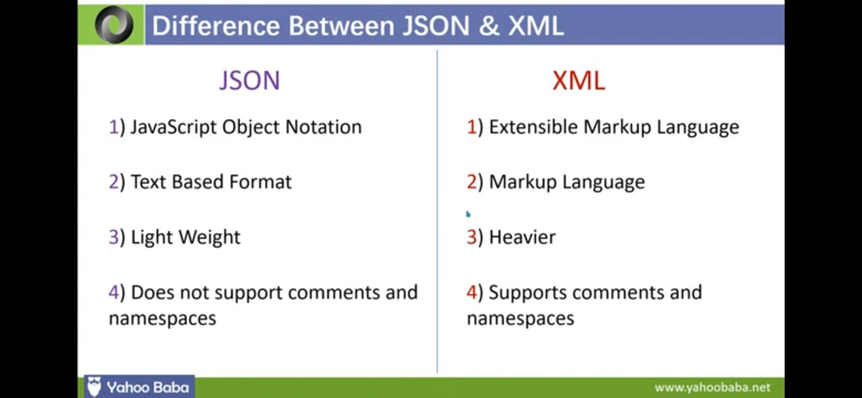

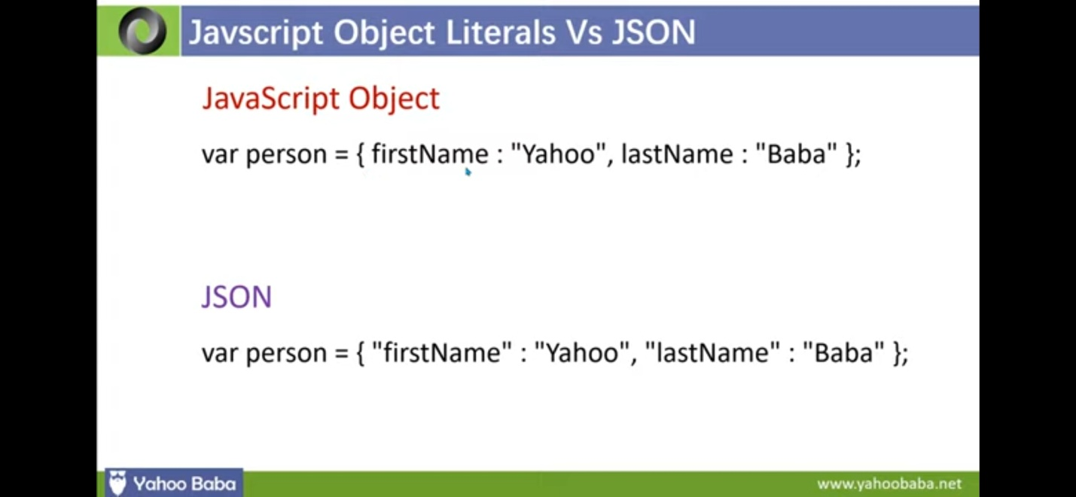

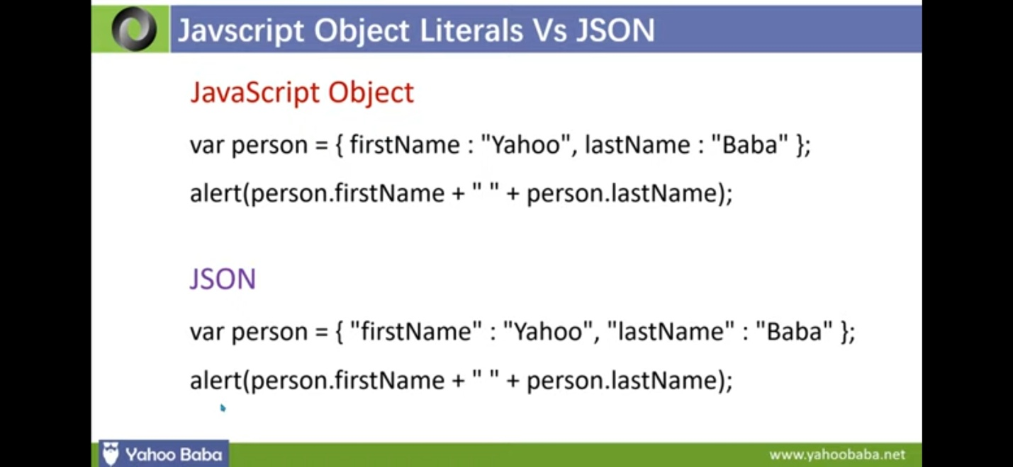

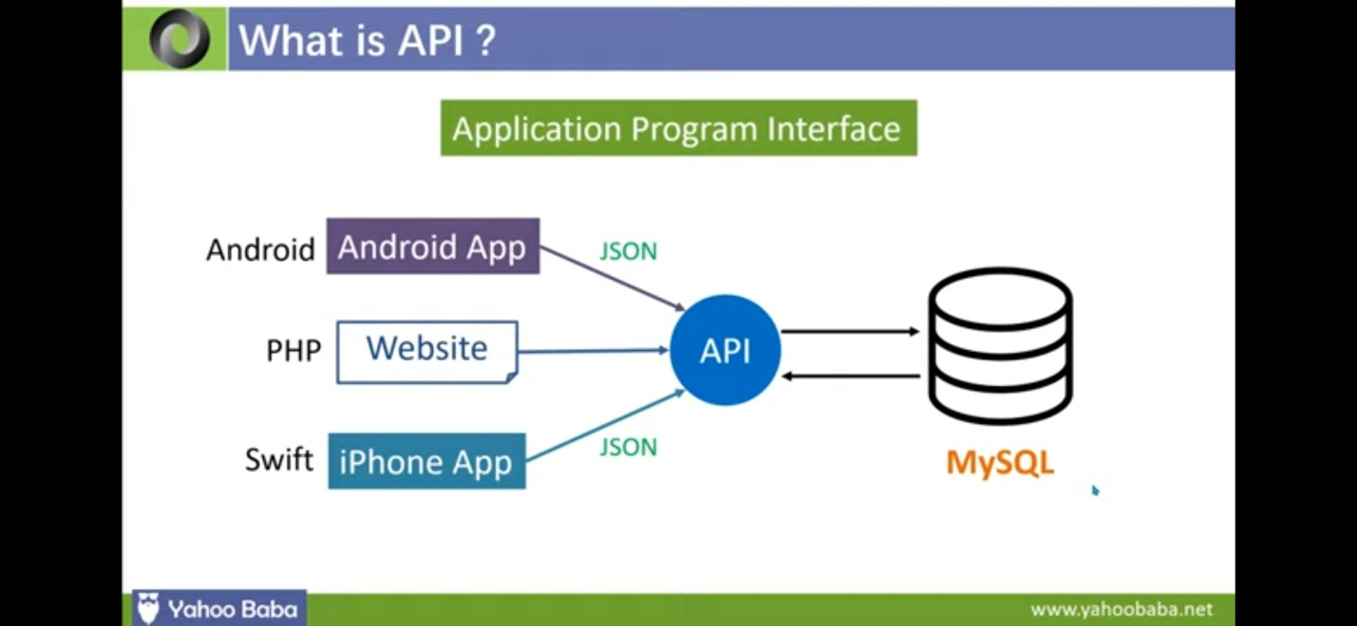

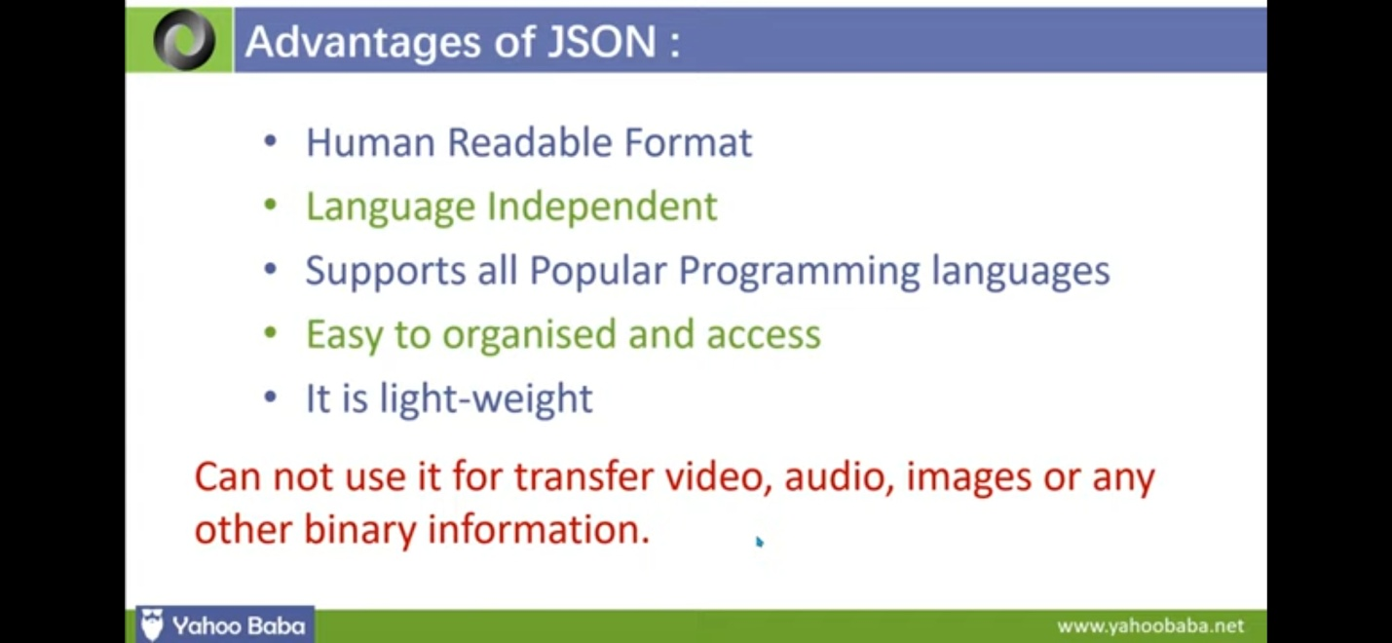

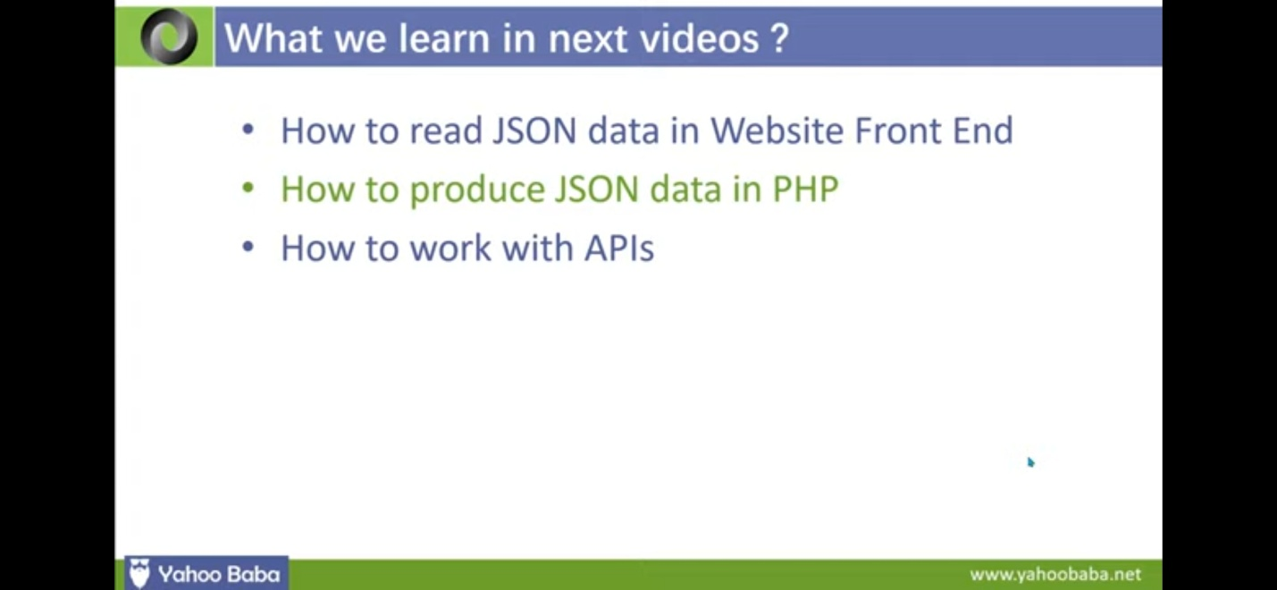

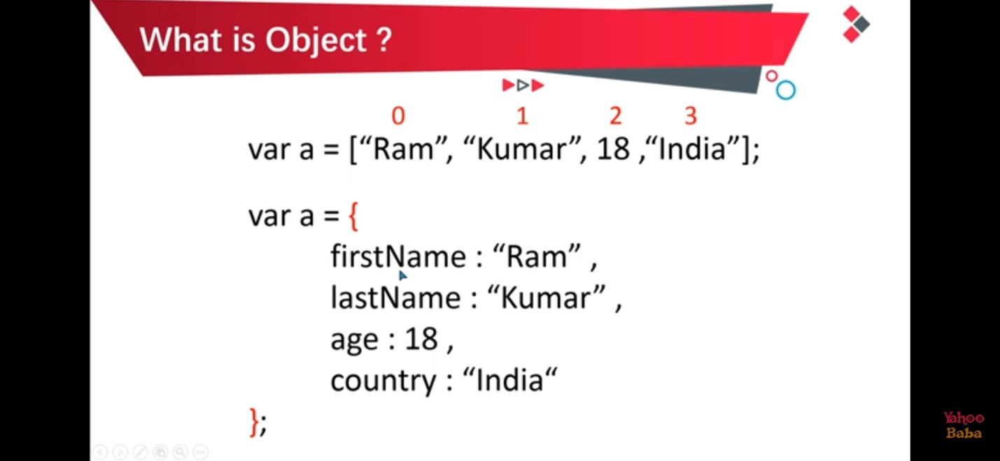

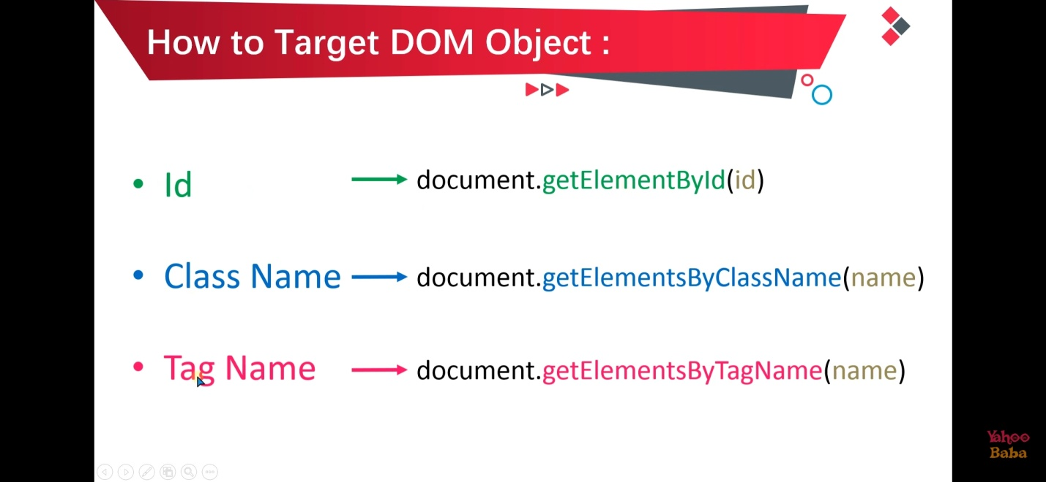

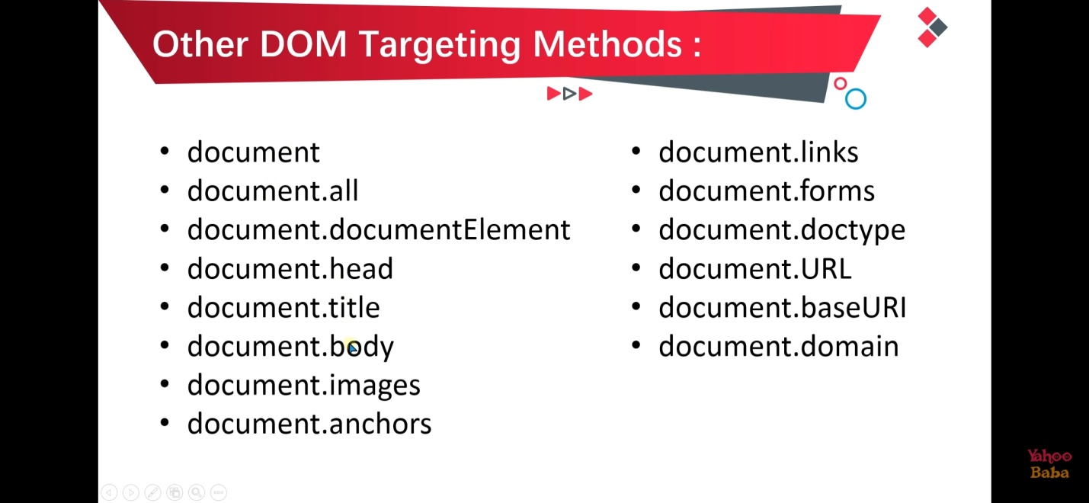

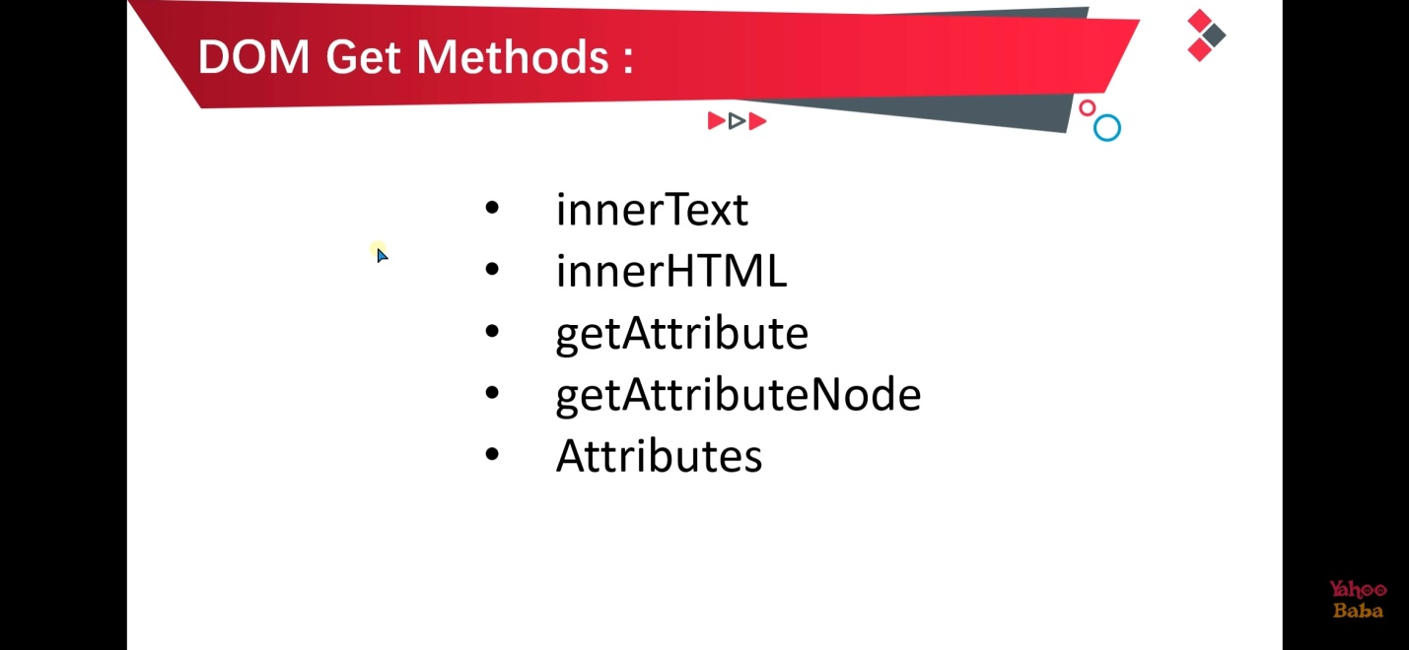

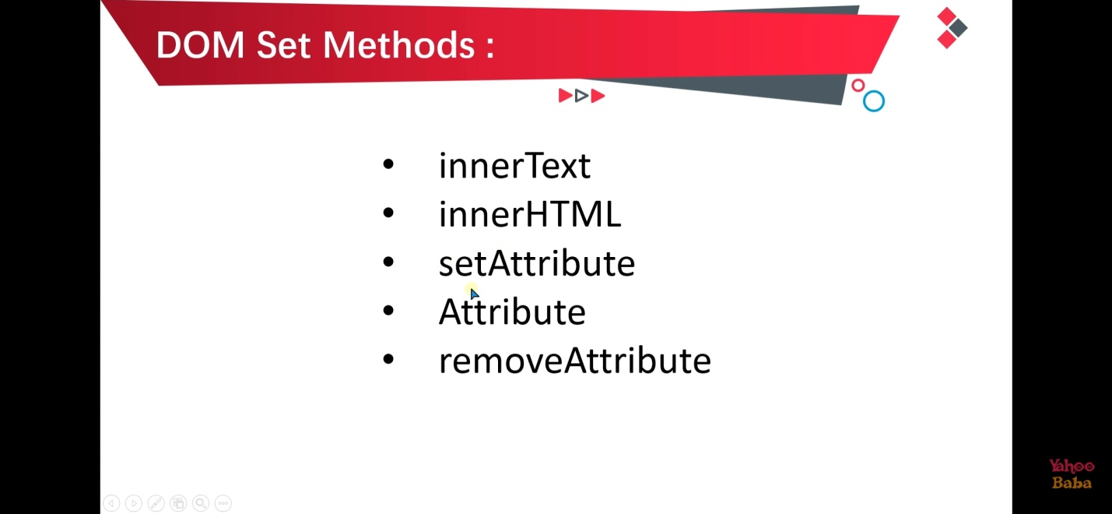

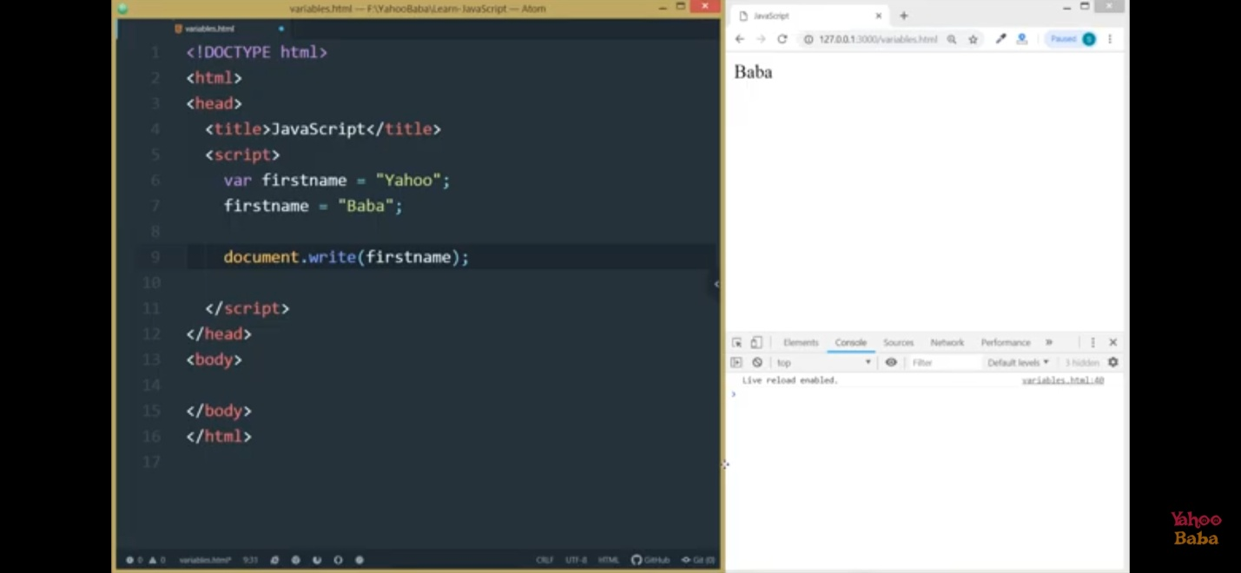

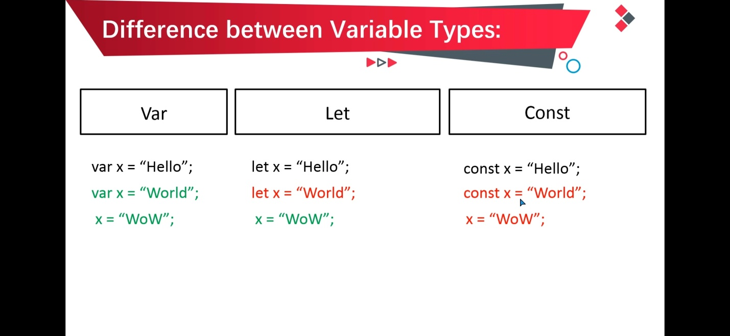

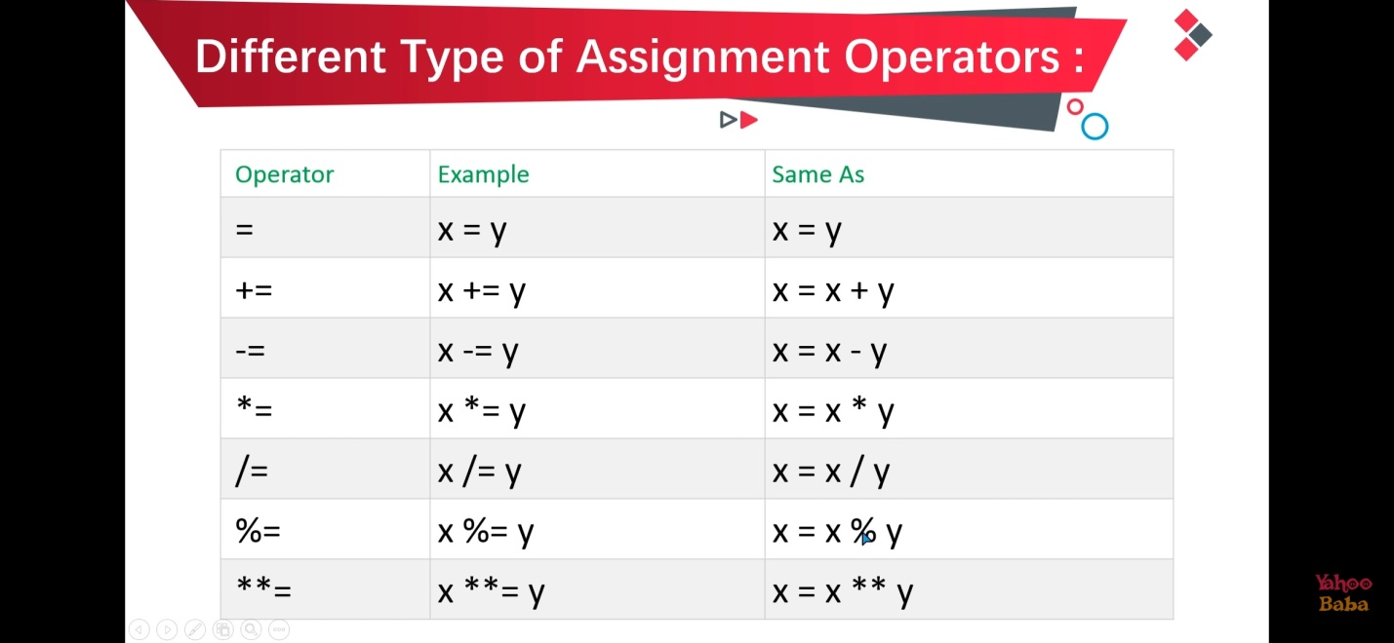

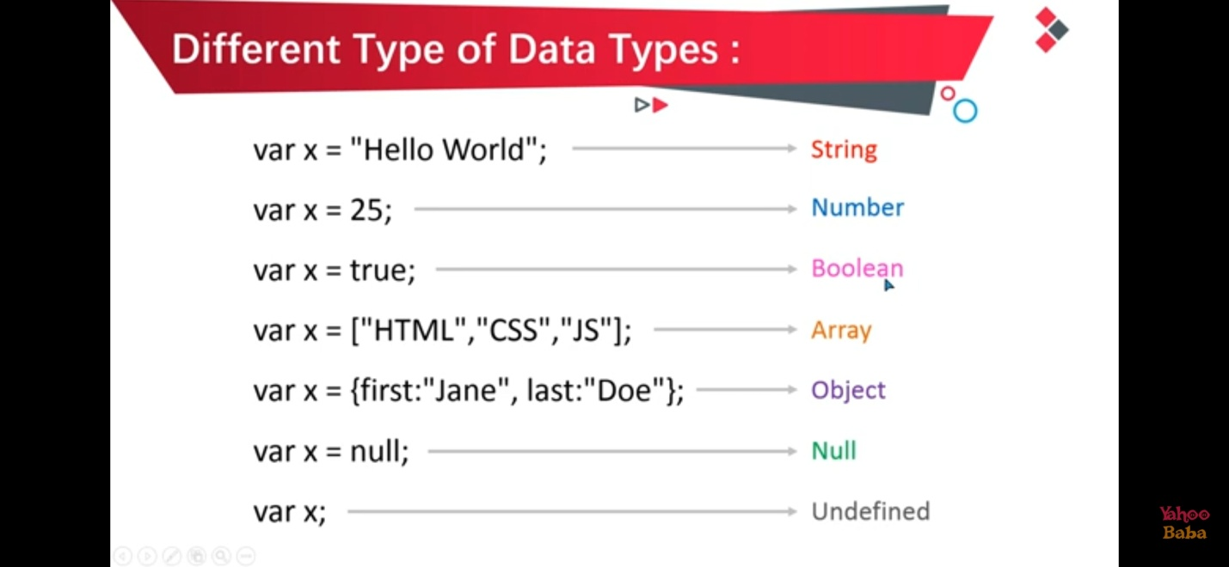

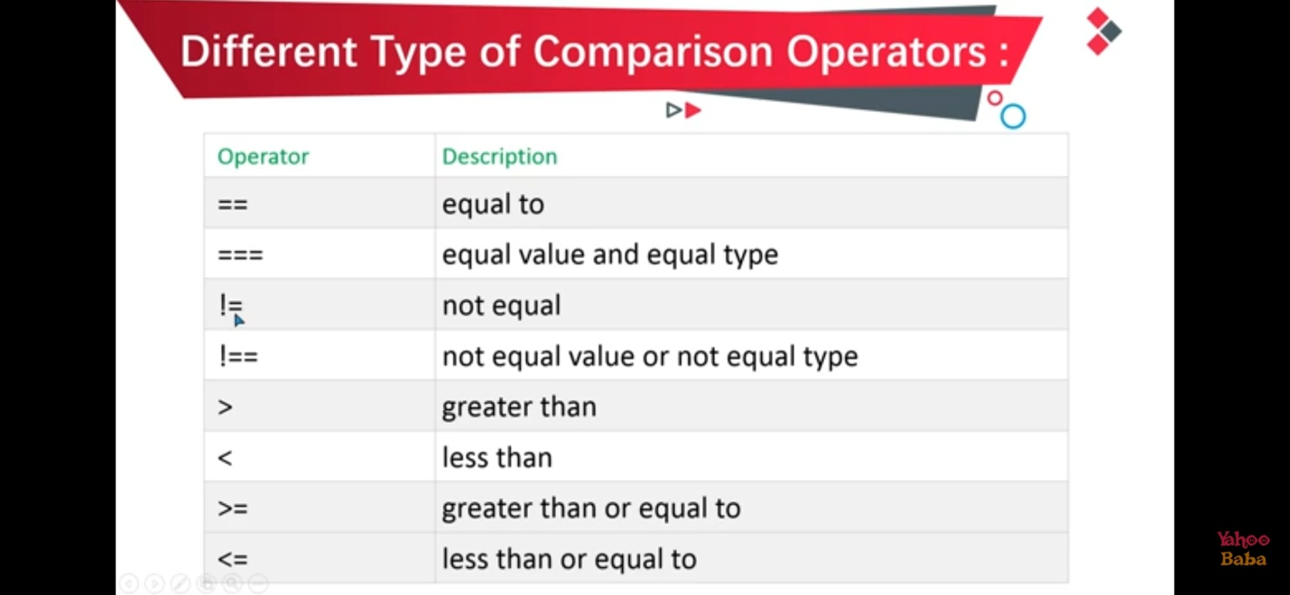

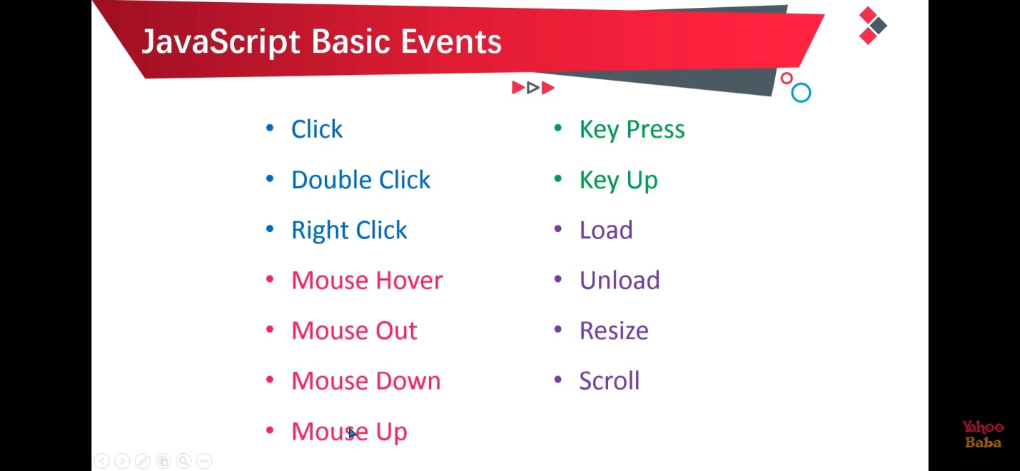

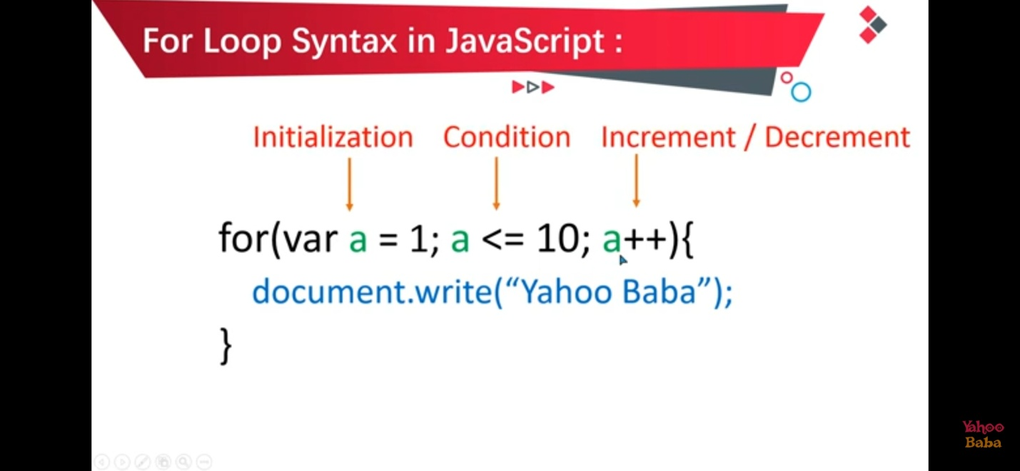

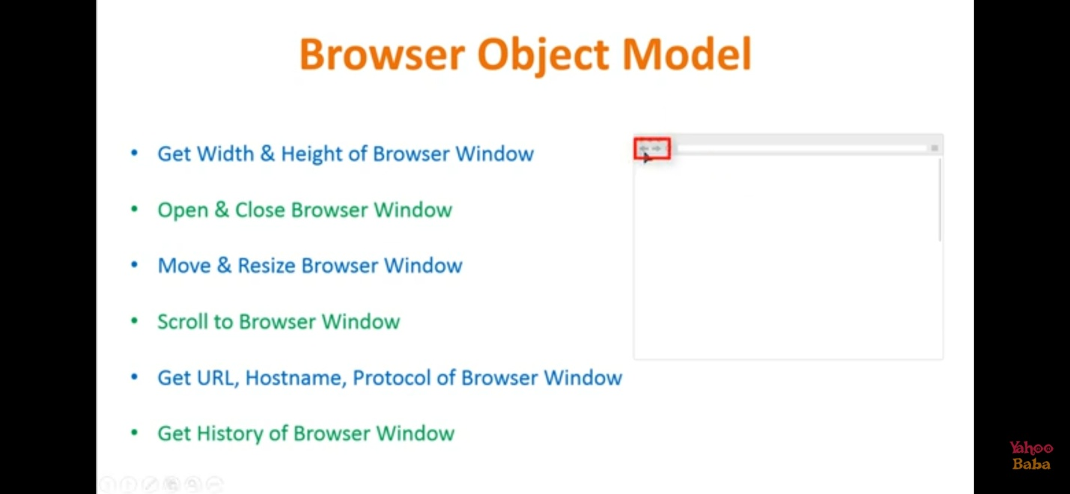

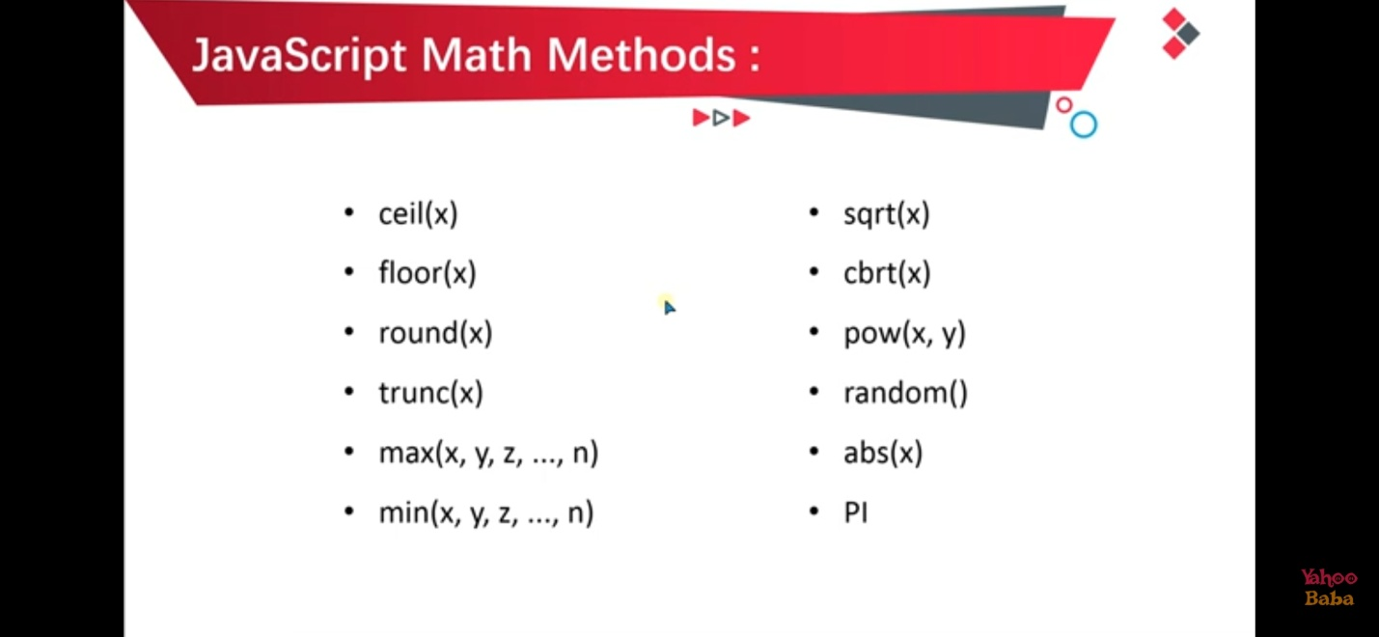

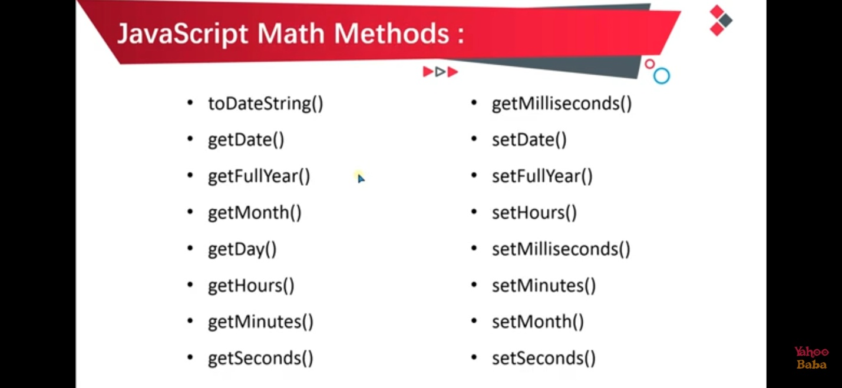

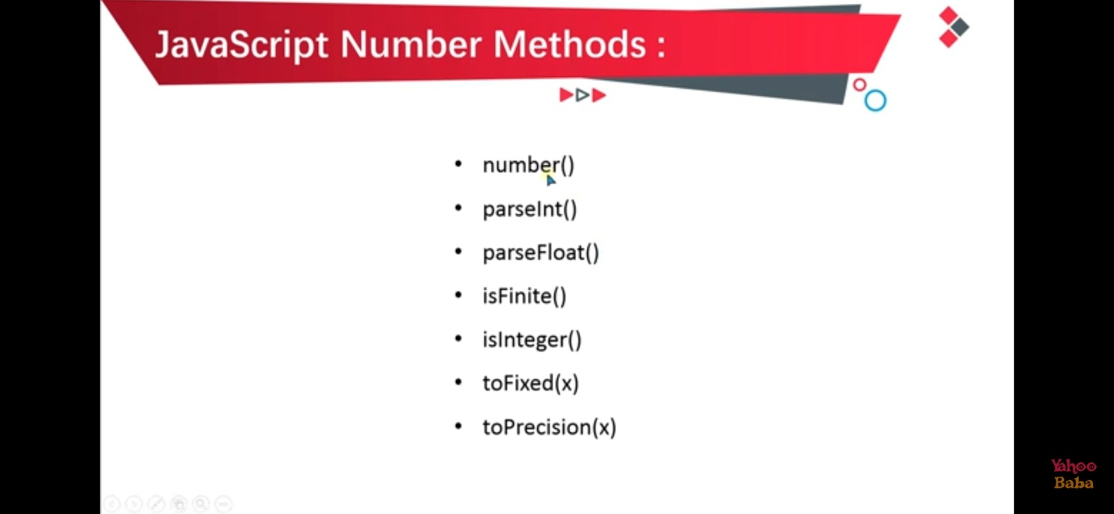

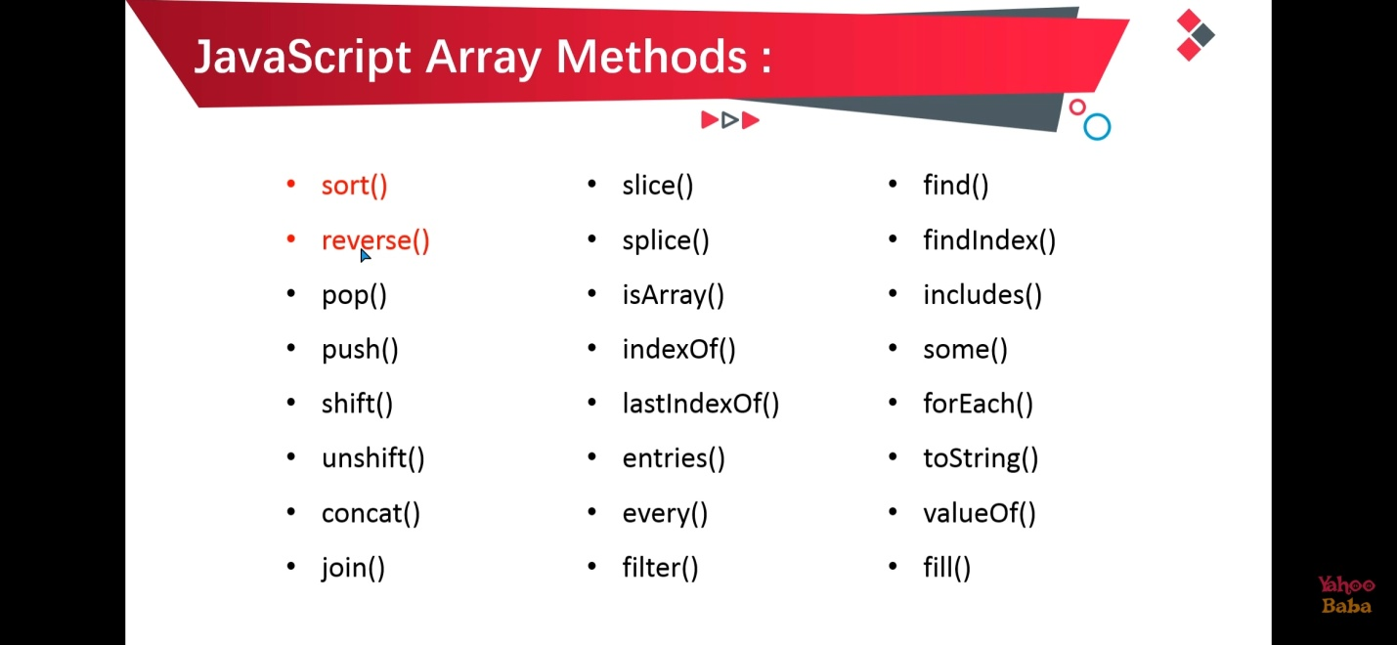

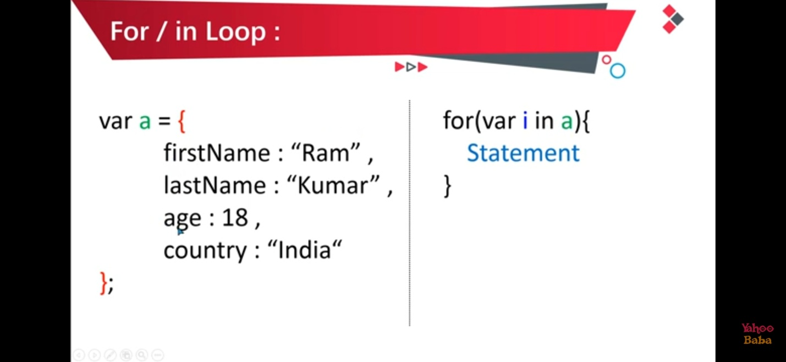

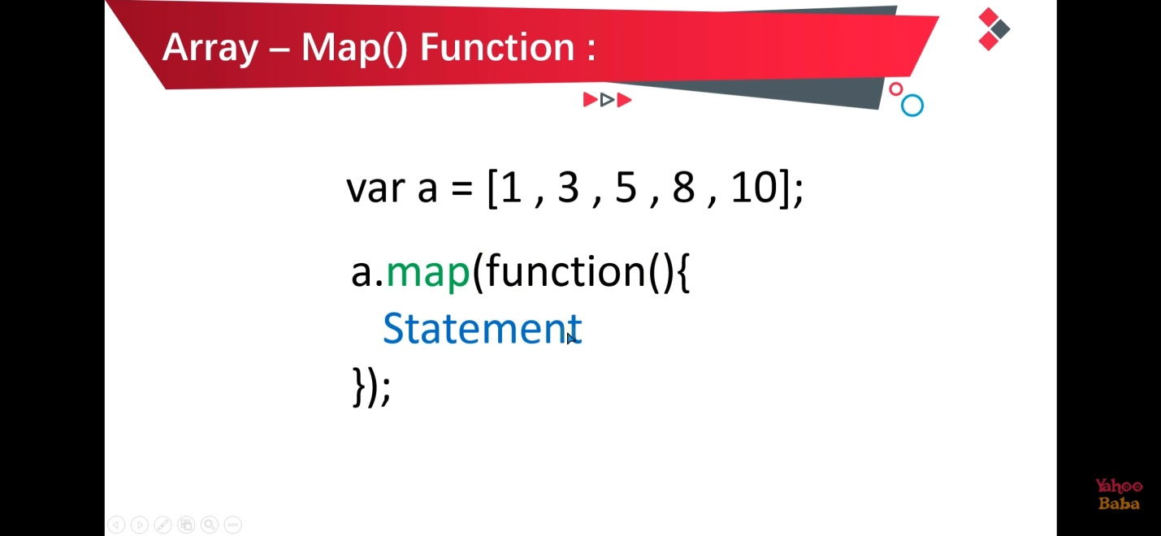

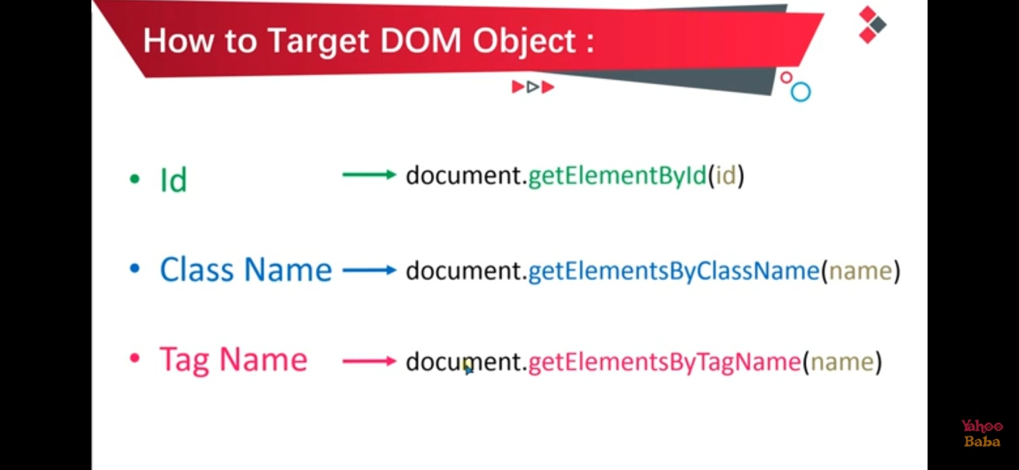

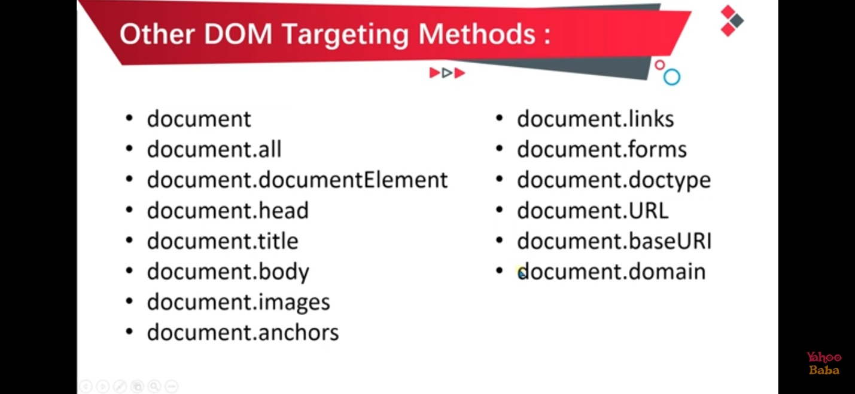

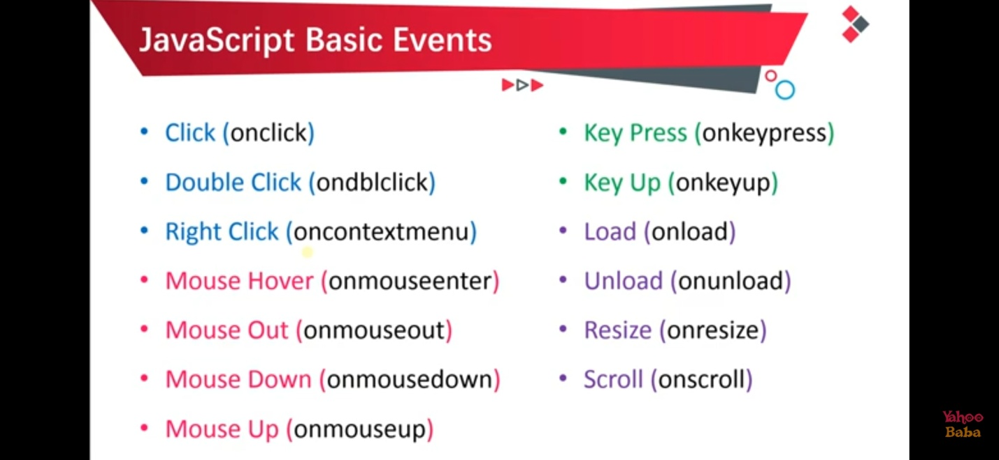

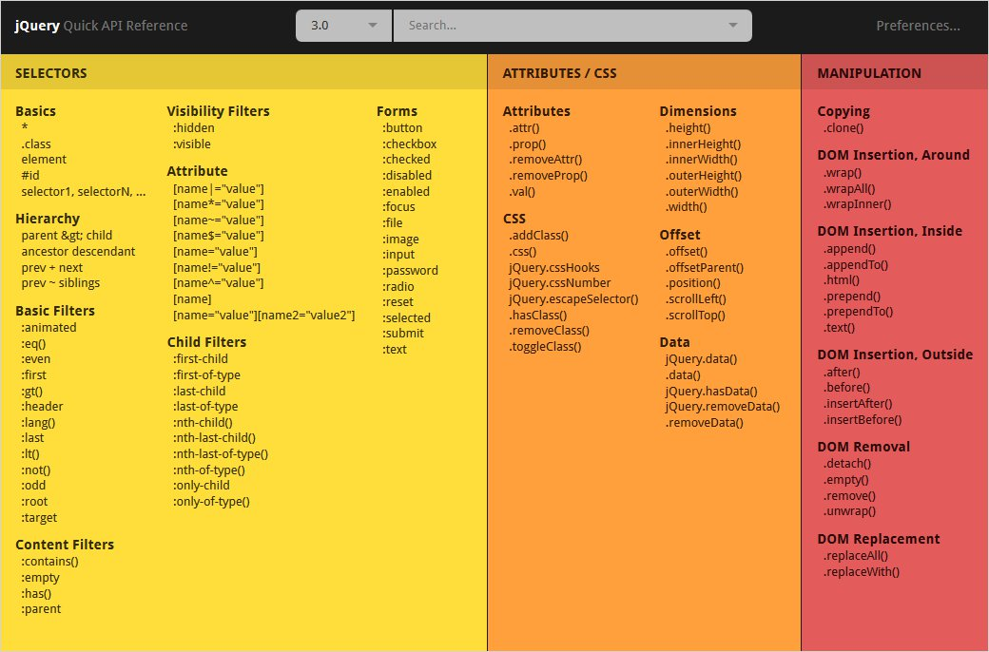

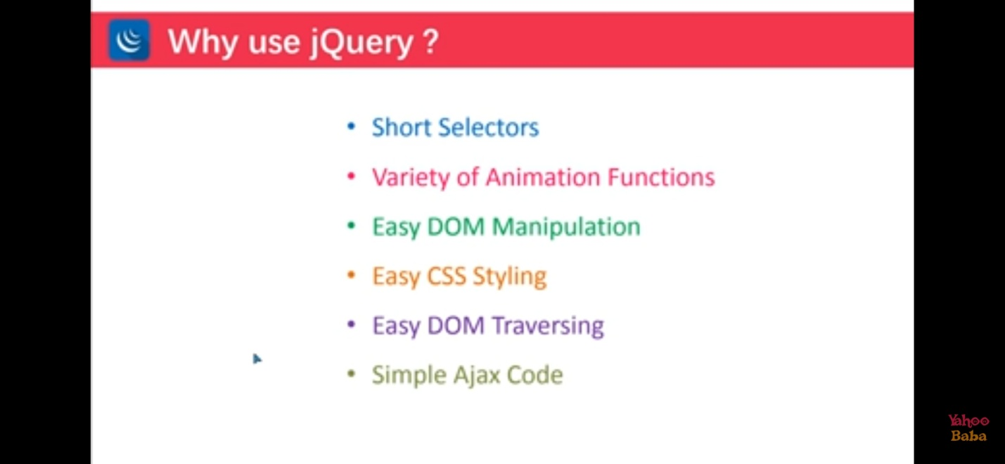

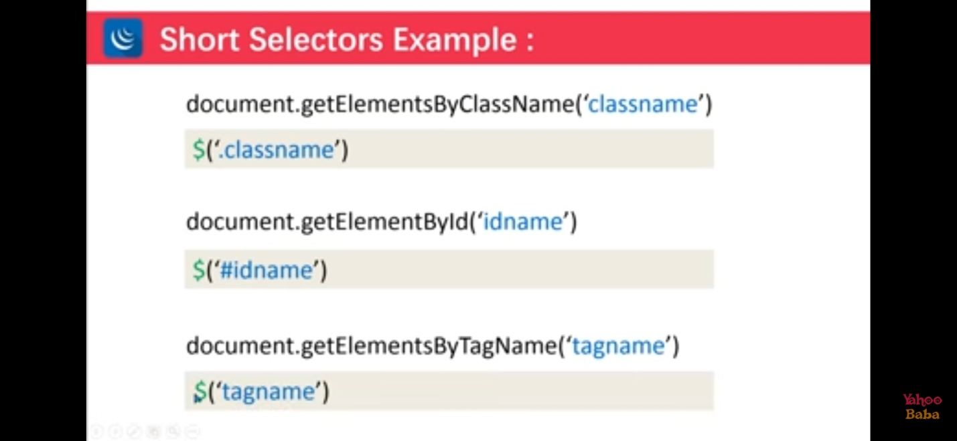

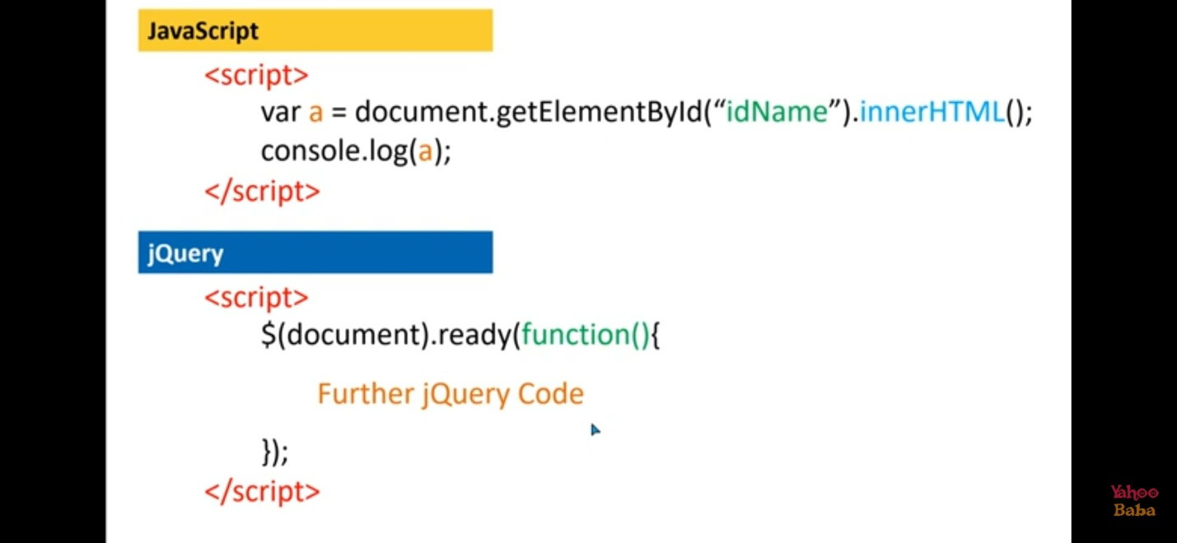

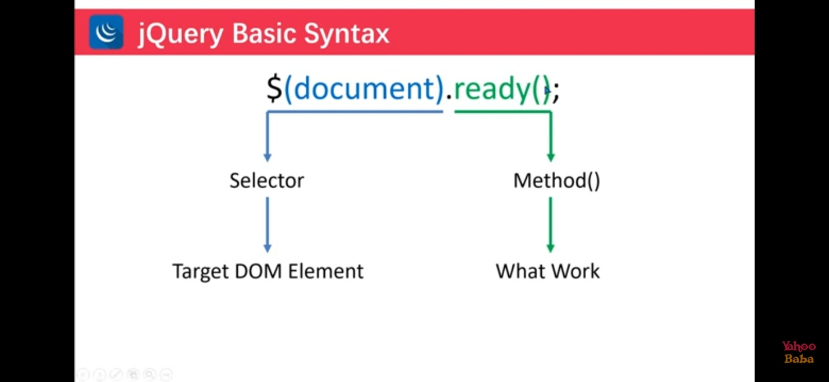

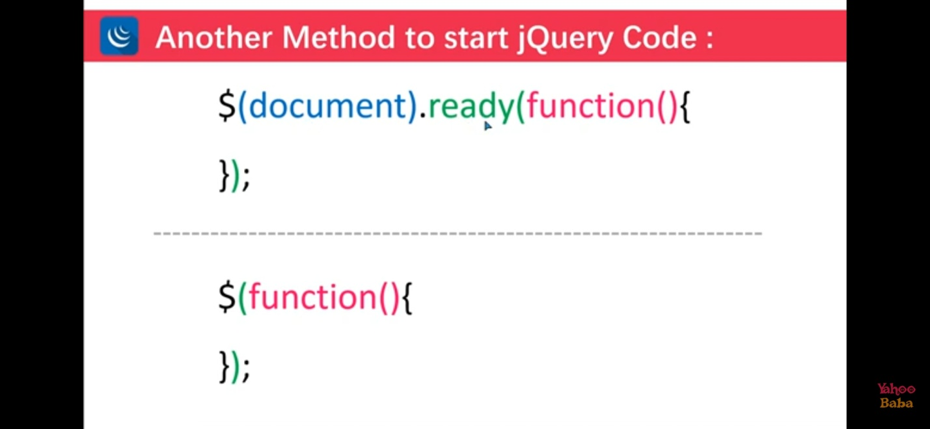

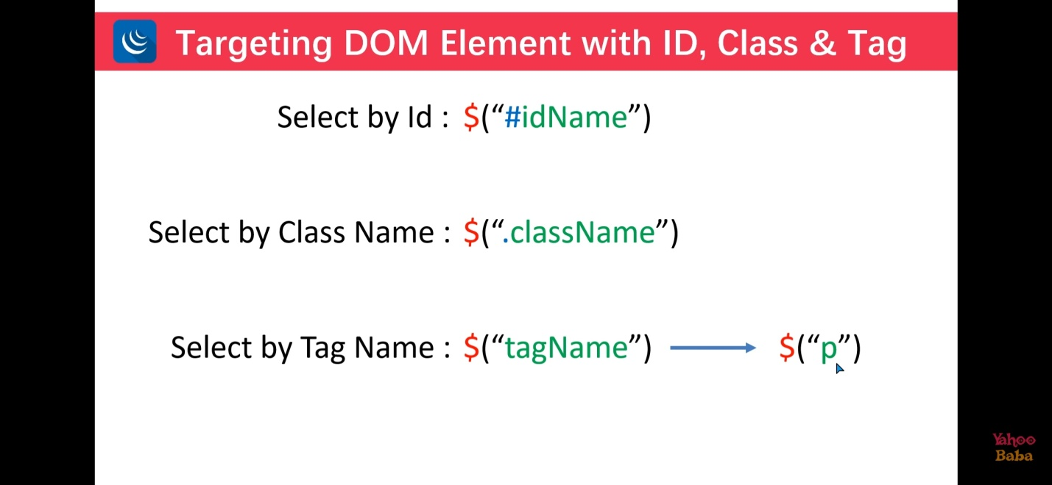

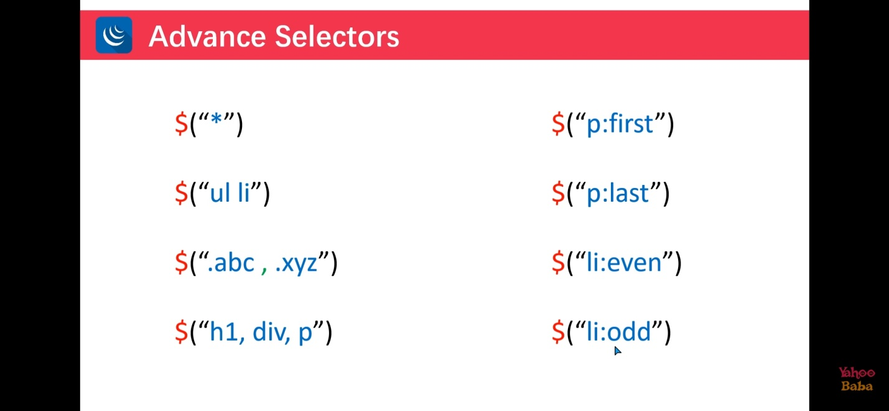

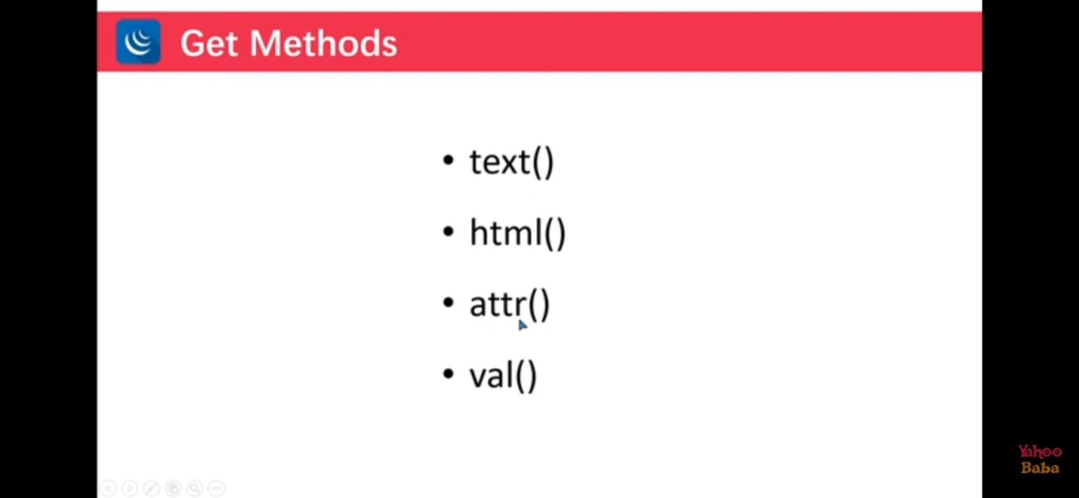

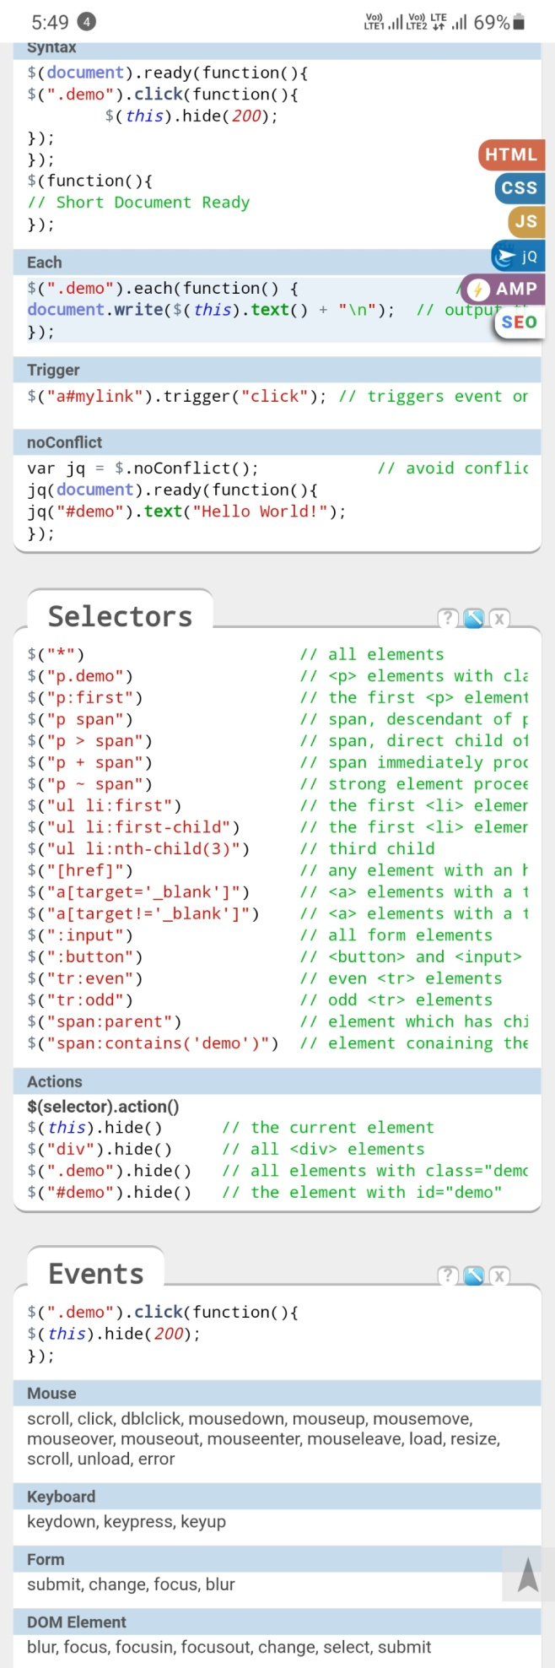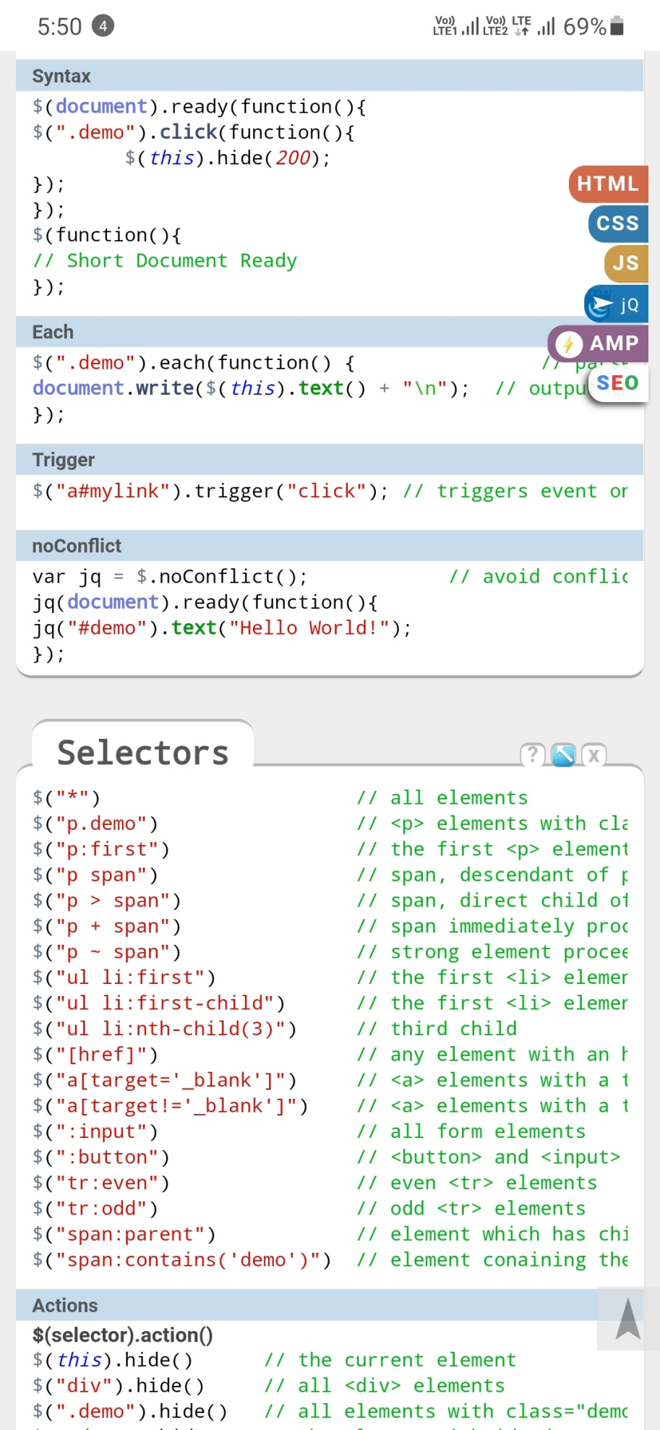

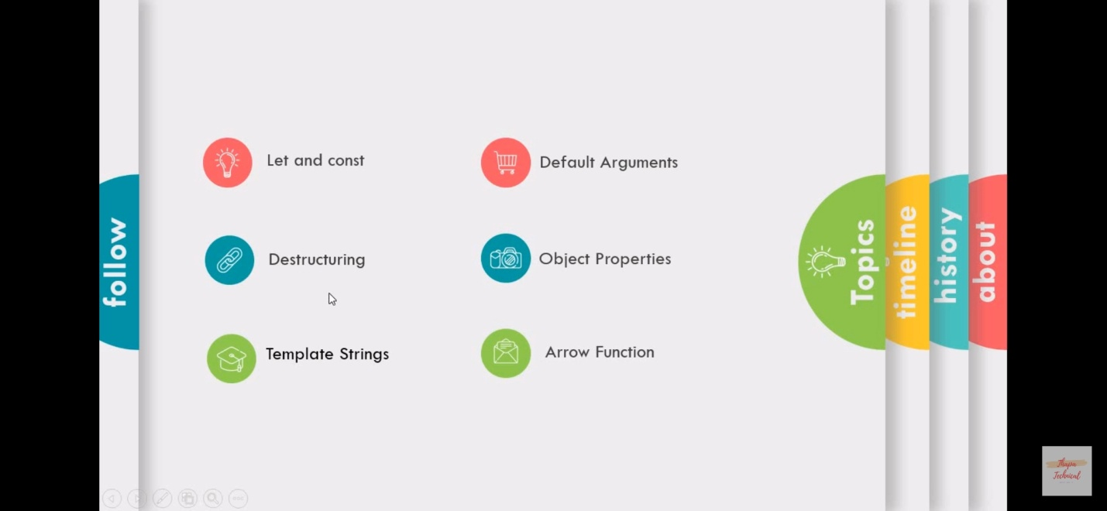

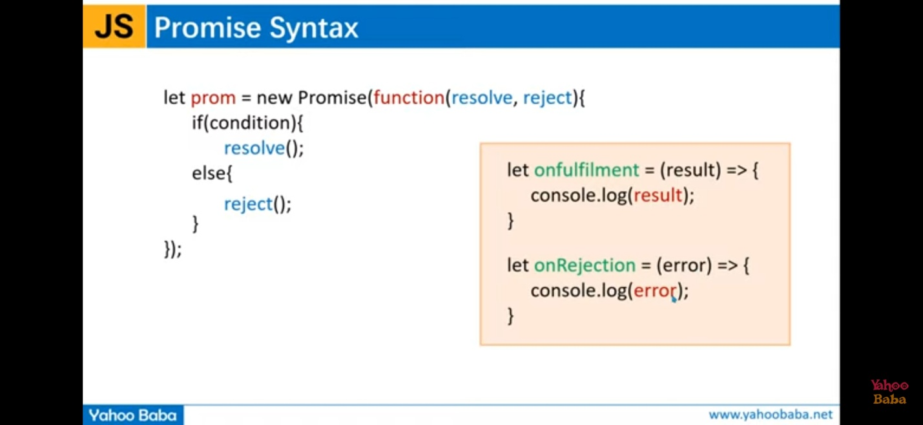

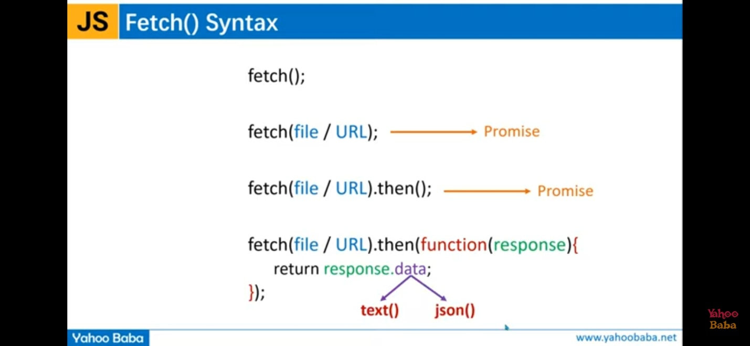

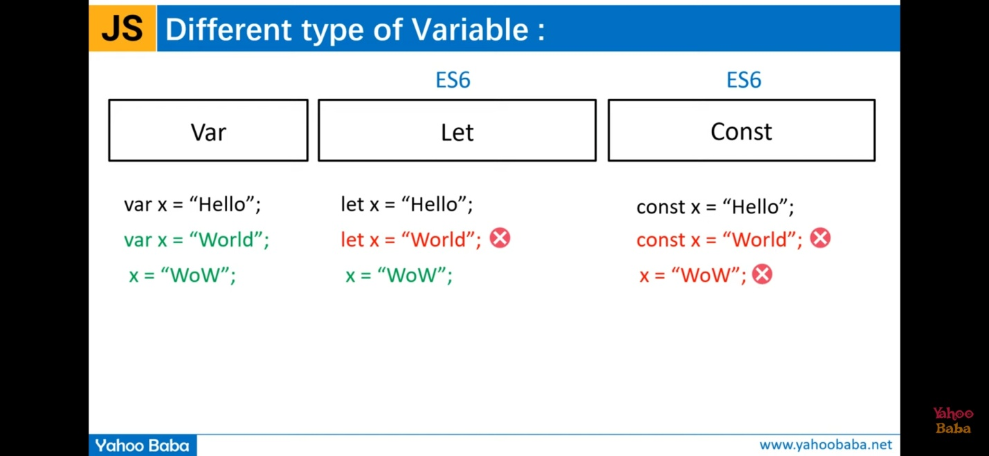

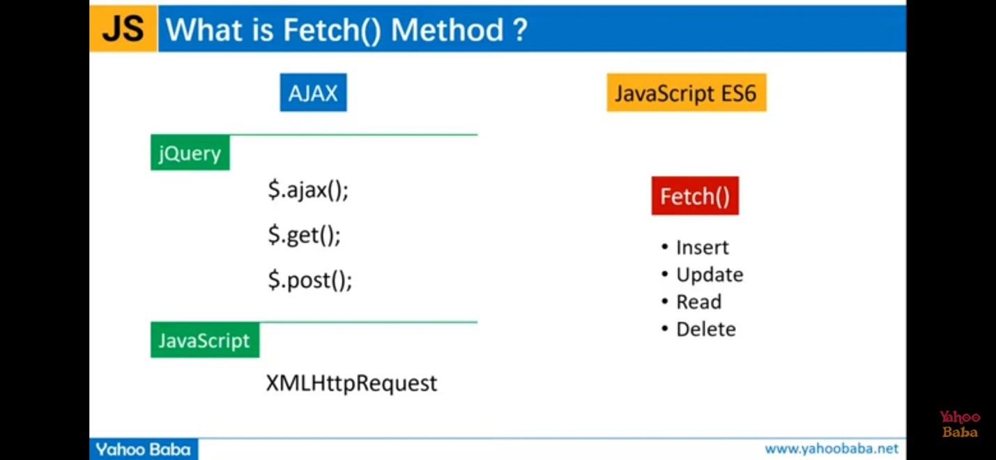

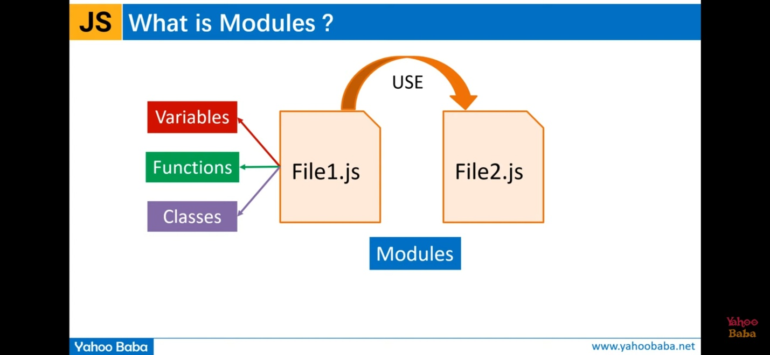

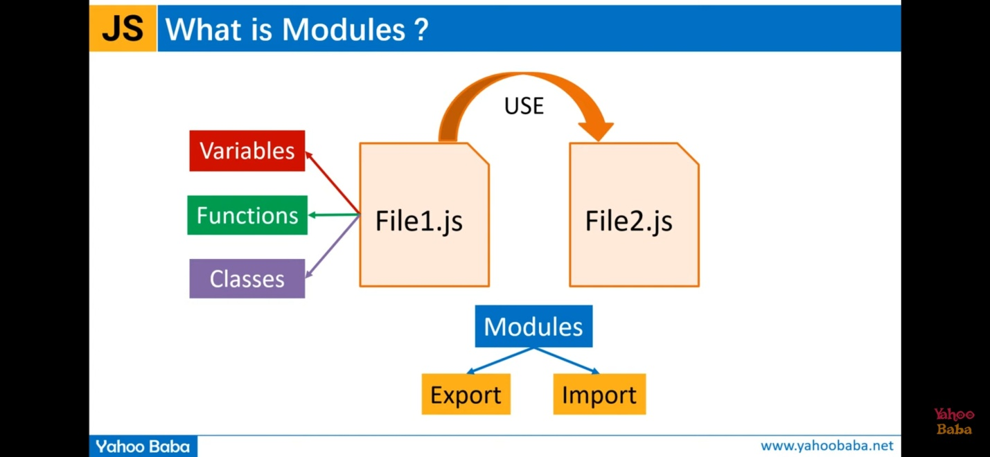

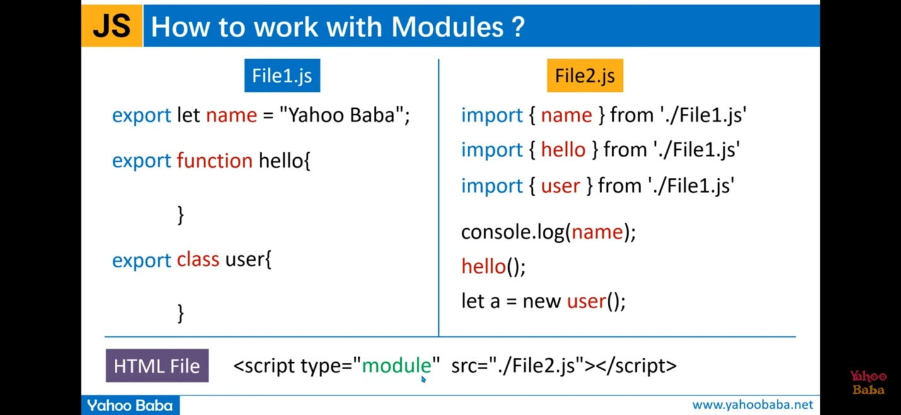

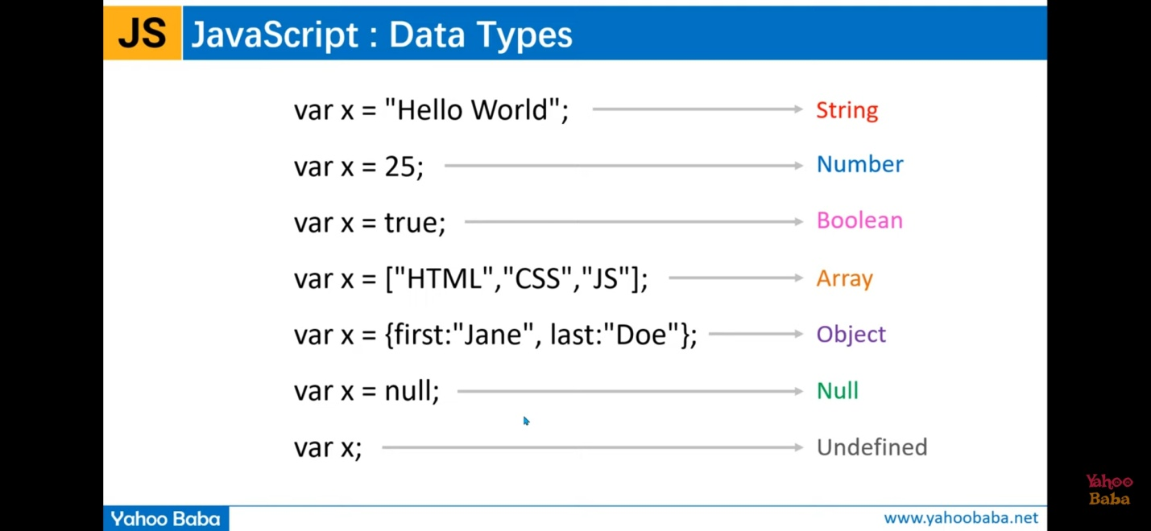

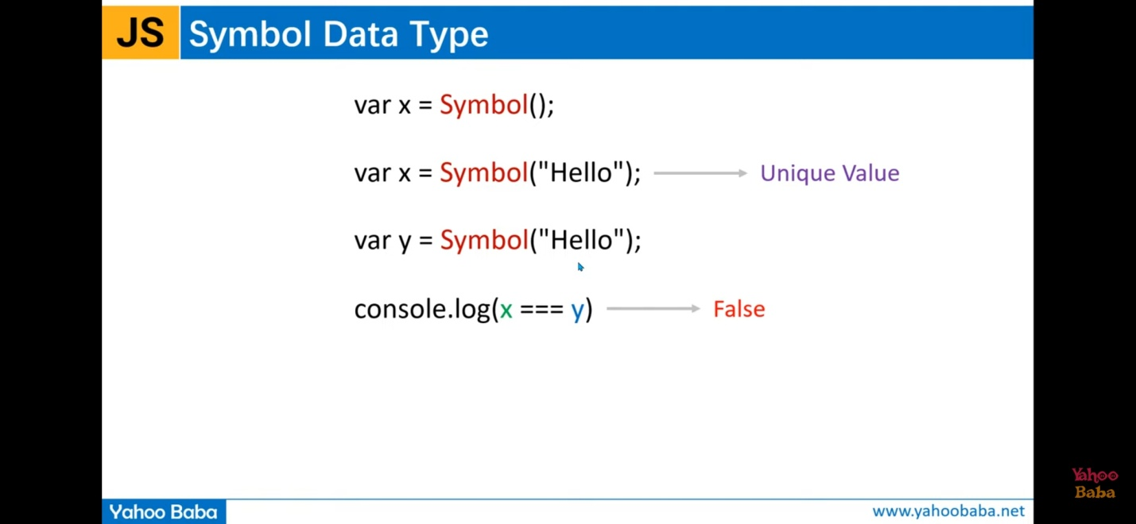

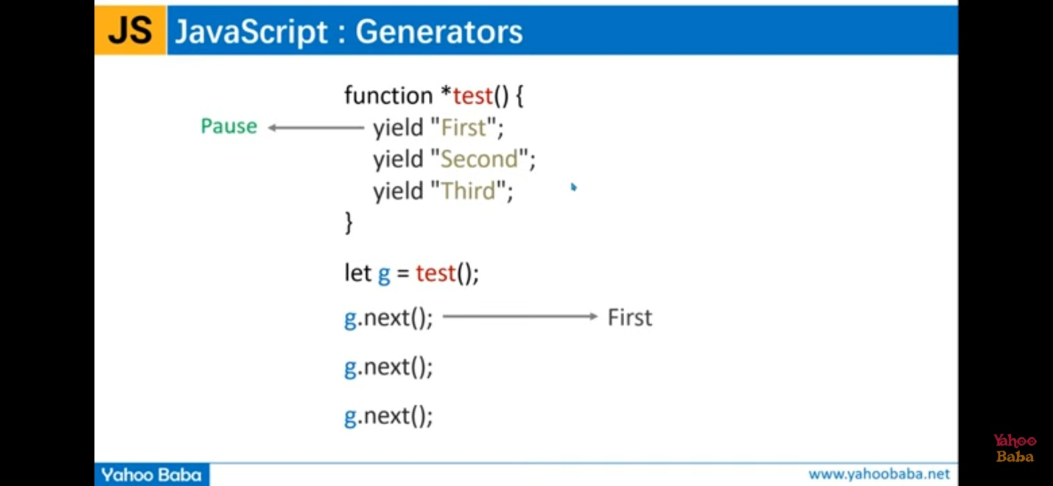

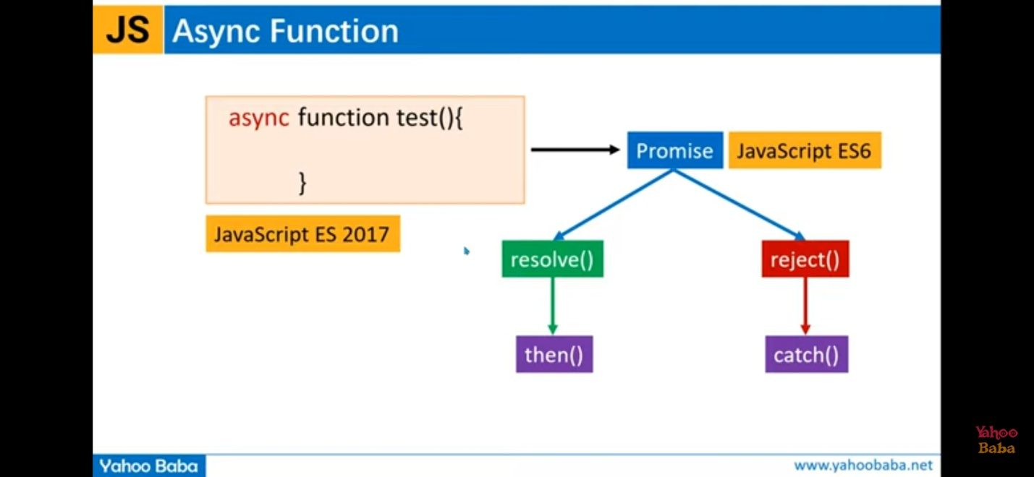

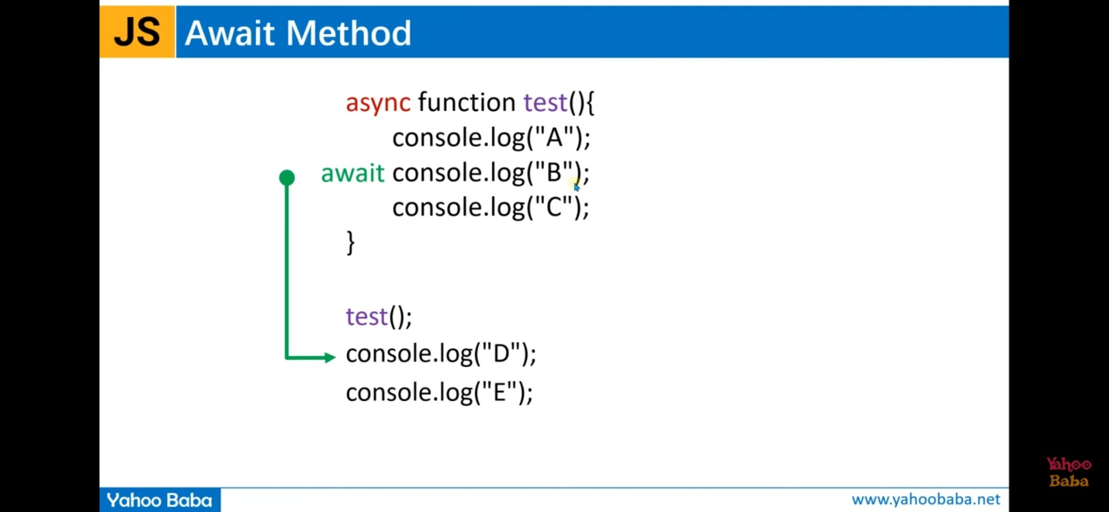

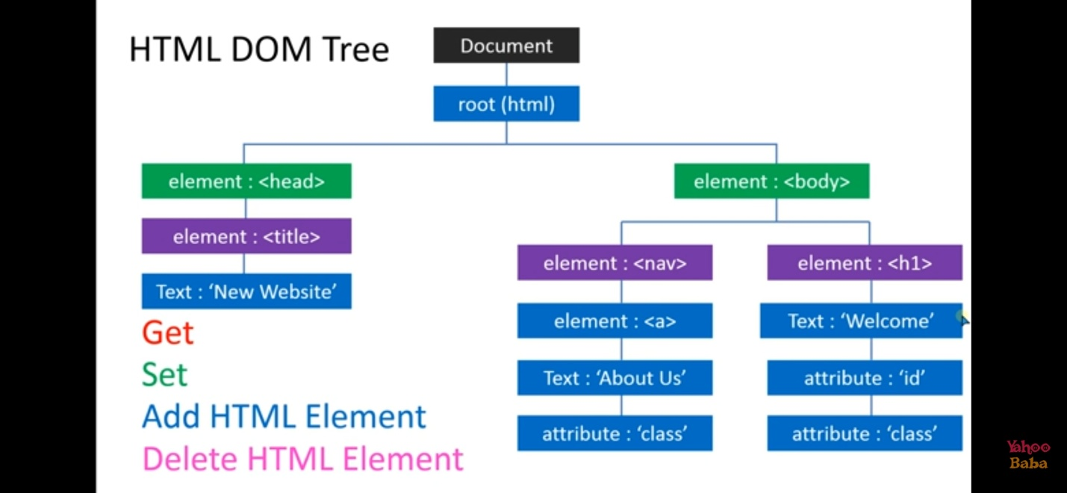

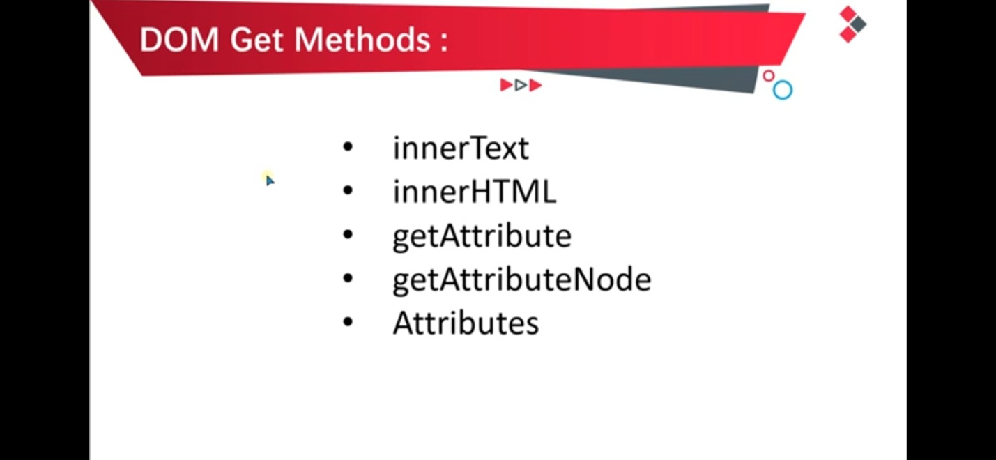

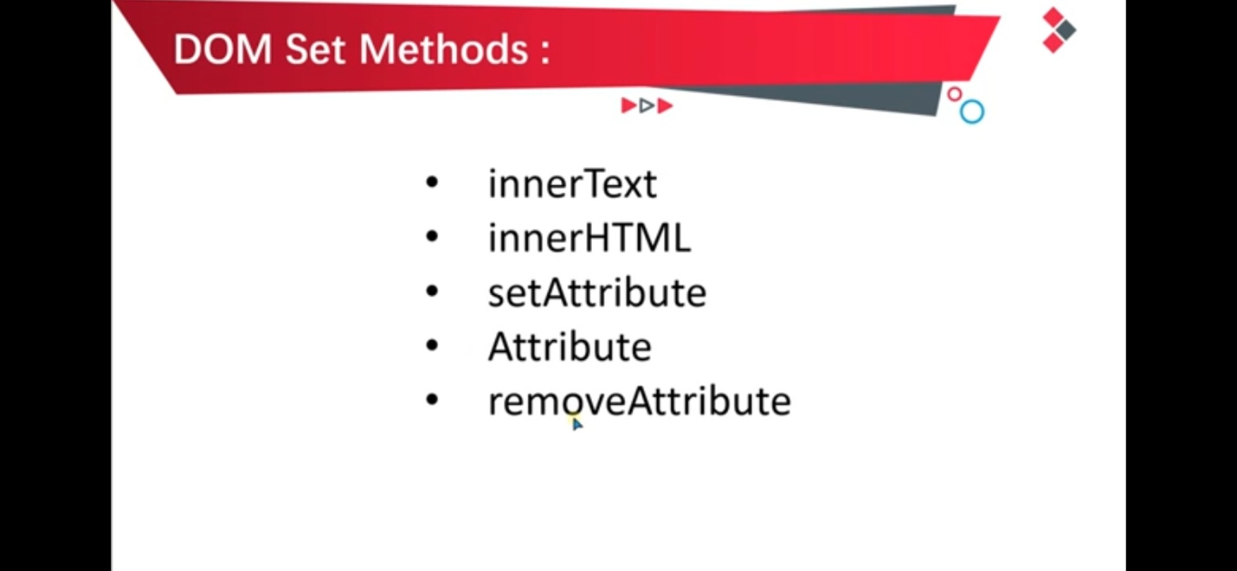

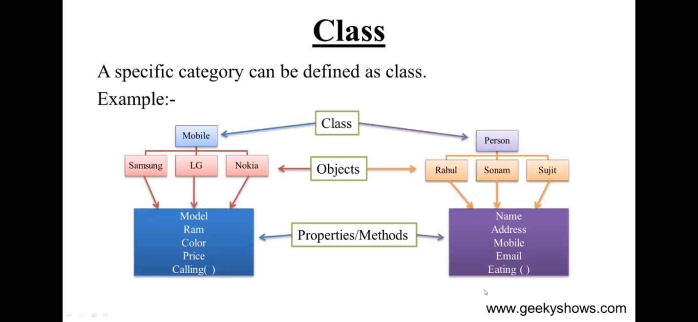

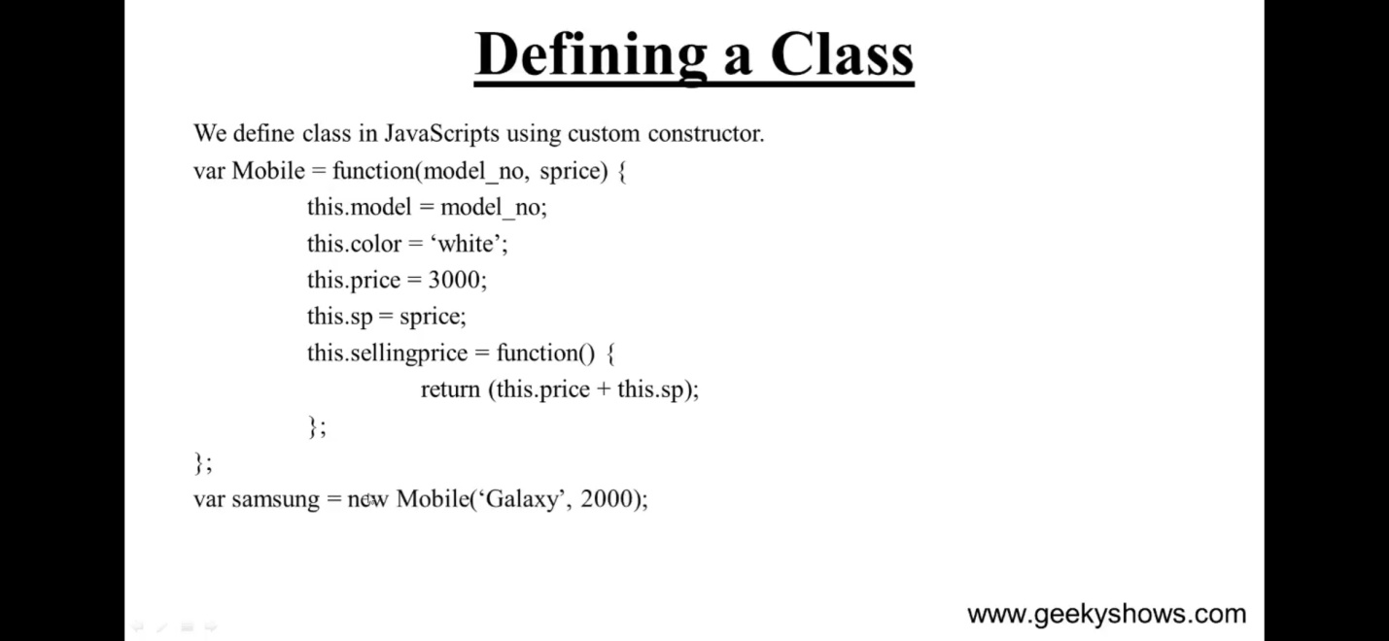

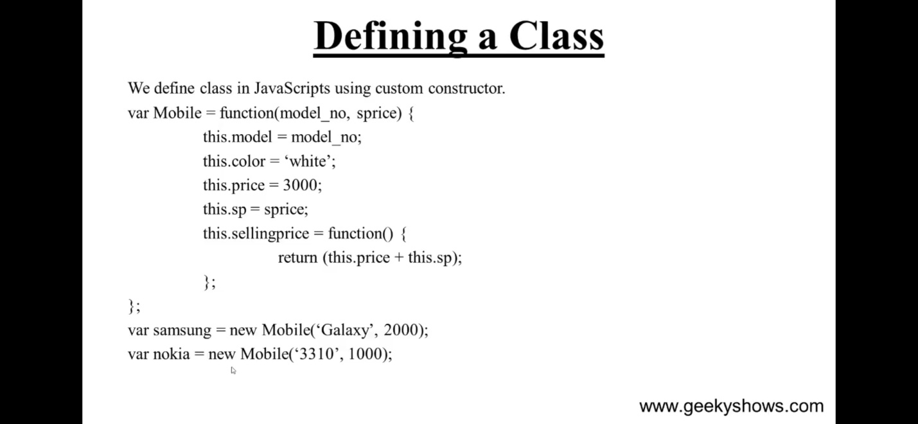

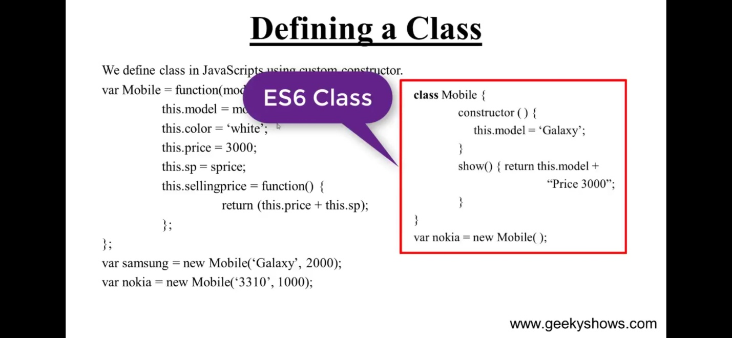

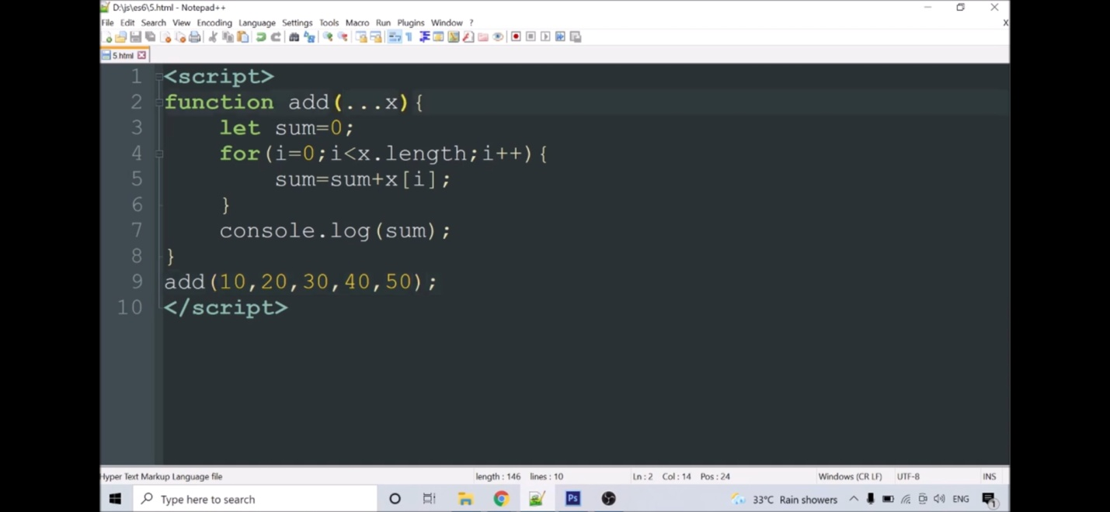

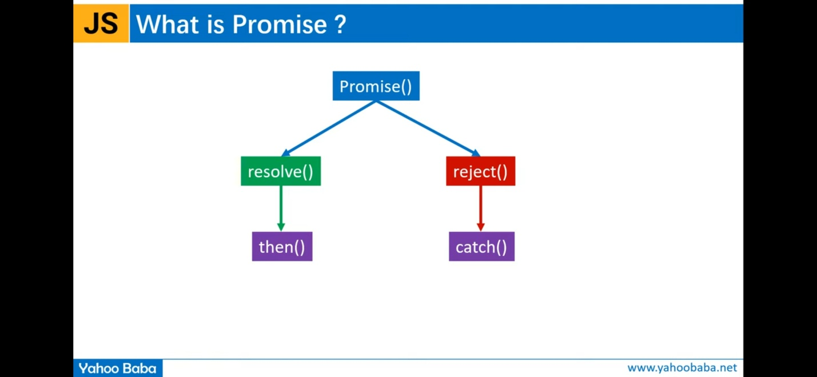

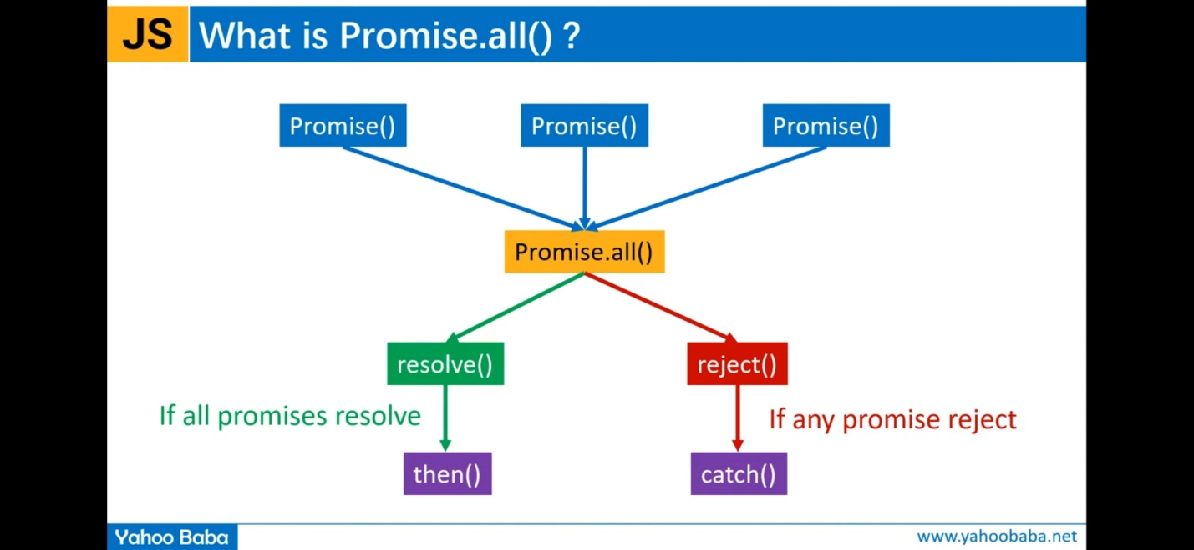

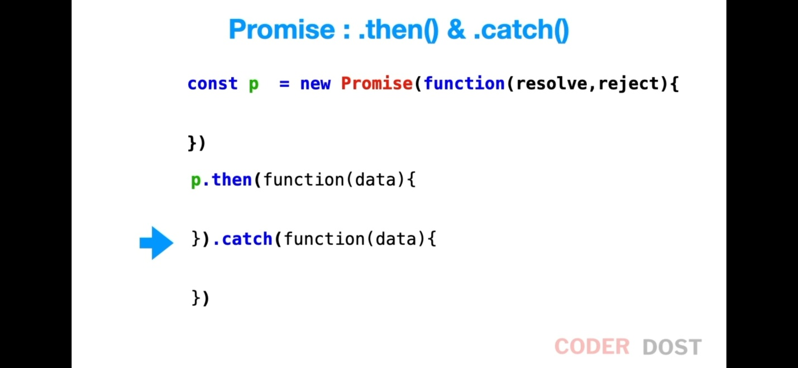

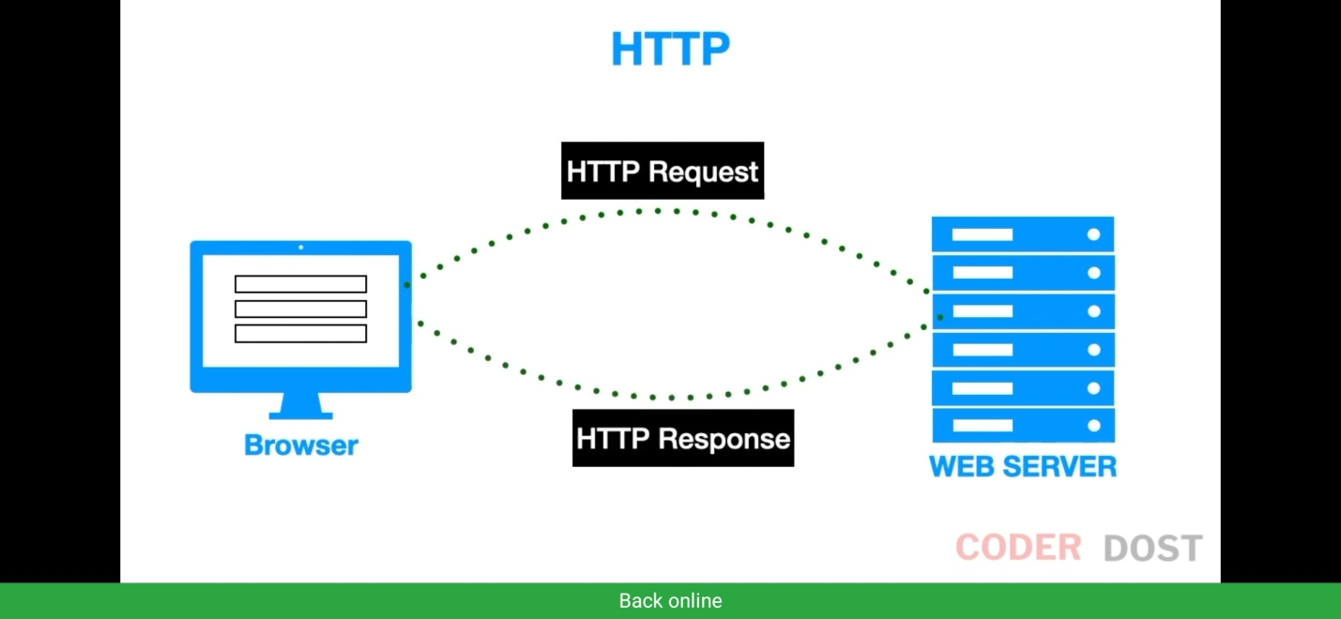

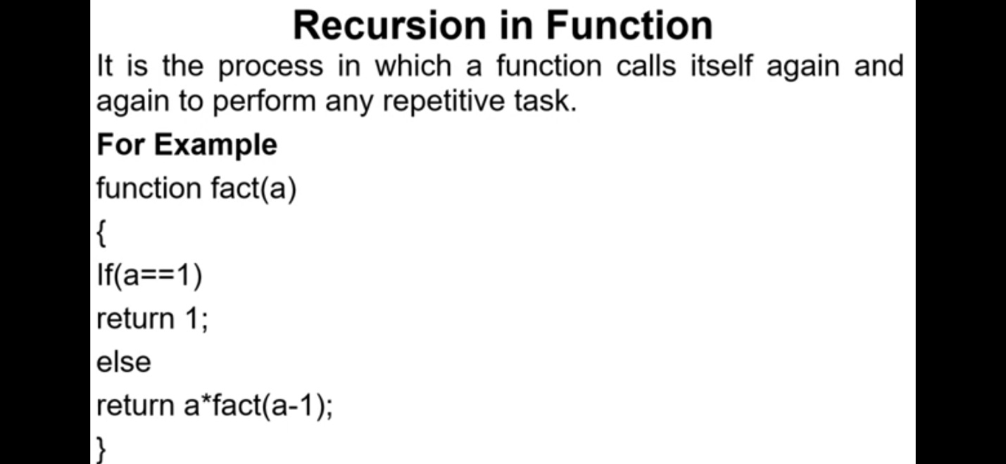

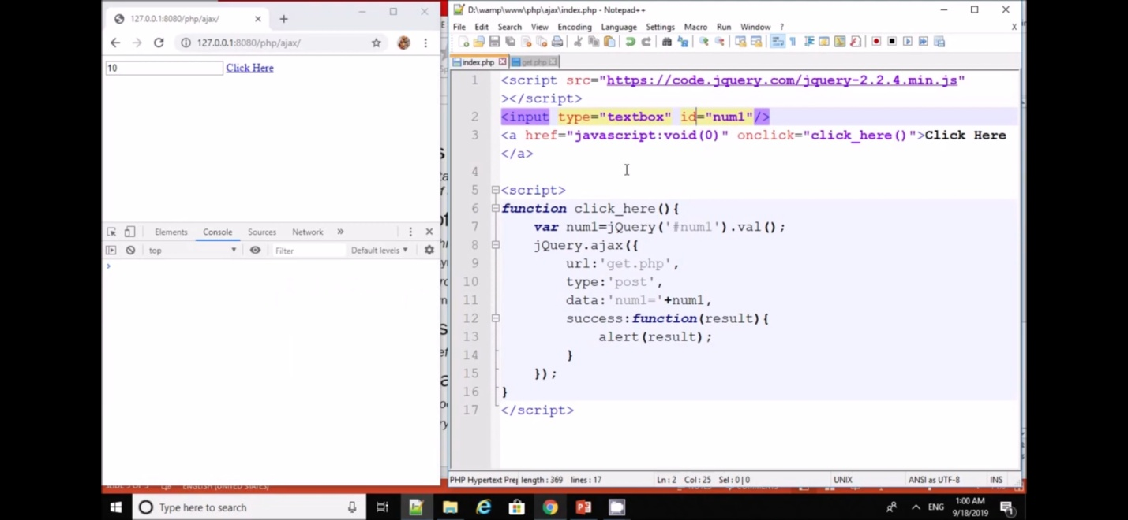

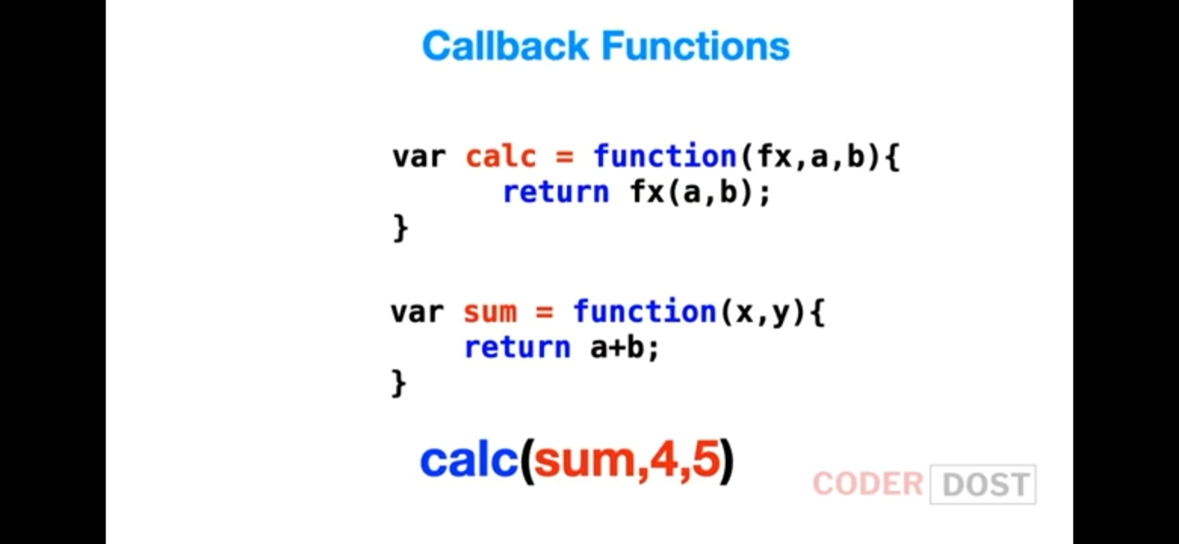

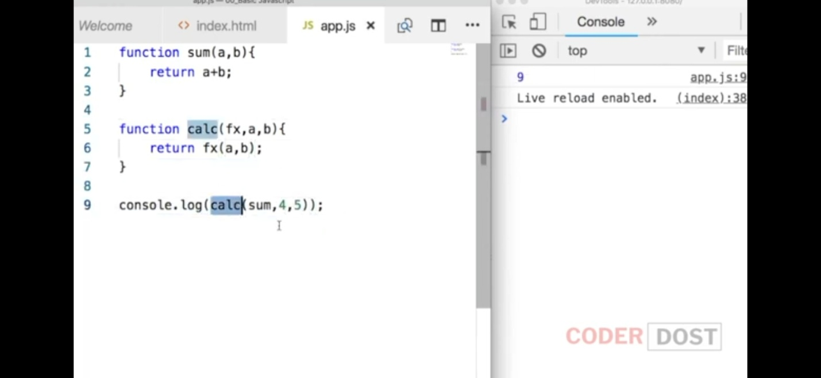

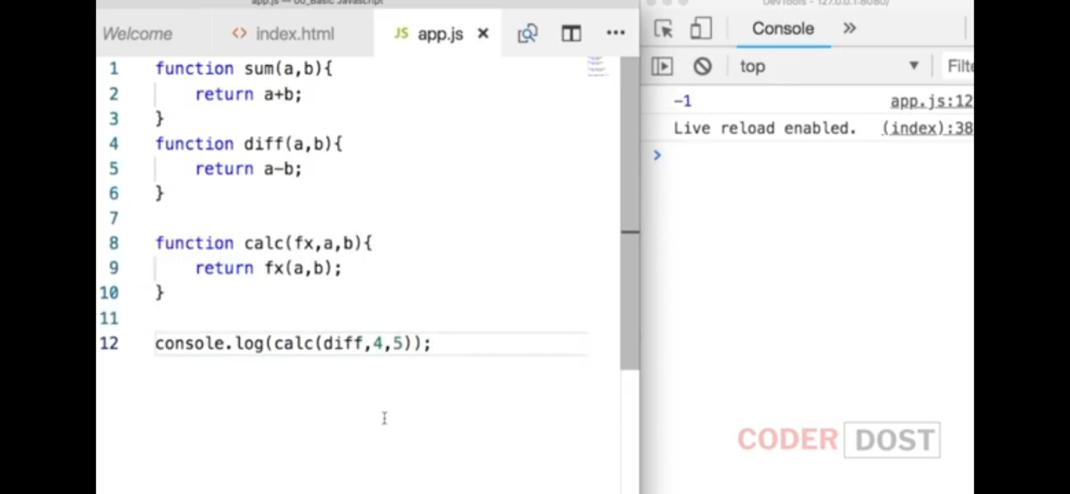

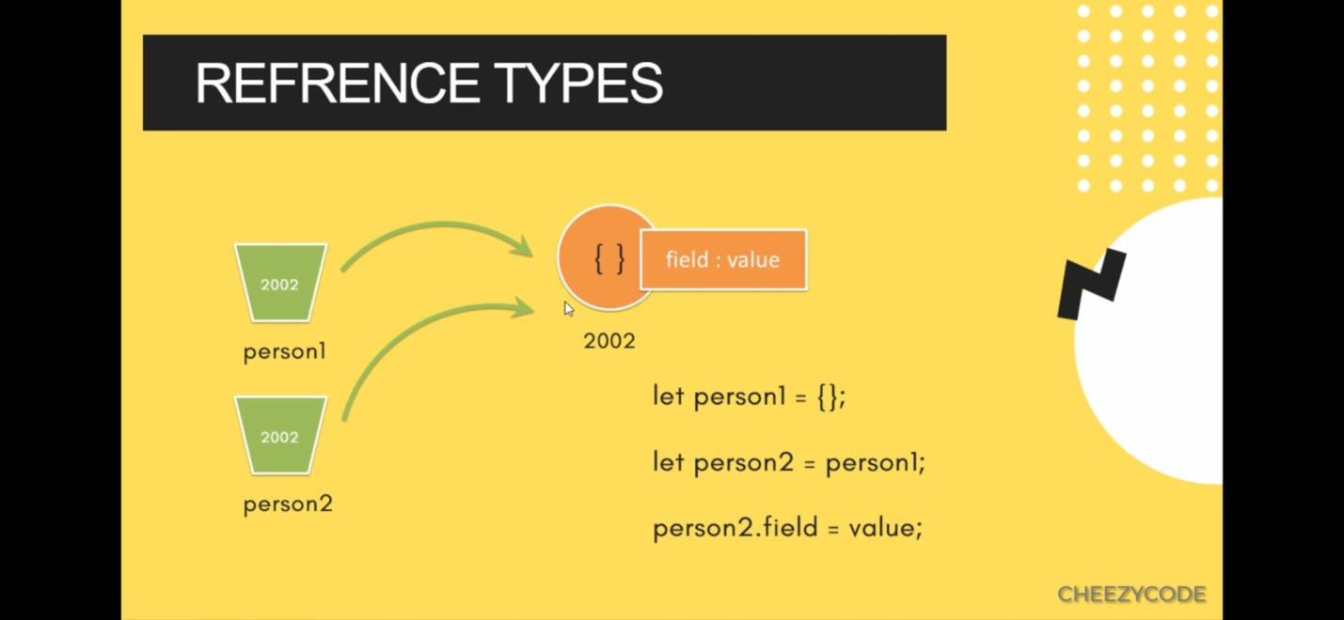

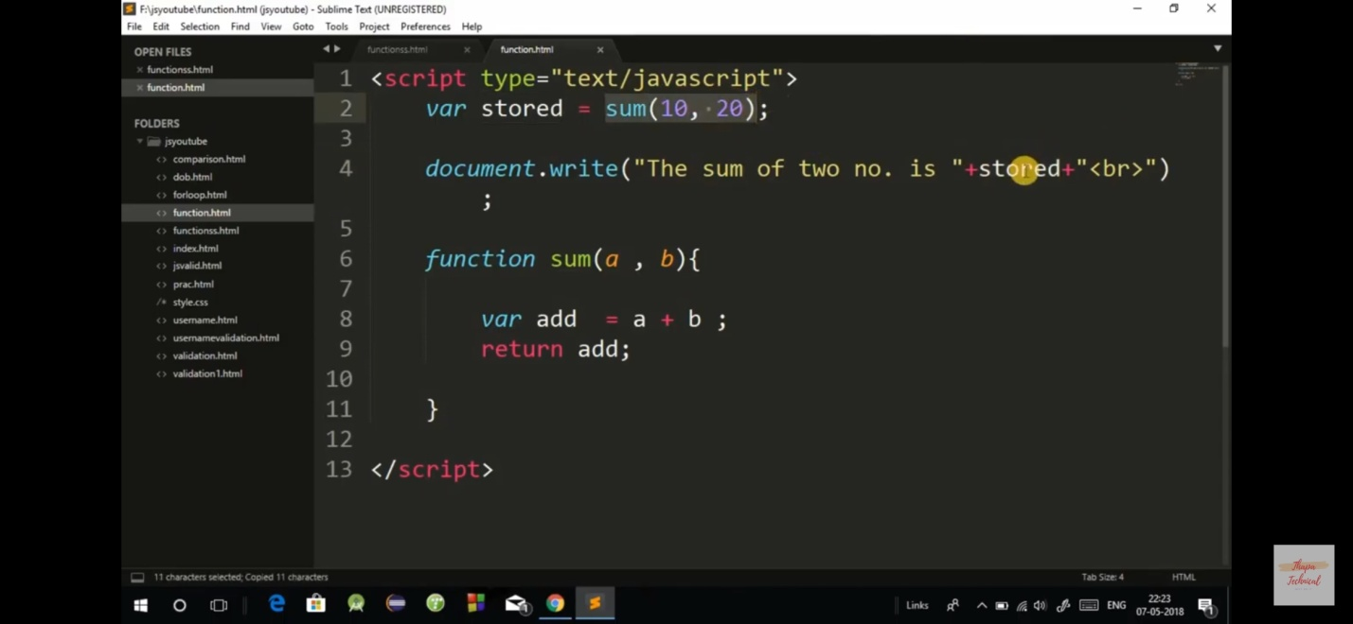

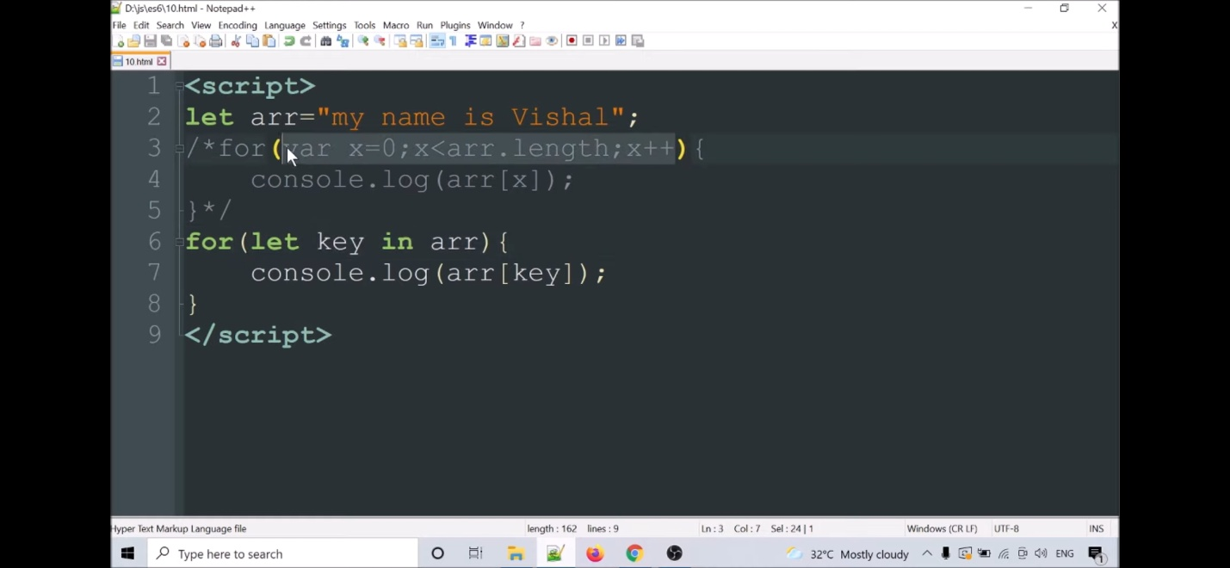

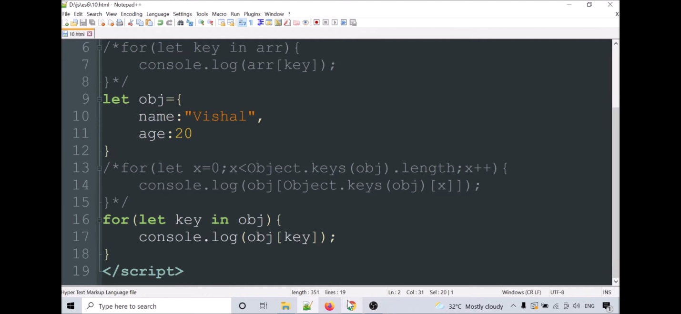

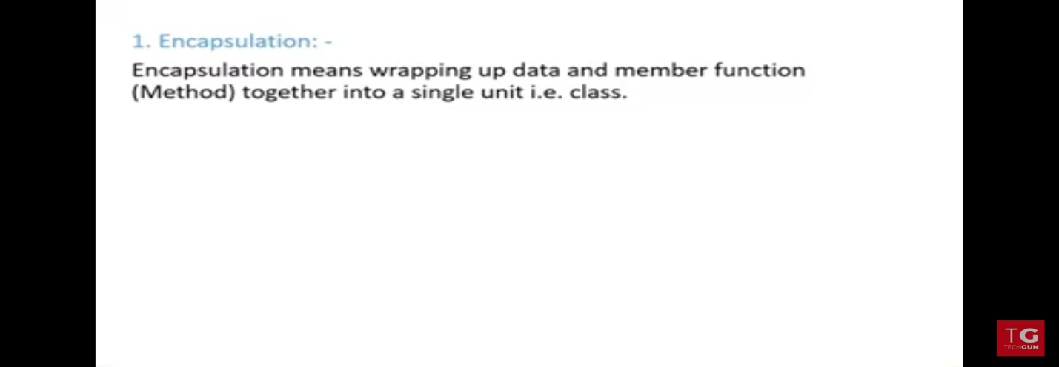

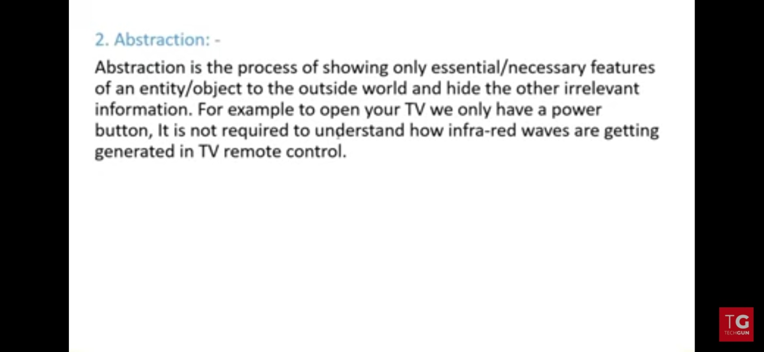

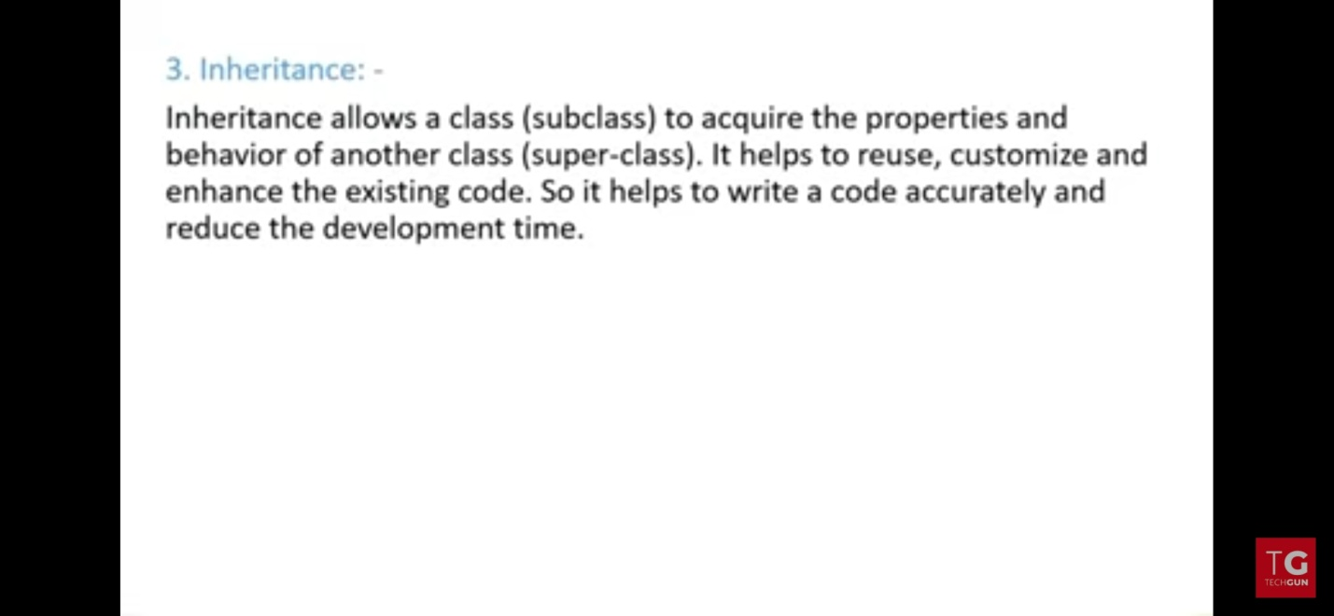

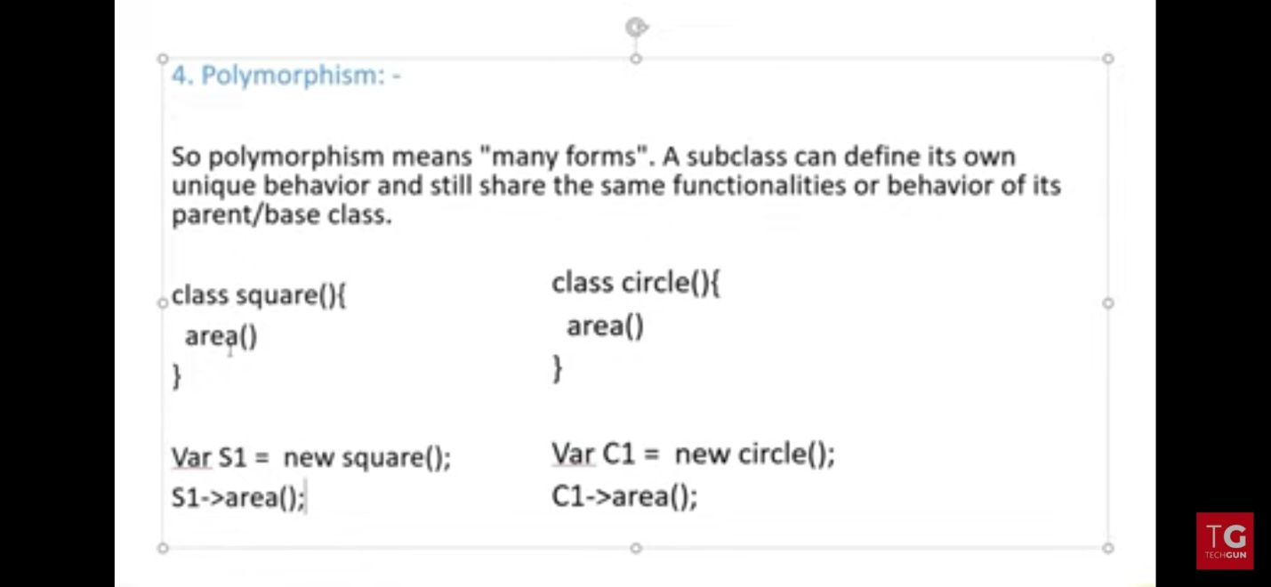

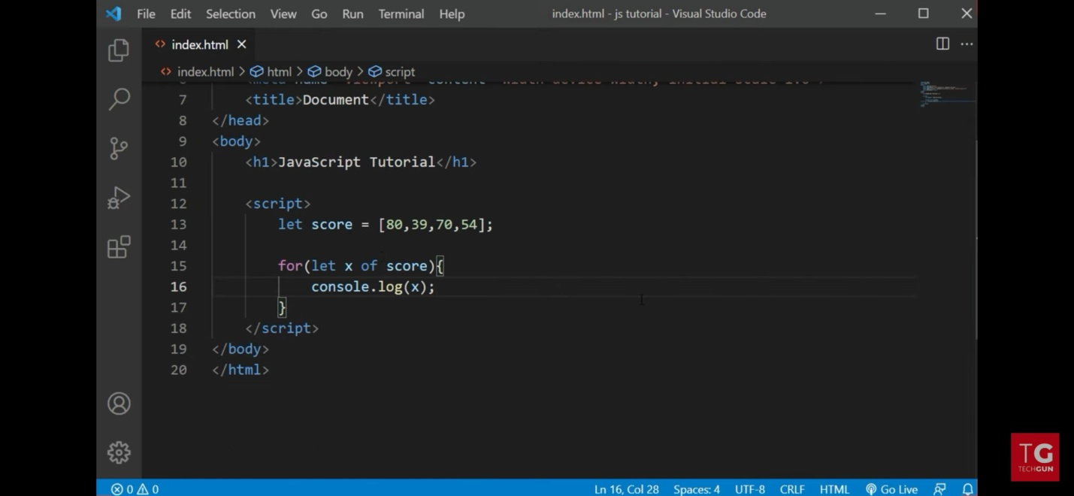

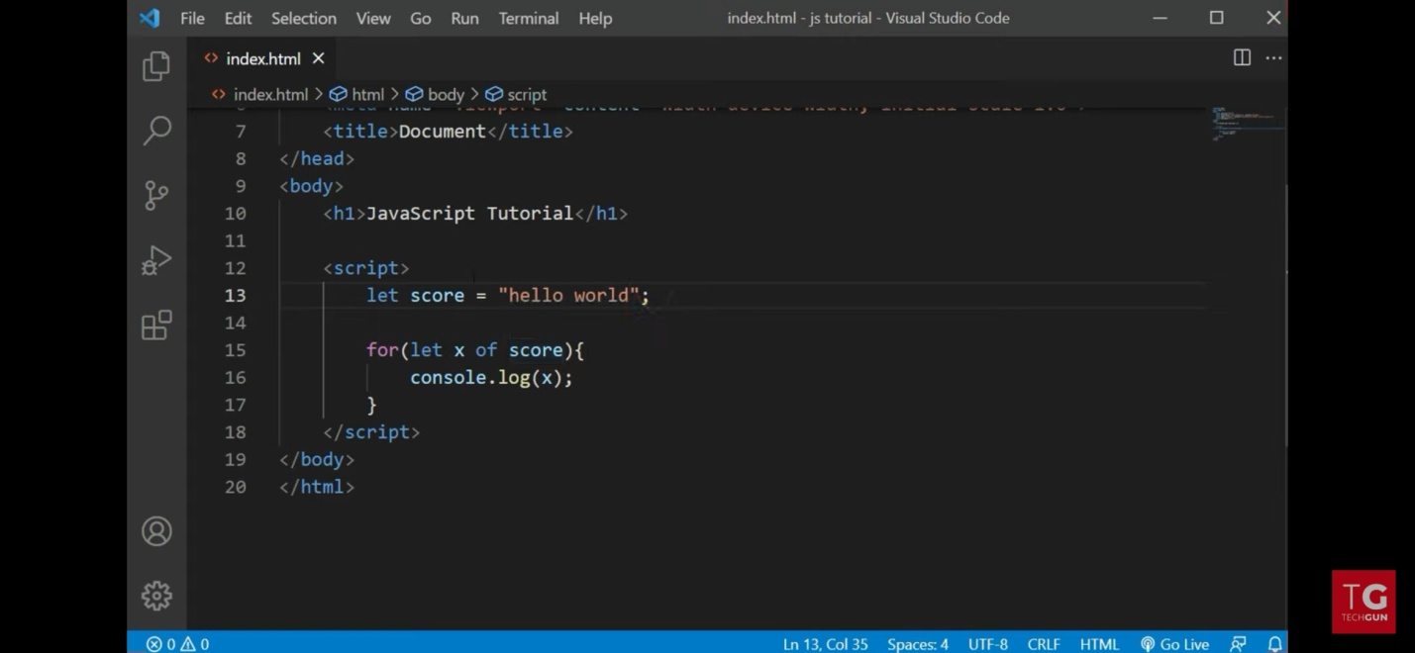

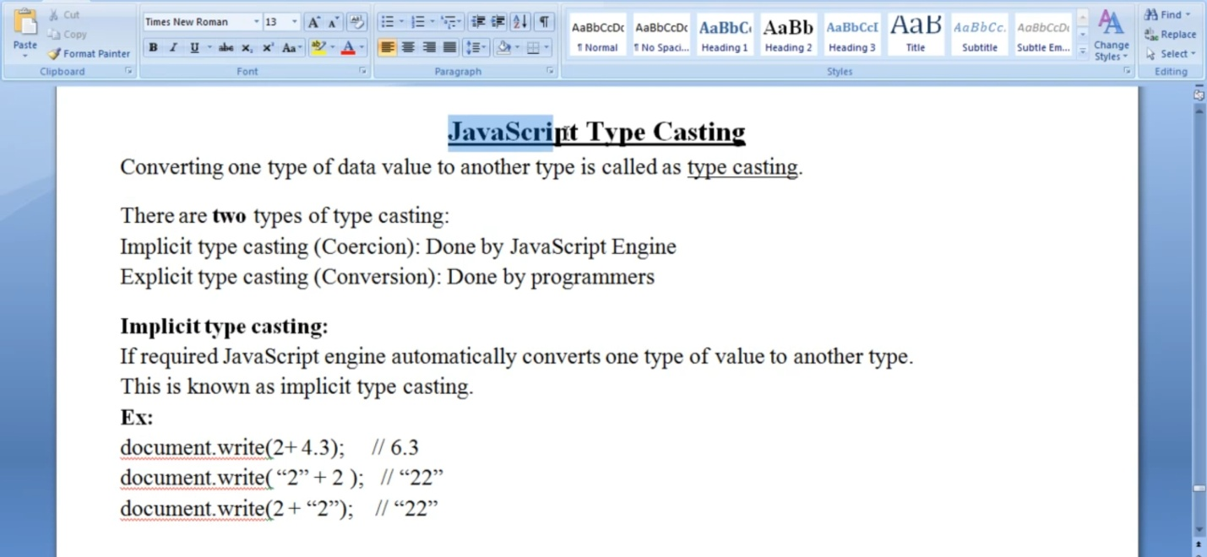

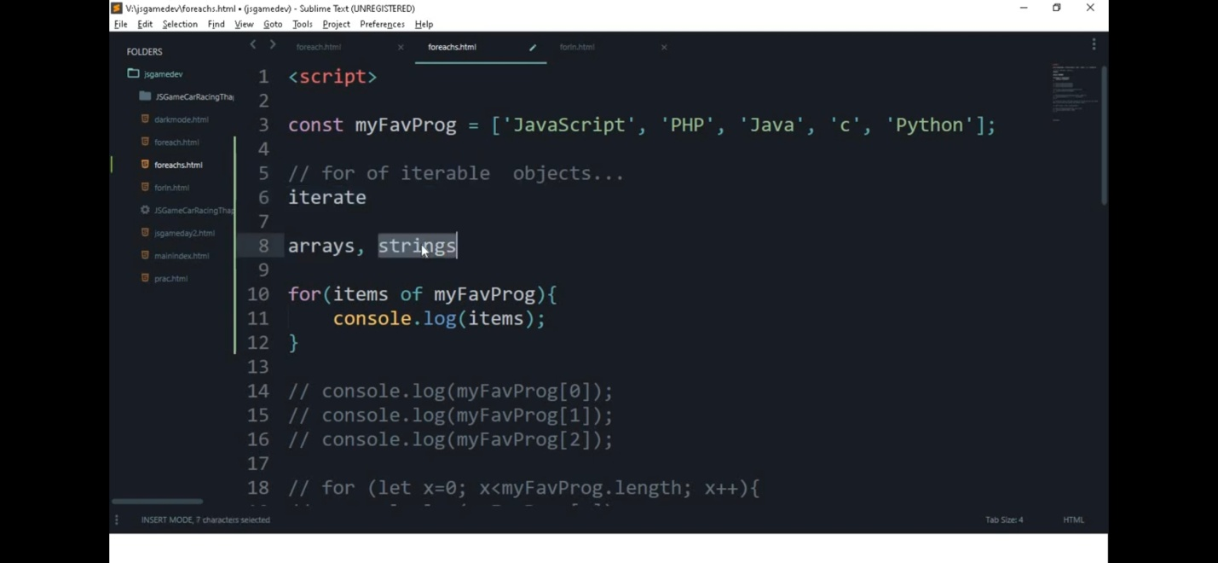

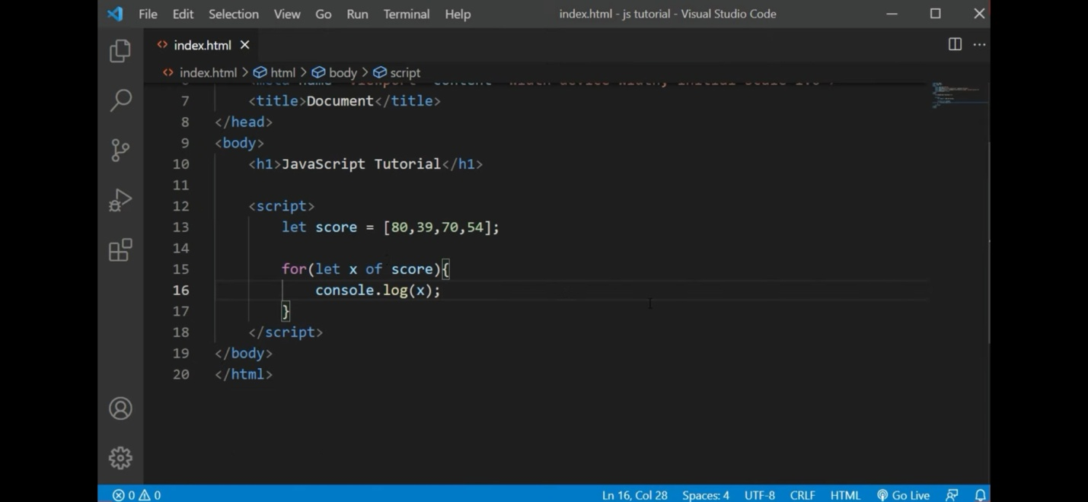

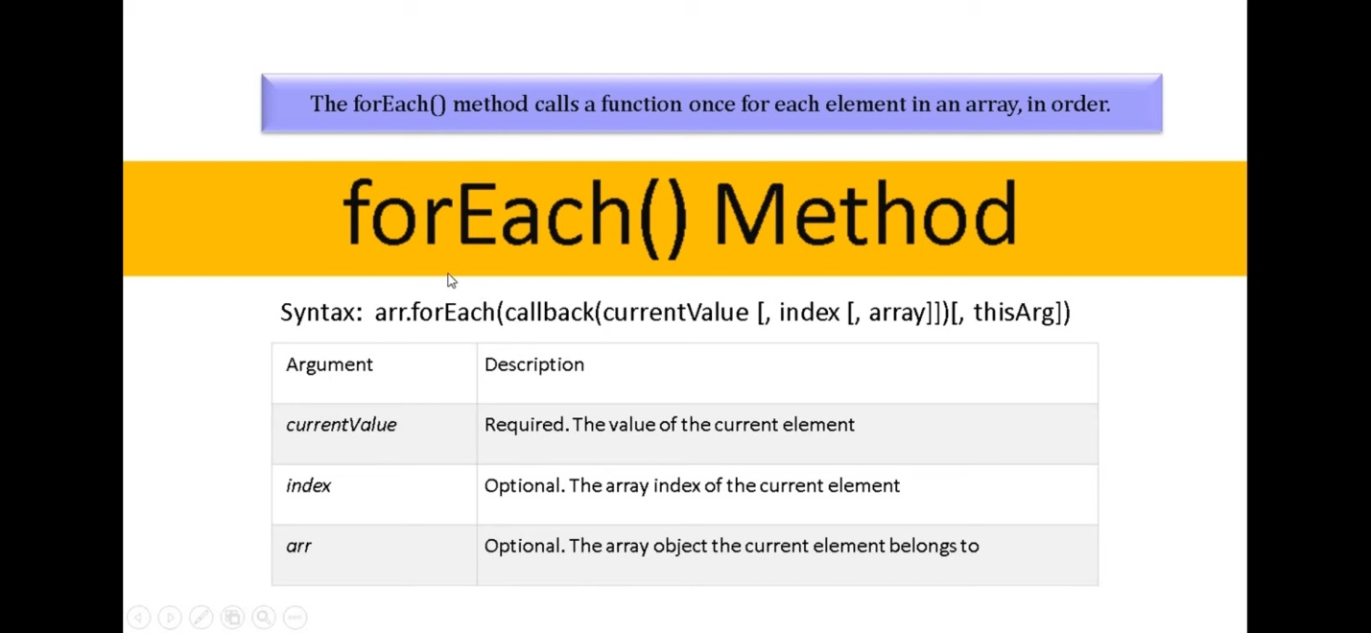

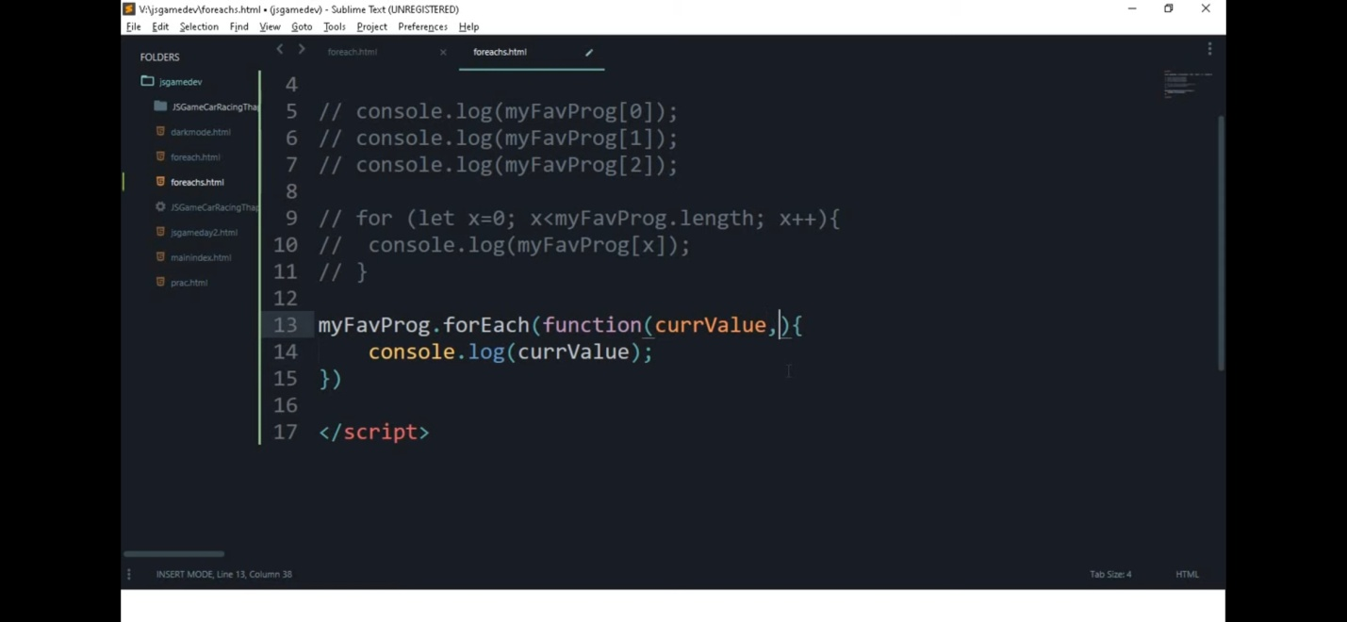

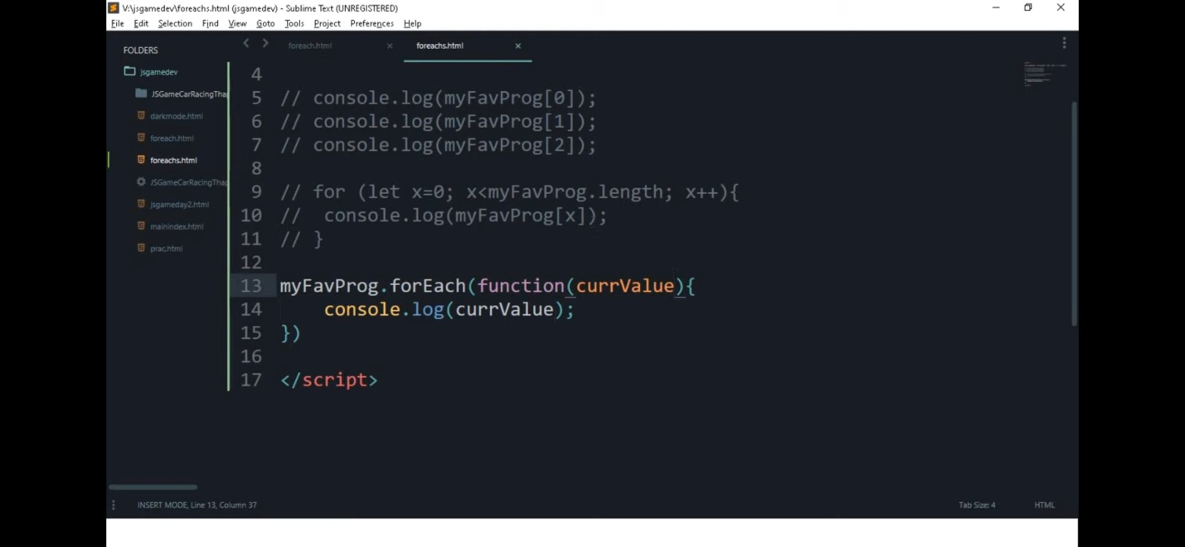

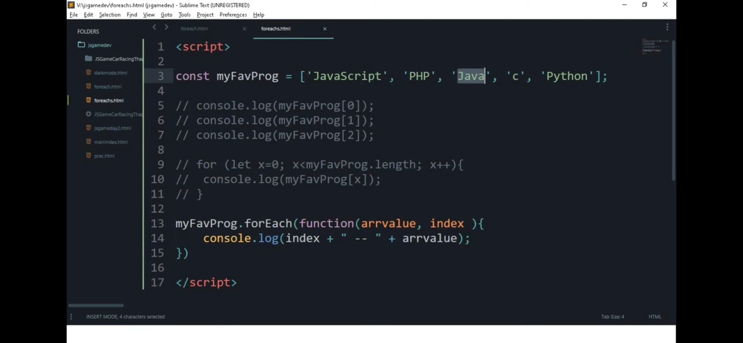

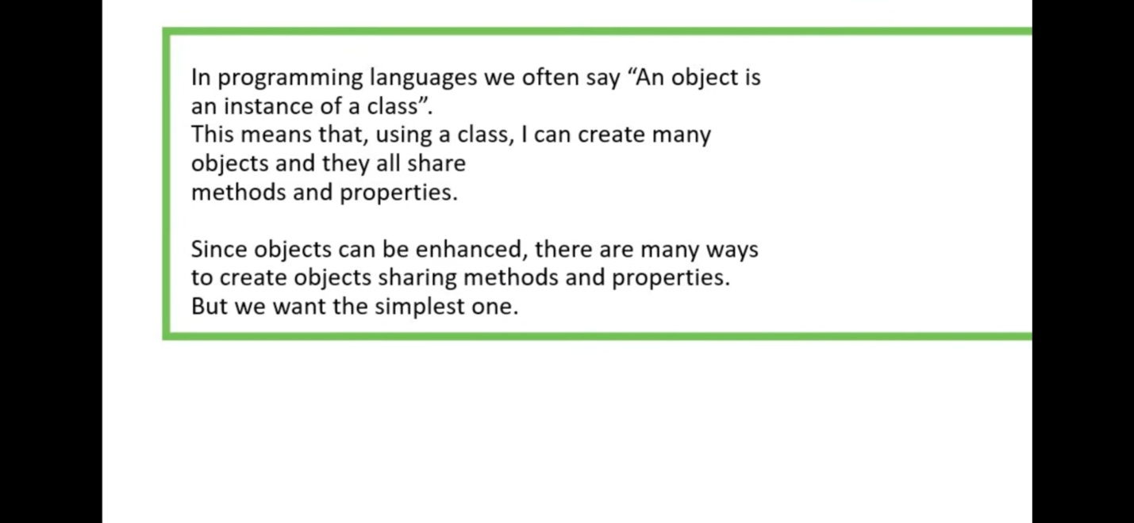

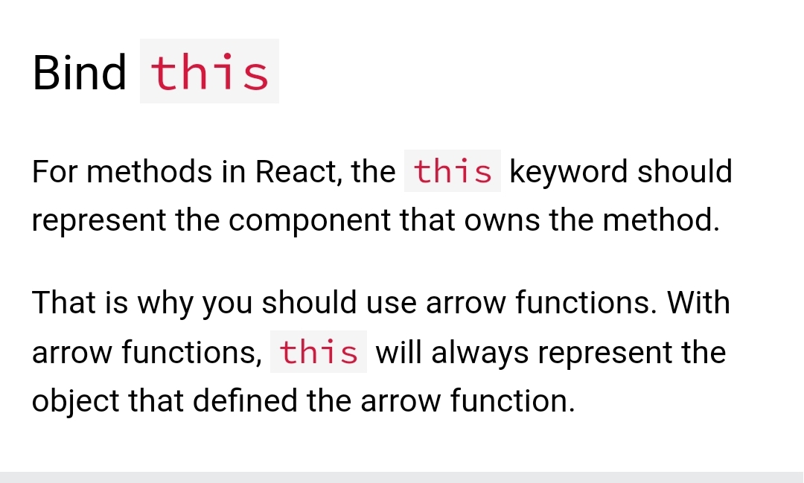

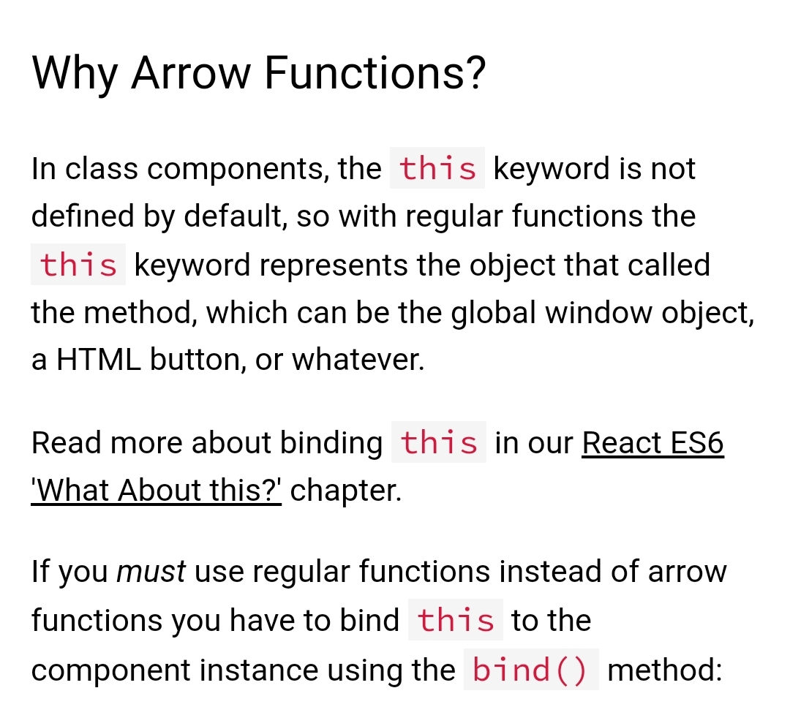

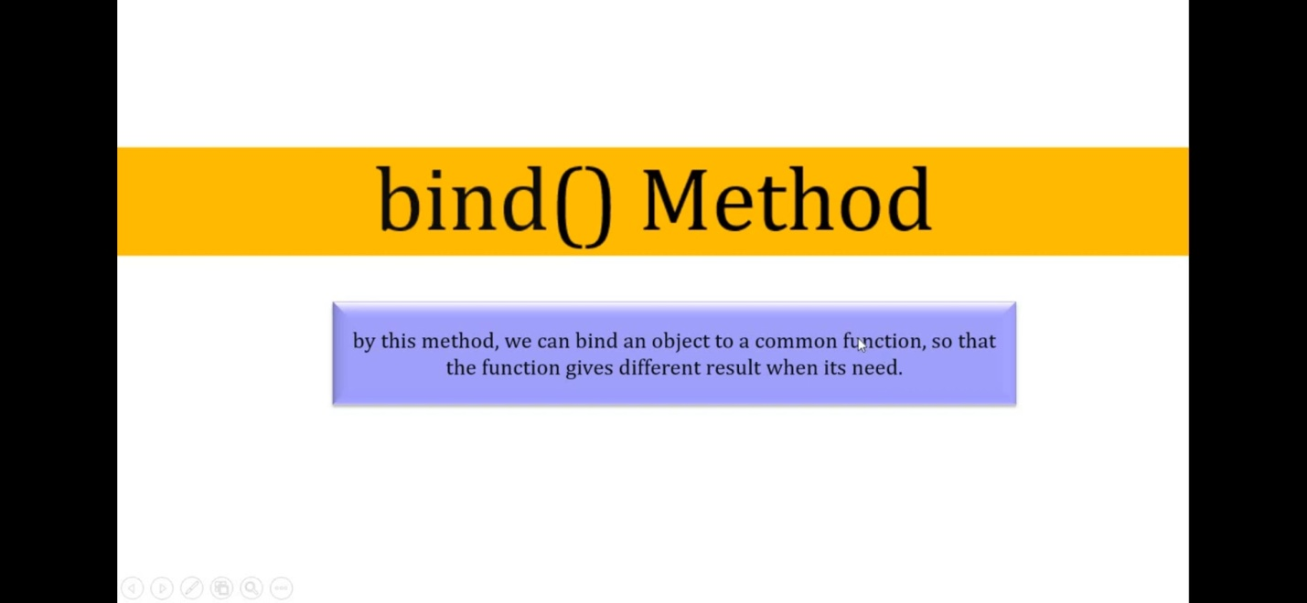

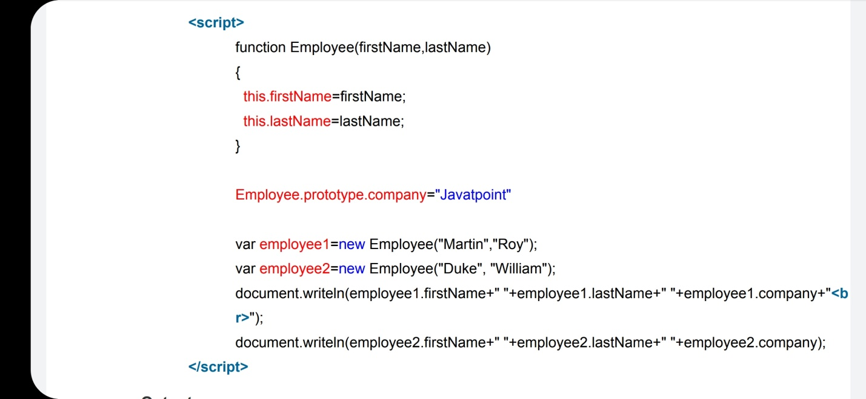

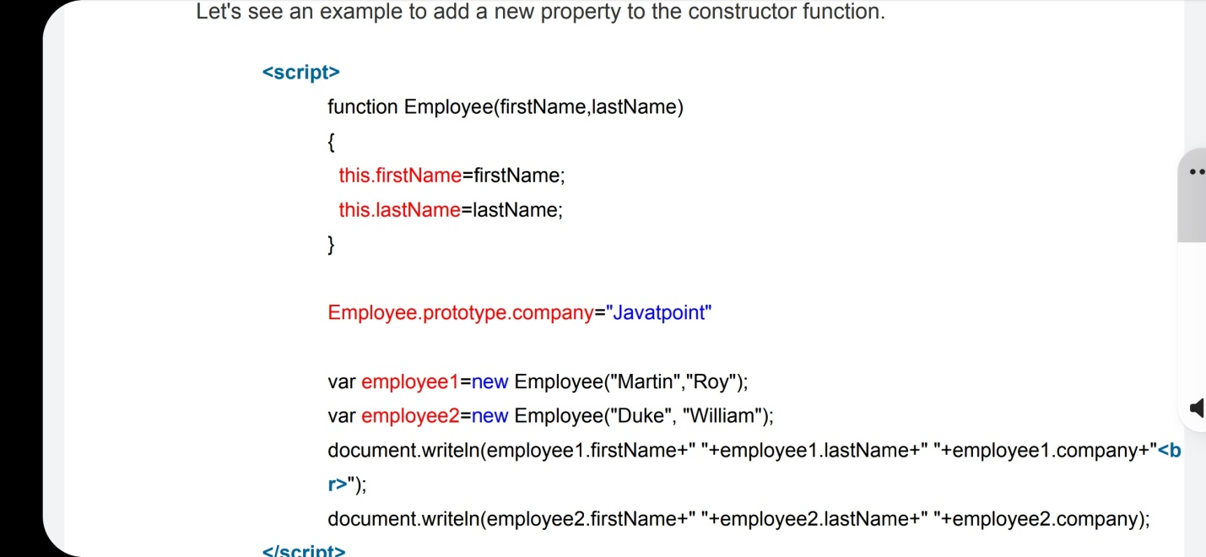

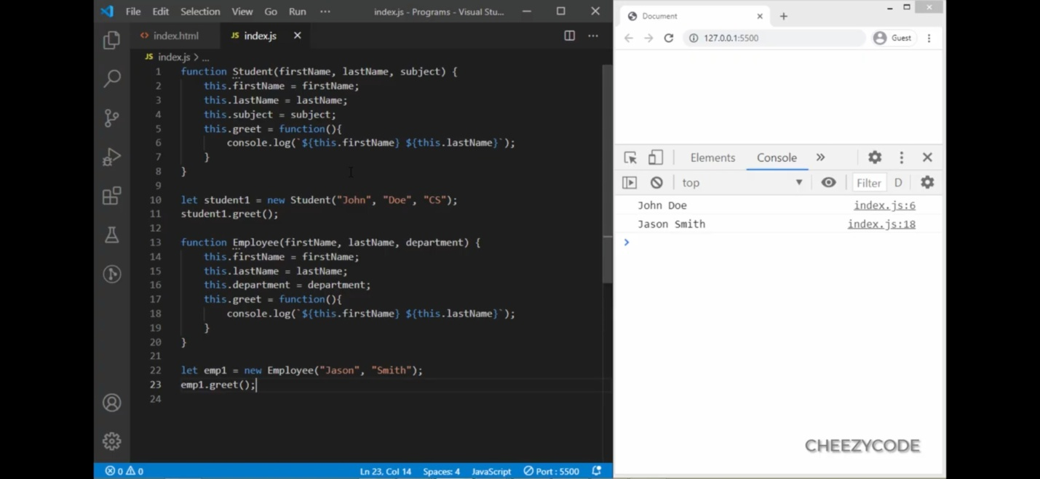

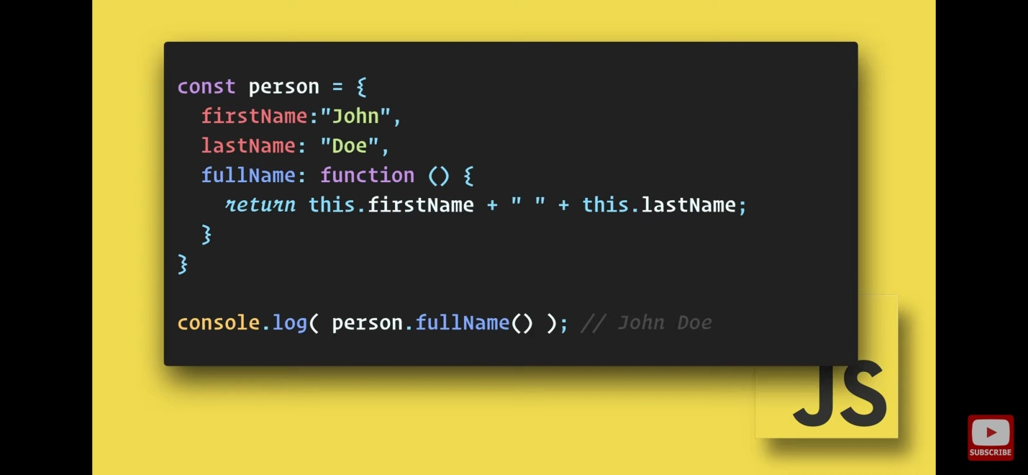

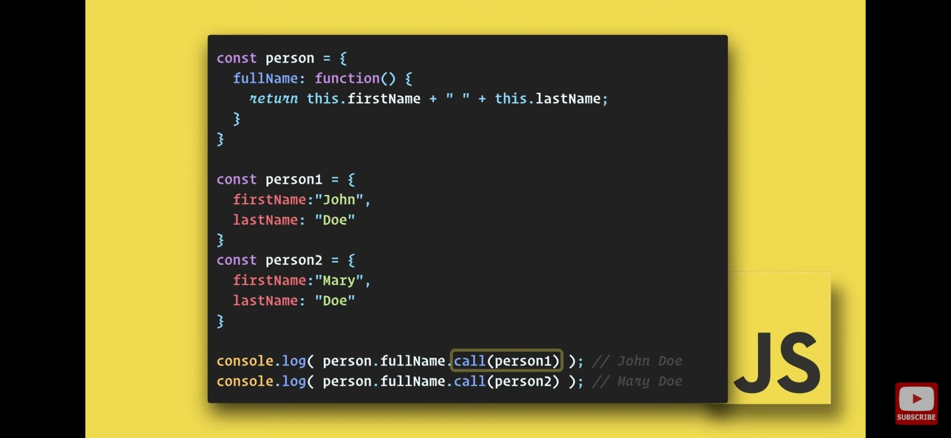

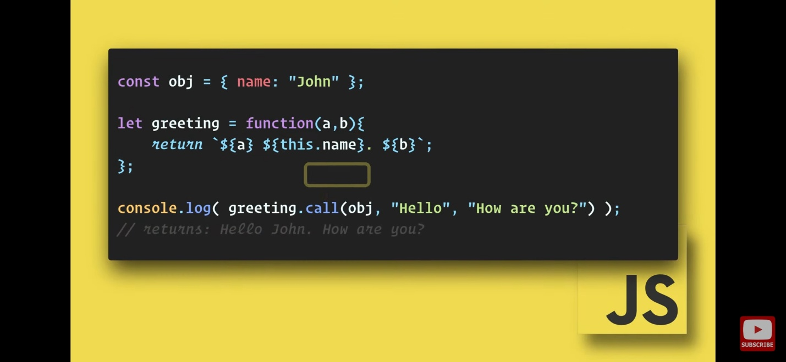

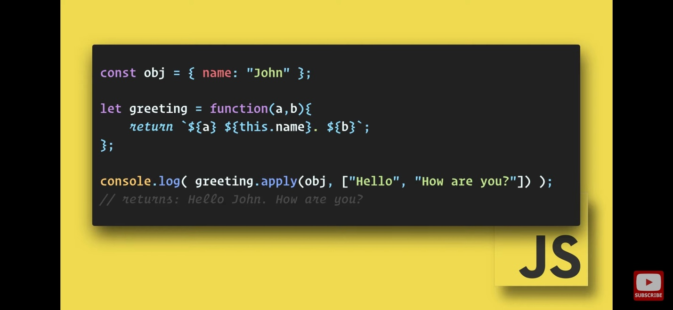

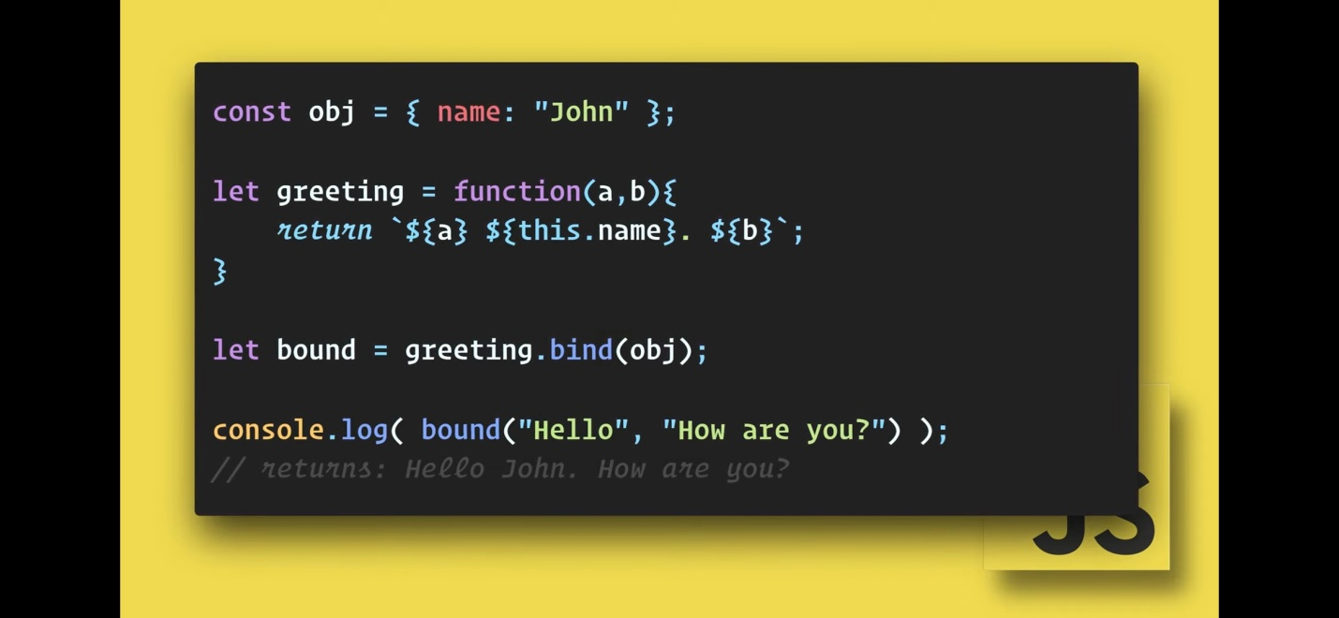

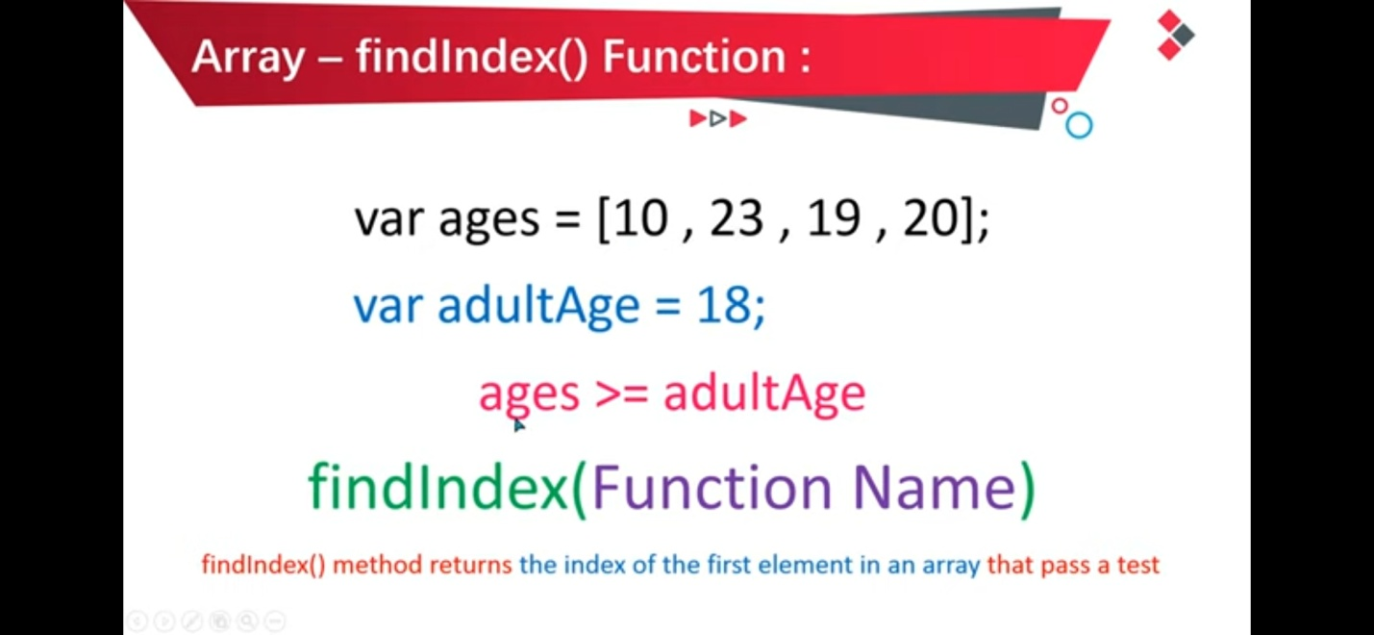

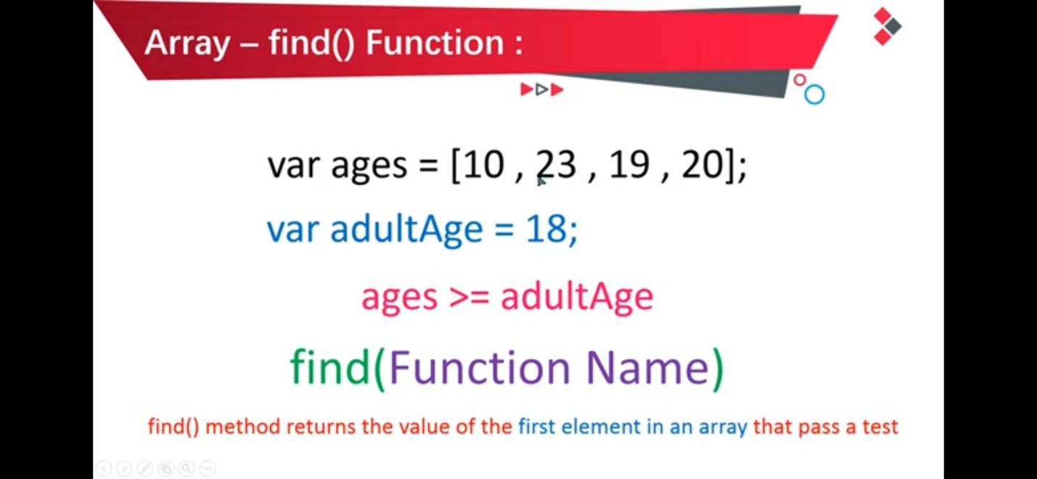

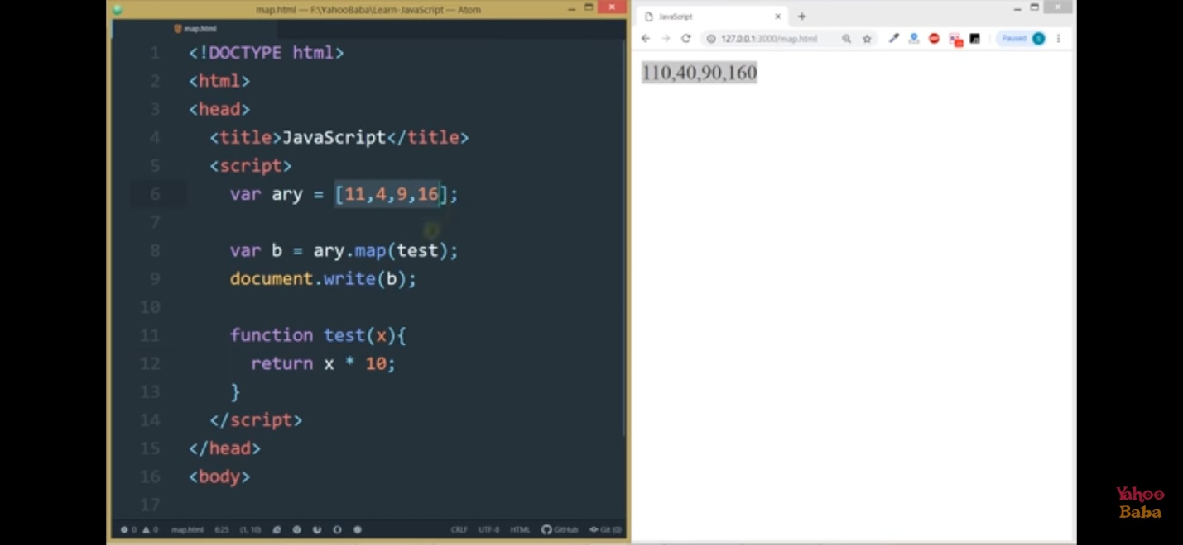

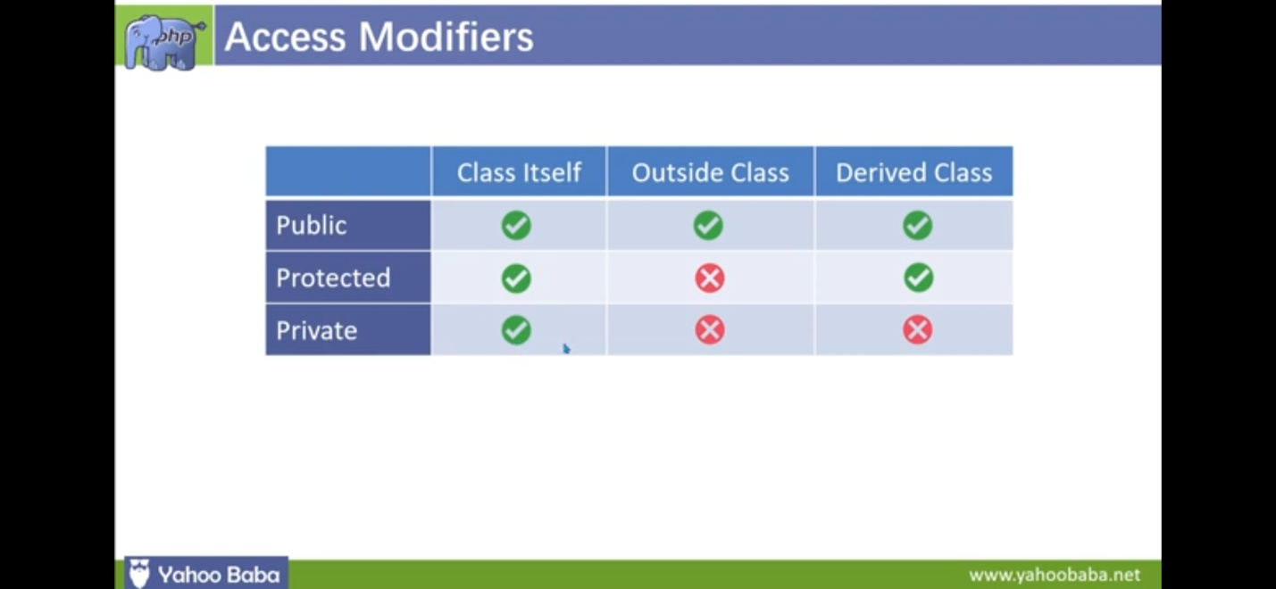

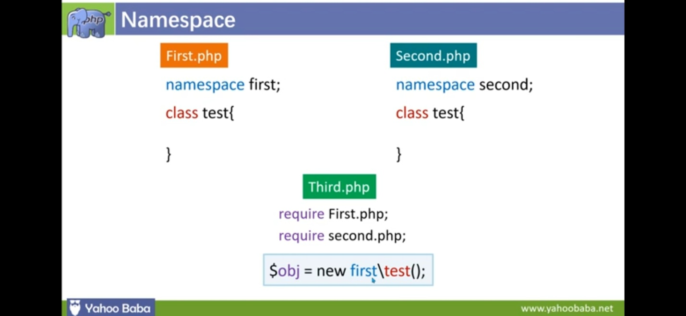

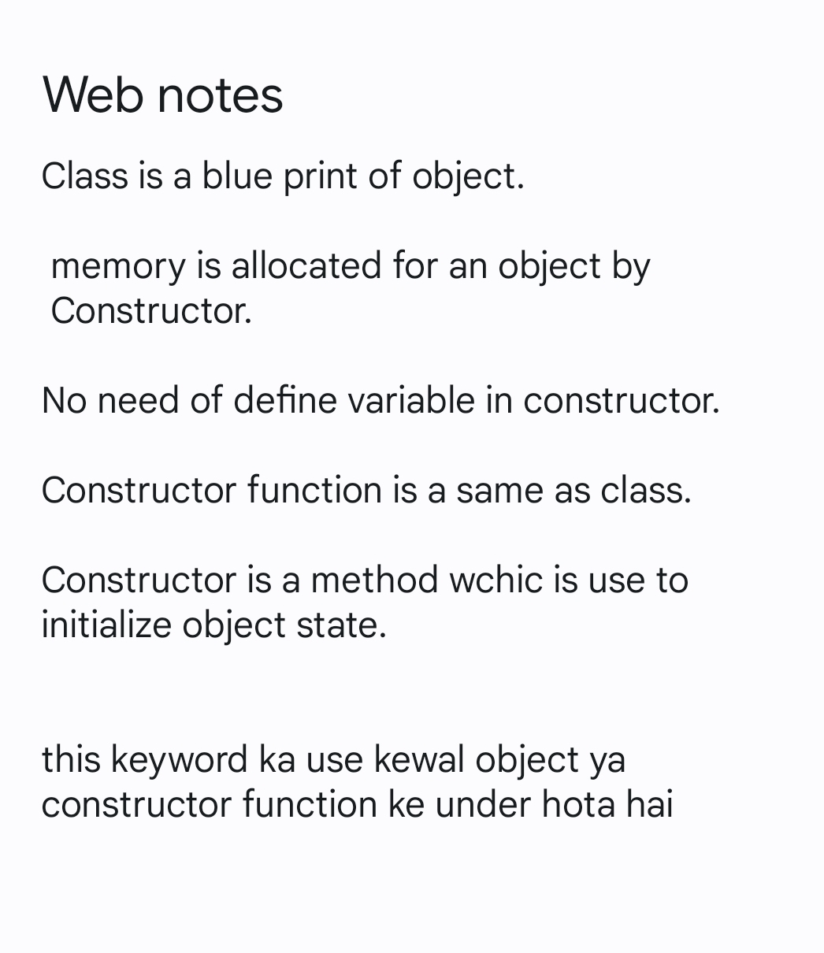

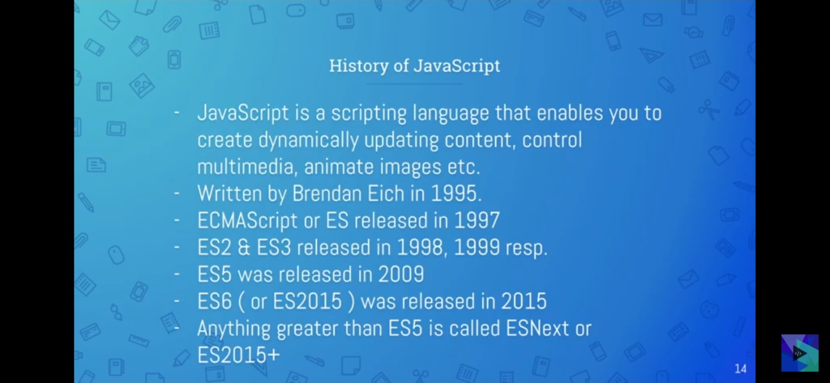

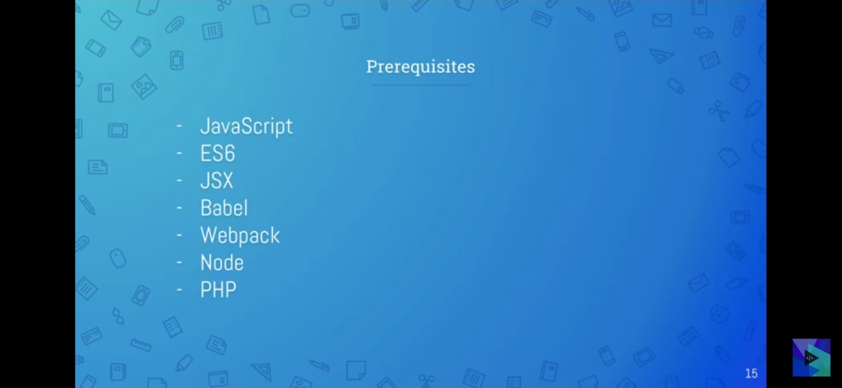

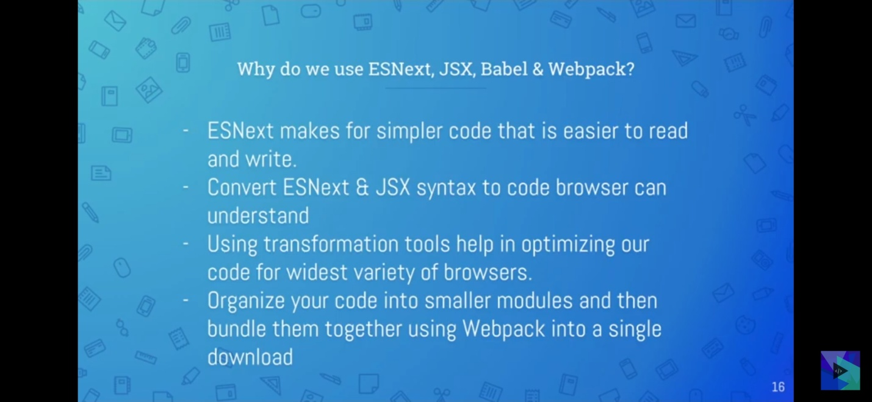

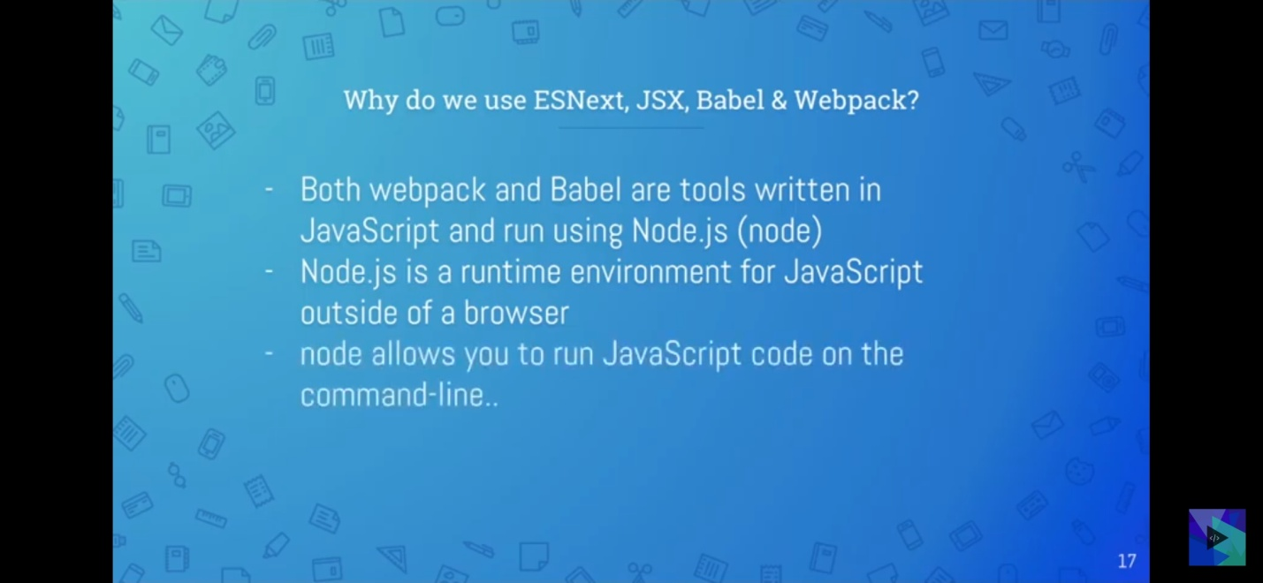

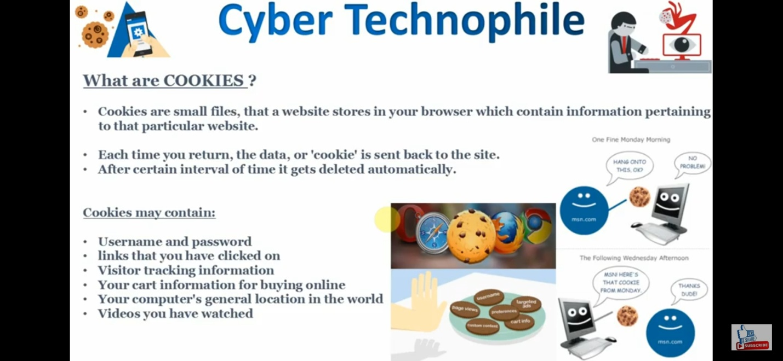

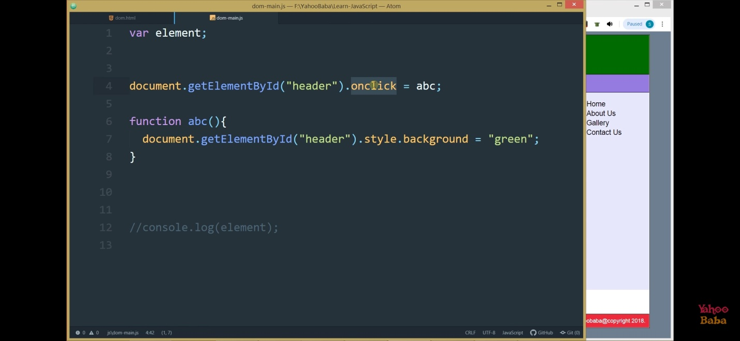

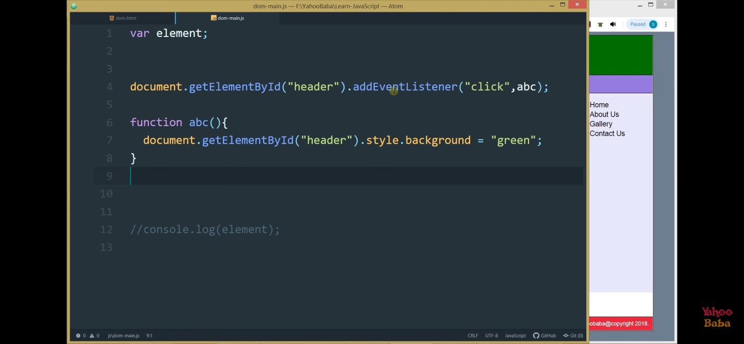

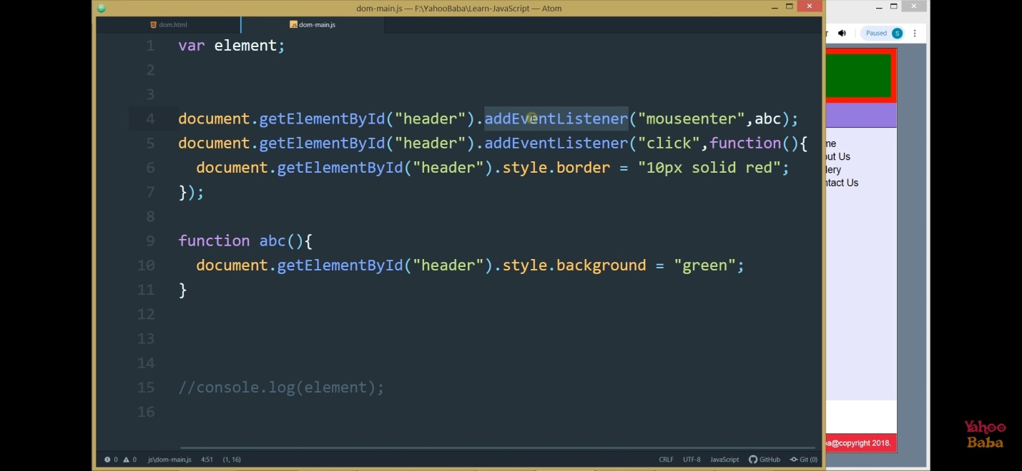

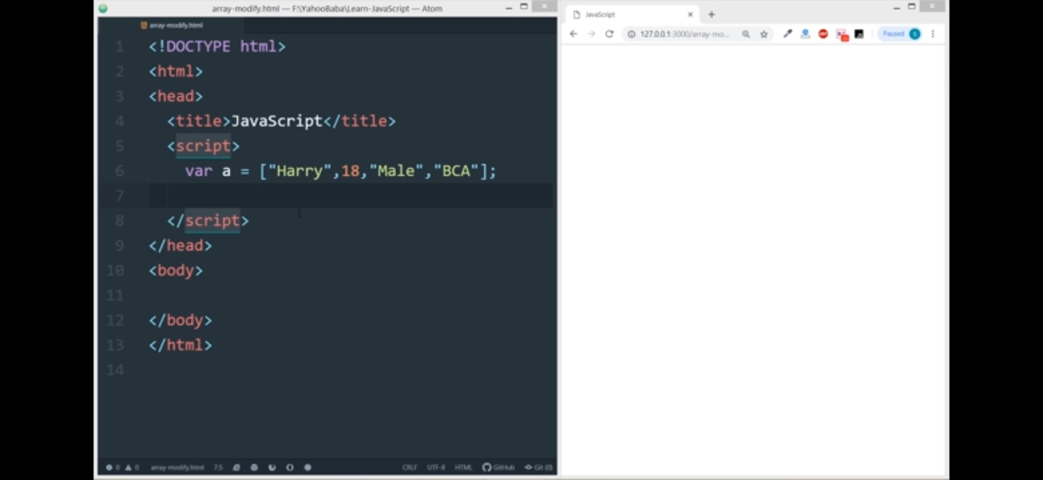

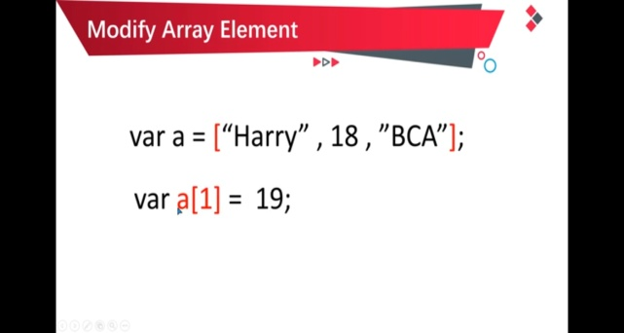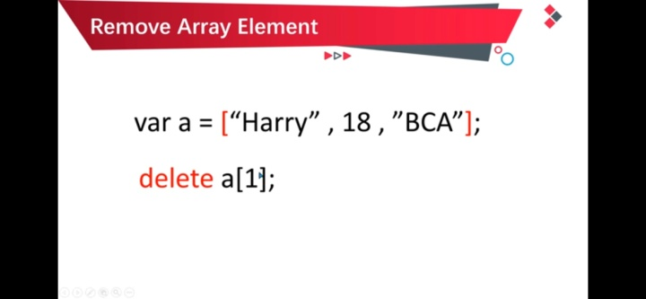

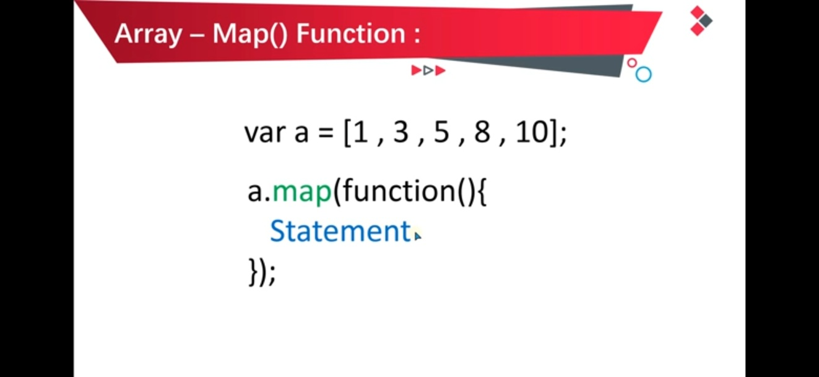

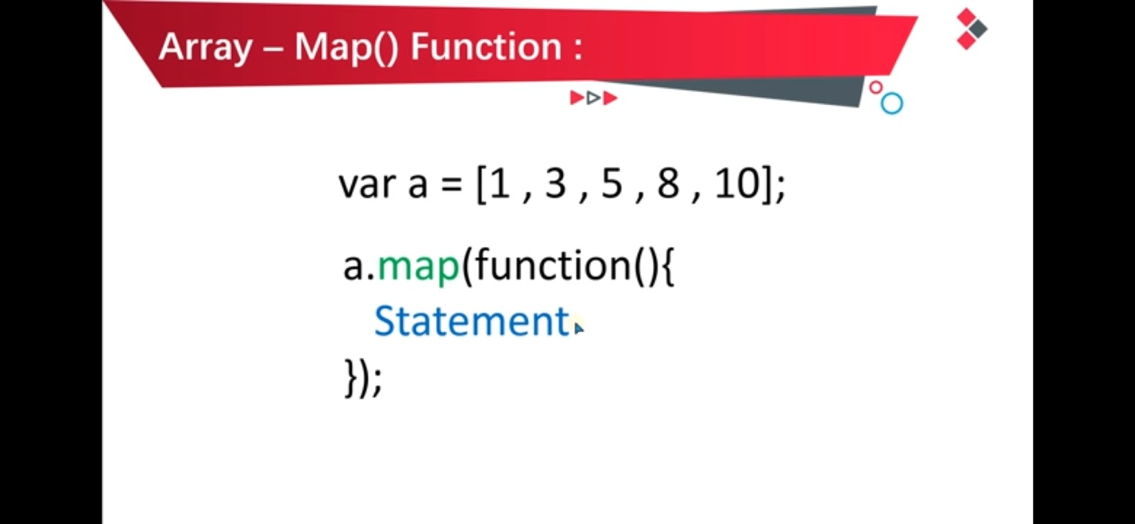

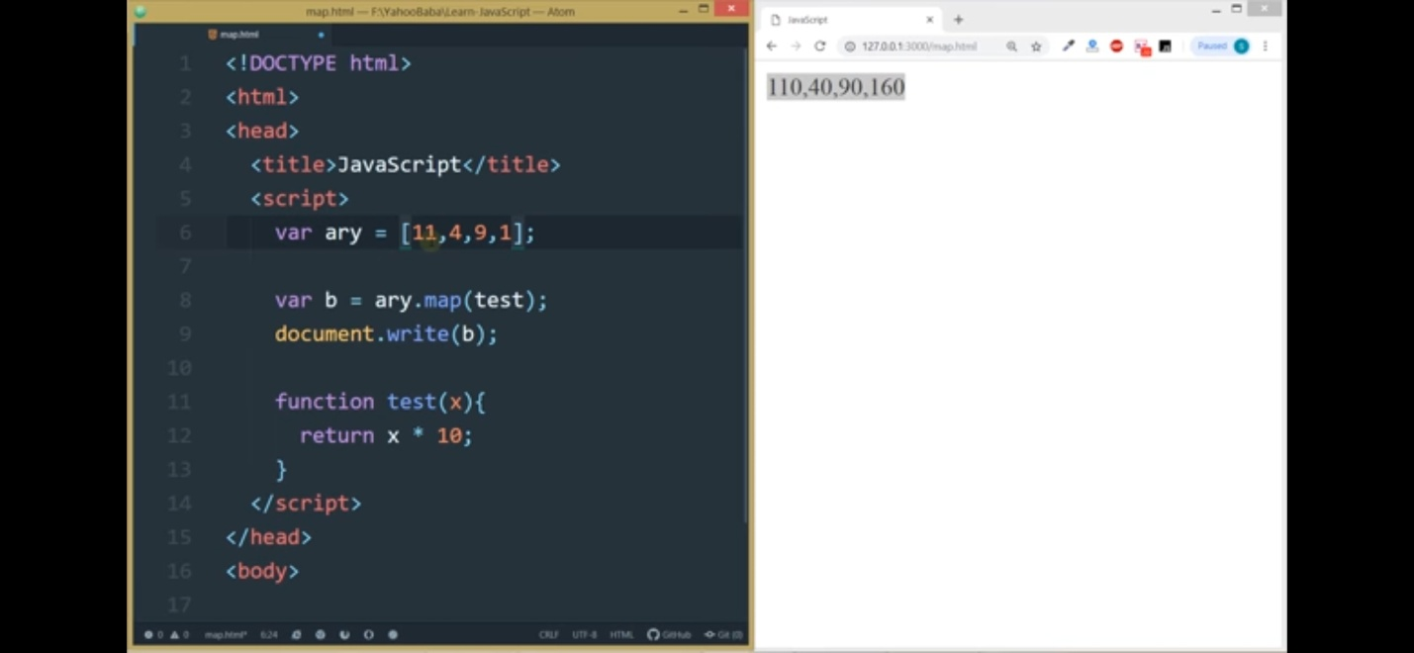

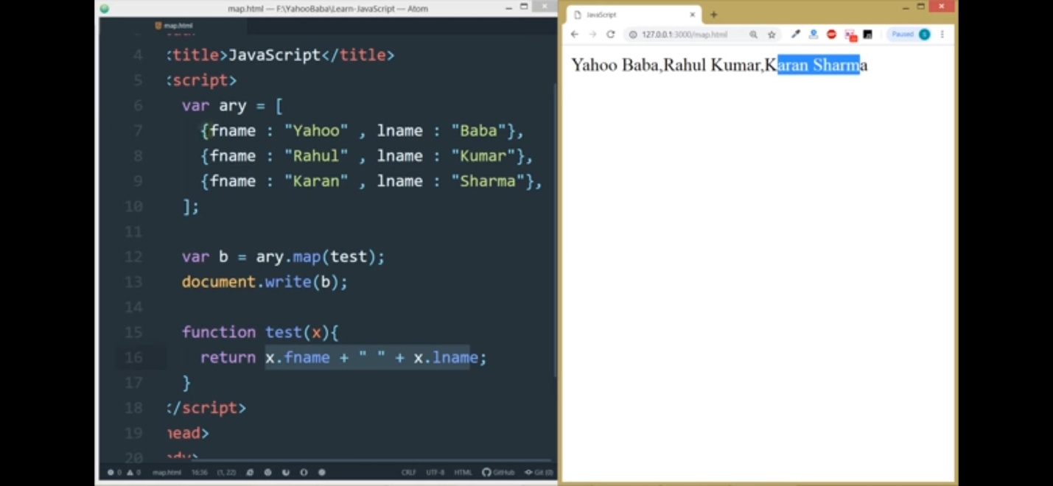

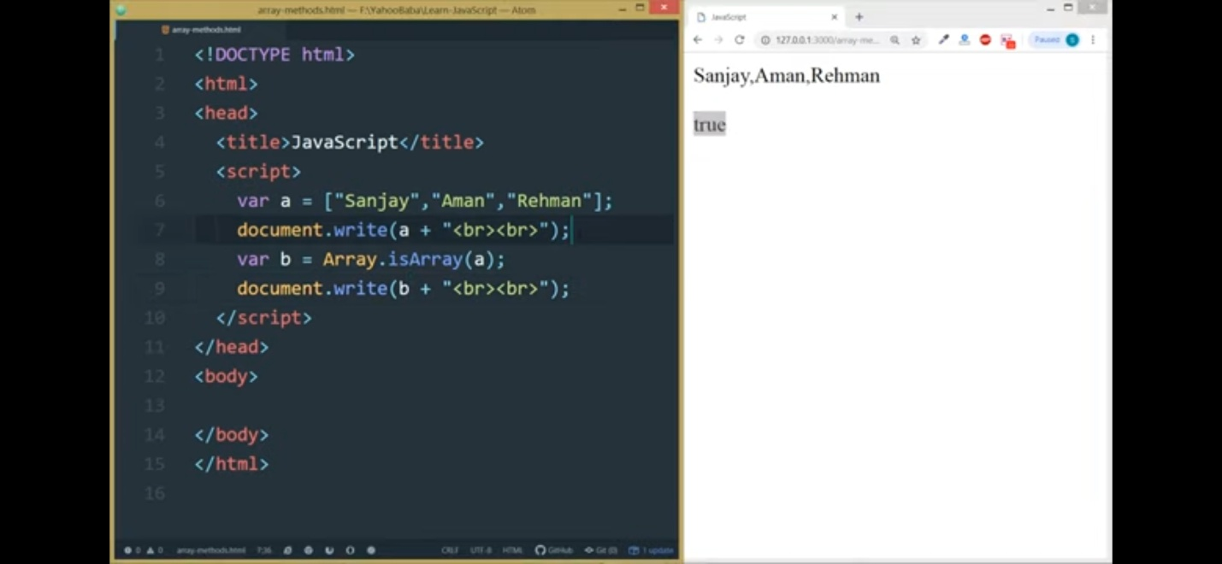

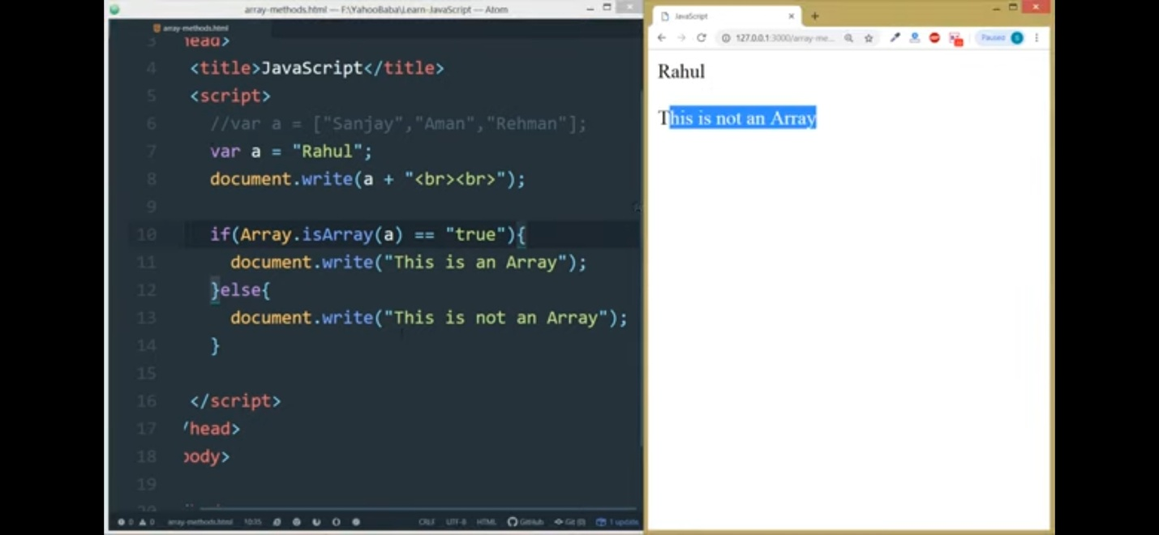

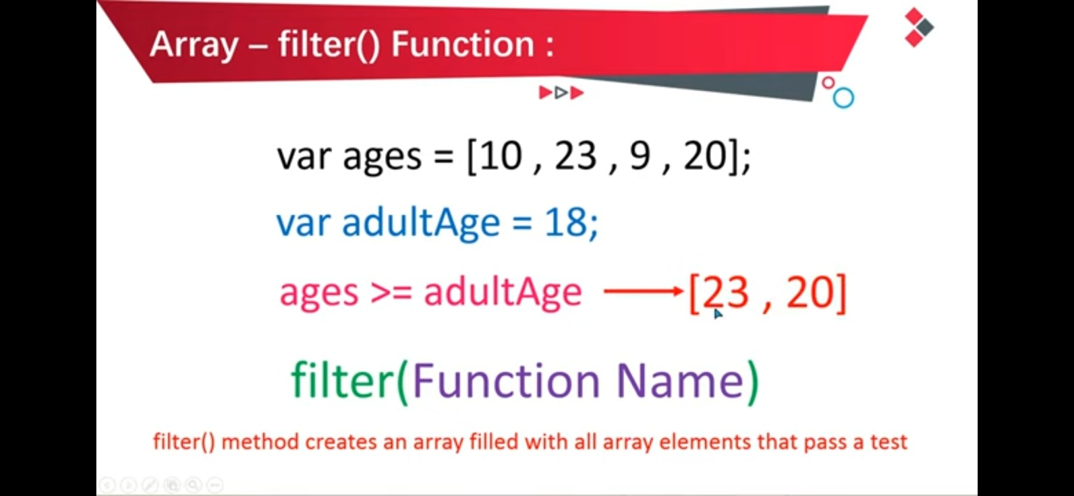

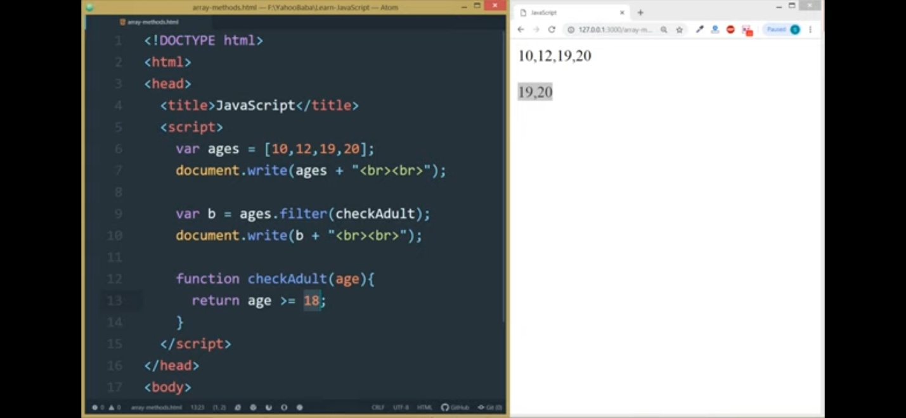

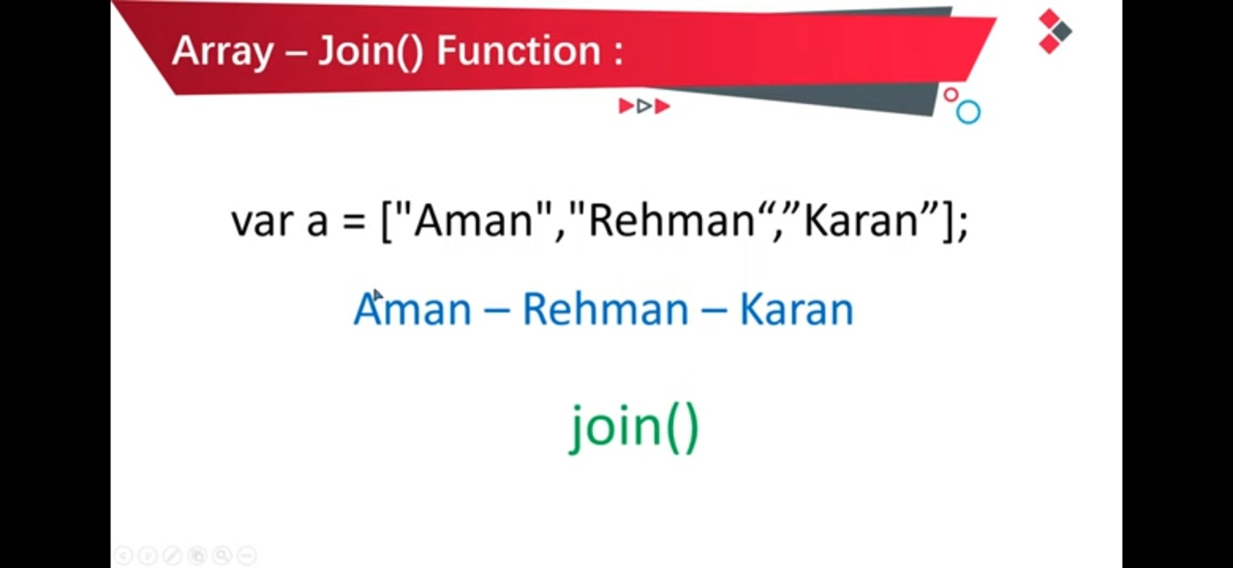

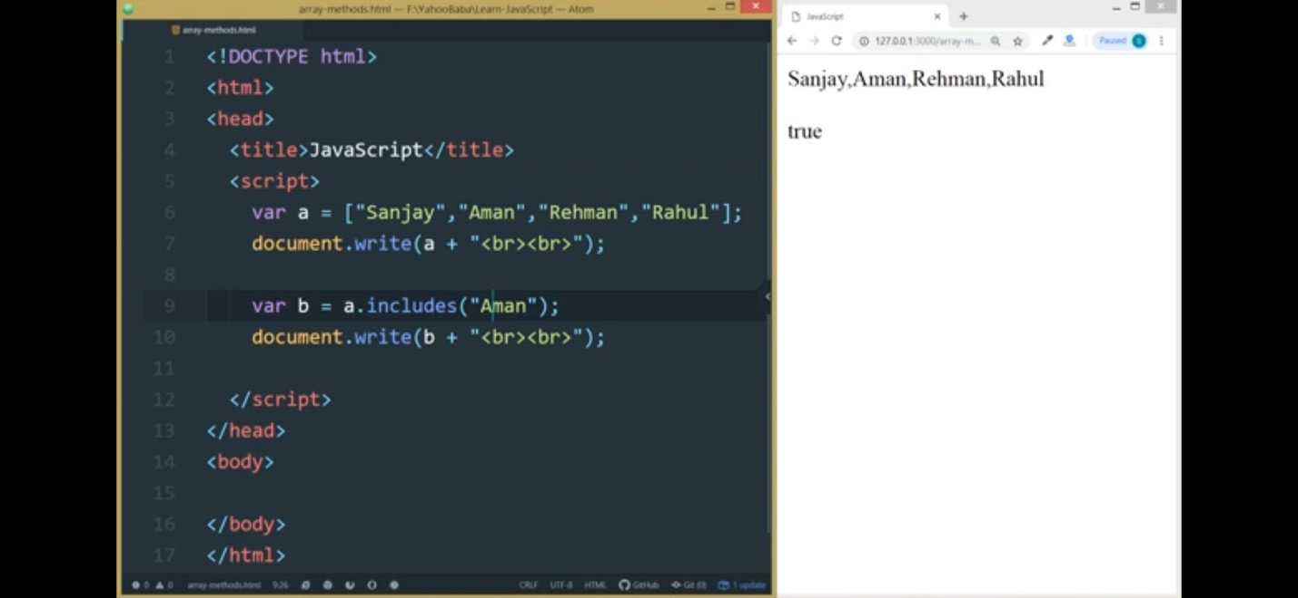

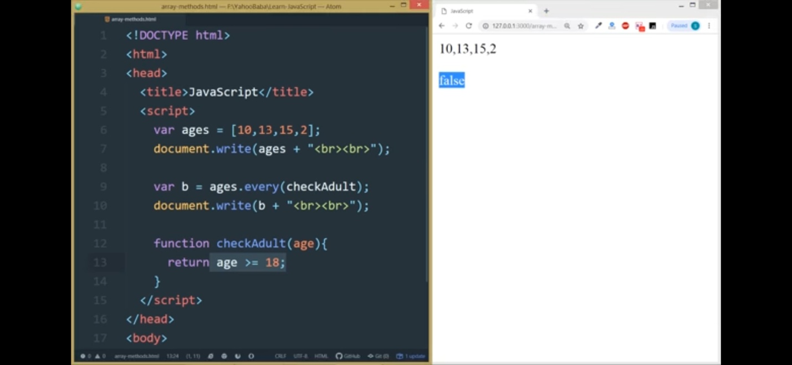

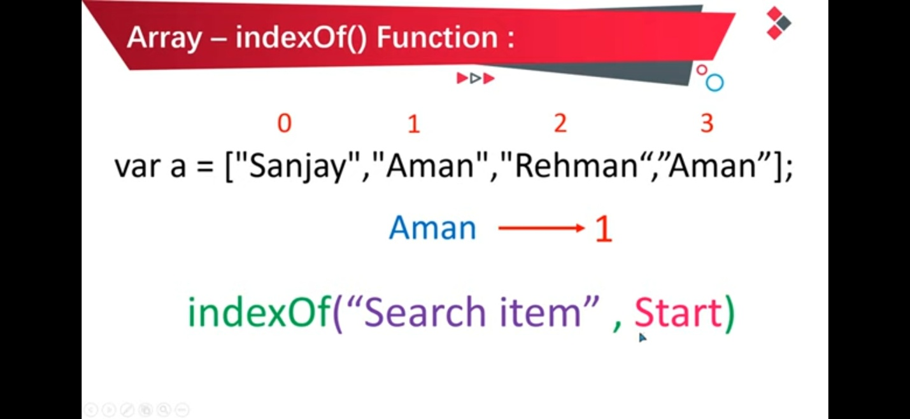

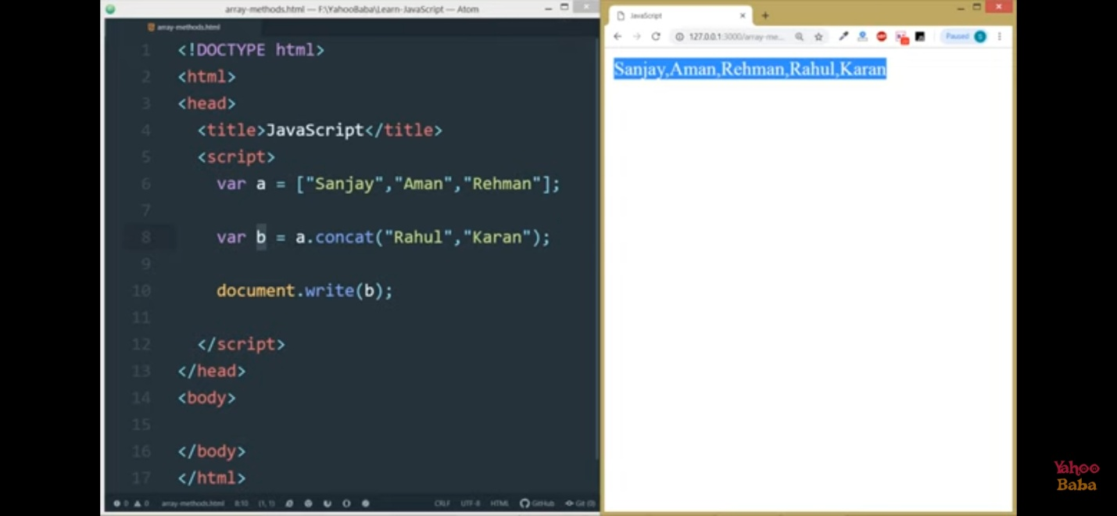

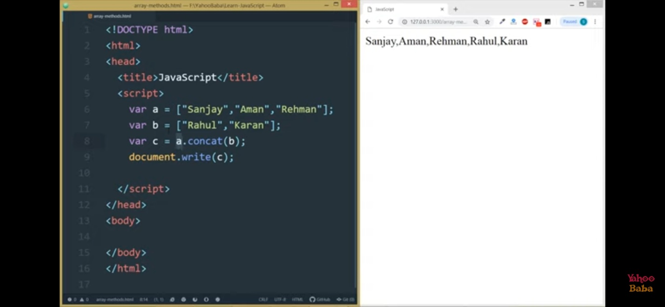

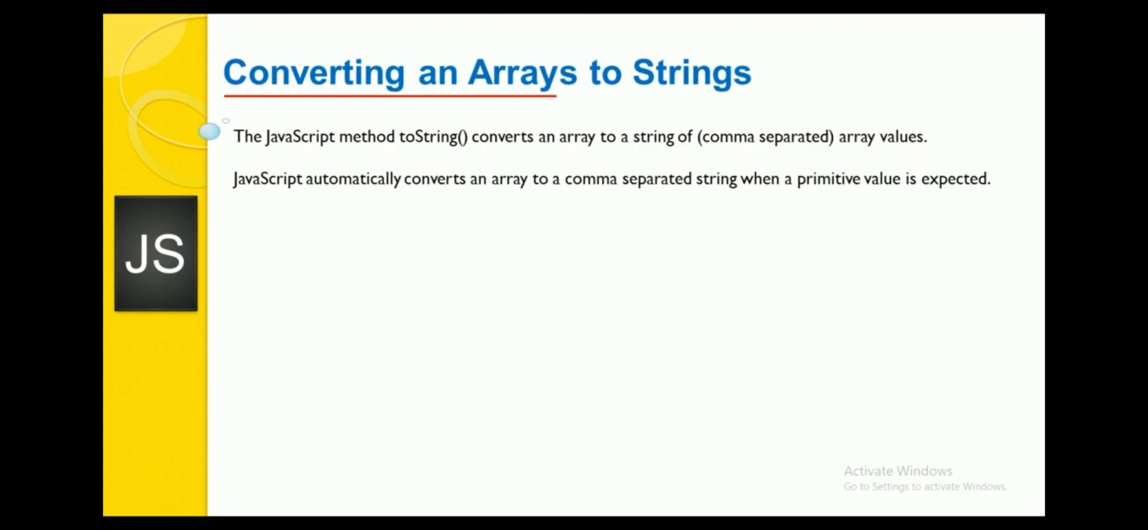

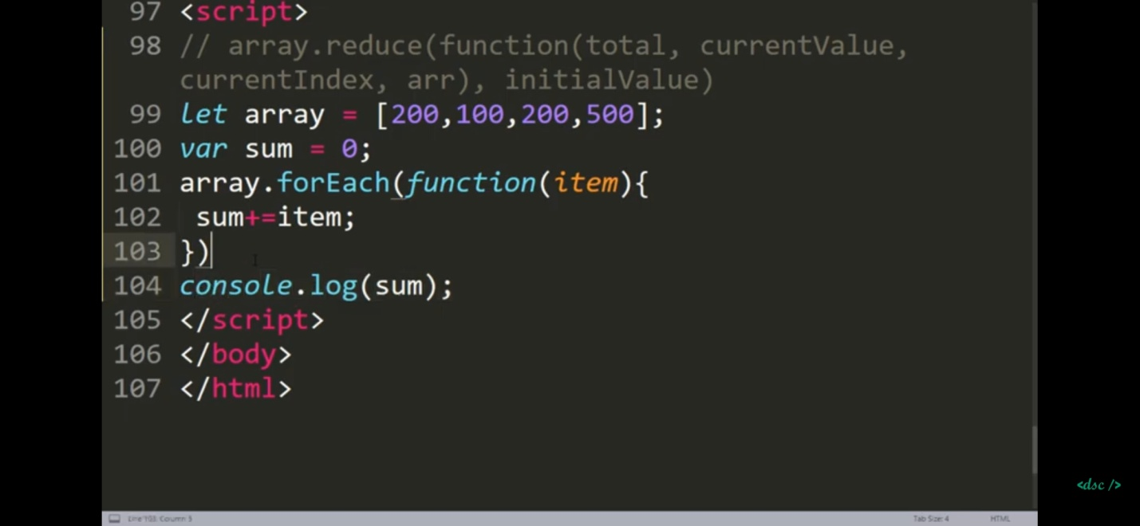

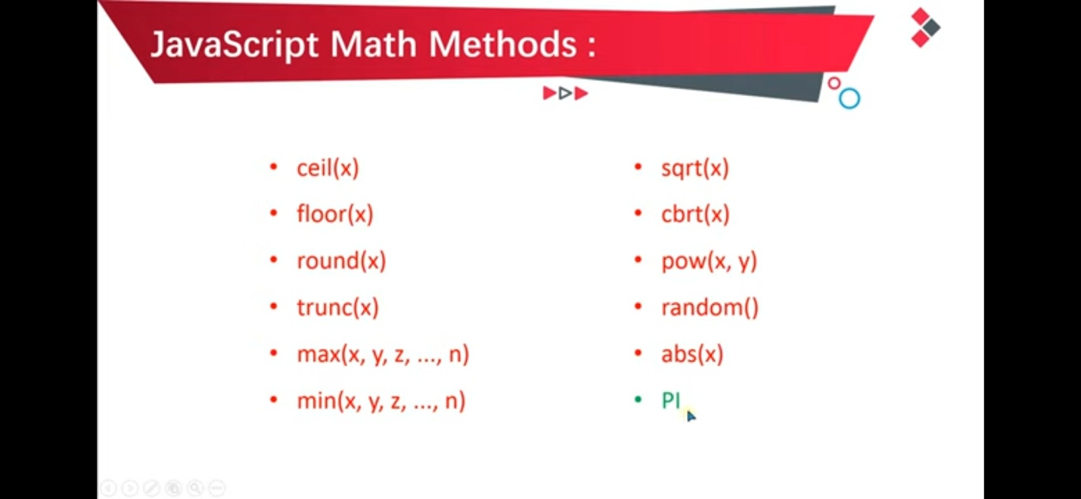

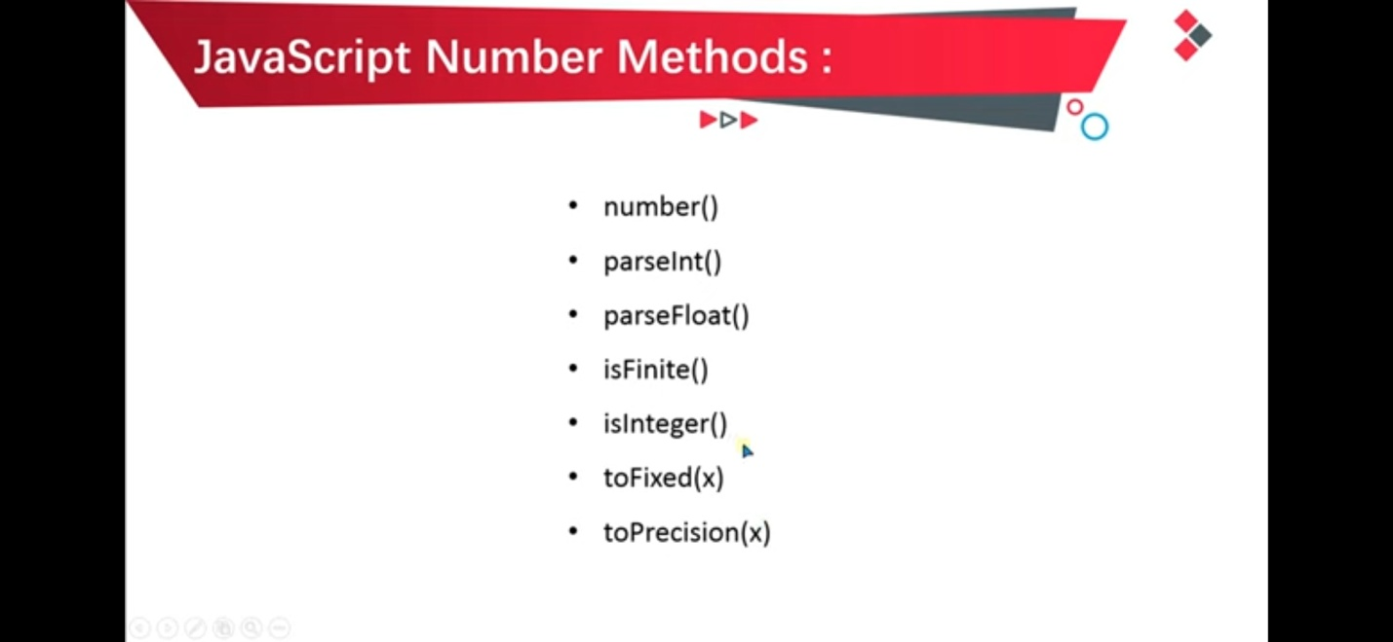

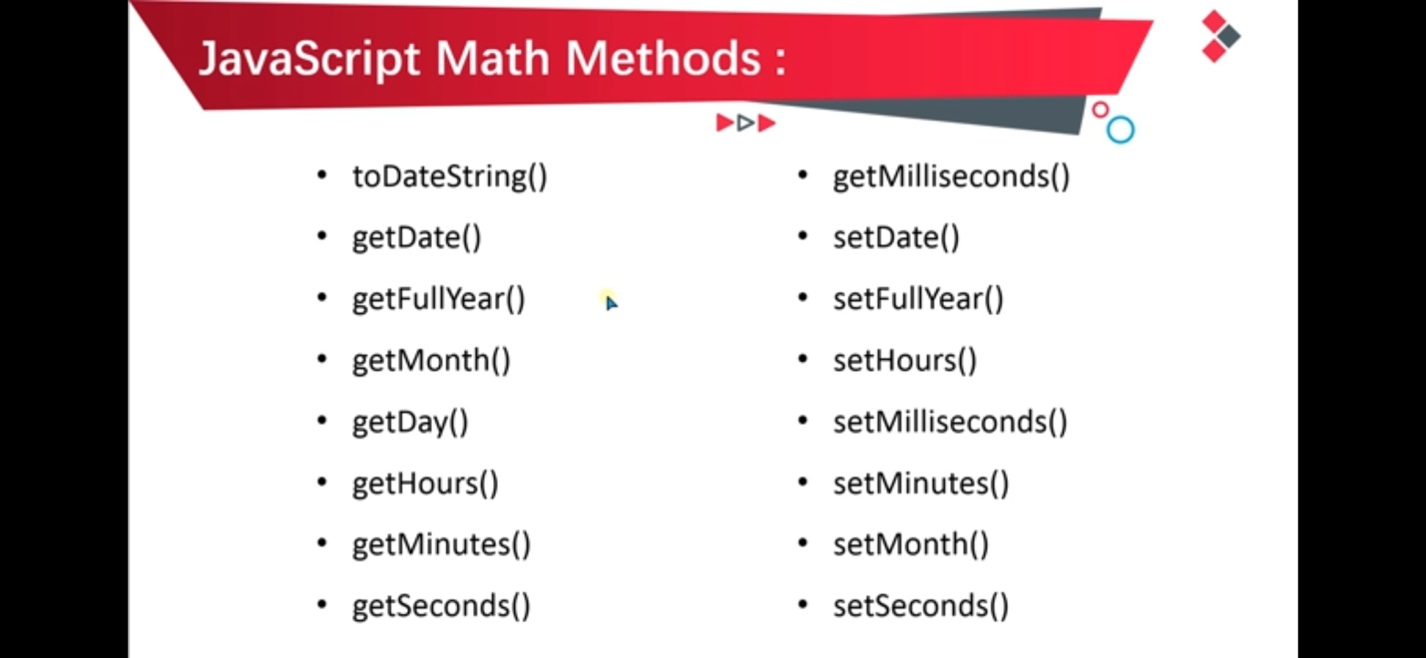

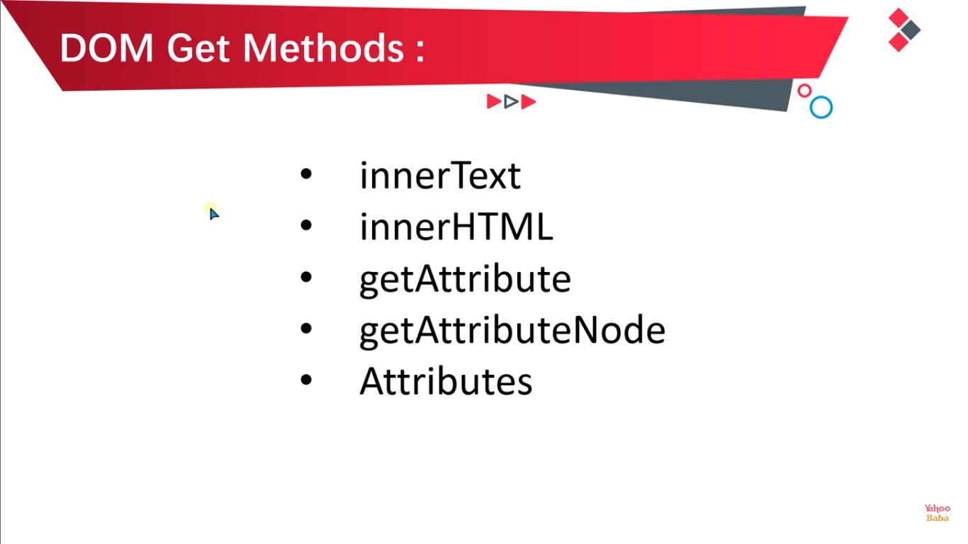

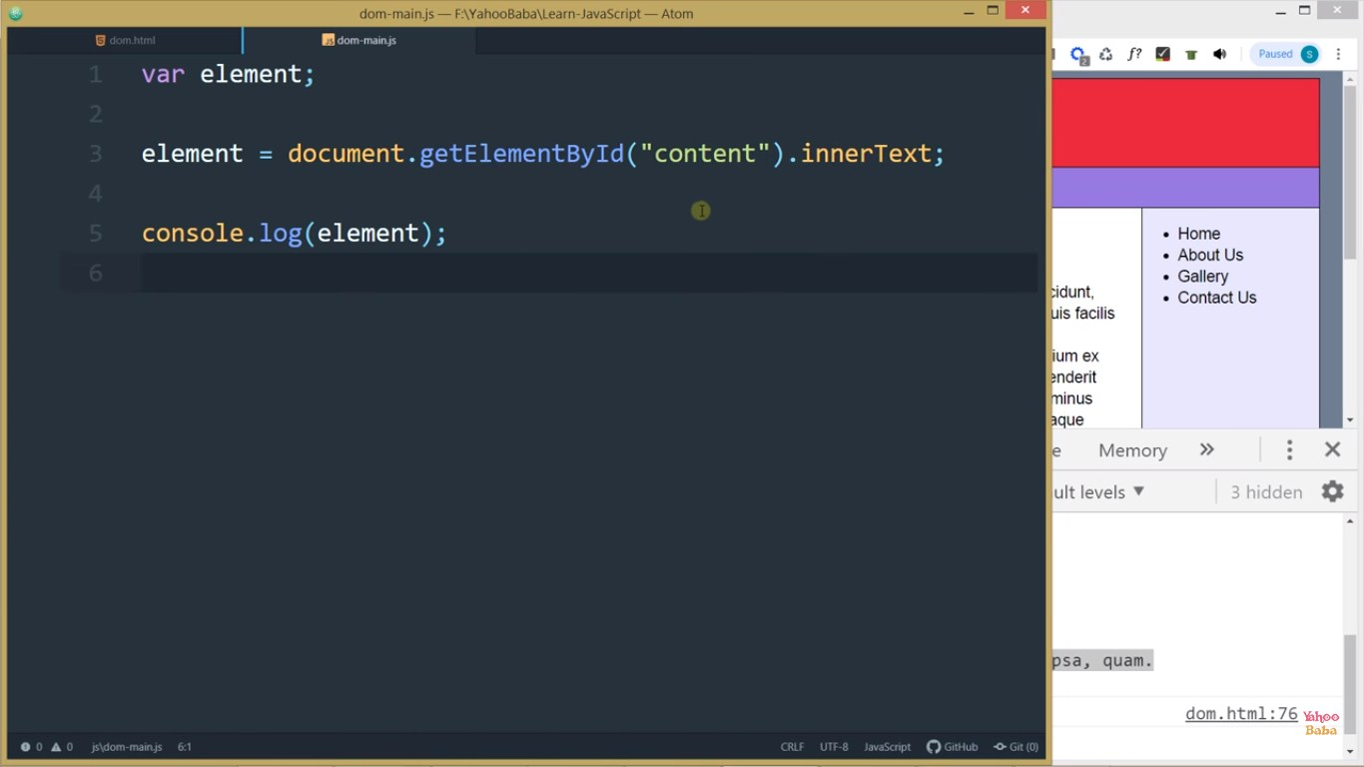

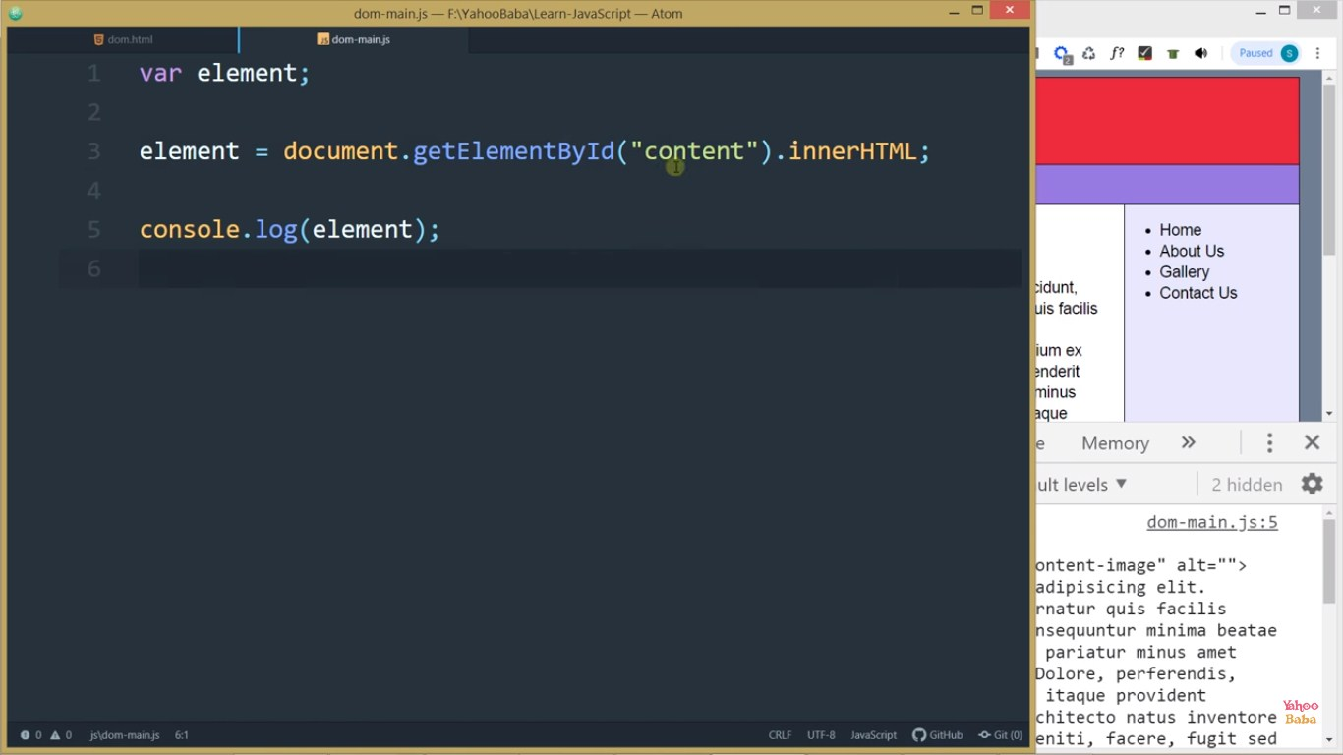

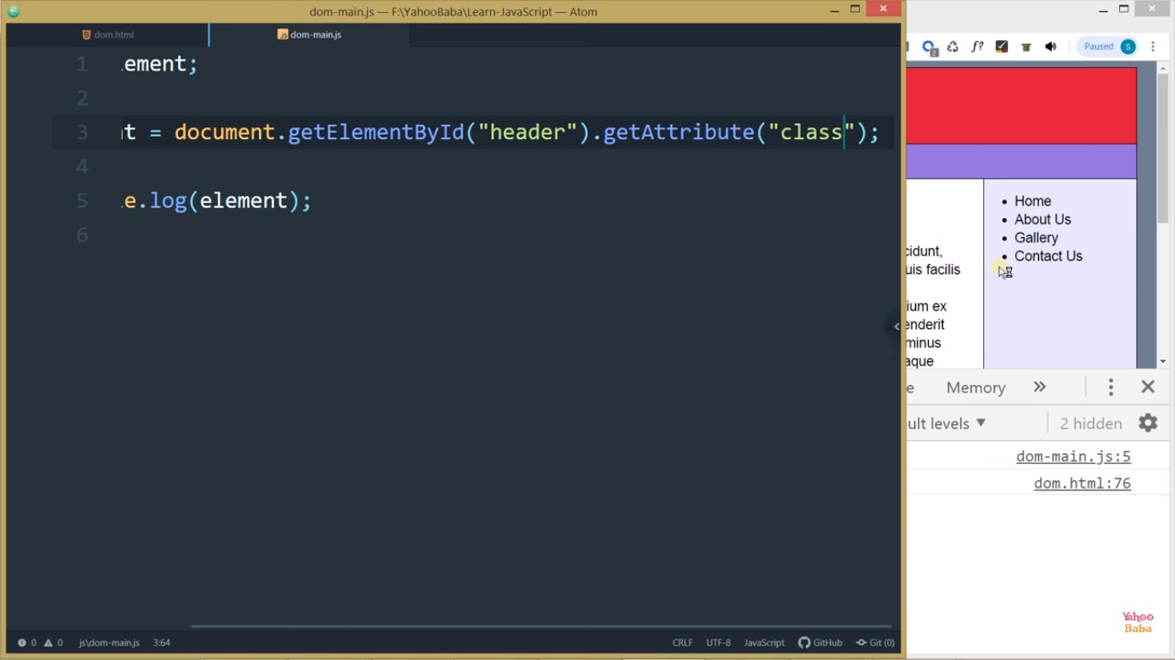

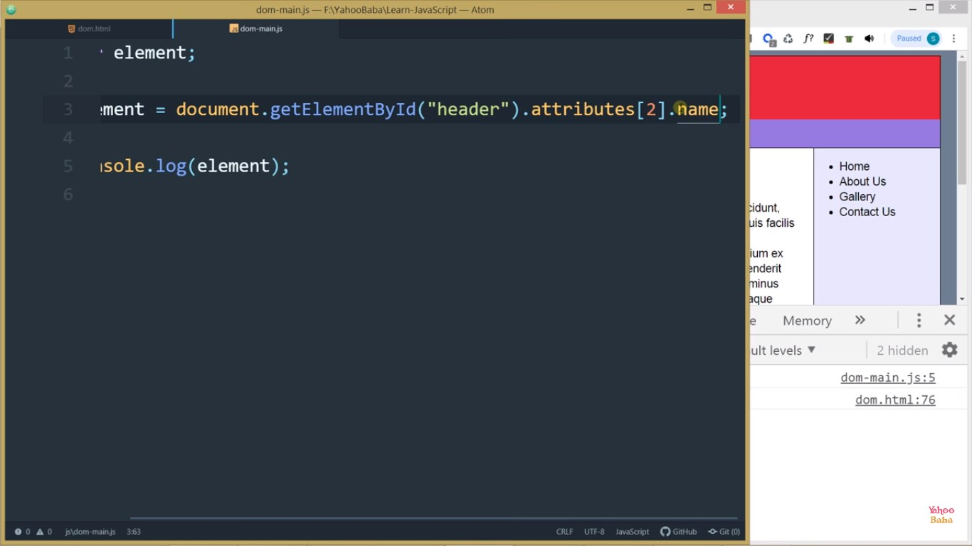

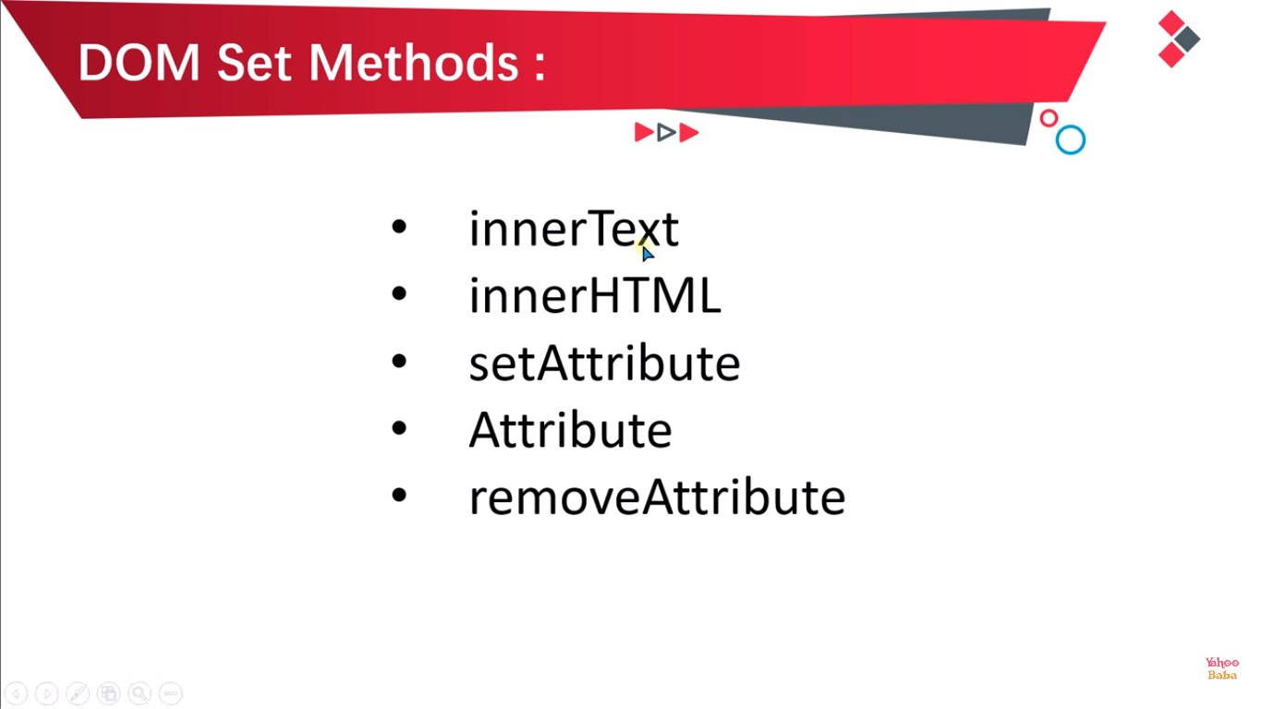

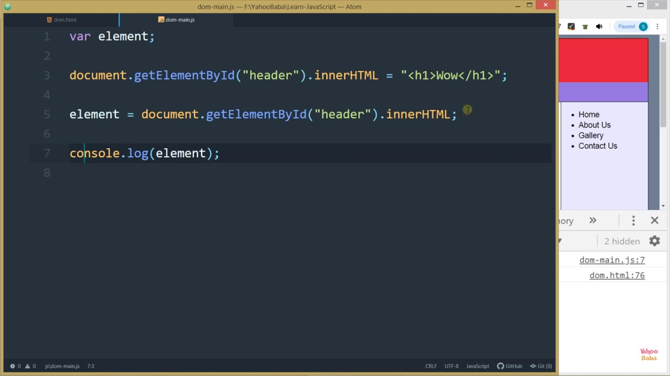

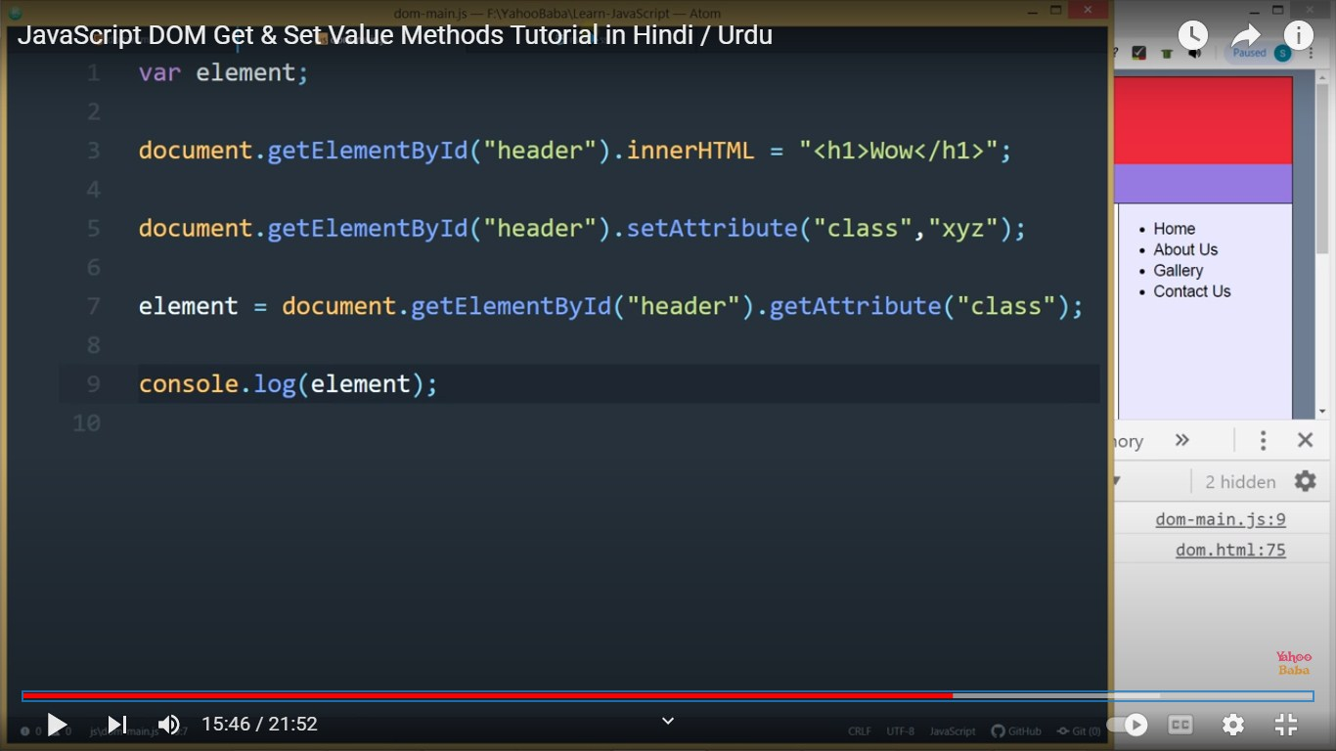

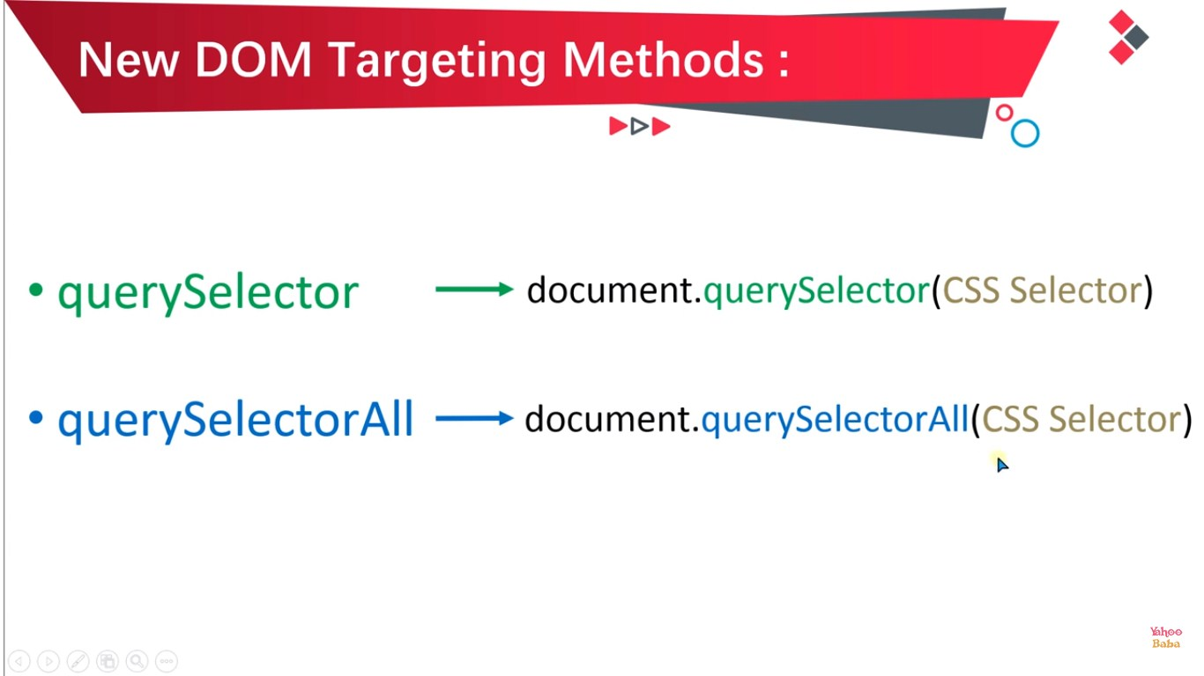

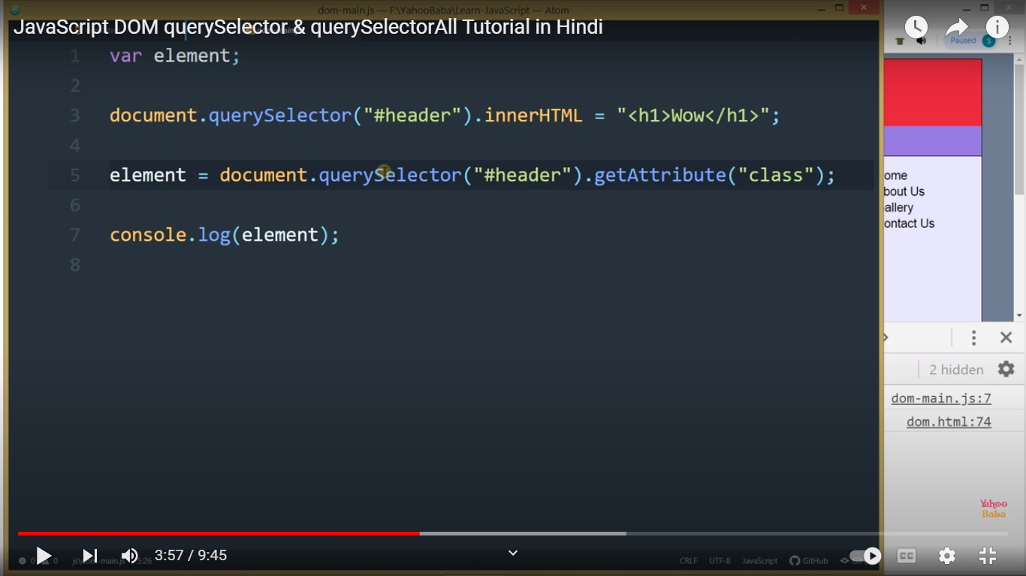

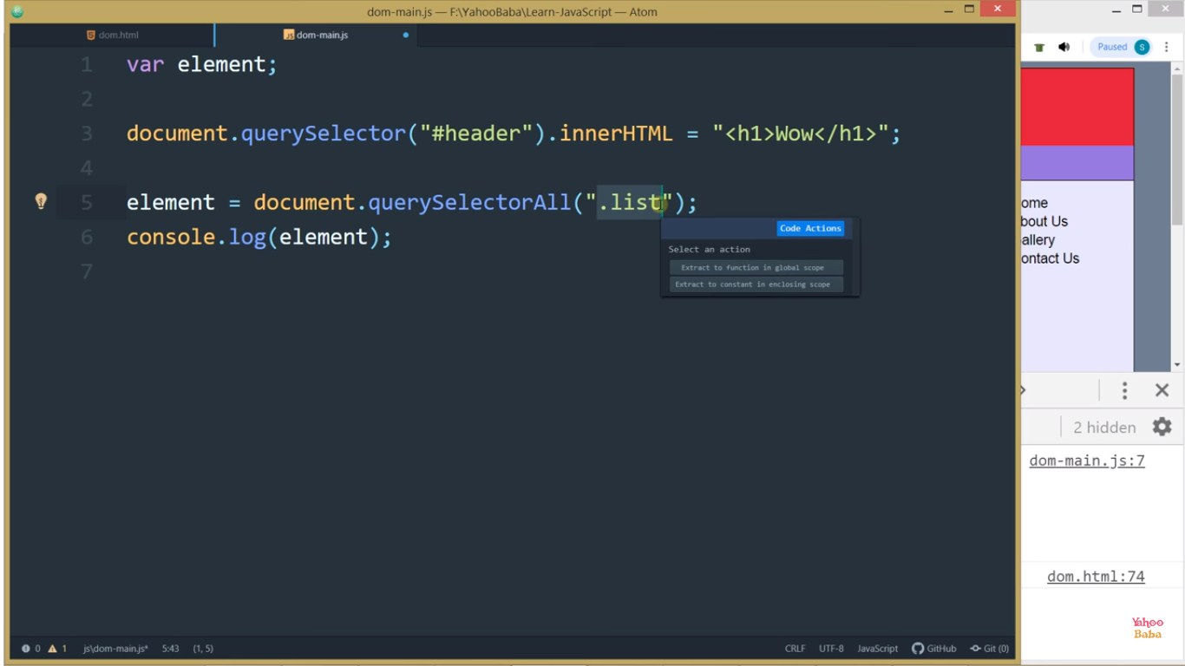

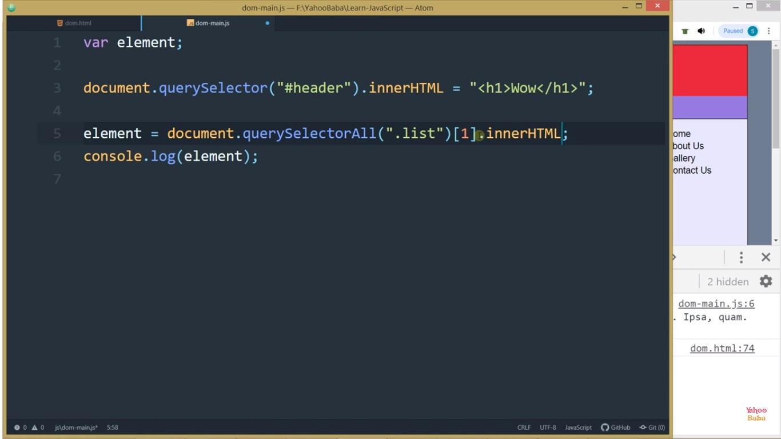

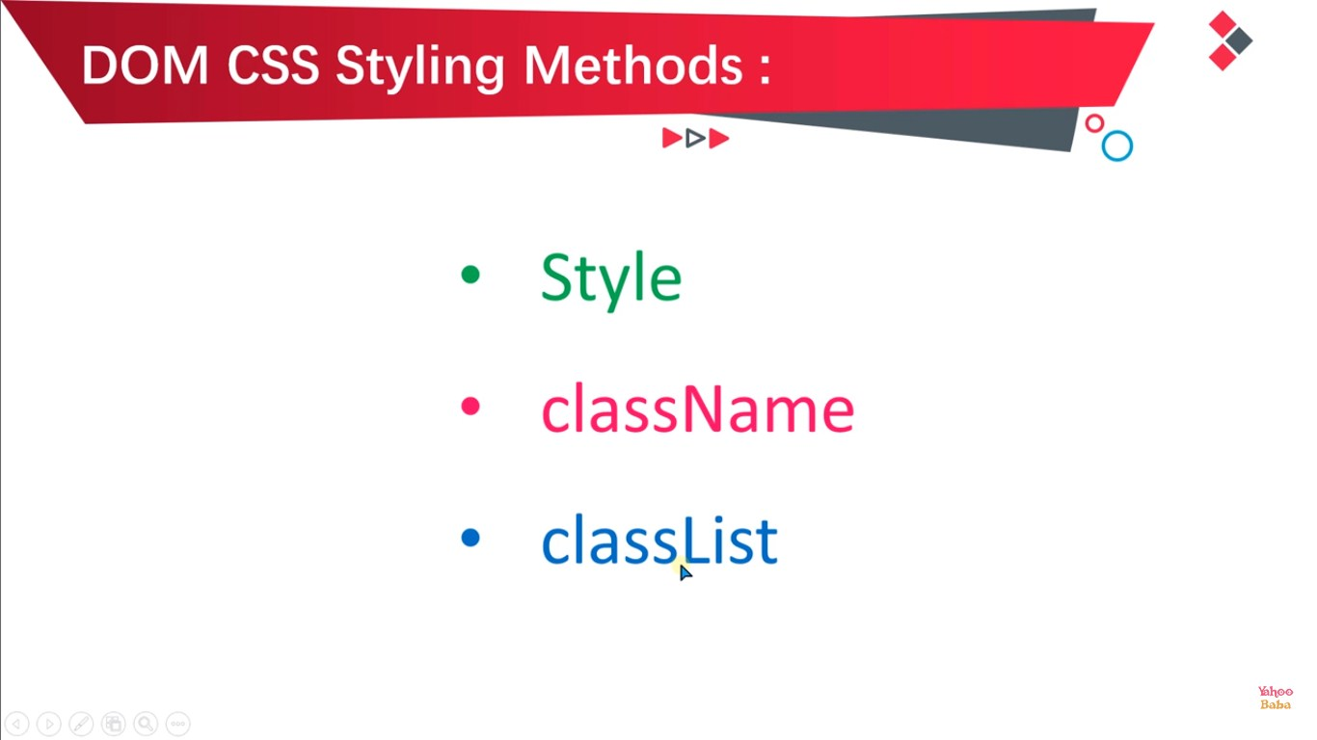

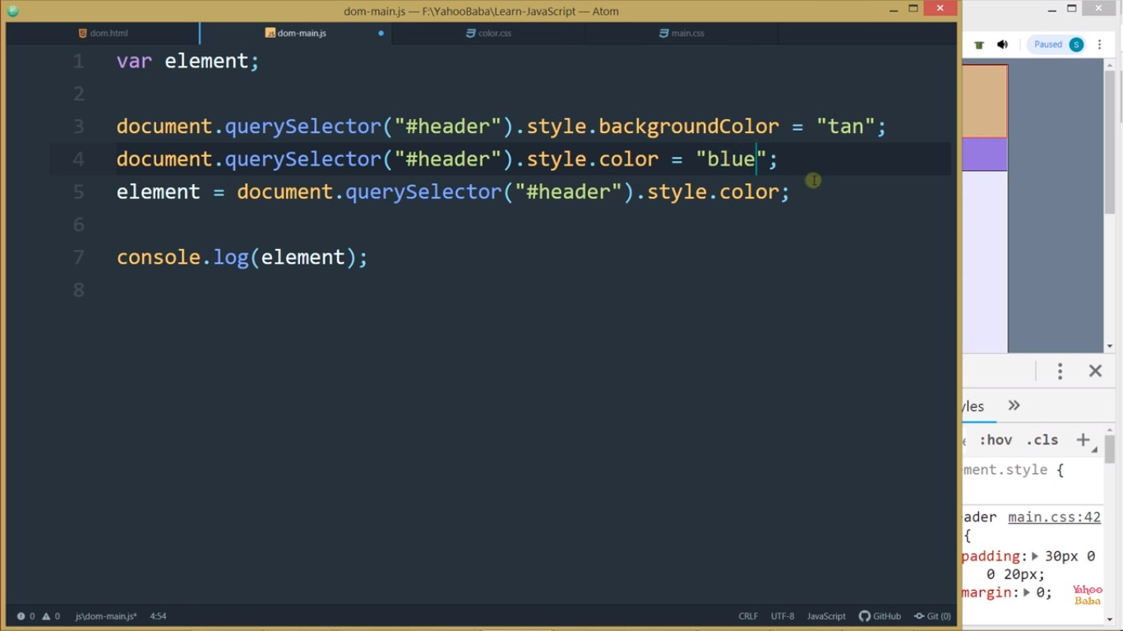

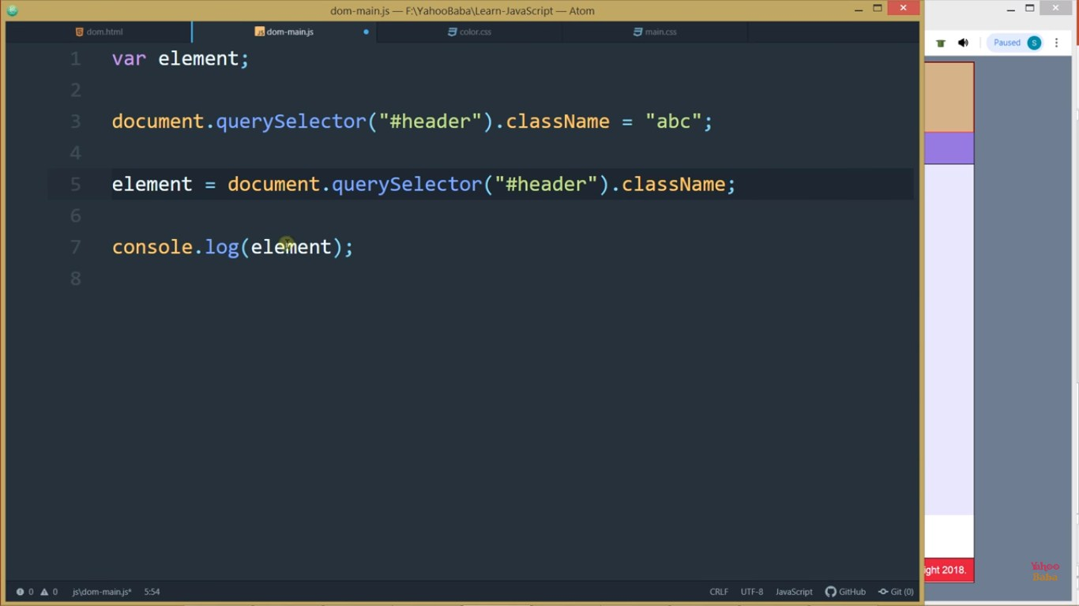

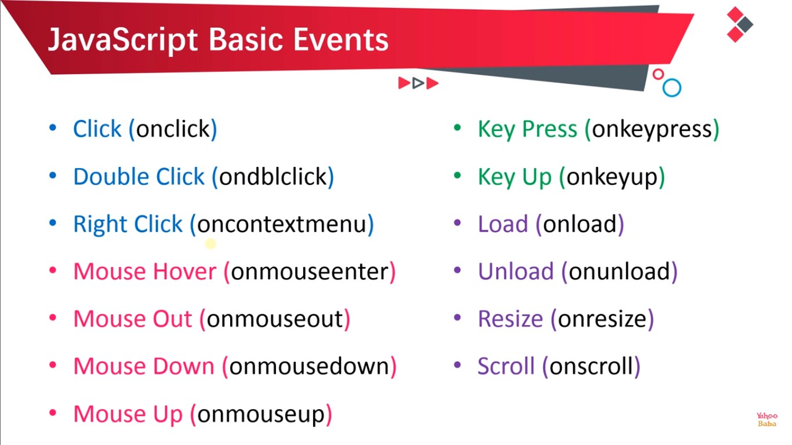

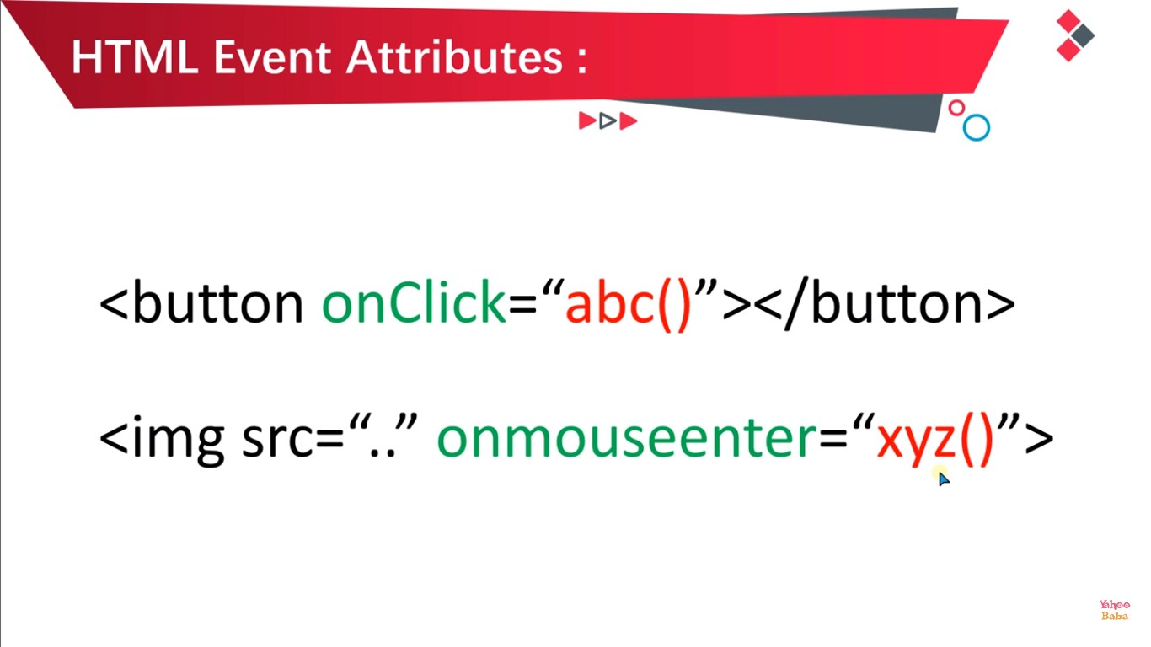

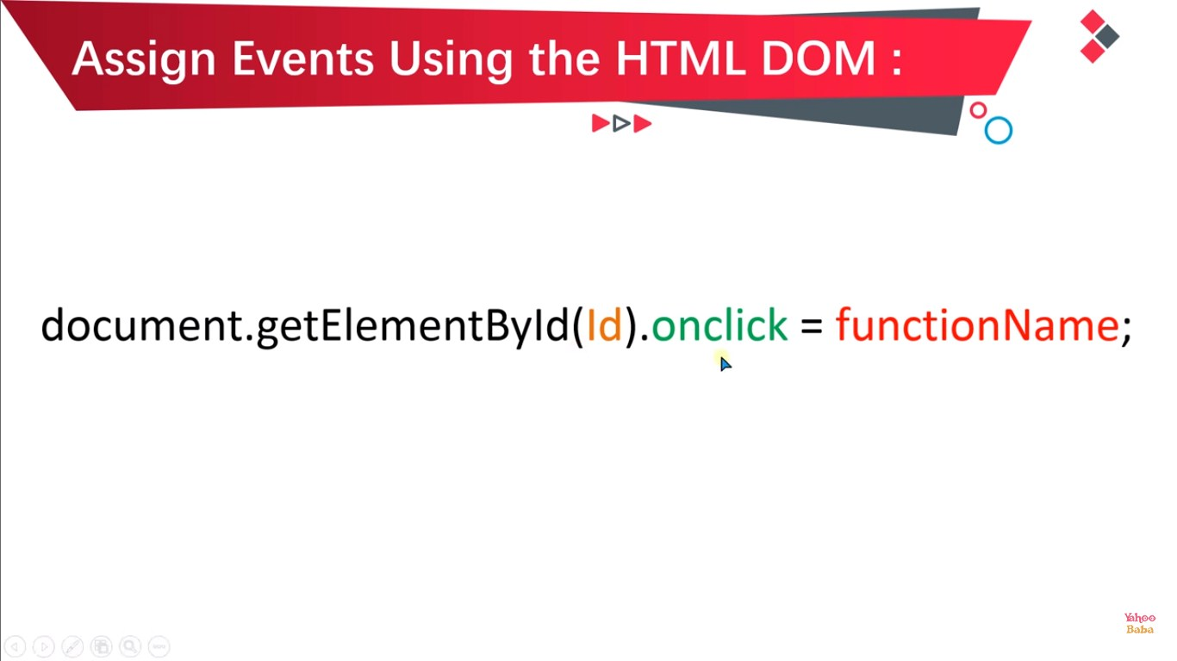

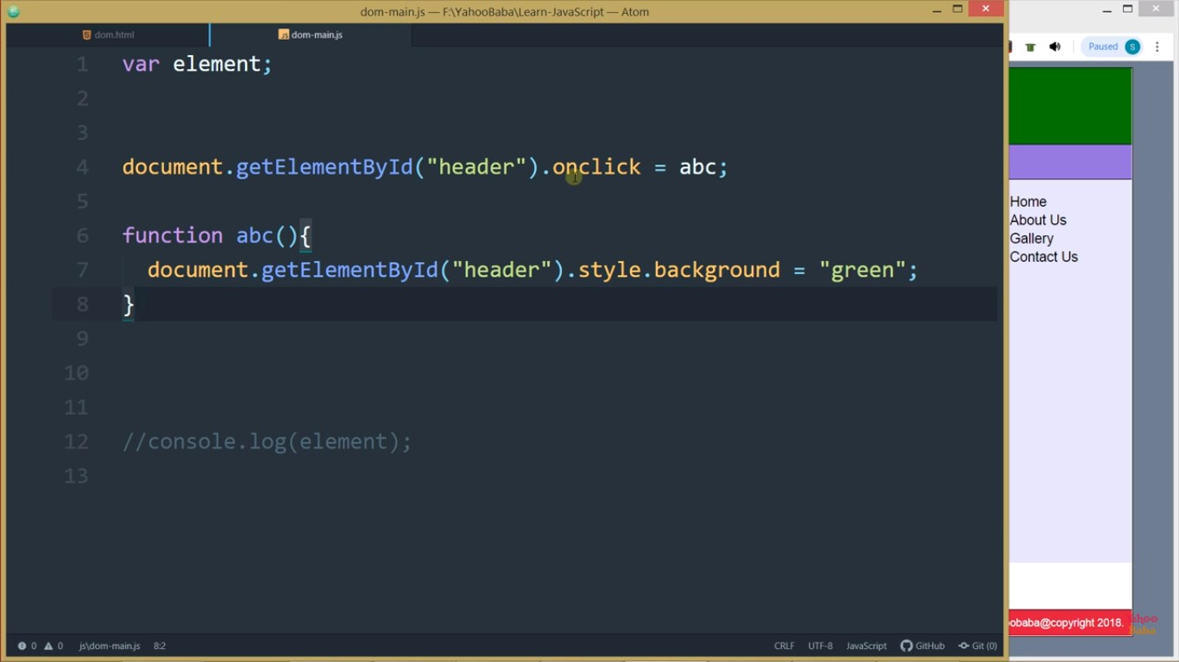

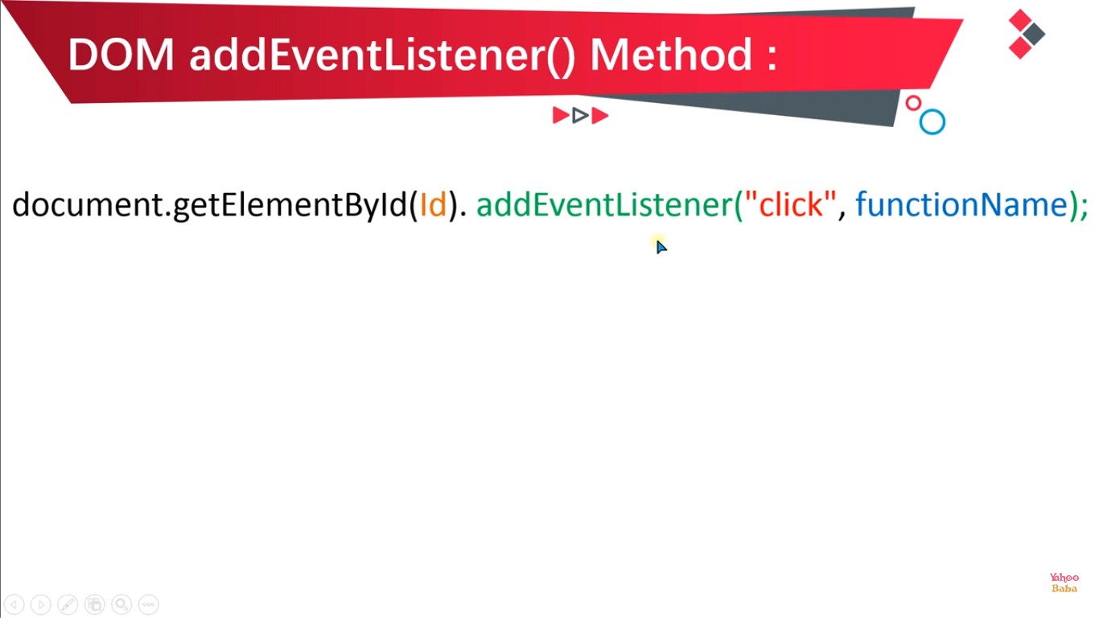

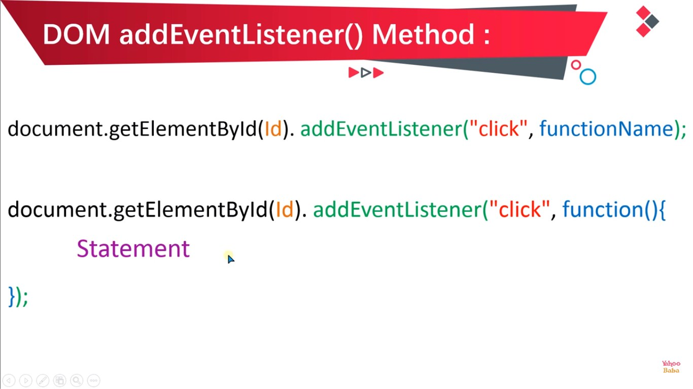

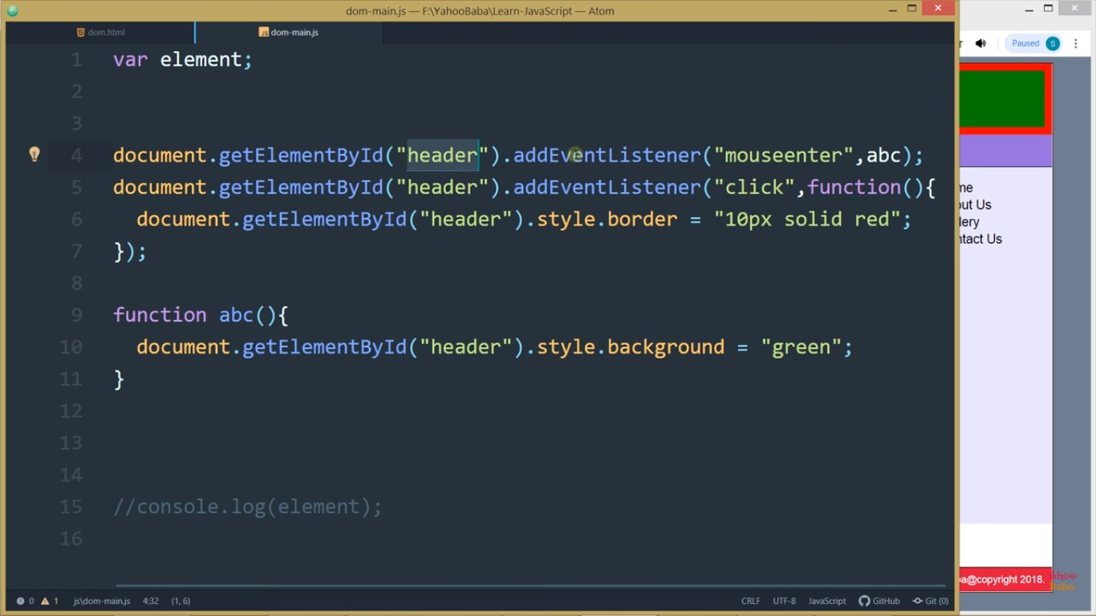

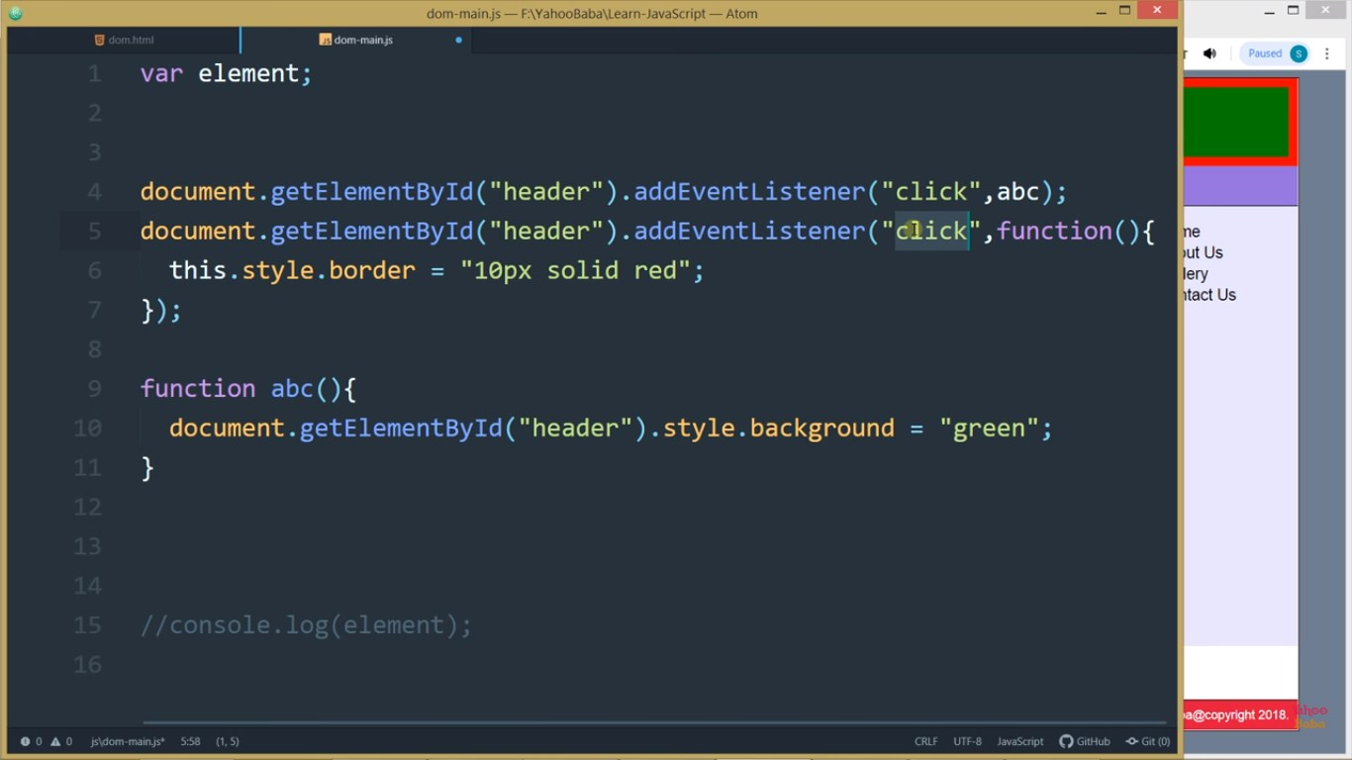

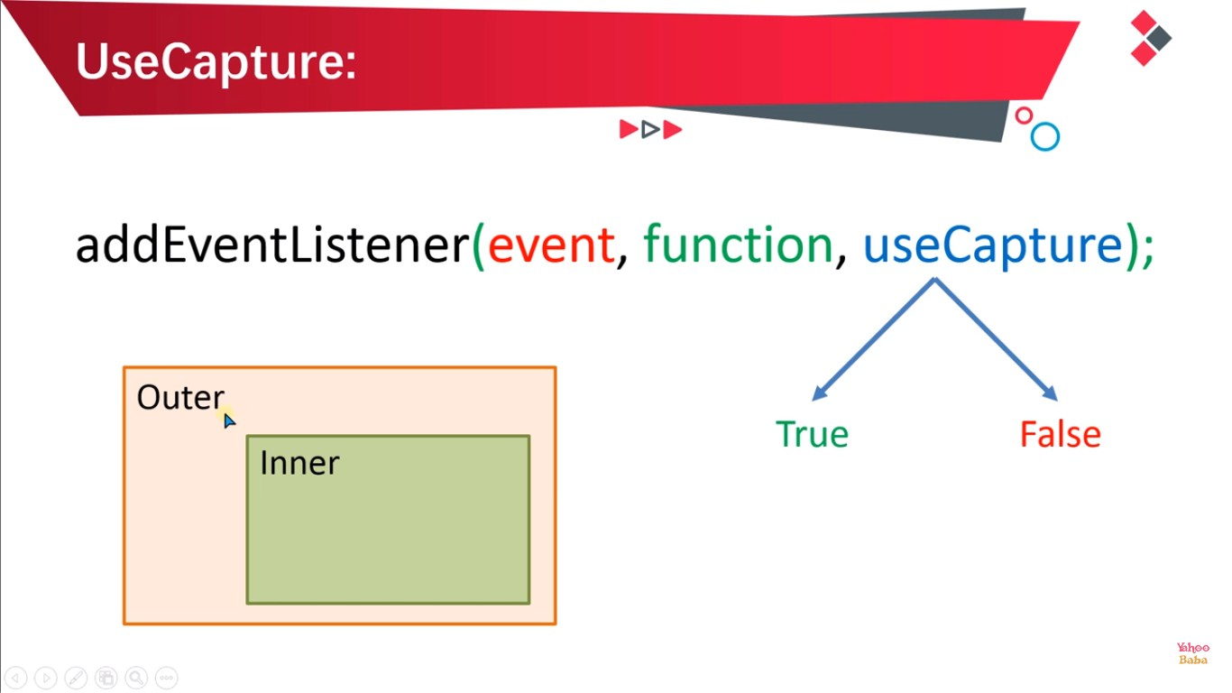

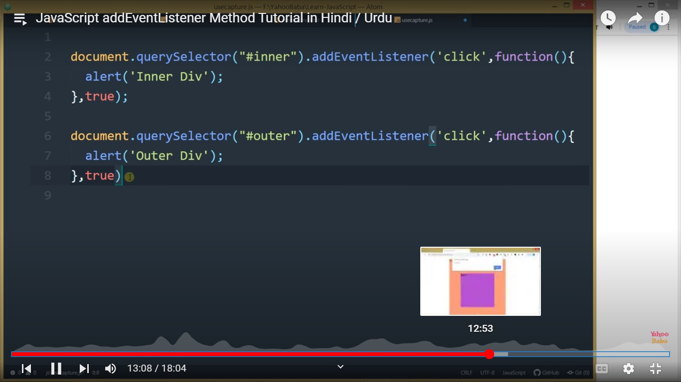

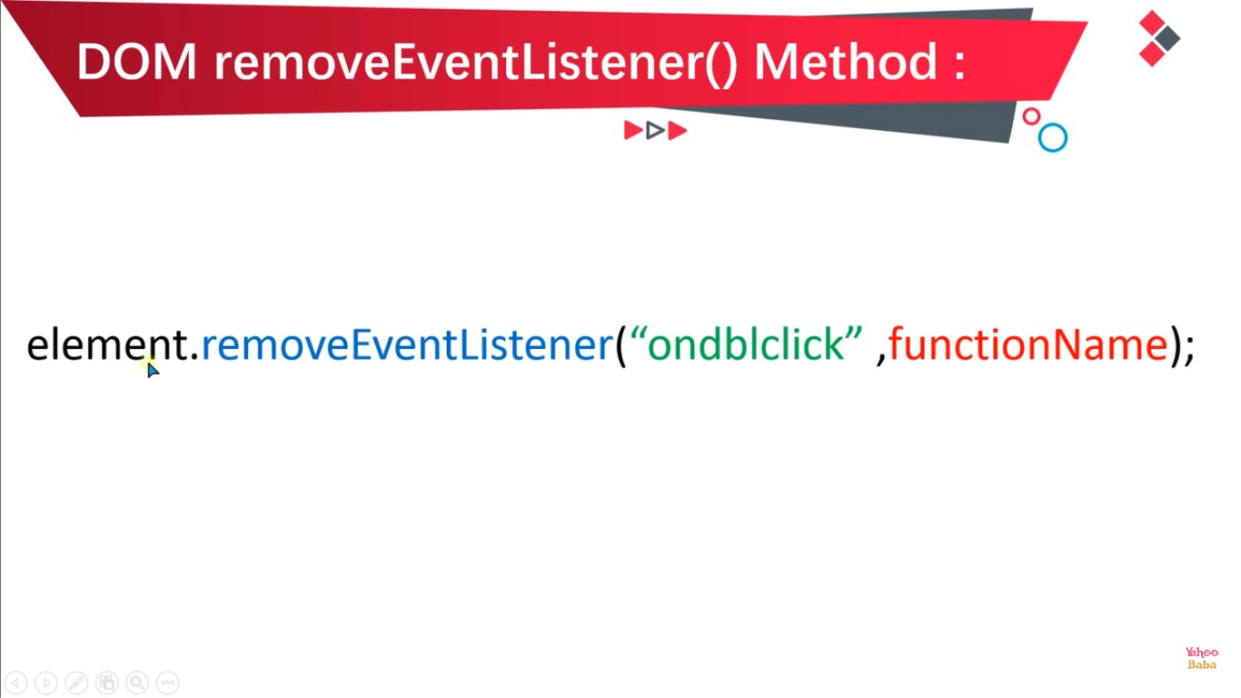

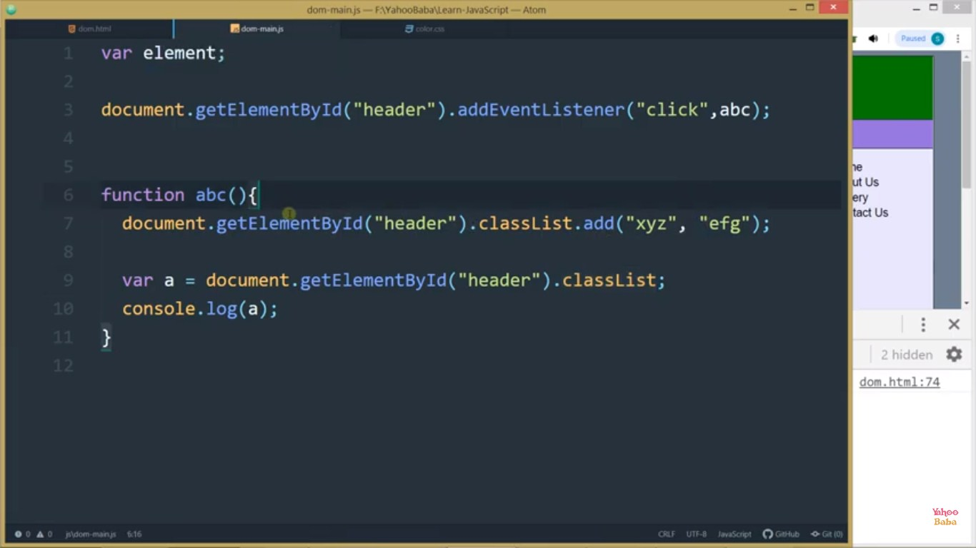

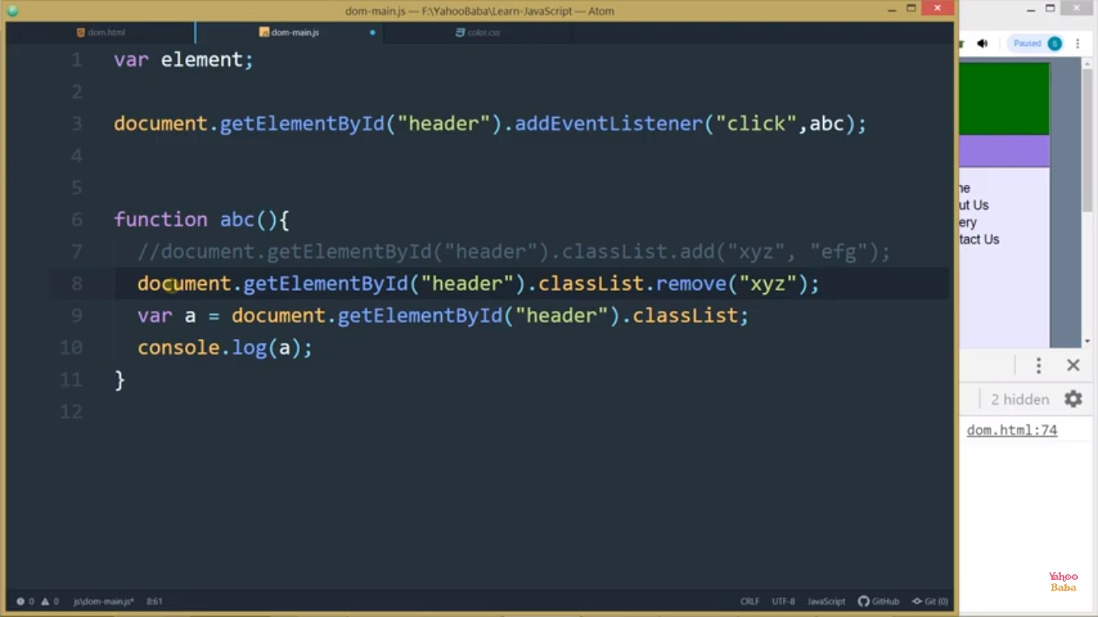

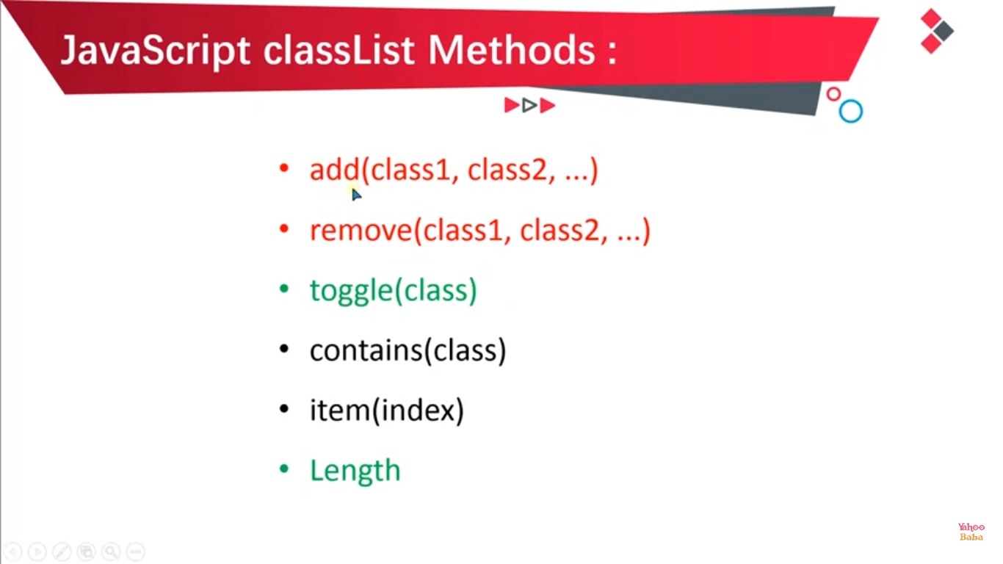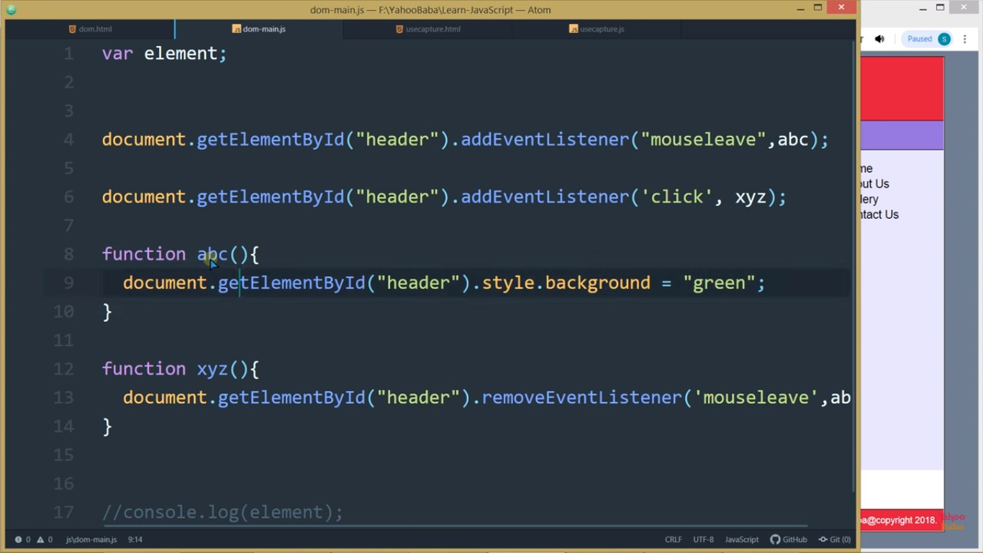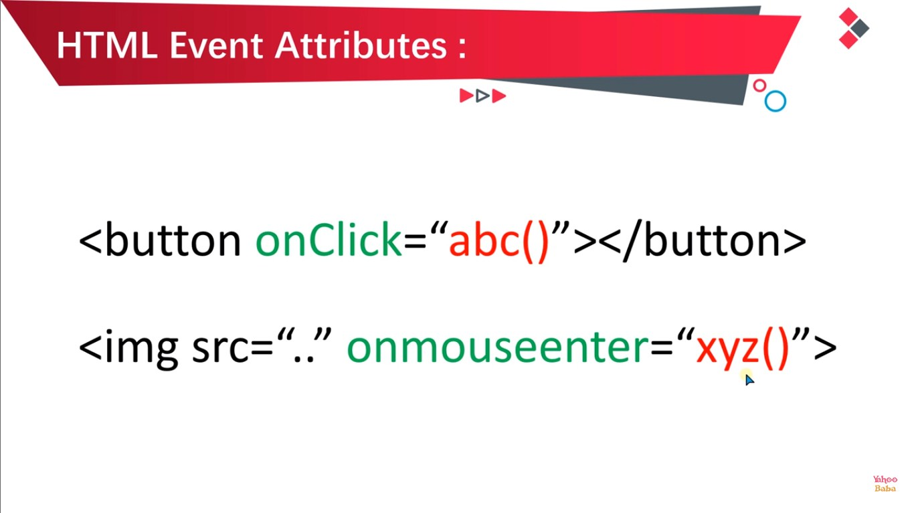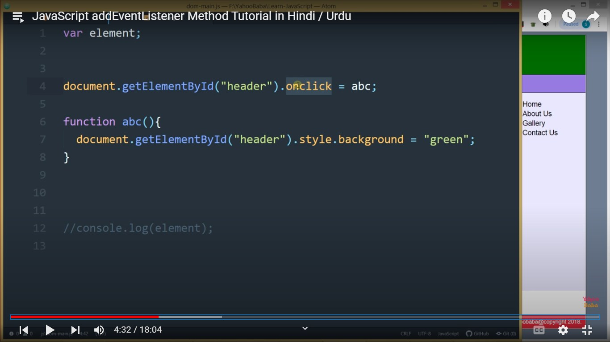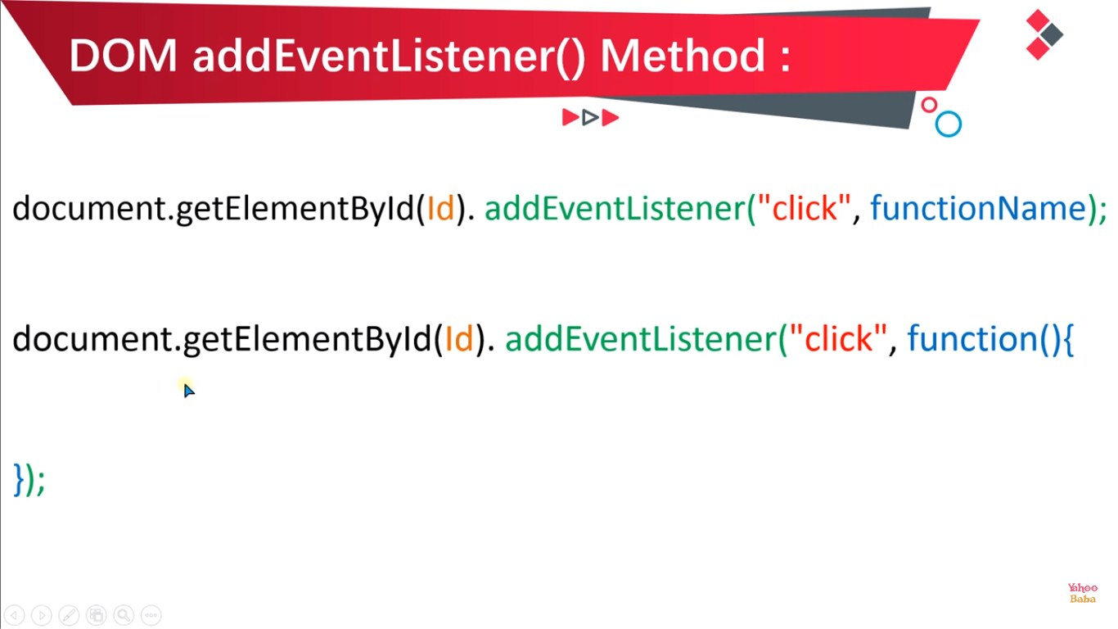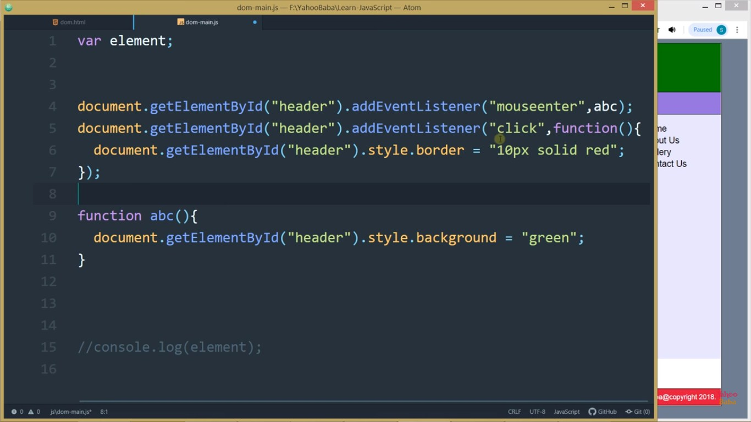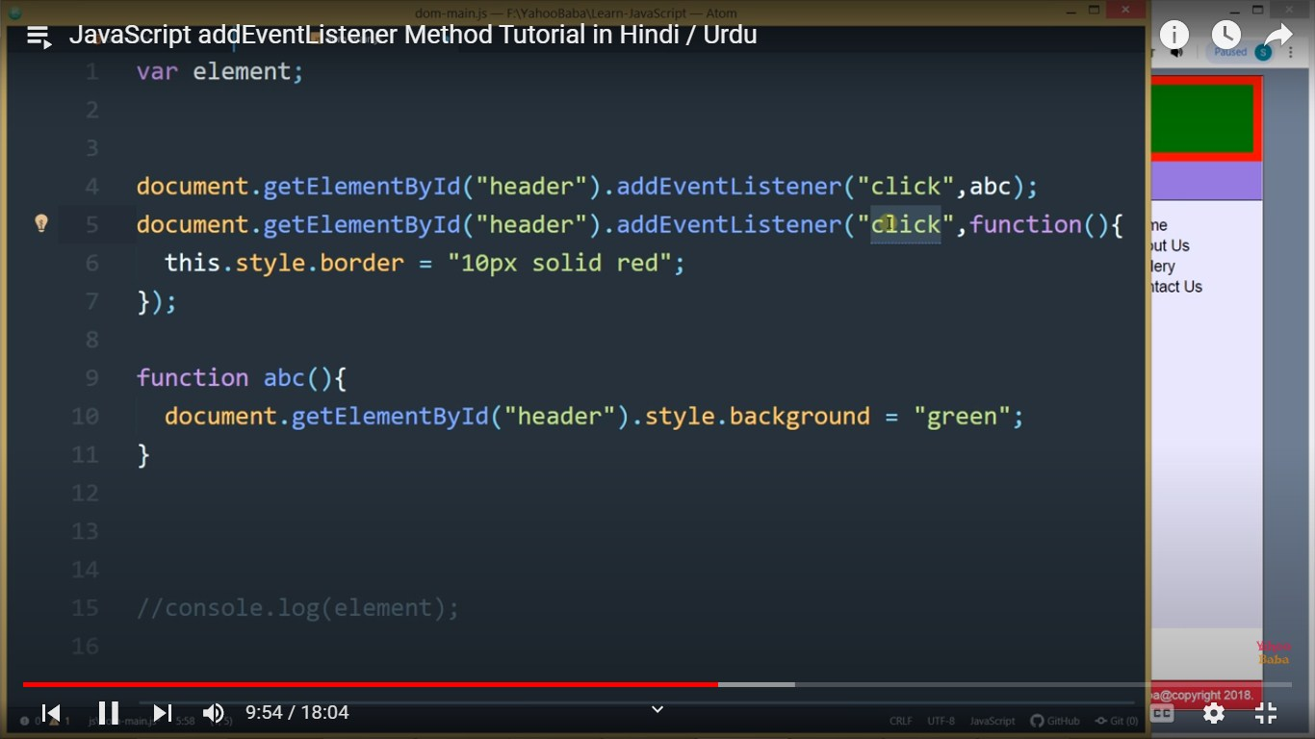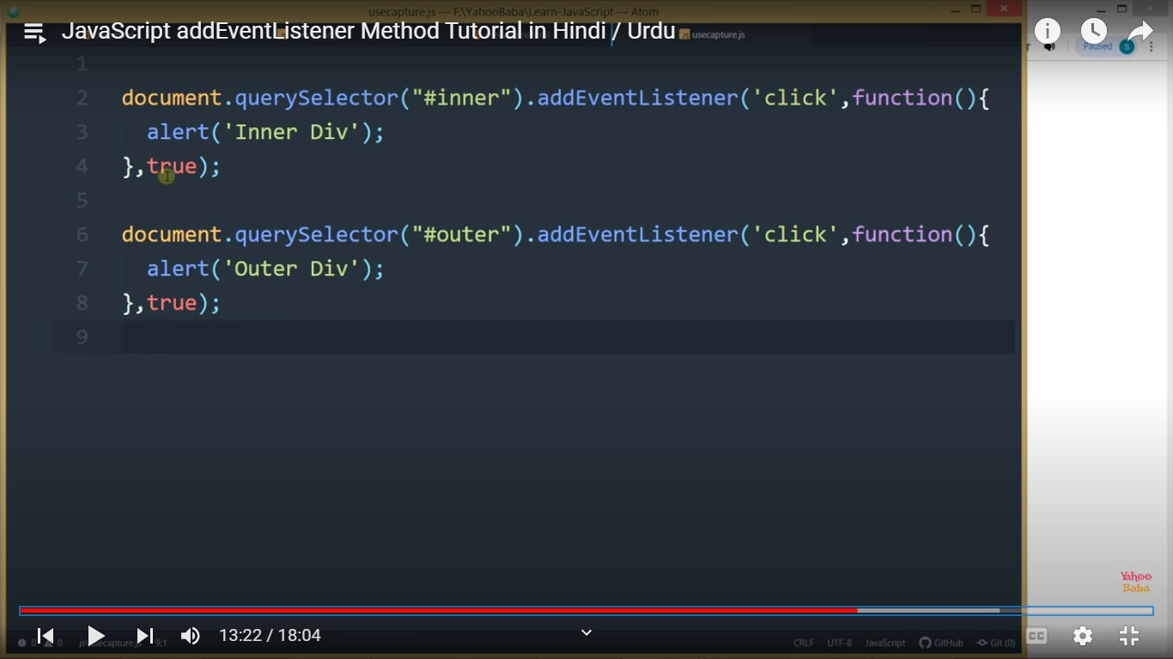



























































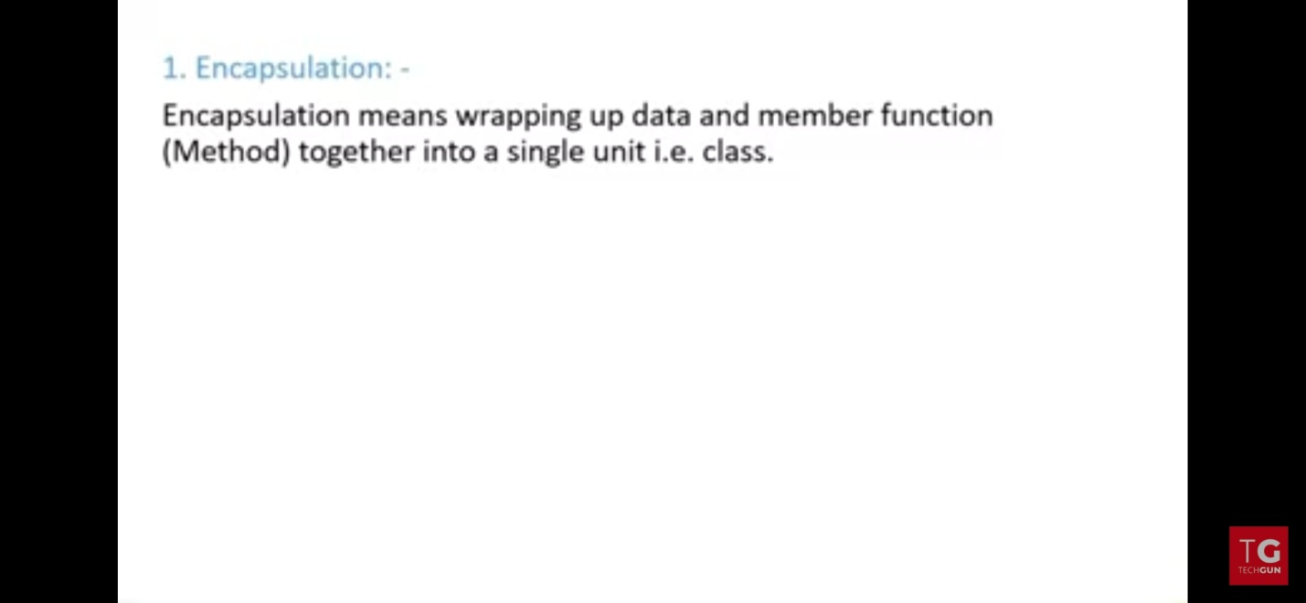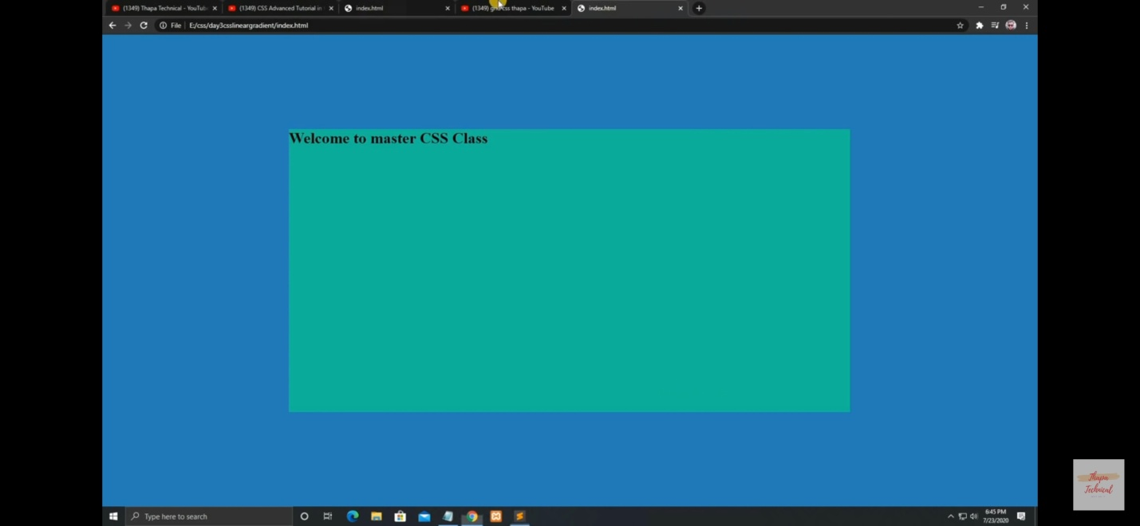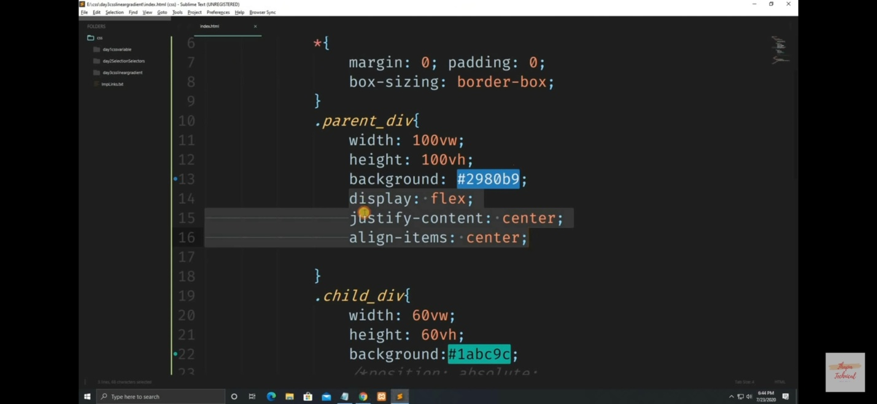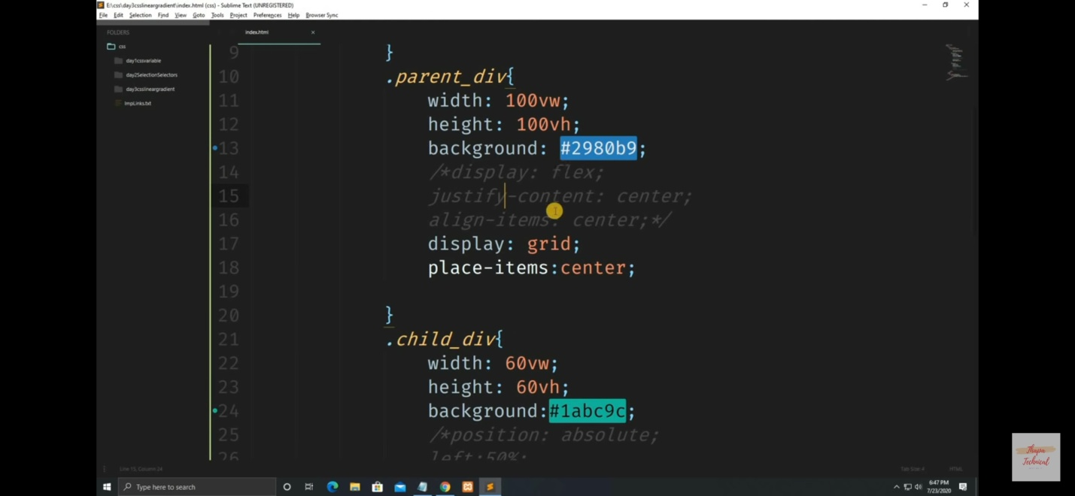

JavaScript Interview Questions

JavaScript interview questions and answers for provides a list of top 20 interview questions. The frequently asked JavaScript interview questions with answers for beginners and professionals are given below.

1) What is JavaScript?

**JavaScript** is *a scripting language*. It is different from Java language. It is object-based, lightweight, cross-platform translated language. It is widely used for client-side validation. The JavaScript Translator (embedded in the browser) is responsible for translating the JavaScript code for the web browser.[More details.](https://www.javatpoint.com/javascript-tutorial)

2) List some features of JavaScript.

Some of the features of JavaScript are:

* Lightweight
* Interpreted programming language
* Good for the applications which are network-centric
* Complementary to Java
* Complementary to HTML
* Open source

Cross-platform

3) Who developed JavaScript, and what was the first name of JavaScript?

JavaScript was developed by Brendan Eich, who was a Netscape programmer. Brendan Eich developed this new scripting language in just ten days in the year September 1995. At the time of its launch, JavaScript was initially called Mocha. After that, it was called Live Script and later known as JavaScript.

Prime Ministers of India | List of Prime Minister of India (1947-2020)

4) List some of the advantages of JavaScript.

Some of the advantages of JavaScript are:

* Server interaction is less
* Feedback to the visitors is immediate
* Interactivity is high
* Interfaces are richer

5) List some of the disadvantages of JavaScript.

Some of the disadvantages of JavaScript are:

* No support for multithreading
* No support for multiprocessing
* Reading and writing of files is not allowed
* No support for networking applications.

6) Define a named function in JavaScript.

The function which has named at the time of definition is called a named function. For example

1. function msg()
2. {
3. document.writeln("Named Function");
4. }
5. msg();

7) Name the types of functions

The types of function are:

* Named - These type of functions contains name at the time of definition. For Example:
  1. function display()
  2. {
  3. document.writeln("Named Function");
  4. }
  5. display();
* Anonymous - These type of functions doesn't contain any name. They are declared dynamically at runtime.
  1. var display=function()
  2. {
  3. document.writeln("Anonymous Function");
  4. }
  5. display();

8) Define anonymous function

It is a function that has no name. These functions are declared dynamically at runtime using the function operator instead of the function declaration. The function operator is more flexible than a function declaration. It can be easily used in the place of an expression. For example:

1. var display=function()
2. {
3. alert("Anonymous Function is invoked");
4. }
5. display();

9) Can an anonymous function be assigned to a variable?

Yes, you can assign an anonymous function to a variable.

10) In JavaScript what is an argument object?

The variables of JavaScript represent the arguments that are passed to a function.

11) Define closure.

In JavaScript, we need closures when a variable which is defined outside the scope in reference is accessed from some inner scope.

1. var num = 10;
2. function sum()
3. {
4. document.writeln(num+num);
5. }
6. sum();

12) If we want to return the character from a specific index which method is used?

The JavaScript string charAt() method is used to find out a char value present at the specified index. The index number starts from 0 and goes to n-1, where n is the length of the string. The index value can't be a negative, greater than or equal to the length of the string. For example:

1. var str="Javatpoint";
2. document.writeln(str.charAt(4));

13) What is the difference between JavaScript and JScript?

Netscape provided the JavaScript language. Microsoft changed the name and called it JScript to avoid the trademark issue. In other words, you can say JScript is the same as JavaScript, but Microsoft provides it.

14) How to write a hello world example of JavaScript?

A simple example of JavaScript hello world is given below. You need to place it inside the body tag of HTML.

1. **<script** type="text/javascript"**>**
2. document.write("JavaScript Hello World!");
3. **</script>**

[More details.](https://www.javatpoint.com/javascript-example)

15) What are the key differences between Java and JavaScript? / How is JavaScript different from Java?

JavaScript is a lightweight programming language (most commonly known as scripting language) developed by Netscape, Inc. It is used to make web pages interactive. It is not a part of the Java platform. Following is a list of some key differences between Java and JavaScript

**A list of key differences between Java and JavaScript**

|  |  |
| --- | --- |
| **Java** | **JavaScript** |
| Java is a complete and strongly typed programming language used for backend coding. In Java, variables must be declared first to use in the program, and the type of a variable is checked at compile-time. | JavaScript is a weakly typed, lightweight programming language (most commonly known as scripting language) and has more relaxed syntax and rules. |
| Java is an object-oriented programming (OOPS) language or structured programming languages such as C, C++, or .Net. | JavaScript is a client-side scripting language, and it doesn't fully support the OOPS concept. It resides inside the HTML documents and is used to make web pages interactive (not achievable with simple HTML). |
| Java creates applications that can run in any virtual machine (JVM) or browser. | JavaScript code can run only in the browser, but it can now run on the server via Node.js. |
| The Java code needs to be compiled. | The JavaScript code doesn't require to be complied. |
| Java Objects are class-based. You can't make any program in Java without creating a class. | JavaScript Objects are prototype-based. |
| Java is a Complete and Standalone language that can be used in backend coding. | JavaScript is assigned within a web page and integrates with its HTML content. |
| Java programs consume more memory. | JavaScript code is used in HTML web pages and requires less memory. |
| The file extension of the Java program is written as ".Java" and it translates source code into bytecodes which are then executed by JVM (Java Virtual Machine). | The JavaScript file extension is written as ".js" and it is interpreted but not compiled. Every browser has a JavaScript interpreter to execute the JS code. |
| Java supports multithreading. | JavaScript doesn't support multithreading. |
| Java uses a thread-based approach to concurrency. | JavaScript uses an event-based approach to concurrency. |

16) How to use external JavaScript file?

I am assuming that js file name is message.js, place the following script tag inside the head tag.

1. **<script** type="text/javascript" src="message.js"**></script>**

[More details.](https://www.javatpoint.com/external-javascript-file)

17) Is JavaScript case sensitive language?

Yes, JavaScript is a case sensitive language. For example:

1. Var msg = "JavaScript is a case-sensitive language"; //Here, var should be used to declare a variable
2. function display()
3. {
4. document.writeln(msg); // It will not display the result.
5. }
6. display();

18) What is BOM?

**BOM** stands for *Browser Object Model*. It provides interaction with the browser. The default object of a browser is a window. So, you can call all the functions of the window by specifying the window or directly. The window object provides various properties like document, history, screen, navigator, location, innerHeight, innerWidth,

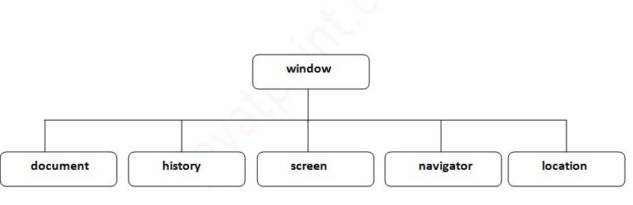 [More Details: Browser Object Model](https://www.javatpoint.com/browser-object-model)

19) What is DOM? What is the use of document object?

**DOM** stands for *Document Object Model*. A document object represents the HTML document. It can be used to access and change the content of HTML.

[More Details: Document Object Model](https://www.javatpoint.com/document-object-model)

20) What is the use of window object?

The window object is created automatically by the browser that represents a window of a browser. It is not an object of JavaScript. It is a browser object.

The window object is used to display the popup dialog box. Let's see with description.

|  |  |
| --- | --- |
| **Method** | **Description** |
| alert() | displays the alert box containing the message with ok button. |
| confirm() | displays the confirm dialog box containing the message with ok and cancel button. |
| prompt() | displays a dialog box to get input from the user. |
| open() | opens the new window. |
| close() | closes the current window. |
| setTimeout() | performs the action after specified time like calling function, evaluating expressions. |

[More details.](https://www.javatpoint.com/window-object)

21) What is the use of history object?

The history object of a browser can be used to switch to history pages such as back and forward from the current page or another page. There are three methods of history object.

1. history.back() - It loads the previous page.
2. history.forward() - It loads the next page.
3. history.go(number) - The number may be positive for forward, negative for backward. It loads the given page number.

[More details.](https://www.javatpoint.com/javascript-history-object)

22) How to write a comment in JavaScript?

There are two types of comments in JavaScript.

1. Single Line Comment: It is represented by // (double forward slash)
2. Multi-Line Comment: Slash represents it with asterisk symbol as /* write comment here */

[More details.](https://www.javatpoint.com/javascript-comment)

23) How to create a function in JavaScript?

To create a function in JavaScript, follow the following syntax.

1. function function_name(){
2. //function body
3. }

[More details.](https://www.javatpoint.com/javascript-function)

24) What are the different data types present in JavaScript?

There are two types of data types in JavaScript:

* Primitive data types
* Non- Primitive data types

**Primitive data types**

The primitive data types are as follows:

**String:** The string data type represents a sequence of characters. It is written within quotes and can be represented using a single or a double quote.

**Example:**

1. var str1 = "Hello JavaTpoint"; //using double quotes
2. var str2 = 'Hello Javatpoint'; //using single quotes

**Number:** The number data type is used to represent numeric values and can be written with or without decimals.

**Example:**

1. var x = 5; //without decimal
2. var y = 5.0; //with decimal

**Boolean:** The Boolean data type is used to represent a Boolean value, either false or true. This data type is generally used for conditional testing.

**Example:**

1. var x = 5;
2. var y =  6;
3. var z =  5;
4. (x == y) // returns false
5. (x == z) //returns true

**BigInt:** The BigInt data type is used to store numbers beyond the Number data type limitation. This data type can store large integers and is represented by adding "n" to an integer literal.

**Example:**

1. var bigInteger =  123456789012345678901234567890;
2. // This is an example of bigInteger.

**Undefined:** The Undefined data type is used when a variable is declared but not assigned. The value of this data type is undefined, and its type is also undefined.

**Example:**

1. var x; // value of x is undefined
2. var y = undefined; // You can also set the value of a variable as undefined.

**Null:** The Null data type is used to represent a non-existent, null, or a invalid value i.e. no value at all.

**Example:**

1. var  x = null;

**Symbol:** Symbol is a new data type introduced in the ES6 version of JavaScript. It is used to store an anonymous and unique value.

**Example:**

1. var symbol1 = Symbol('symbol');

**typeof:** The typeof operator is used to determine what type of data a variable or operand contains. It can be used with or without parentheses (typeof(x) or typeof x). This is mainly used in situations when you need to process the values of different types.

**Example:**

1. typeof 10;  // Returns: "number"
2. typeof 10.0;  // Returns: "number"
3. typeof 2.5e-4;  // Returns: "number"
4. typeof Infinity;  // Returns: "number"
5. typeof NaN;  // Returns: "number". Despite being "Not-A-Number"
6. // Strings
7. typeof '';  // Returns: "string"
8. typeof 'Welcome to JavaTpoint';  // Returns: "string"
9. typeof '12';  // Returns: "string". Number within quotes is typeof string
10. // Booleans
11. typeof true;  // Returns: "boolean"
12. typeof false;  // Returns: "boolean"
13. // Undefined
14. typeof undefined;  // Returns: "undefined"
15. typeof undeclaredVariable; // Returns: "undefined"
16. // Null
17. typeof Null;  // Returns: "object"
18. // Objects
19. typeof {name: "John", age: 18};  // Returns: "object"
20. // Arrays
21. typeof [1, 2, 3];  // Returns: "object"
22. // Functions
23. typeof function(){};  // Returns: "function"

**Non-Primitive data types**

In the above examples, we can see that the primitive data types can store only a single value. To store multiple and complex values, we have to use non-primitive data types.

The non-primitive data types are as follows:

**Object:** The Object is a non-primitive data type. It is used to store collections of data. An object contains properties, defined as a key-value pair. A property key (name) is always a string, but the value can be any data type, such as strings, numbers, Booleans, or complex data types like arrays, functions, and other objects.

**Example:**

1. // Collection of data in key-value pairs
2. var obj1 = {
3. x:  123,
4. y:  "Welcome to JavaTpoint",
5. z: function(){
6. return this.x;
7. }
8. }

**Array:** The Array data type is used to represent a group of similar values. Every value in an array has a numeric position, called its index, and it may contain data of any data type-numbers, strings, Booleans, functions, objects, and even other arrays. The array index starts from 0 so that the first array element is arr[0], not arr[1].

**Example:**

1. var colors = ["Red", "Yellow", "Green", "Orange"];
2. var cities = ["Noida", "Delhi", "Ghaziabad"];
3. alert(colors[2]);   // Output: Green
4. alert(cities[1]);   // Output: Delhi

[More details.](https://www.javatpoint.com/javascript-data-types)

25) What is the difference between == and ===?

The == operator checks equality only whereas === checks equality, and data type, i.e., a value must be of the same type.

26) How to write HTML code dynamically using JavaScript?

The innerHTML property is used to write the HTML code using JavaScript dynamically. Let's see a simple example:

1. document.getElementById('mylocation').innerHTML="<h2>This is heading using JavaScript</h2>";

[More details.](https://www.javatpoint.com/javascript-innerHTML)

27) How to write normal text code using JavaScript dynamically?

The innerText property is used to write the simple text using JavaScript dynamically. Let's see a simple example:

1. document.getElementById('mylocation').innerText="This is text using JavaScript";

[More details.](https://www.javatpoint.com/javascript-innerText)

28) How to create objects in JavaScript?

There are 3 ways to create an object in JavaScript.

1. By object literal
2. By creating an instance of Object
3. By Object Constructor

Let's see a simple code to create an object using object literal.

1. emp={id:102,name:"Rahul Kumar",salary:50000}

[More details.](https://www.javatpoint.com/javascript-objects)

29) How to create an array in JavaScript?

There are 3 ways to create an array in JavaScript.

1. By array literal
2. By creating an instance of Array
3. By using an Array constructor

Let's see a simple code to create an array using object literal.

1. var emp=["Shyam","Vimal","Ratan"];

[More details.](https://www.javatpoint.com/javascript-array)

30) What does the isNaN() function?

The isNan() function returns true if the variable value is not a number. For example:

1. function number(num) {
2. if (isNaN(num)) {
3. return "Not a Number";
4. }
5. return "Number";
6. }
7. console.log(number('1000F'));
8. // expected output: "Not a Number"
10. console.log(number('1000'));
11. // expected output: "Number"

31) What is the output of 10+20+"30" in JavaScript?

3030 because 10+20 will be 30. If there is numeric value before and after +, it treats as binary + (arithmetic operator).

1. function display()
2. {
3. document.writeln(10+20+"30");
4. }
5. display();

32) What is the output of "10"+20+30 in JavaScript?

102030 because after a string all the + will be treated as string concatenation operator (not binary +).

1. function display()
2. {
3. document.writeln("10"+20+30);
4. }
5. display();

33) Difference between Client side JavaScript and Server side JavaScript?

**Client-side JavaScript** comprises the basic language and predefined objects which are relevant to running JavaScript in a browser. The client-side JavaScript is embedded directly by in the HTML pages. The browser interprets this script at runtime.

**Server-side JavaScript** also resembles client-side JavaScript. It has a relevant JavaScript which is to run in a server. The server-side JavaScript are deployed only after compilation.

34) In which location cookies are stored on the hard disk?

The storage of cookies on the hard disk depends on the OS and the browser.

The Netscape Navigator on Windows uses a cookies.txt file that contains all the cookies. The path is c:\Program Files\Netscape\Users\username\cookies.txt

The Internet Explorer stores the cookies on a file username@website.txt. The path is: c:\Windows\Cookies\username@Website.txt.

35) What's the difference between event.preventDefault() and event.stopPropagation() methods in JavaScript?

In JavaScript, the event.preventDefault() method is used to prevent the default behavior of an element.

**For example:** If you use it in a form element, it prevents it from submitting. If used in an anchor element, it prevents it from navigating. If used in a contextmenu, it prevents it from showing or displaying.

On the other hand, the event.stopPropagation() method is used to stop the propagation of an event or stop the event from occurring in the bubbling or capturing phase.

36) What is the real name of JavaScript?

The original name was **Mocha**, a name chosen by Marc Andreessen, founder of Netscape. In September of 1995, the name was changed to LiveScript. In December 1995, after receiving a trademark license from Sun, the name JavaScript was adopted.

37) How can you check if the event.preventDefault() method was used in an element?

When we use the event.defaultPrevent() method in the event object returns a Boolean indicating that the event.preventDefault() was called in a particular element.

38) What is the difference between undefined value and null value?

**Undefined value:** A value that is not defined and has no keyword is known as undefined value. For example:

1. int number;//Here, a number has an undefined value.

**Null value:** A value that is explicitly specified by the keyword "null" is known as a null value. For example:

1. String str=null;//Here, str has a null value.

39) How to set the cursor to wait in JavaScript?

The cursor can be set to wait in JavaScript by using the property "cursor". The following example illustrates the usage:

1. **<script>**
2. window.document.body.style.cursor = "wait";
3. **</script>**

40) What is this [[[]]]?

This is a three-dimensional array.

1. var myArray = [[[]]];

41) Are Java and JavaScript same?

No, Java and JavaScript are the two different languages. Java is a robust, secured and object-oriented programming language whereas JavaScript is a client-side scripting language with some limitations.

42) What is negative infinity?

Negative Infinity is a number in JavaScript which can be derived by dividing the negative number by zero. For example:

1. var num=-5;
2. function display()
3. {
4. document.writeln(num/0);
5. }
6. display();
7. //expected output: -Infinity

43) What is the difference between View state and Session state?

"View state" is specific to a page in a session whereas "Session state" is specific to a user or browser that can be accessed across all pages in the web application.

44) What are the pop-up boxes available in JavaScript?

* Alert Box
* Confirm Box
* Prompt Box

Example of alert() in JavaScript

1. **<script** type="text/javascript"**>**
2. function msg(){
3. alert("Hello Alert Box");
4. }
5. **</script>**
6. **<input** type="button" value="click" onclick="msg()"**/>**

Example of confirm() in JavaScript

1. **<script** type="text/javascript"**>**
2. function msg(){
3. var v= confirm("Are u sure?");
4. if(v==true){
5. alert("ok");
6. }
7. else{
8. alert("cancel");
9. }
11. }
12. **</script>**
14. **<input** type="button" value="delete record" onclick="msg()"**/>**

Example of prompt() in JavaScript

1. **<script** type="text/javascript"**>**
2. function msg(){
3. var v= prompt("Who are you?");
4. alert("I am "+v);
6. }
7. **</script>**
9. **<input** type="button" value="click" onclick="msg()"**/>**

45) How can we detect OS of the client machine using JavaScript?

The **navigator.appVersion** string can be used to detect the operating system on the client machine.

46) How to submit a form using JavaScript by clicking a link?

Let's see the JavaScript code to submit the form by clicking the link.

1. **<form** name="myform" action="index.php"**>**
2. Search: **<input** type='text' name='query' **/>**
3. **<a** href="javascript: submitform()"**>**Search**</a>**
4. **</form>**
5. **<script** type="text/javascript"**>**
6. function submitform()
7. {
8. document.myform.submit();
9. }
10. **</script>**

47) Is JavaScript faster than ASP script?

Yes, because it doesn't require web server's support for execution.

48) How to change the background color of HTML document using JavaScript?

1. **<script** type="text/javascript"**>**
2. document.body.bgColor="pink";
3. **</script>**

49) How to handle exceptions in JavaScript?

By the help of try/catch block, we can handle exceptions in JavaScript. JavaScript supports try, catch, finally and throw keywords for exception handling.

50) How to validate a form in JavaScript?

1. **<script>**
2. function validateform(){
3. var name=document.myform.name.value;
4. var password=document.myform.password.value;
6. if (name==null || name==""){
7. alert("Name can't be blank");
8. return false;
9. }else if(password.length**<6**){
10. alert("Password must be at least 6 characters long.");
11. return false;
12. }
13. }
14. **</script>**
15. **<body>**
16. **<form** name="myform" method="post" action="abc.jsp" onsubmit="return validateform()" **>**
17. Name: **<input** type="text" name="name"**><br/>**
18. Password: **<input** type="password" name="password"**><br/>**
19. **<input** type="submit" value="register"**>**
20. **</form>**

[**Test it Now**](https://www.javatpoint.com/oprweb/test.jsp?filename=jsvalidation1)

Visit here: [JavaScript form validation](https://www.javatpoint.com/javascript-form-validation).

51) How to validate email in JavaScript?

1. **<script>**
2. function validateemail()
3. {
4. var x=document.myform.email.value;
5. var atposition=x.indexOf("@");
6. var dotposition=x.lastIndexOf(".");
7. if (atposition**<1** || dotposition**<atposition**+2 || dotposition+2**>**=x.length){
8. alert("Please enter a valid e-mail address \n atpostion:"+atposition+"\n dotposition:"+dotposition);
9. return false;
10. }
11. }
12. **</script>**
13. **<body>**
14. **<form** name="myform"  method="post" action="#" onsubmit="return validateemail();"**>**
15. Email: **<input** type="text" name="email"**><br/>**
17. **<input** type="submit" value="register"**>**
18. **</form>**

[**Test it Now**](https://www.javatpoint.com/oprweb/test.jsp?filename=jsvalidation3)

Visit here: [JavaScript Email validation](https://www.javatpoint.com/javascript-form-validation#email).

52) What is this keyword in JavaScript?

The this keyword is a reference variable that refers to the current object. For example:

1. var address=
2. {
3. company:"Javatpoint",
4. city:"Noida",
5. state:"UP",
6. fullAddress:function()
7. {
8. return this.company+" "+this.city+" "+this.state;
9. }
10. };
11. var fetch=address.fullAddress();
12. document.writeln(fetch);

53) What is the requirement of debugging in JavaScript?

JavaScript didn't show any error message in a browser. However, these mistakes can affect the output. The best practice to find out the error is to debug the code. The code can be debugged easily by using web browsers like Google Chrome, Mozilla Firebox.

To perform debugging, we can use any of the following approaches:

* Using console.log() method
* Using debugger keyword

54) What is the use of debugger keyword in JavaScript?

JavaScript debugger keyword sets the breakpoint through the code itself. The debugger stops the execution of the program at the position it is applied. Now, we can start the flow of execution manually. If an exception occurs, the execution will stop again on that particular line.. For example:

1. function display()
2. {
3. x = 10;
4. y = 15;
5. z = x + y;
6. debugger;
7. document.write(z);
8. document.write(a);
9. }
10. display();

55) What is the role of a strict mode in JavaScript?

The JavaScript strict mode is used to generates silent errors. It provides "use strict"; expression to enable the strict mode. This expression can only be placed as the first statement in a script or a function. For example:

1. "use strict";
2. x=10;
3. console.log(x);

57) What is the use of Math object in JavaScript?

The JavaScript math object provides several constants and methods to perform a mathematical operation. Unlike date object, it doesn't have constructors. For example:

1. function display()
2. {
3. document.writeln(Math.random());
4. }
5. display();

58) What is the use of a Date object in JavaScript?

The JavaScript date object can be used to get a year, month and day. You can display a timer on the webpage by the help of JavaScript date object.

1. function display()
2. {
3. var date=new Date();
4. var day=date.getDate();
5. var month=date.getMonth()+1;
6. var year=date.getFullYear();
7. document.write("**<br>**Date is: "+day+"/"+month+"/"+year);
8. }
9. display();

59) What is the use of a Number object in JavaScript?

The JavaScript number object enables you to represent a numeric value. It may be integer or floating-point. JavaScript number object follows the IEEE standard to represent the floating-point numbers.

1. function display()
2. {
3. var x=102;//integer value
4. var y=102.7;//floating point value
5. var z=13e4;//exponent value, output: 130000
6. var n=new Number(16);//integer value by number object
7. document.write(x+" "+y+" "+z+" "+n);
8. }
9. display();

60) What is the use of a Boolean object in JavaScript?

The JavaScript Boolean is an object that represents value in two states: true or false. You can create the JavaScript Boolean object by Boolean() constructor.

1. function display()
2. {
3. document.writeln(10**<20**);//true
4. document.writeln(10**<5**);//false
5. }
6. display();

61) What is the use of a TypedArray object in JavaScript?

The JavaScript TypedArray object illustrates an array like a view of an underlying binary data buffer. There is any number of different global properties, whose values are TypedArray constructors for specific element types.

1. function display()
2. {
3. var arr1= [1,2,3,4,5,6,7,8,9,10];
4. arr1.copyWithin(2) ;
5. document.write(arr1);
6. }
7. display();

62) What is the use of a Set object in JavaScript?

The JavaScript Set object is used to store the elements with unique values. The values can be of any type i.e. whether primitive values or object references. For example:

1. function display()
2. {
3. var set = new Set();
4. set.add("jQuery");
5. set.add("AngularJS");
6. set.add("Bootstrap");
7. for (let elements of set) {
8. document.writeln(elements+"**<br>**");
9. }
10. }
11. display();

63) What is the use of a WeakSet object in JavaScript?

The JavaScript WeakSet object is the type of collection that allows us to store weakly held objects. Unlike Set, the WeakSet are the collections of objects only. It doesn't contain the arbitrary values. For example:

1. function display()
2. {
3. var ws = new WeakSet();
4. var obj1={};
5. var obj2={};
6. ws.add(obj1);
7. ws.add(obj2);
8. //Let's check whether the WeakSet object contains the added object
9. document.writeln(ws.has(obj1)+"**<br>**");
10. document.writeln(ws.has(obj2));
11. }
12. display()

64) What is the use of a Map object in JavaScript?

The JavaScript Map object is used to map keys to values. It stores each element as key-value pair. It operates the elements such as search, update and delete on the basis of specified key. For example:

1. function display()
2. {
3. var map=new Map();
4. map.set(1,"jQuery");
5. map.set(2,"AngularJS");
6. map.set(3,"Bootstrap");
7. document.writeln(map.get(1)+"**<br>**");
8. document.writeln(map.get(2)+"**<br>**");
9. document.writeln(map.get(3));
10. }
11. display();

65) What is the use of a WeakMap object in JavaScript?

The JavaScript WeakMap object is a type of collection which is almost similar to Map. It stores each element as a key-value pair where keys are weakly referenced. Here, the keys are objects and the values are arbitrary values. For example:

1. function display()
2. {
3. var wm = new WeakMap();
4. var obj1 = {};
5. var obj2 = {};
6. var obj3= {};
7. wm.set(obj1, "jQuery");
8. wm.set(obj2, "AngularJS");
9. wm.set(obj3,"Bootstrap");
10. document.writeln(wm.has(obj2));
11. }
12. display();

66) What are the falsy values in JavaScript, and how can we check if a value is falsy?

Those values which become false while converting to Boolean are called falsy values.

1. const falsyValues = ['', 0, null, undefined, NaN, false];

We can check if a value is falsy by using the Boolean function or the Double NOT operator (!!).

67) What do you understand by hoisting in JavaScript?

Hoisting is the default behavior of JavaScript where all the variable and function declarations are moved on top. In simple words, we can say that Hoisting is a process in which, irrespective of where the variables and functions are declared, they are moved on top of the scope. The scope can be both local and global.

**Example 1:**

1. hoistedVariable = 12;
2. console.log(hoistedVariable); // outputs 12 even when the variable is declared after it is initialized
3. var hoistedVariable;

**Example2:**

1. hoistedFunction();  // Outputs " Welcome to JavaTpoint " even when the function is declared after calling
2. function hoistedFunction(){
3. console.log(" Welcome to JavaTpoint ");
4. }
5. Example3:
6. // Hoisting in a local scope
7. function doSomething(){
8. x = 11;
9. console.log(x);
10. var x;
11. }
12. doSomething(); // Outputs 11 since the local variable "x" is hoisted inside the local scope

ES6 Interview Questions

A list of frequently asked **ES6 Interview Questions** and Answers are given below.

1) What is ES6 or ECMAScript 2015?

ES6 was released in June 2015, which is stated as the sixth edition of the language. Initially, it was named **ES6** and later renamed to ECMAScript 2015. This edition includes several new features that are modules, iterators, class, arrow functions, for...of loop, promises, and many more. Brendan Eich developed it.

2) Define ECMAScript.

It is the specification that is defined in the ECMA-262 standard to create a general-purpose scripting language.

3) What are the new features introduced in ES6?

The new features that are introduced in ES6 are listed as follows:

* Let and const keywords.
* Default Parameters.
* Arrow functions.
* Template Literals.
* Object Literals.
* Rest and spread operators.
* Destructuring assignment.
* Modules, Classes, Generators, and iterators.
* Promises, and many more.

4) Define let and const keywords.

**let:** The variables declared using **let** keyword will be mutable, i.e., the values of the variable can be changed. It is similar to **var** keyword except that it provides block scoping.

**const:** The variables declared using **the const** keyword are immutable and block-scoped. The value of the variables cannot be changed or re-assigned if they are declared by using **the const** keyword.

5) What is the arrow function, and how to create it?

Arrow functions are introduced in [ES6](https://www.javatpoint.com/es6). Arrow functions are the shorthand notation to write [ES6 functions](https://www.javatpoint.com/es6-functions). The definition of the arrow function consists of parameters, followed by an arrow (=>) and the body of the function.

An Arrow function is also called as **'fat arrow'** function. We cannot use them as constructors.

**Syntax**

1. **const** functionName = (arg1, arg2, ...) => {
2. //body of the function
3. }

6) Give an example of an Arrow function in ES6? List down its advantages.

Arrow function provides us a more accurate way of writing the [functions in JavaScript](https://www.javatpoint.com/javascript-function). They allow us to write smaller function syntax.

The context within the arrow functions is lexically or statically scoped. Arrow functions do not include any prototype property, and cannot be used with the new keyword.

You can learn more about arrow functions by clicking on this link [ES6 Arrow Function](https://www.javatpoint.com/es6-arrow-function).

**Example**

1. var myfun = () => {
2. console.log("It is an Arrow Function");
3. };
4. myfun();

**Output**

It is an Arrow Function

**Advantages of Arrow Function**

The advantages of the arrow function are listed below:

* It reduces code size.
* The return statement is optional for a single line function.
* Lexically bind the context.
* Functional braces are optional for a single-line statement.

7) Discuss spread operator in ES6 with an example.

The spread operator is represented by three dots (...) to obtain the list of parameters. It allows the expansion of an iterable such as array or string in places where more than zero arguments are expected.

The spread operator syntax is similar to the rest operator, but functionality is entirely opposite to it. It is also used to combine or to perform the concatenation between arrays. Let's understand it by an example.

**Example**

1. let num1 = [40,50,60];
3. let num2 = [10,20,30,...num1,70,80,90,100];
5. console.log(num2);

**Output**

[

10, 20, 30, 40, 50,

60, 70, 80, 90, 100

]

8) Discuss the Rest parameter in ES6 with an example.

It is introduced in ES6 that improves the ability to handle the parameters. With rest parameters, it is possible to represent indefinite parameters as an array. By using the rest parameter, we can call a function with any number of arguments.

**Example**

1. function show(...args) {
2. let sum = 0;
3. **for** (let i of args) {
4. sum += i;
5. }
6. console.log("Sum = "+sum);
7. }
9. show(10, 20, 30);

**Output**

Sum = 60

9) What are the template literals in ES6?

Template literals are a new feature introduced in ES6. It provides an easy way of creating multiline strings and perform string interpolation.

Template literals allow embedded expressions and also called as string literals.

Prior to ES6, template literals were referred to as **template strings**. Template literals are enclosed by the **backtick (` `) character**. Placeholders in template literals are represented by the dollar sign and the curly braces **(${expression})**. If we require to use an expression within the backticks, then we can place that expression in the **(${expression})**.

To learn more about template literals in ES6, follow this link [ES6 Template Literals.](https://www.javatpoint.com/es6-template-literals)

**Example**

1. let str1 = "Hello";
3. let str2 = "World";
5. let str = `${str1} ${str2}`;
6. console.log(str);

**Output**

Hello World

10) Discuss Destructuring Assignment in ES6.

Destructuring is introduced in ECMAScript 2015 or ES6 to extract data from objects and arrays into separate variables. It allows us to extract smaller fragments from objects and arrays.

To learn more about array destructuring in ES6, follow this link [ES6 Array Destructuring](https://www.javatpoint.com/es6-array-destructuring).

To learn more about object destructuring in ES6, follow this link [ES6 Object Destructuring](https://www.javatpoint.com/es6-object-destructuring).

**Example**

1. let fullname =['Alan','Rickman'];
2. let [fname,lname] = fullname;
3. console.log (fname,lname);

**Output**

Alan Rickman

11) How to create a class in ES6?

This keyword is used for creating the class. We can include the classes in our code either by using class expression or by class declaration. A class definition can only include **functions** and **constructors**. These components are together called as data members of the class.

Constructors in classes allocate the memory to the objects of the class. Functions in a class are responsible for performing the actions to the objects.

To learn more about classes in ES6, follow this link [ES6 Classes](https://www.javatpoint.com/es6-classes).

Let us see the syntax for creating classes.

**Syntax: In ES5**

1. var var_name = **new** class_name {
2. }

**Syntax: In ES6 (Using class keyword)**

1. **class** class_name{
2. }

12) What do you understand by Generator function?

A generator provides us a new way to work with iterators and functions. The generator is a special kind of function that may be paused in the middle either one or many times and can be resumed later. The declaration **function* (*function* keyword followed by an asterisk)** is used to define a generator function.

When the generator gets called, it does not run its code. Instead, it returns a special object, which is called a **Generator object** to manage the execution. Let us see an example of generators in ES6.

To learn more about Generators in ES6, follow this link [ES6 Generators](https://www.javatpoint.com/es6-generators).

**Example**

1. function* gen()
2. {
3. yield 100;
4. yield;
5. yield 200;
6. }
7. // Calling the Generator Function
8. var mygen = gen();
9. console.log(mygen.next().value);
10. console.log(mygen.next().value);
11. console.log(mygen.next().value);

**Output**

100

undefined

200

13) What are the default parameters?

By using the default parameters, we can initialize named parameters with default values if there is no value or **undefined** is passed.

**Example**

1. var show = (a, b=200) => {
2. console.log(a + " " + b);
3. }
4. show(100);

**Output**

100 200

14) What do you mean by IIFE (Immediately invoked function expressions)?

IIFE is a function in JavaScript that runs as soon as it is defined. It is also called as the **Self-Executing Anonymous Function**. It includes two major parts that are as follows:

* The first part is an anonymous function that has a lexical scope (static scope), which is enclosed within the **Grouping operator ()**.
* The second part creates the IIFE by which the [JavaScript](https://www.javatpoint.com/javascript-tutorial) engine will interpret the function directly.

You can learn more about arrow functions by clicking on this link [ES6 IIFE](https://www.javatpoint.com/es6-immediately-invoked-function-expression).

**Example**

1. (function()
2. {
3. console.log("Hello World");
4. })();

**Output**

Hello World

15) Discuss the for...in loop.

It is similar to for loop that iterates through the properties of an object. It is useful when we require to visit the properties or keys of the object.

**Example**

1. function Mobile(model_no){
2. **this**.Model = model_no;
3. **this**.Color = 'White';
4. **this**.RAM = '4GB';
5. }
6. var Samsung = **new** Mobile("Galaxy");
7. **for**(var props in Samsung)
8. {
9. console.log(props+ " : " +Samsung[props]);
10. }

**Output**

Model: Galaxy

Color: White

RAM: 4GB

16) Discuss the for...of loop.

This loop is used for iterating the iterables (arrays, string, etc.).

**Example**

1. var fruits = ['Apple', 'Banana', 'Mango', 'Orange'];
2. **for**(let value of fruits)
3. {
4. console.log(value);
5. }

**Output**

Apple

Banana

Mango

Orange

17) Define set.

A set is a data structure that allows us to create a collection of unique values. It is a collection of values that are similar to arrays, but it does not include any duplicates. It supports both object references and primitive values.

To learn more about Sets in ES6, follow this link [ES6 Sets](https://www.javatpoint.com/es6-set).

**Example**

1. let colors = **new** Set(['Green', 'Red', 'Orange', 'Yellow', 'Red']);
2. console.log(colors);

**Output**

Set { 'Green', 'Red', 'Orange', 'Yellow' }

18) Define Map.

Prior to ES6, when we require the mapping of keys and values, we often use an object. **Map object** is a new collection type, which is introduced in ES6. It holds the key-value pairs in which any type of values can be used as either keys or values.

A map object always remembers the actual insertion order of the keys. Maps are ordered, so they traverse the elements in their insertion order.

To learn more about Map in ES6, follow this link [ES6 Maps](https://www.javatpoint.com/es6-map).

19) What do you understand by Weakset?

Using weakset, it is possible to store weakly held objects in a collection. As similar to set, weakset cannot store duplicate values. Weakset cannot be iterated.

Weakset only includes **add(value), delete(value)** and **has(value)** methods of the set object.

20) What do you understand by Weakmap?

Weak maps are almost similar to maps, but the keys in weak maps must be objects. It stores each element as a key-value pair where keys are weakly referenced. Here, the keys are objects, and the values are arbitrary.

A weak map object iterates the element in their insertion order. It only includes **delete(key), get(key), has(key)** and **set(key, value)** method.

21) Explain Promises in ES6.

ES6 promises are the easiest way to work with asynchronous programming in JavaScript. Asynchronous programming includes running of processes individually from the main thread, and it notifies the main thread when it gets complete.

Prior to ES6, there is the use of **Callbacks** for performing asynchronous programming. Promises are used to overcome the problem of **Callback hell**.

To learn more about promises, follow this link: [ES6 Promises](https://www.javatpoint.com/es6-promises).

22) What are the states of promises in ES6?

Promises have mainly three states that are as follows:

* **Pending:** It is the initial state of every promise. It represents that the result has not been computed yet.
* **Fulfilled:** It represents the completion of an operation.
* **Rejected:** It represents the failure that occurs during computation.

Once the promise is fulfilled or rejected, then it will be immutable. The **Promise()** constructor takes two arguments that are **rejected** function and a **resolve** function. Based on the asynchronous operation, it returns either the first argument or the second argument.

23) What do you understand by Callback and Callback hell in JavaScript?

**Callback:** It is used to handle the execution of function after the completion of the execution of another function. A callback would be helpful in working with events. In the callback, a function can be passed as an argument to another function. It is a great way when we are dealing with basic cases such as minimal asynchronous operations.

**Callback hell:** When we develop a web application that includes a lot of code, then working with callback is messy. This excessive Callback nesting is often referred to as **Callback hell**.

24) List the comparisons between ES5 and ES6.

ES5 and ES6 are similar in their nature, but there are some differences between them. The comparison between ES5 and ES6 are tabulated as follows:

|  |  |  |
| --- | --- | --- |
| **Based on** | **ES5** | **ES6** |
| **Definition** | ES5 is the fifth edition of the ECMAScript (a trademarked scripting language specification defined by ECMA International) | ES6 is the sixth edition of the ECMAScript (a trademarked scripting language specification defined by ECMA International). |
| **Release** | It was introduced in 2009. | It was introduced in 2015. |
| **Data-types** | ES5 supports primitive data types that are **string, boolean, number, null,** and **undefined**. | In ES6, there are some additions to JavaScript data types. It introduced a new primitive data type **'symbol'** for supporting unique values. |
| **Defining Variables** | In ES5, we could only define the variables by using the **var** keyword. | In ES6, there are two new ways to define variables that are **let** and **const**. |
| **Performance** | As ES5 is prior to ES6, there is a non-presence of some features, so it has a lower performance than ES6. | Because of new features and the shorthand storage implementation ES6 has a higher performance than ES5. |
| **Support** | A wide range of communities supports it. | It also has a lot of community support, but it is lesser than ES5. |
| **Object Manipulation** | ES5 is time-consuming than ES6. | Due to destructuring and speed operators, object manipulation can be processed more smoothly in ES6. |
| **Arrow Functions** | In ES5, both **function** and **return** keywords are used to define a function. | An arrow function is a new feature introduced in ES6 by which we don't require the **function** keyword to define the function. |
| **Loops** | In ES5, there is a use of **for** loop to iterate over elements. | ES6 introduced the concept of **for...of** loop to perform an iteration over the values of the iterable objects. |

To learn more about the difference between ES5 and ES6, follow this link: [ES5 v/s ES6](https://www.javatpoint.com/es5-vs-es6)

25) Define Modules in JavaScript.

Modules are the piece of JavaScript code written in a file. By using Modules, it is easy to maintain the code, debug the code, and reuse the code. Each module is a piece of code that gets executed once it is loaded.

26) What do you understand by the term Hoisting in JavaScript?

It is a JavaScript's default behavior, which is used to move all the declarations at the top of the scope before the execution of code. It can be applied to functions as well as on variables. It allows the JavaScript to use the component before its declaration. It does not apply to scripts that run in strict mode.

27) List the new Array methods introduced in ES6?

There are many array methods available in ES6, which are listed below:

* Array.of()
* Array.from()
* Array.prototype.copyWithin()
* Array.prototype.find()
* Array.prototype.findIndex()
* Array.prototype.entries()
* Array.prototype.keys()
* Array.prototype.values()
* Array.prototype.fill()

To learn more about the above array methods, follow this link: [ES6 Array methods](https://www.javatpoint.com/es6-array-methods).

28) What are the new String methods introduced in ES6?

There are four string methods introduced in ES6 that are listed as follows:

* string.startsWith()
* string.endsWith()
* string.includes()
* string.repeat()

To learn more about the strings, follow this link: [ES6 Strings.](https://www.javatpoint.com/es6-strings)

29) Define Babel.

Babel is one of the popular transpilers of JavaScript. It is mainly used for converting the ES6 plus code into the backward-compatible version of JavaScript that can be run by previous JavaScript engines.

30) Define Webpack.

It is an open-source JavaScript module bundler that takes modules with dependencies. It allows us to run an environment that hosts Babel.

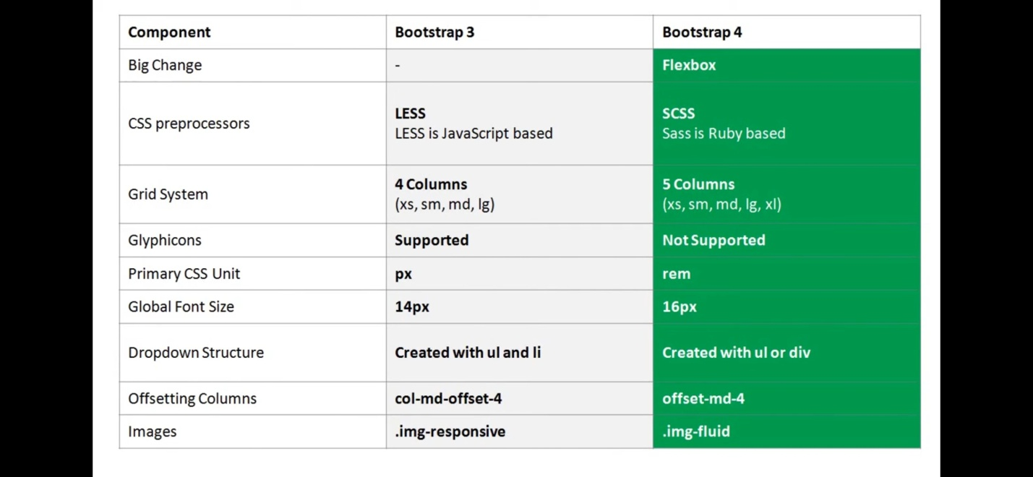

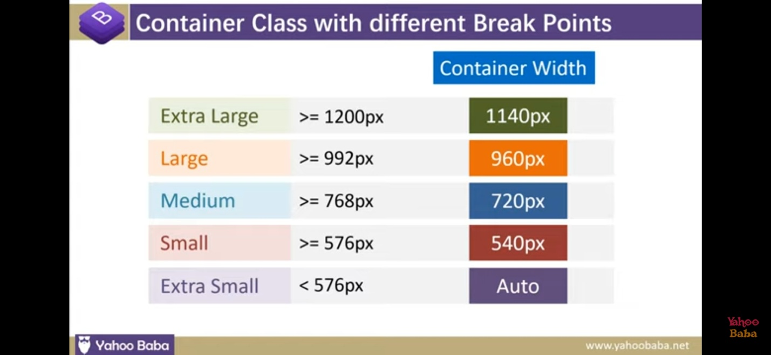

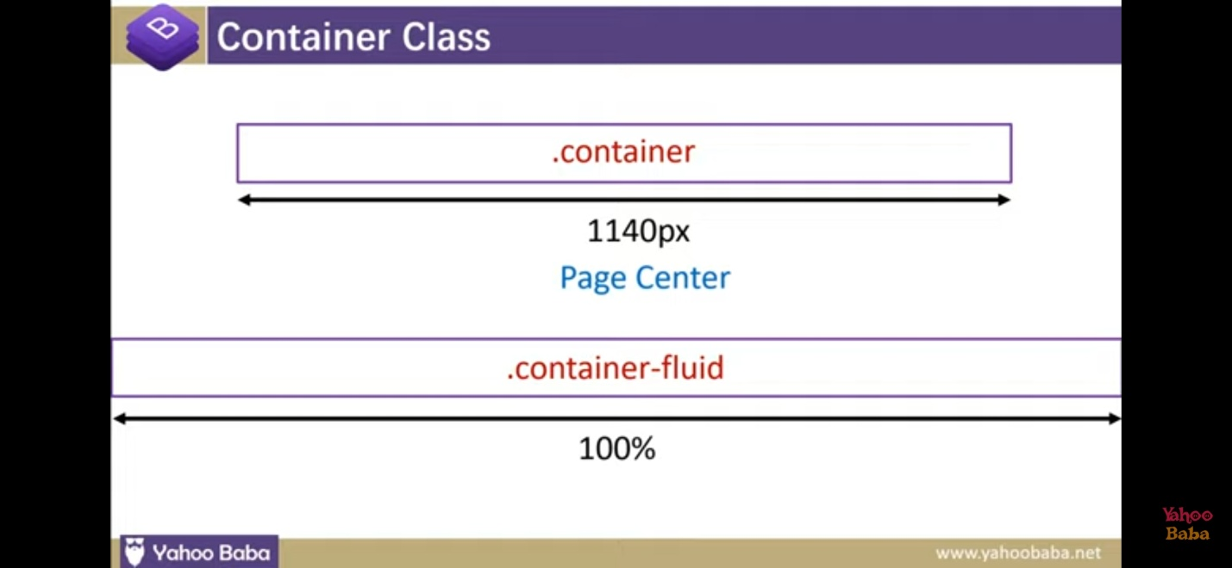

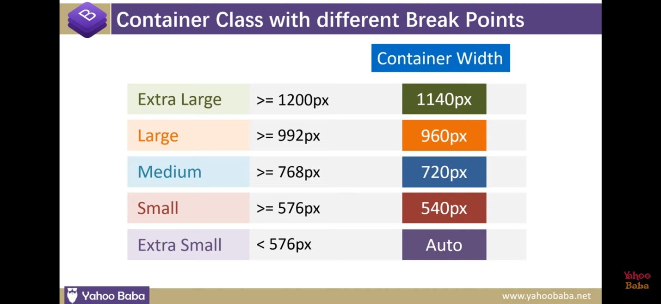

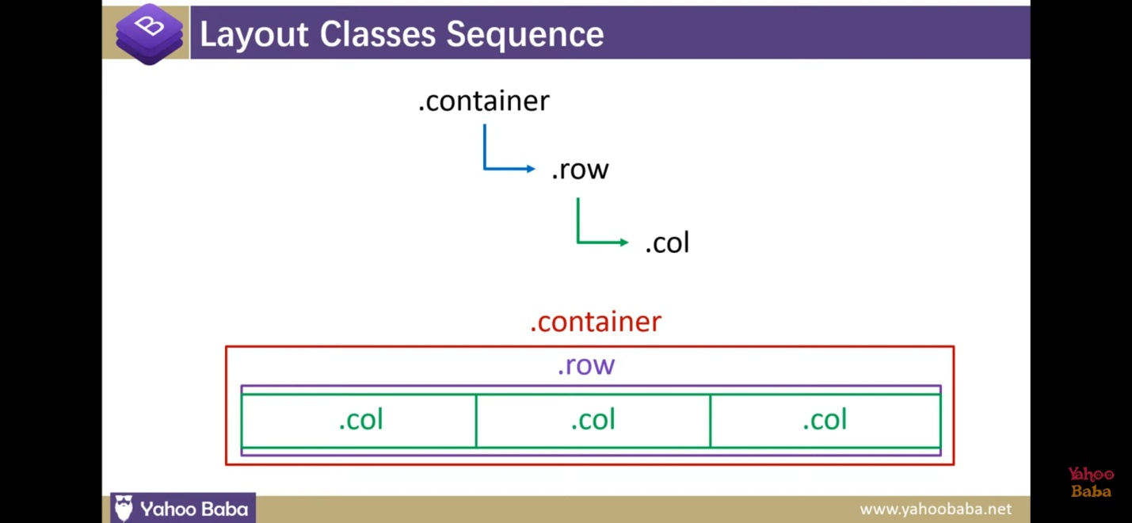

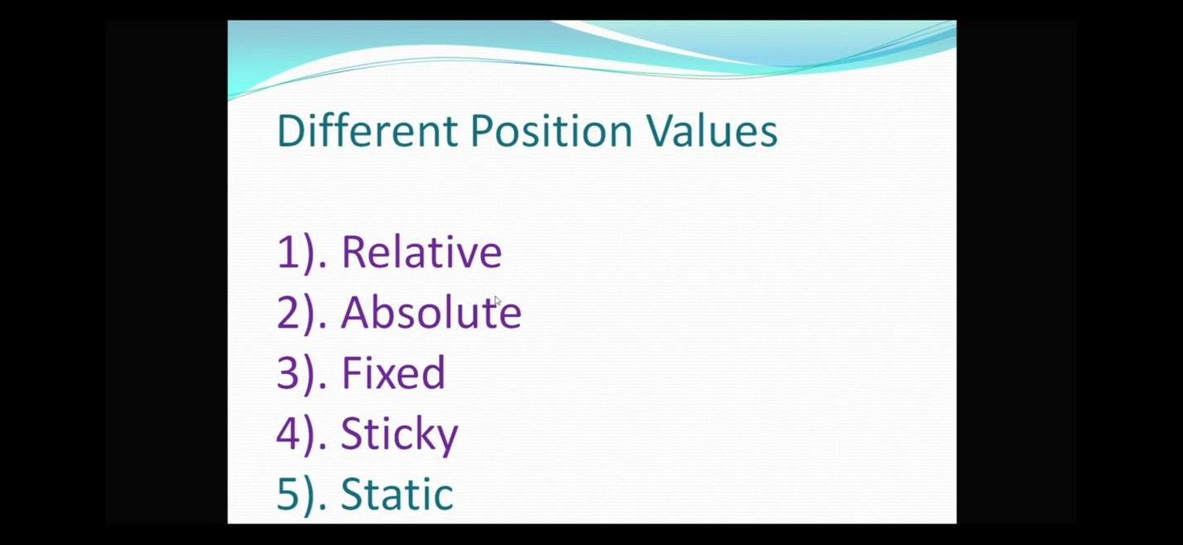

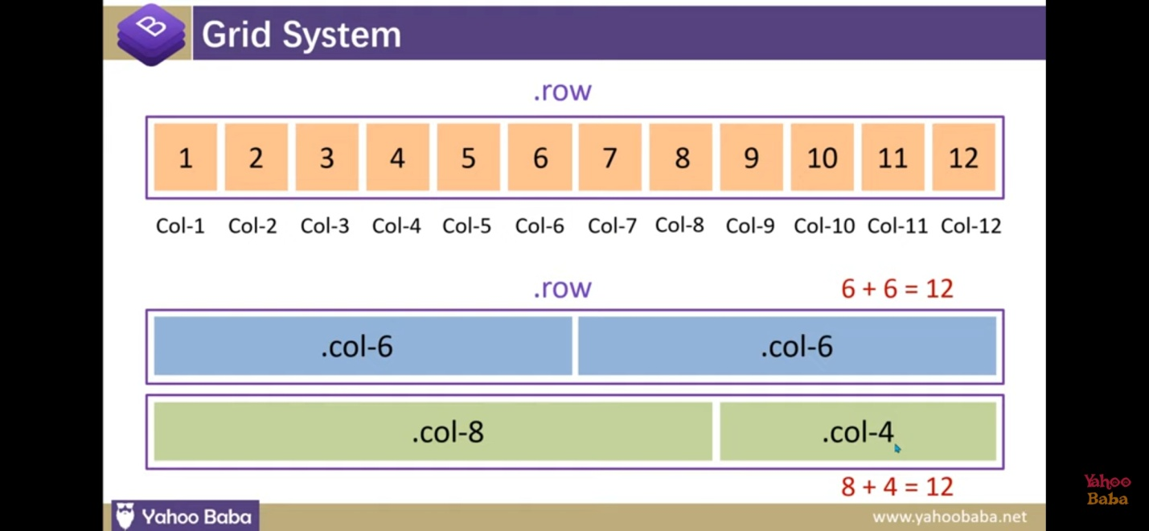

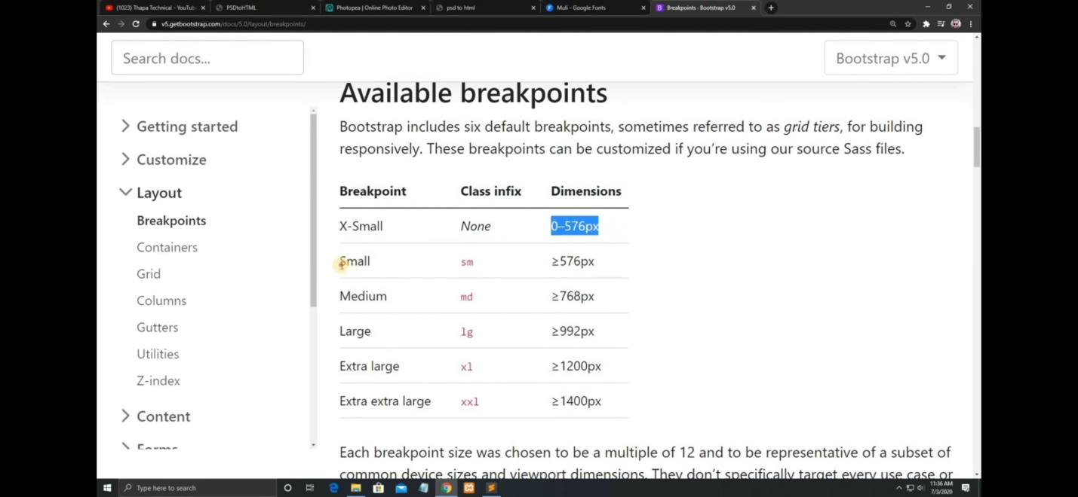

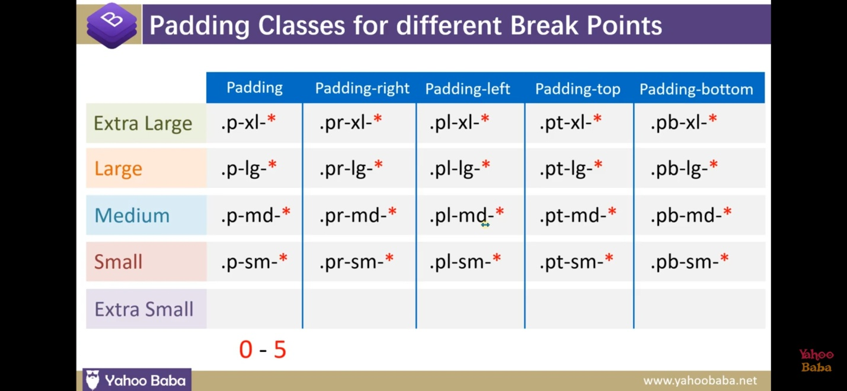

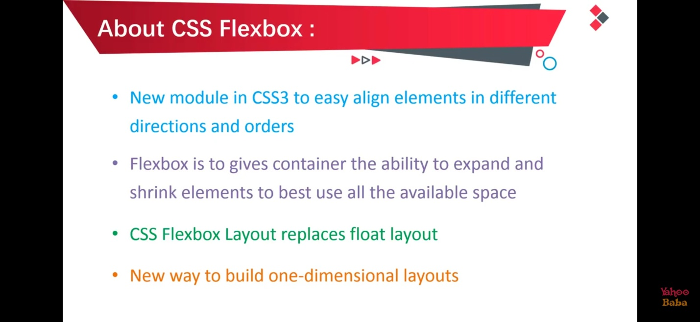

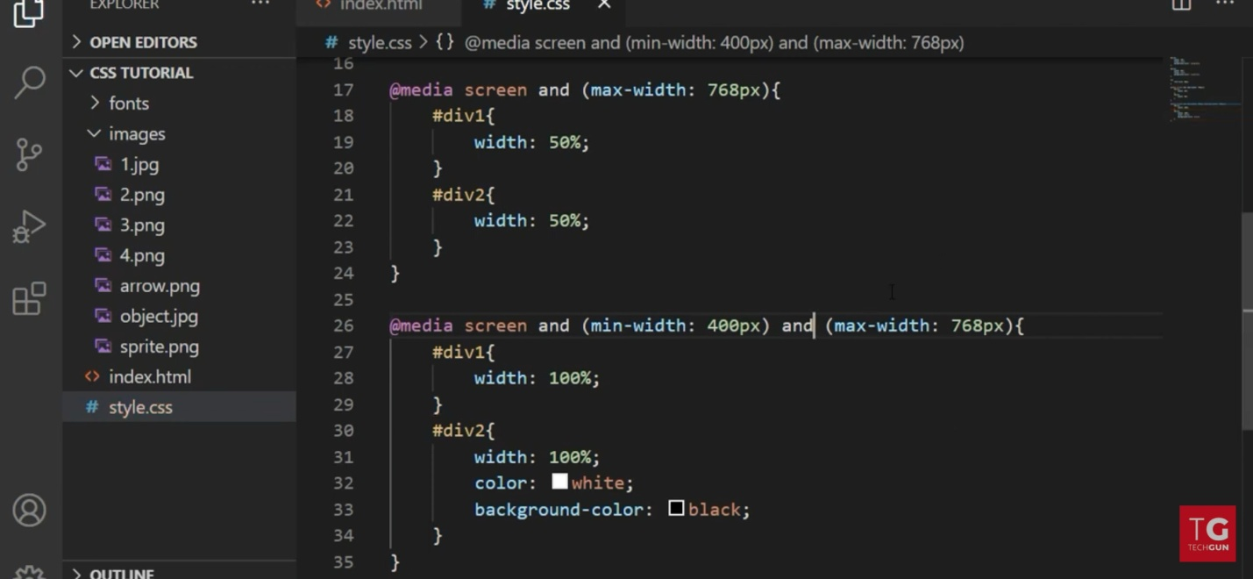

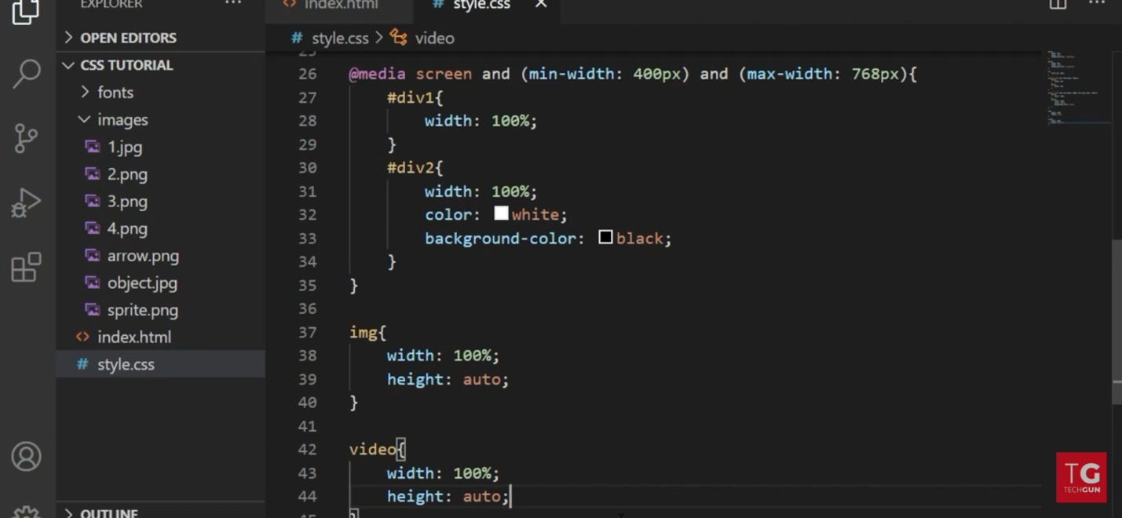

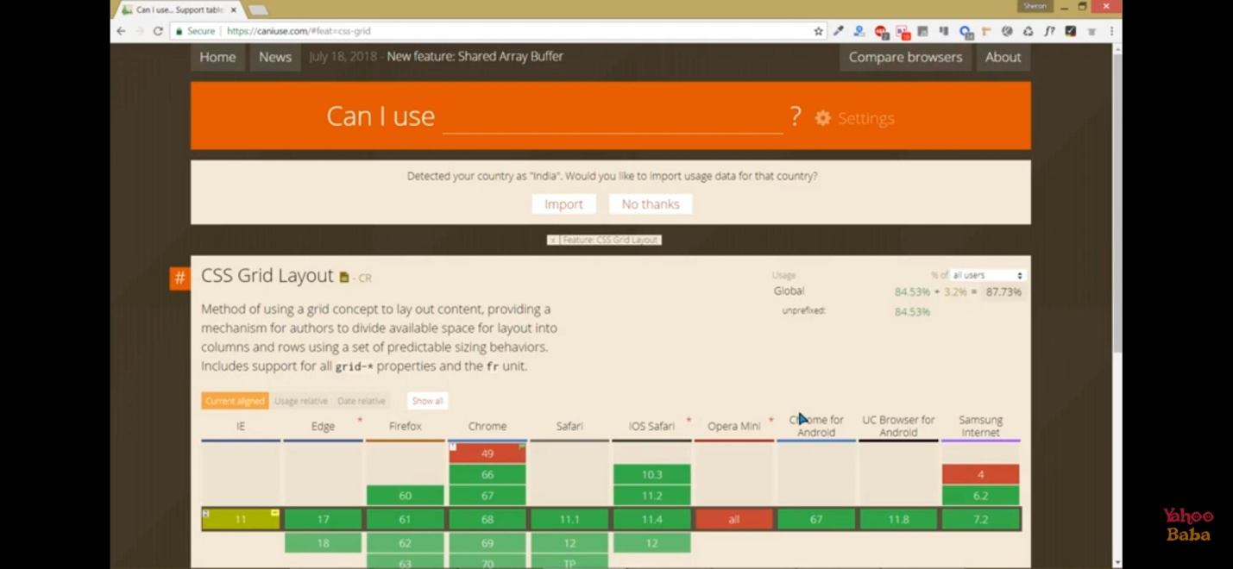

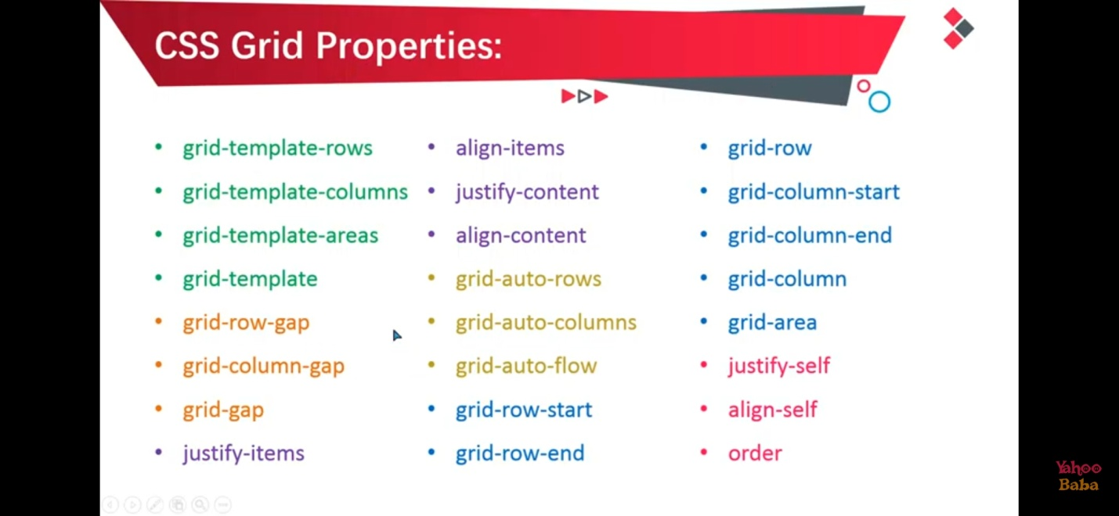

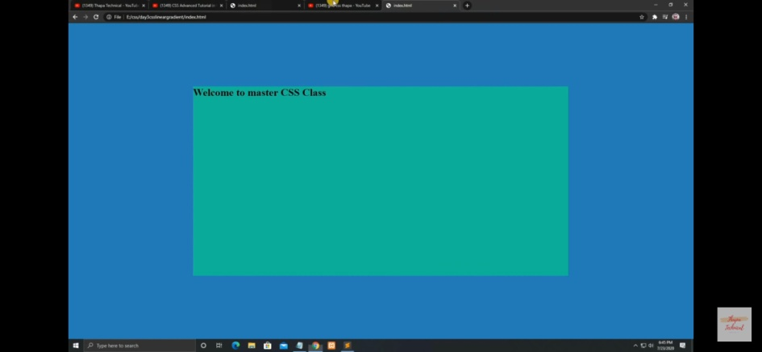

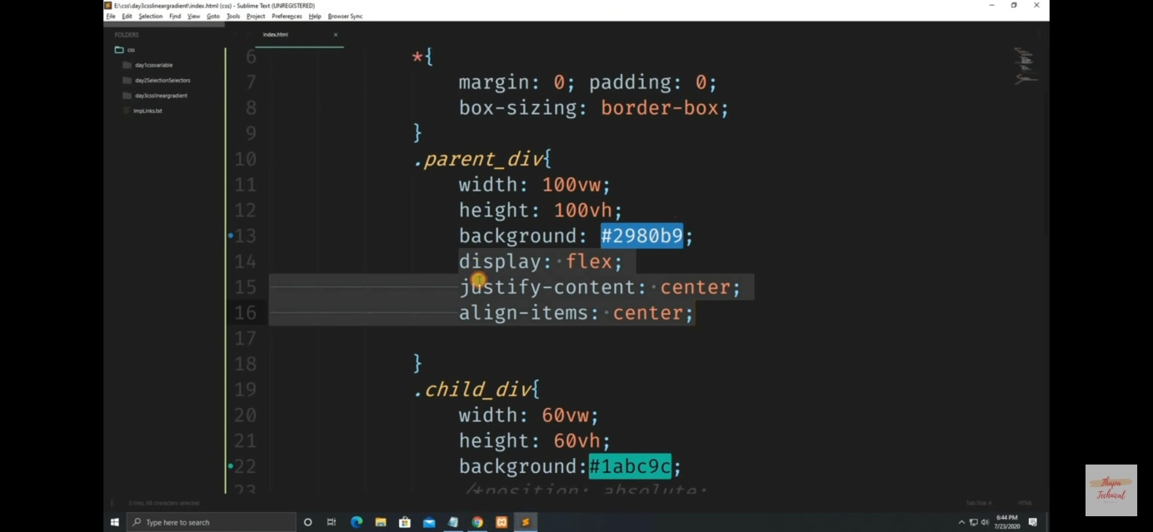



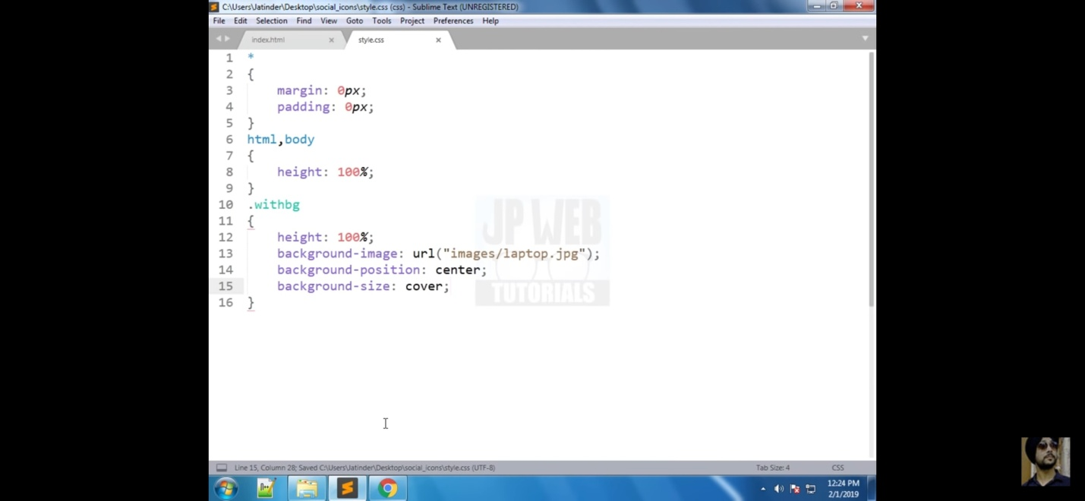

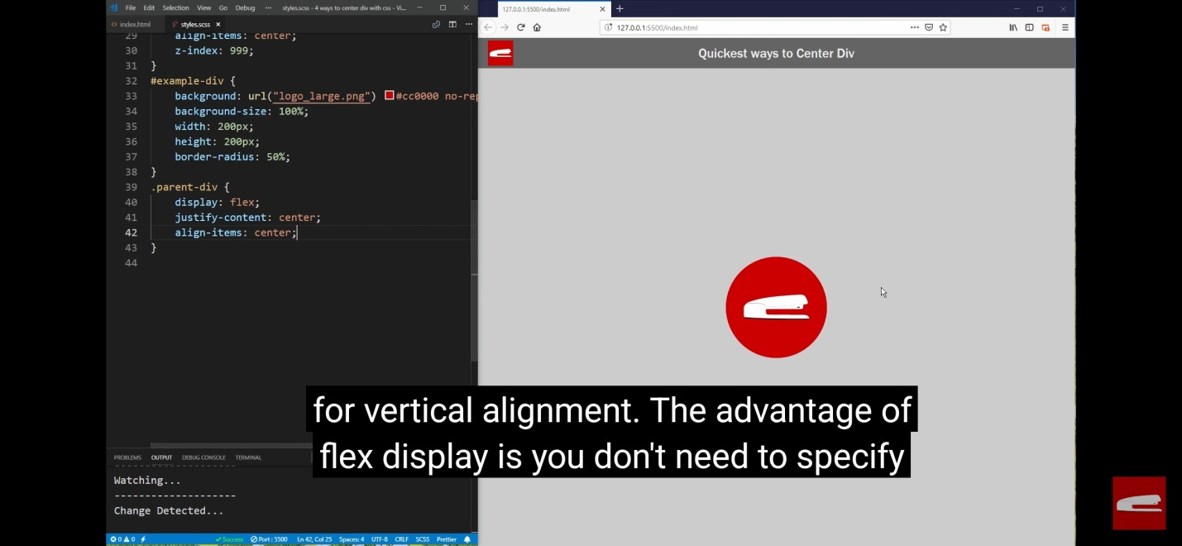

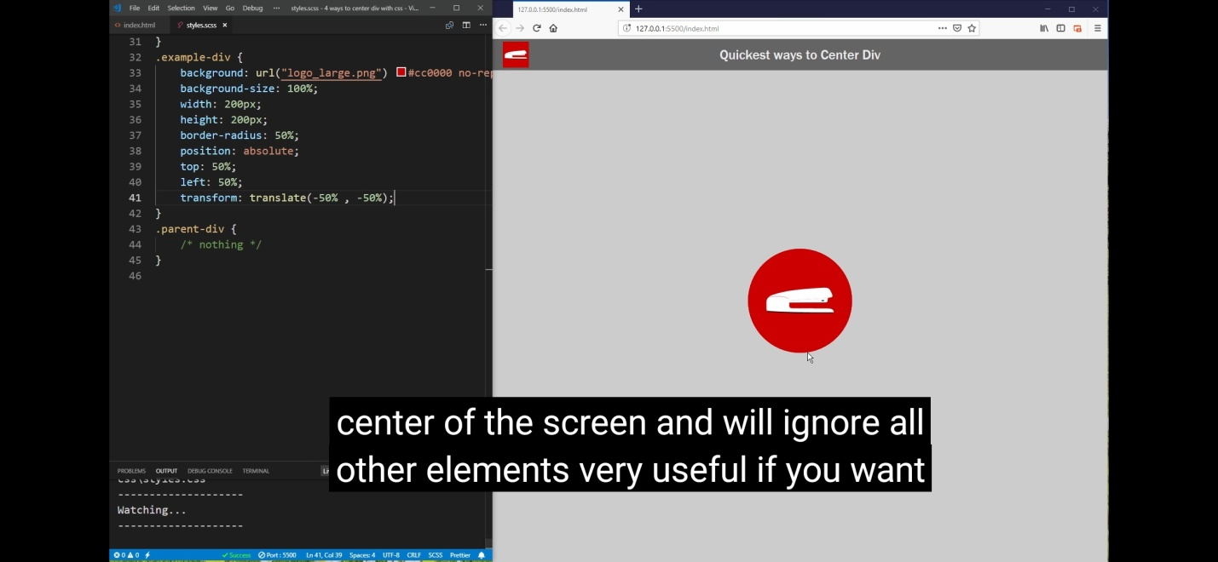

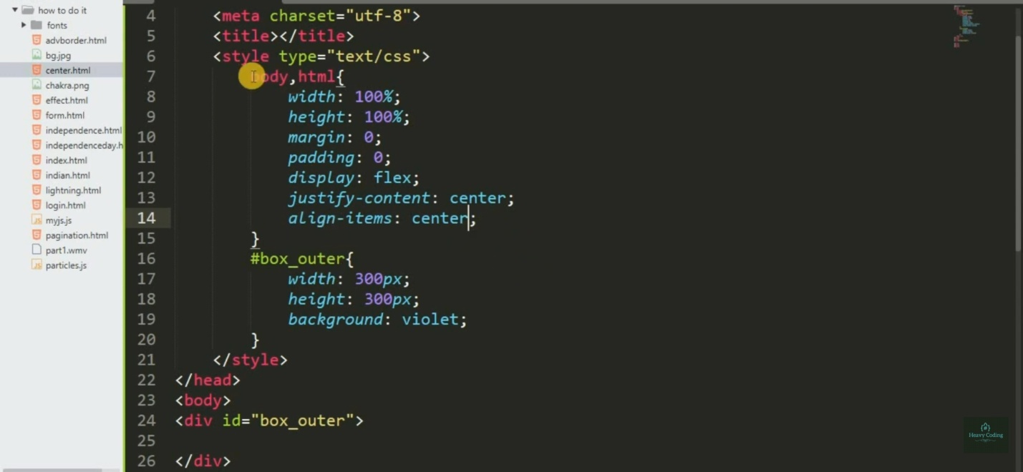

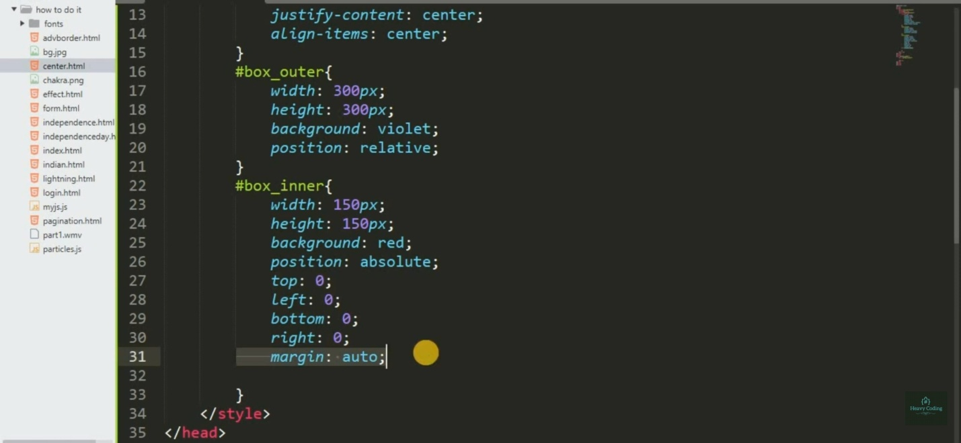

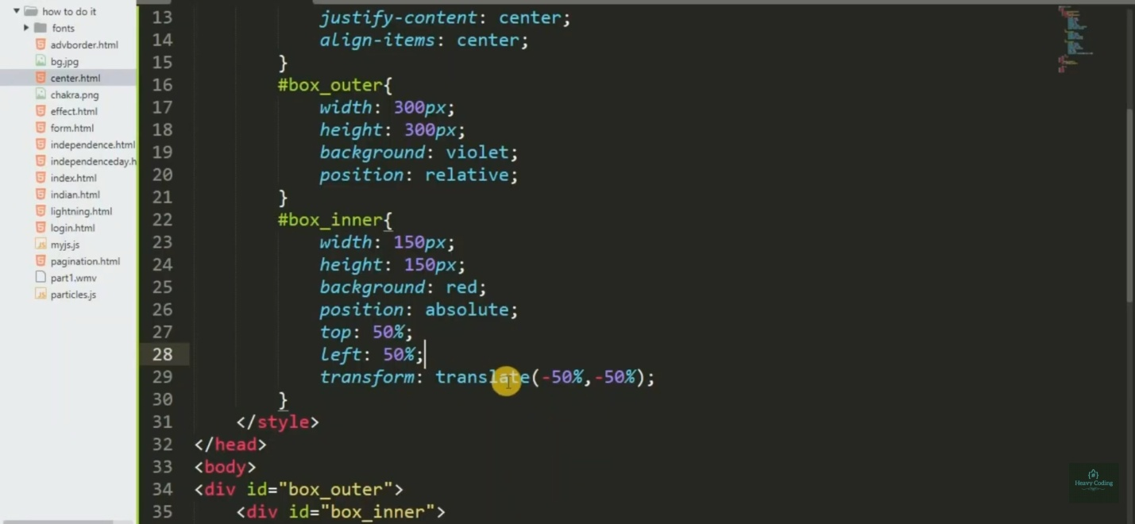

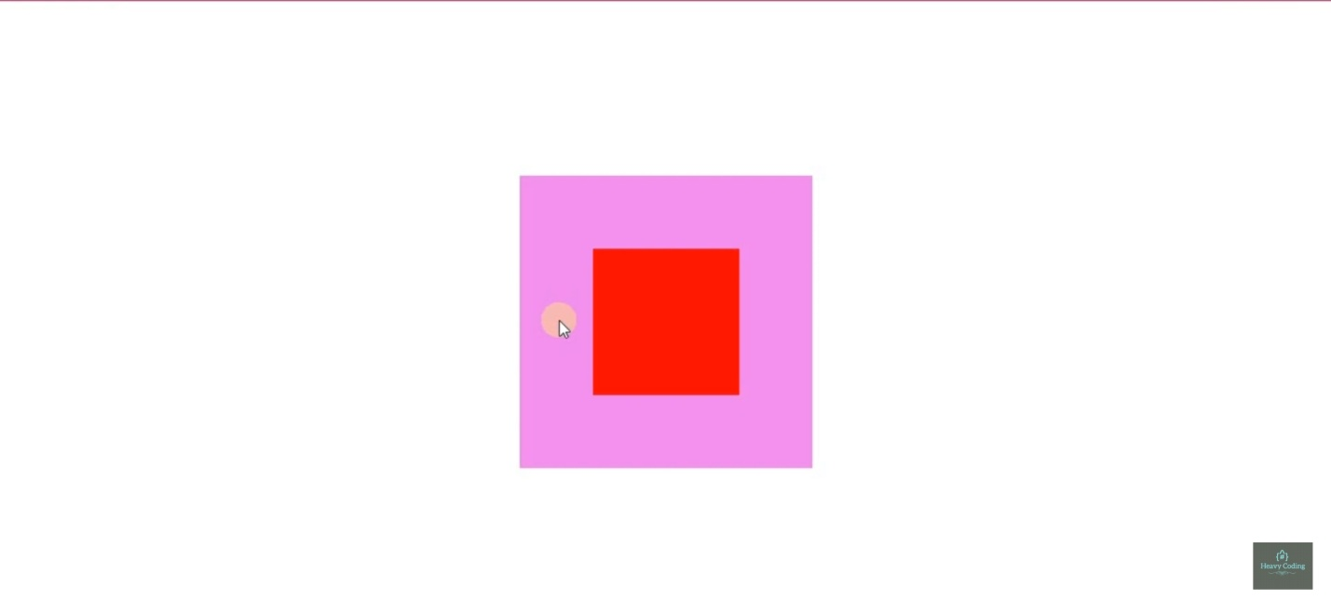

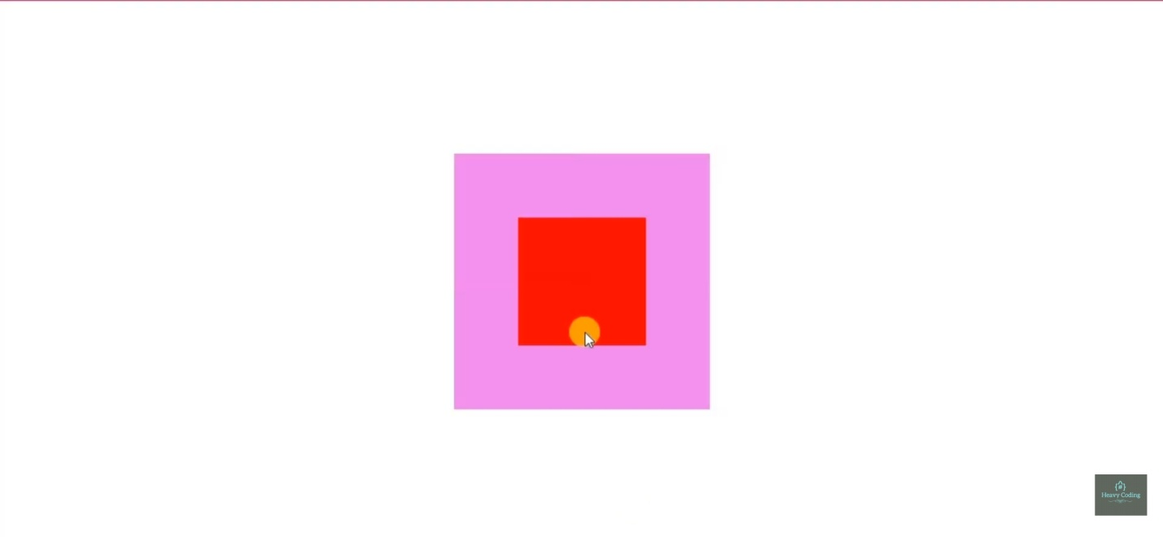

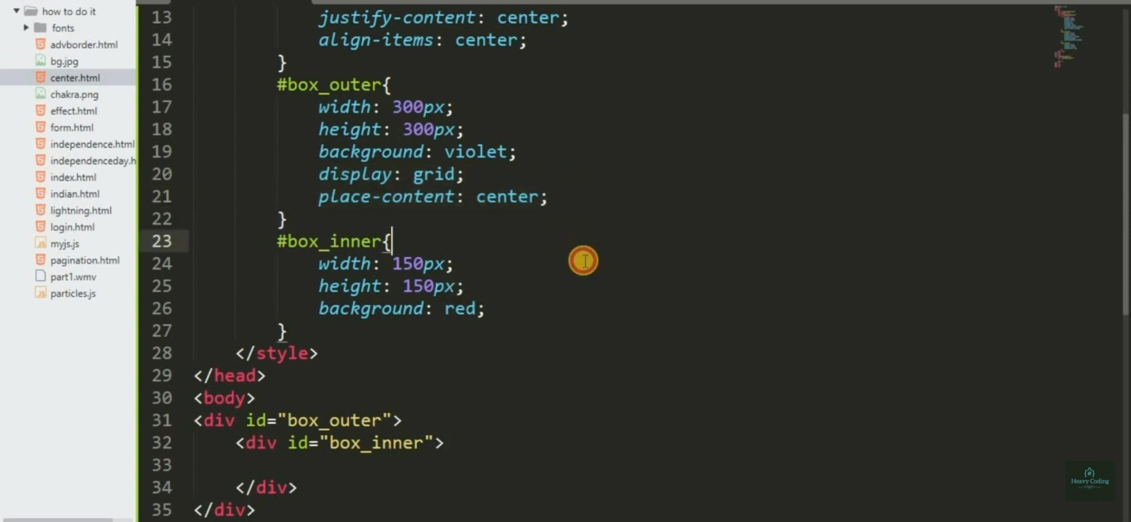

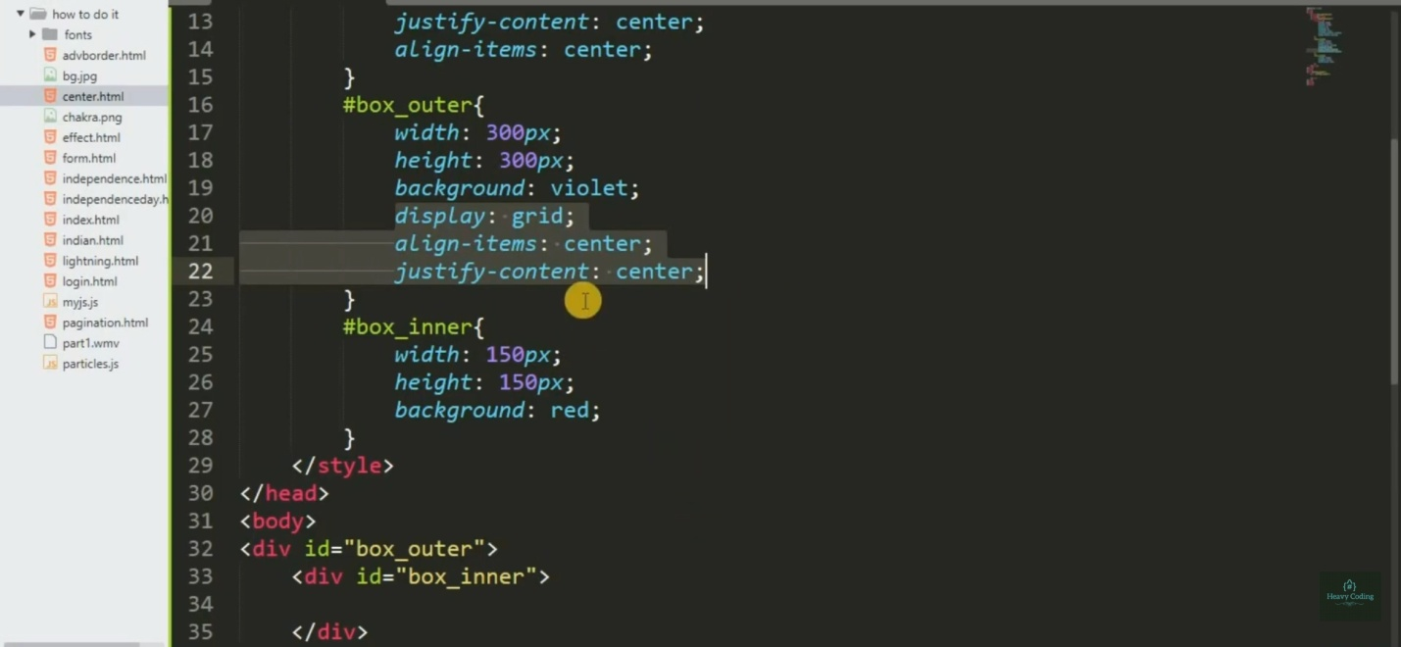

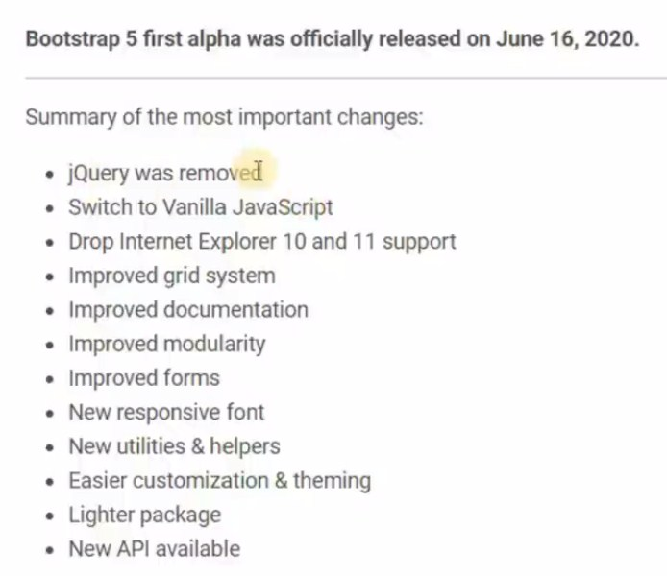

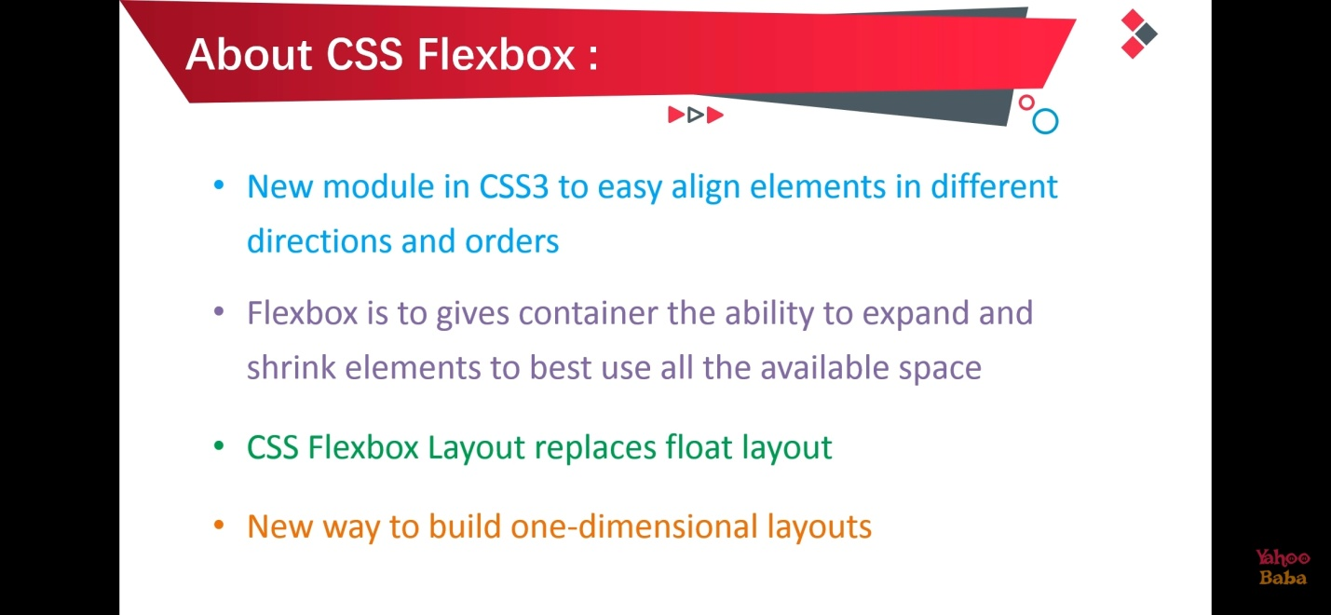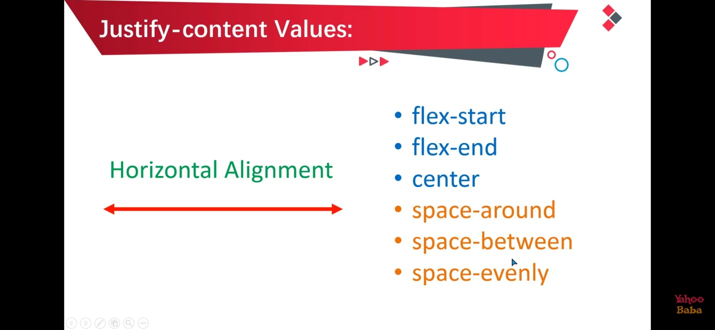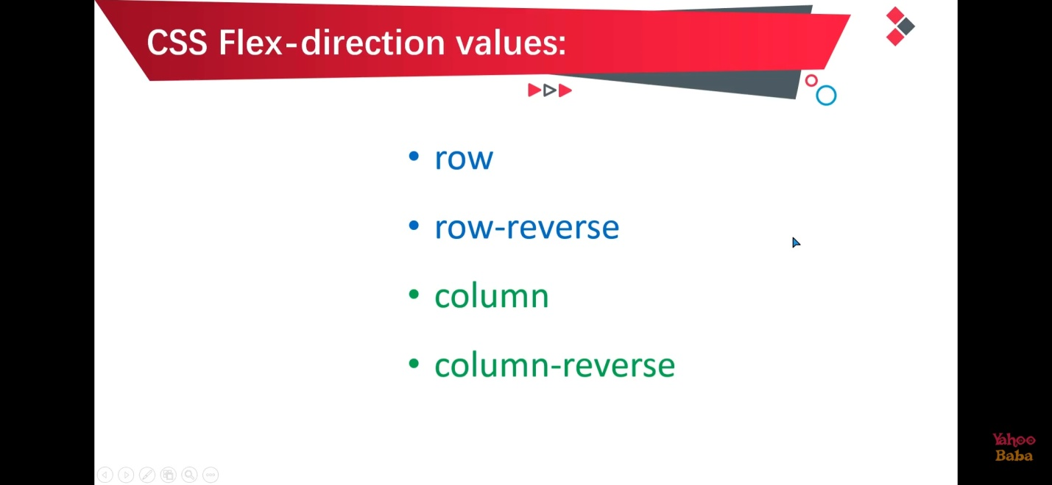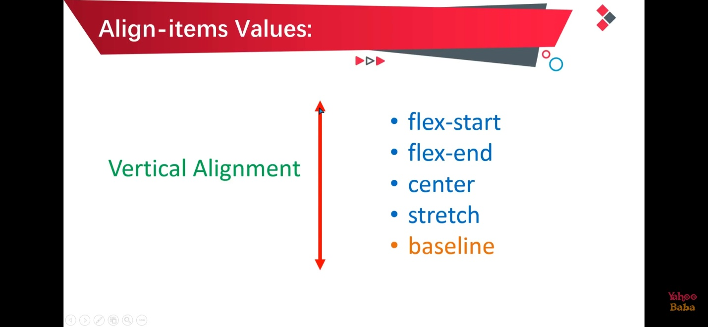

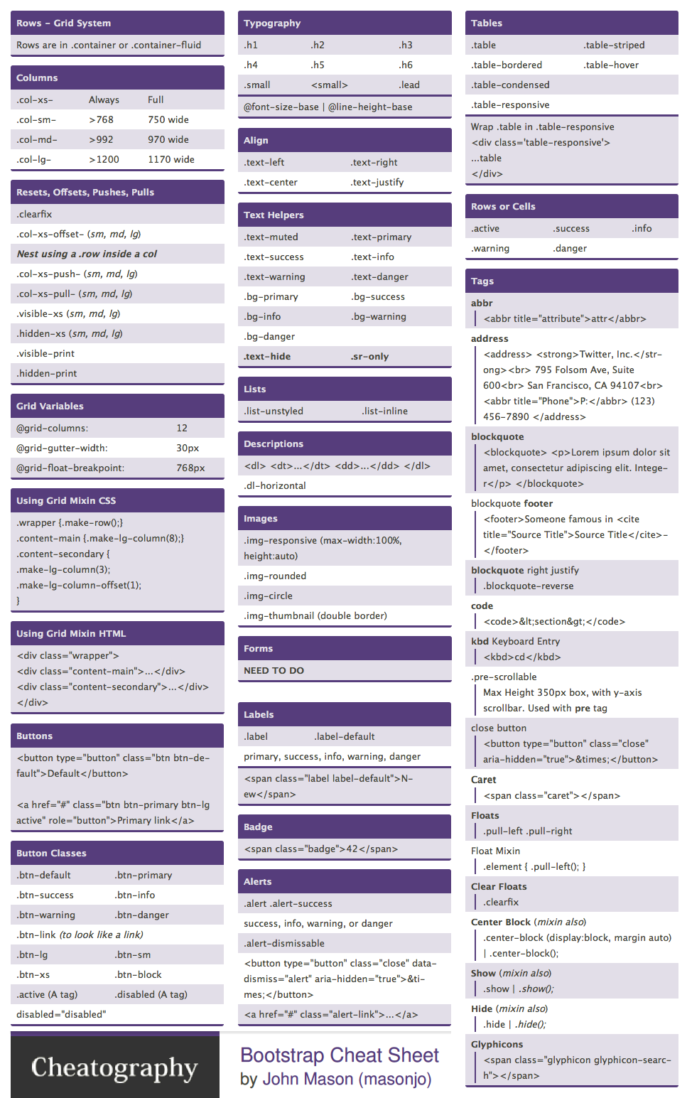

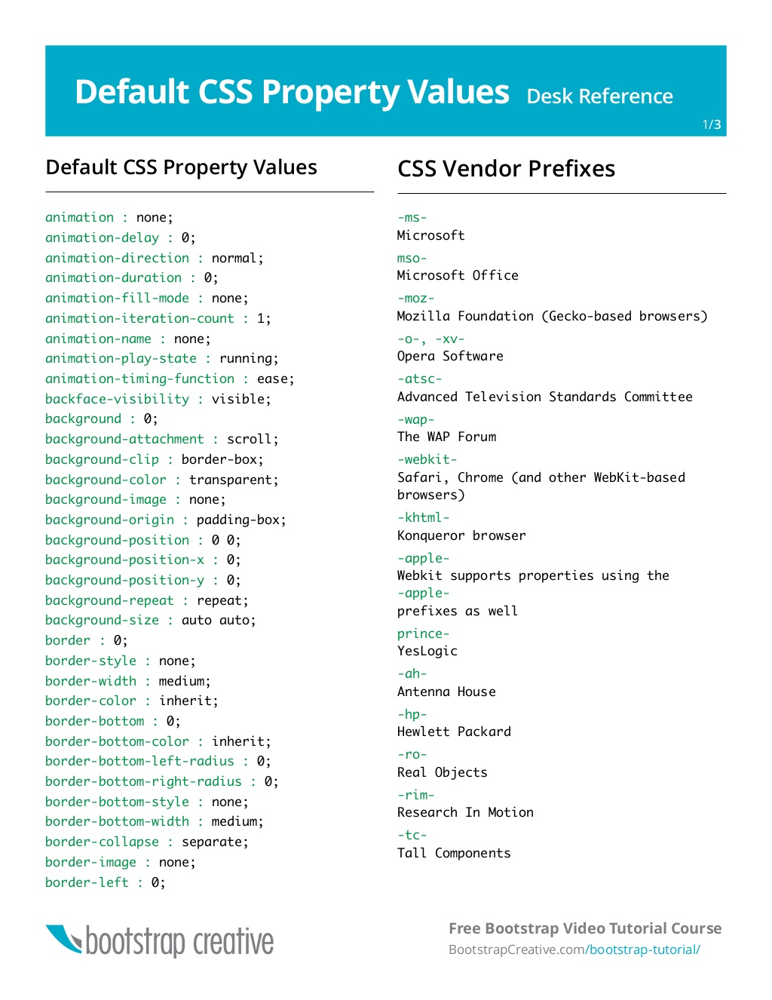

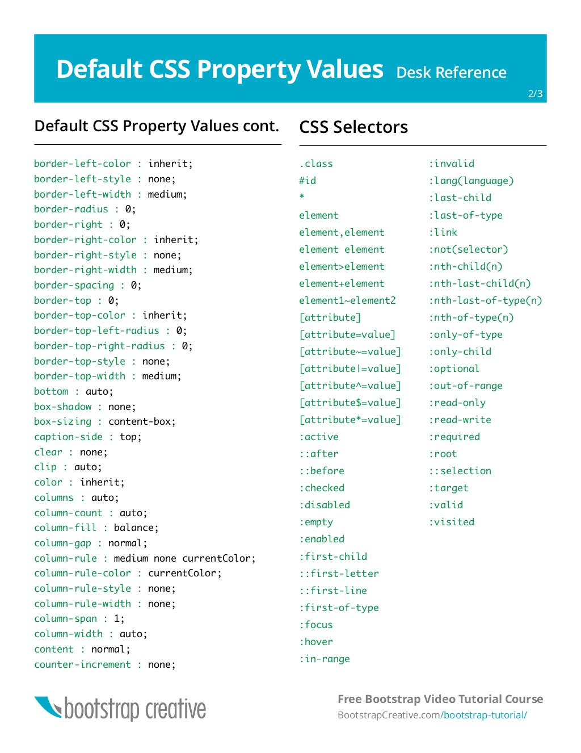

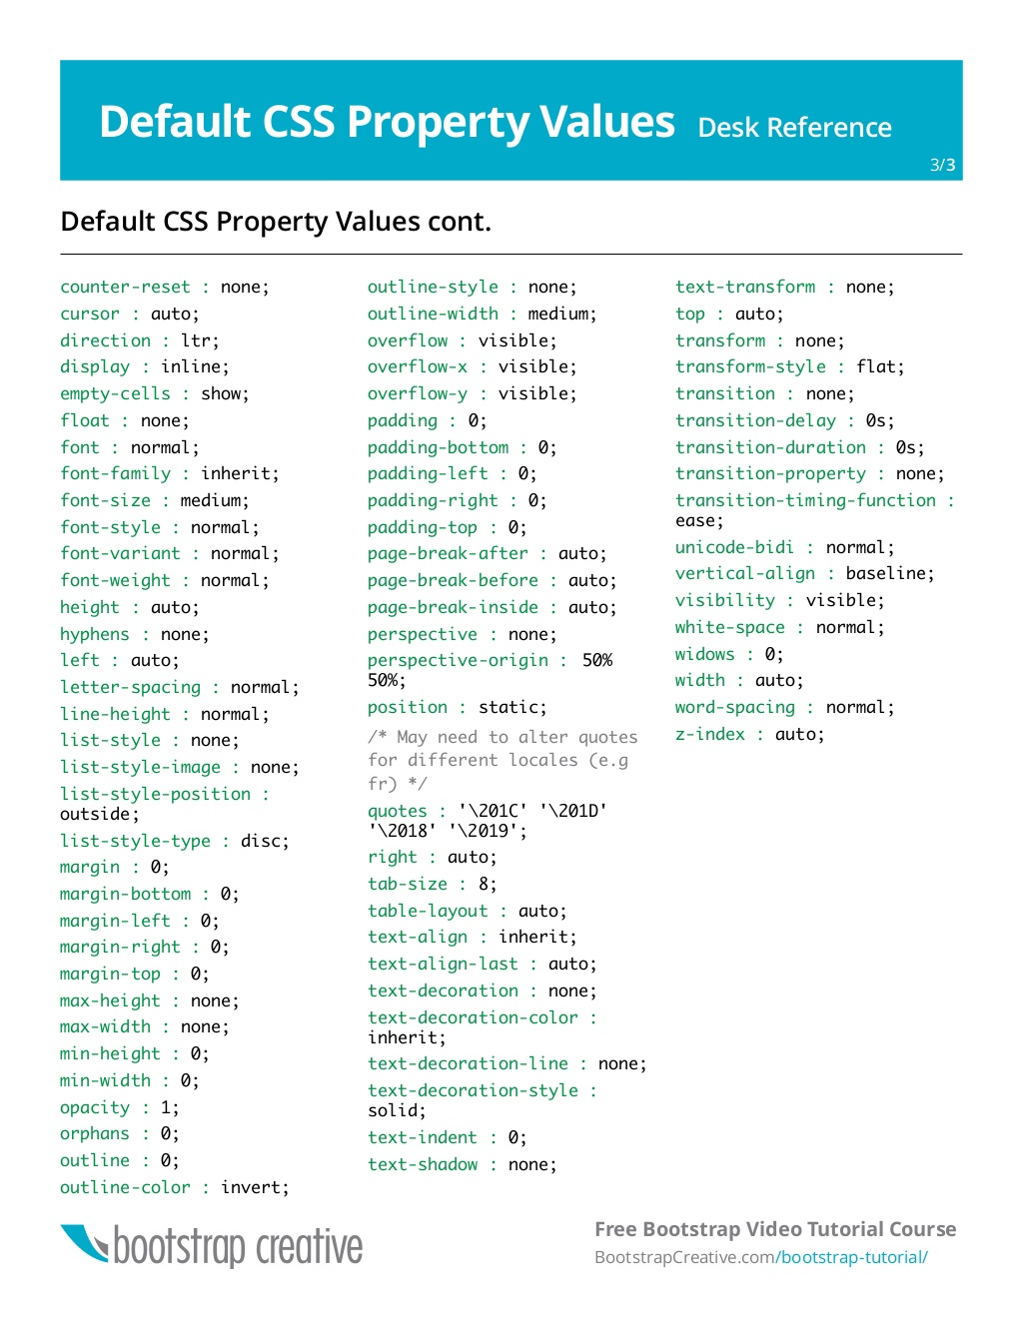

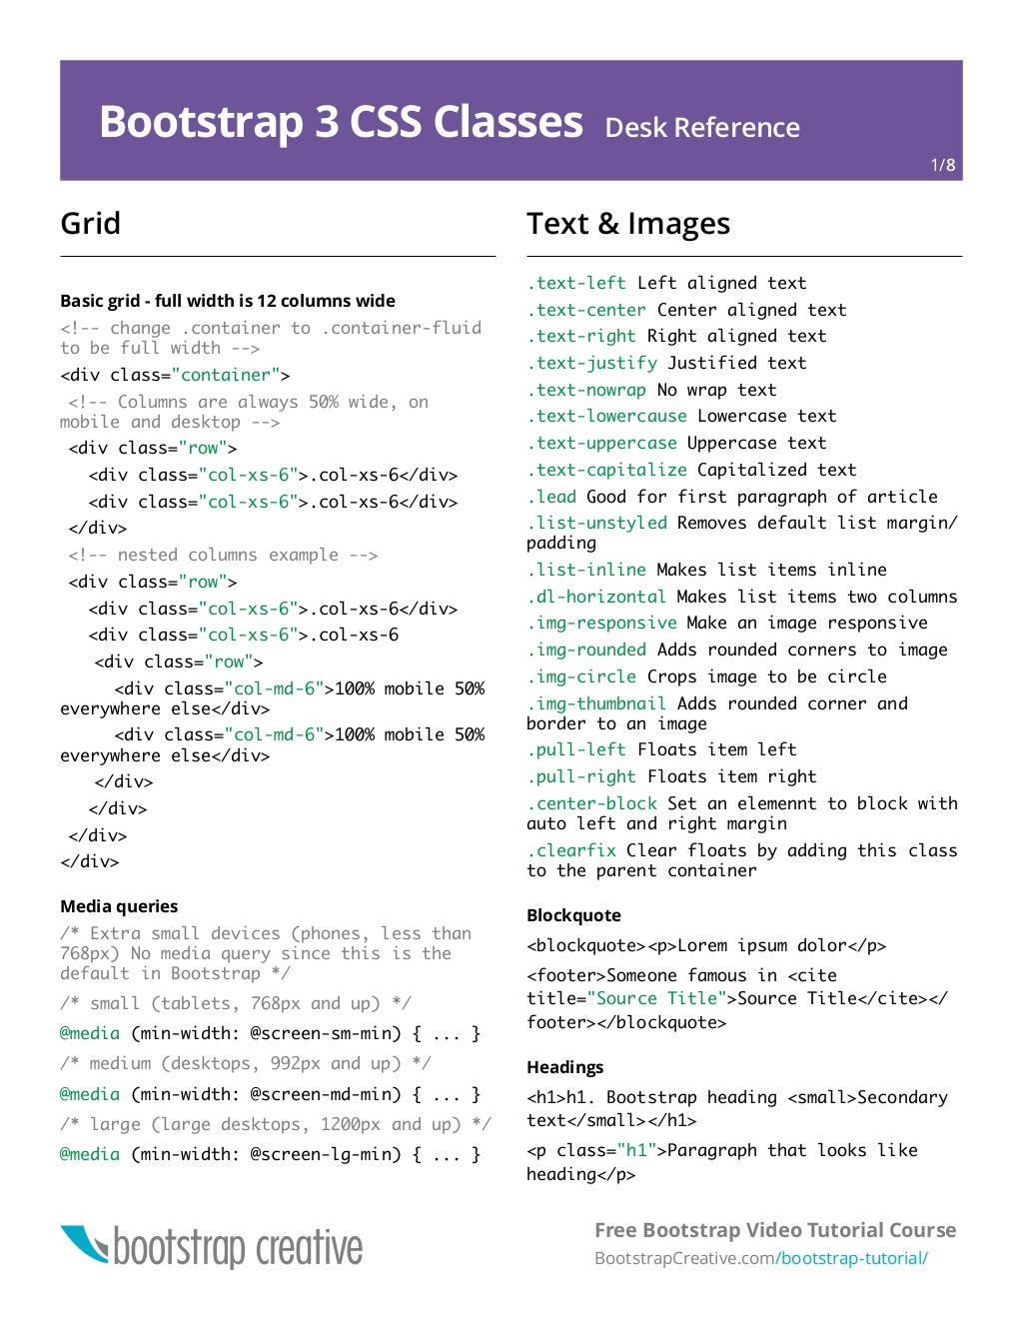

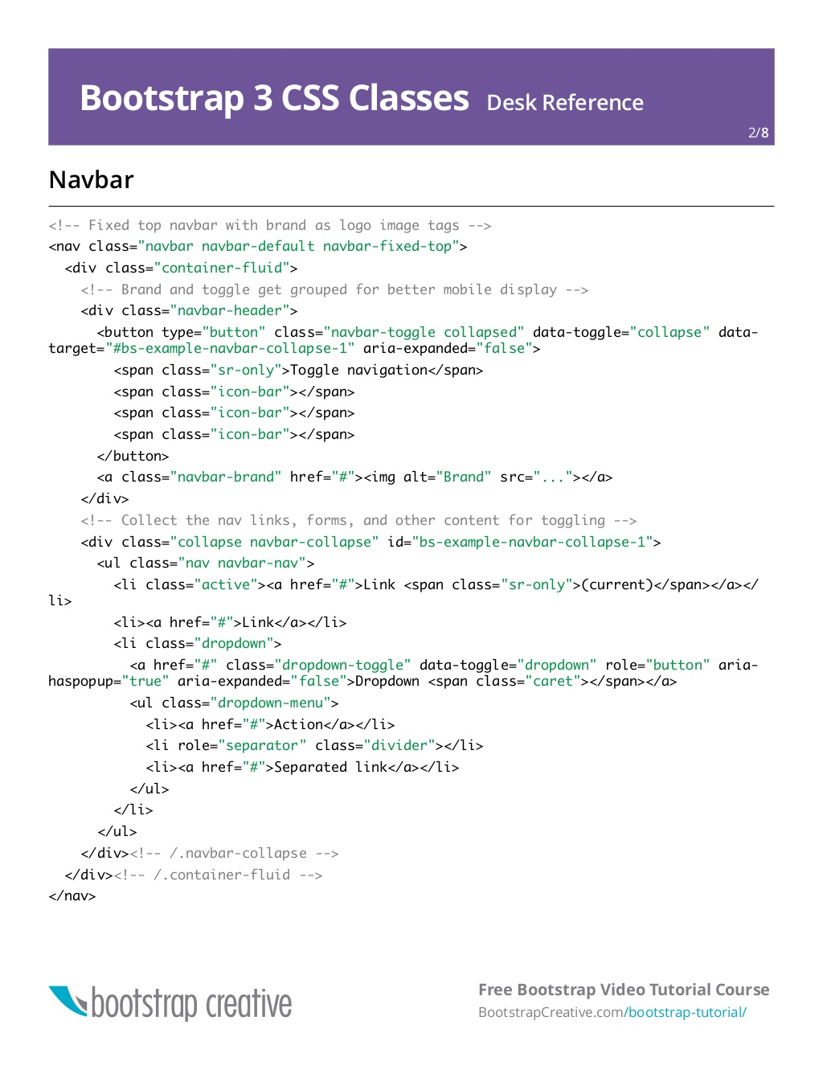

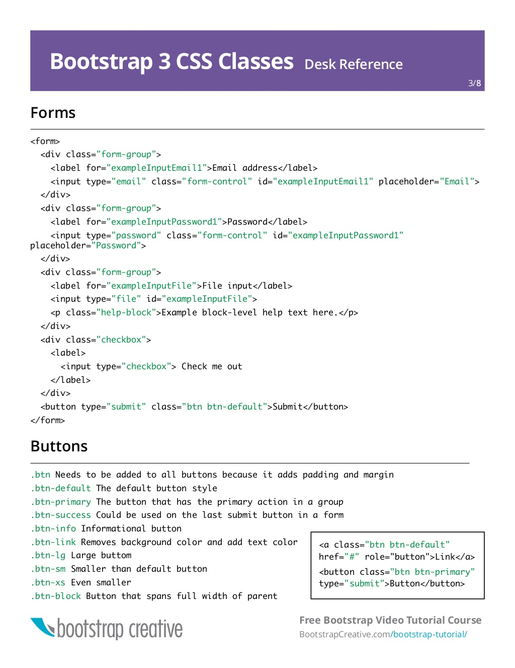

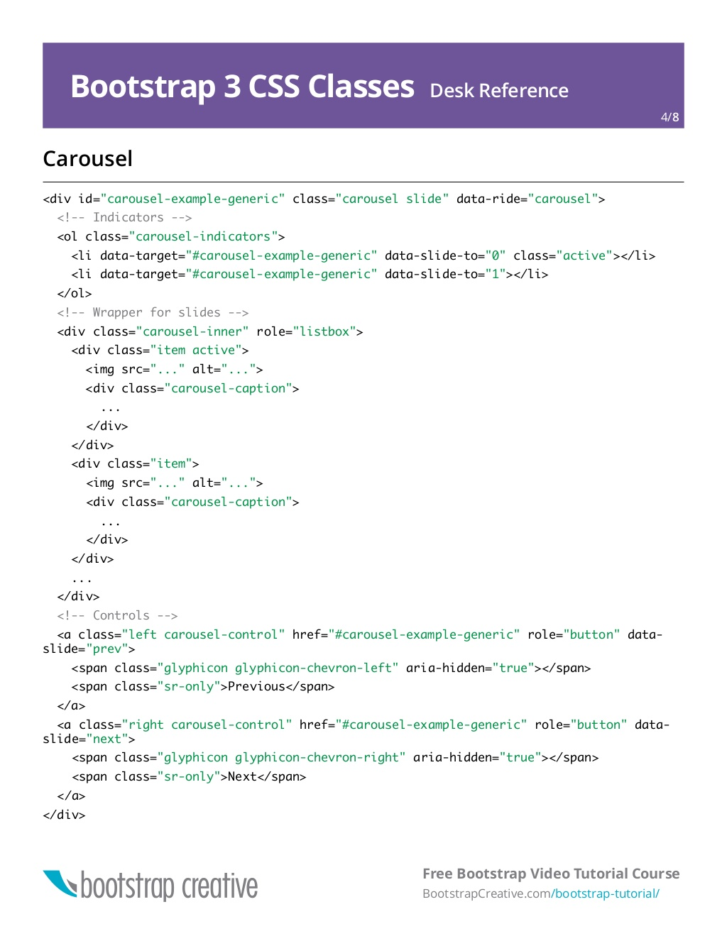

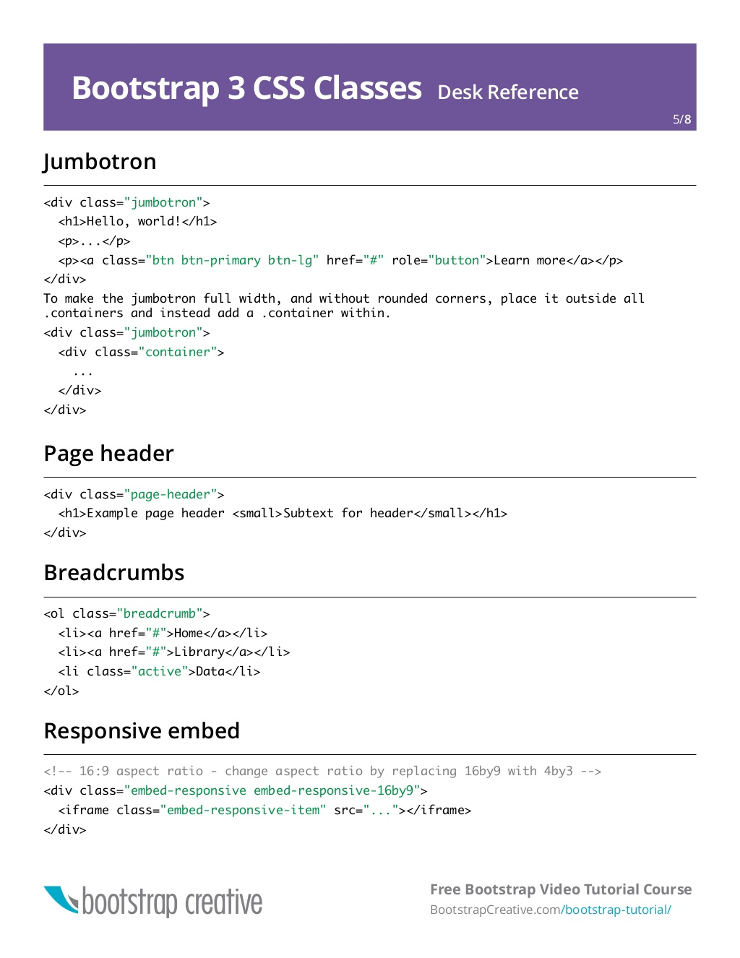

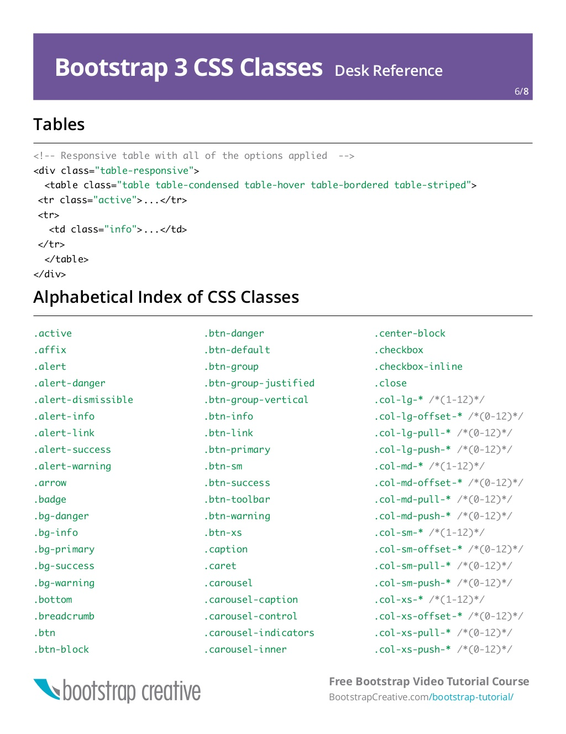

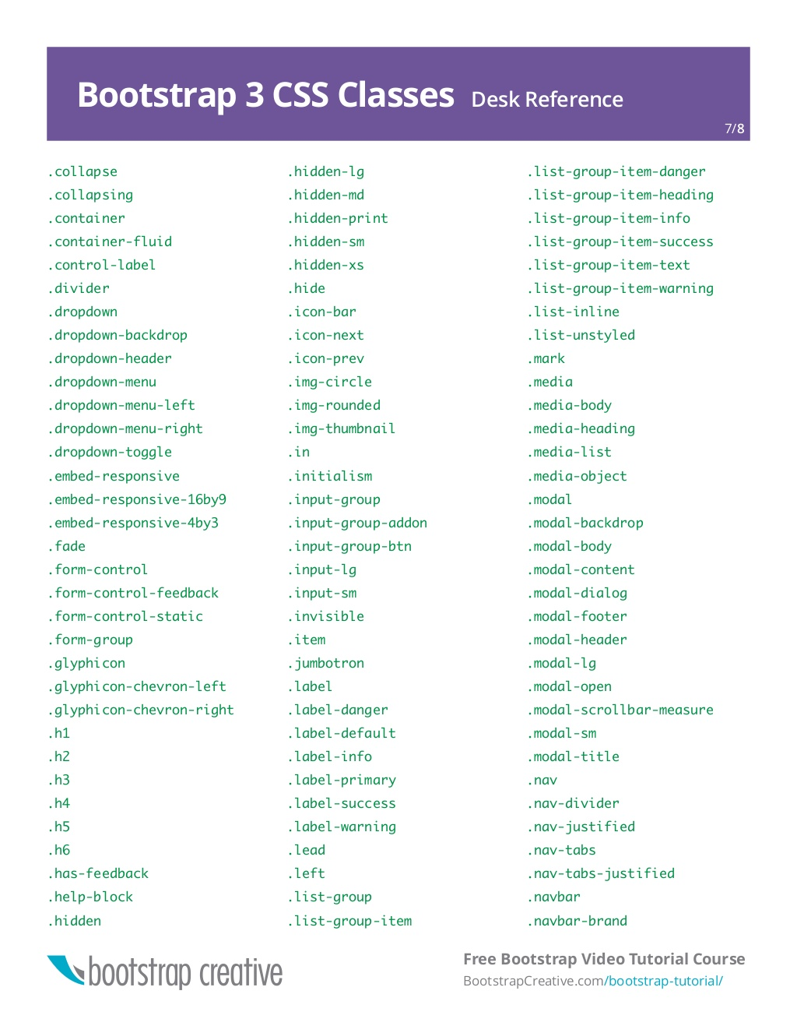

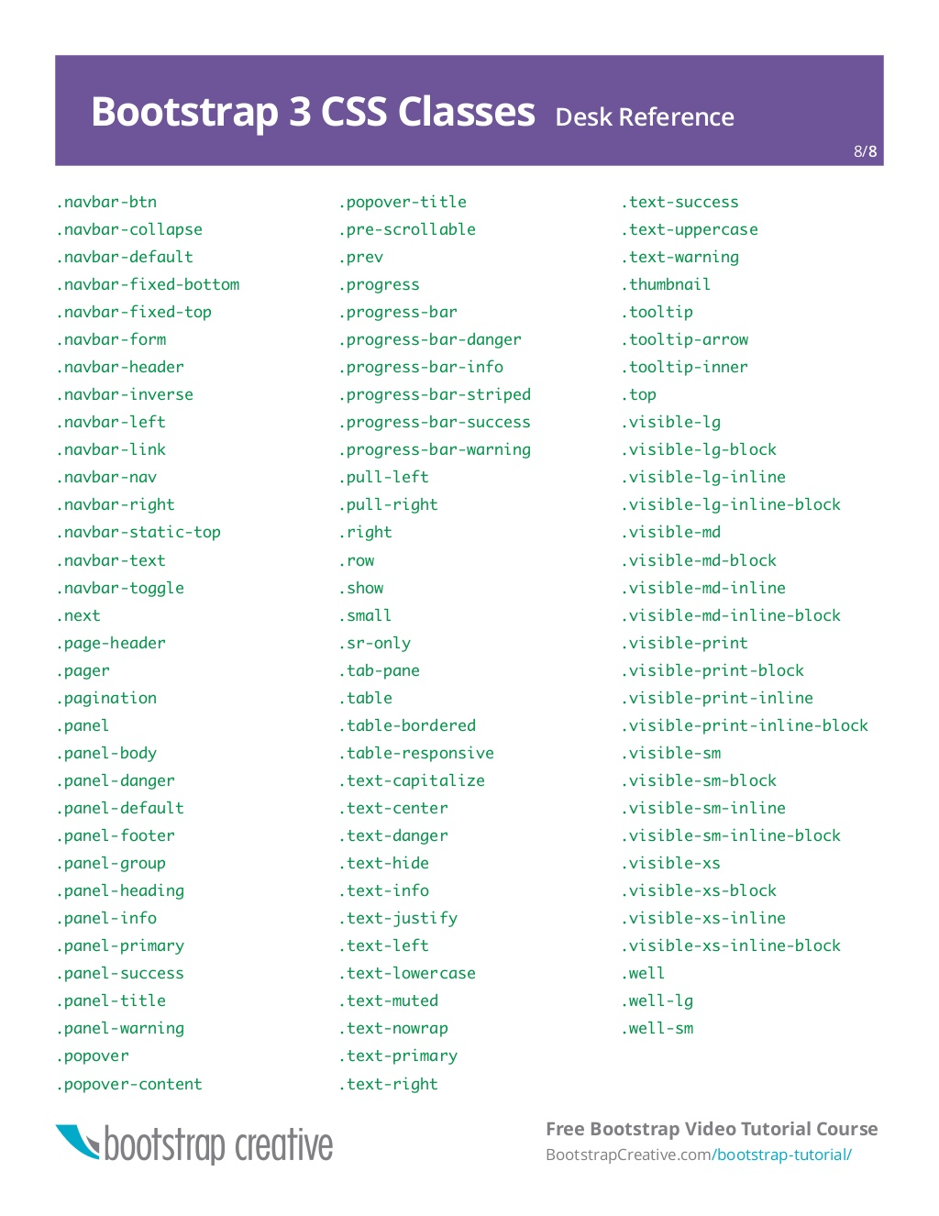

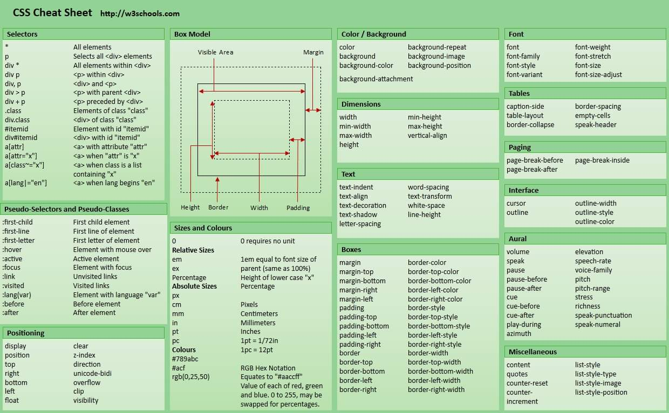

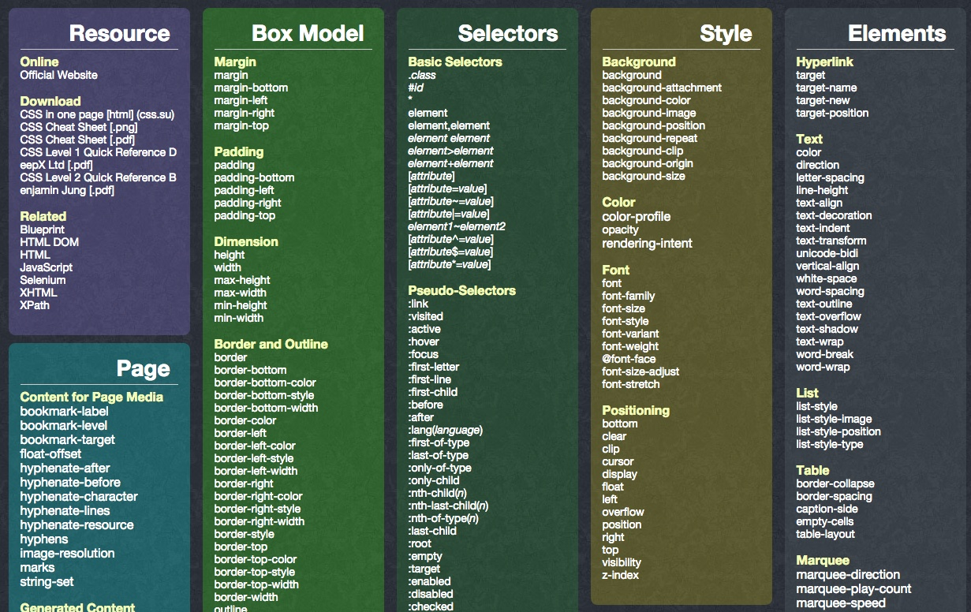

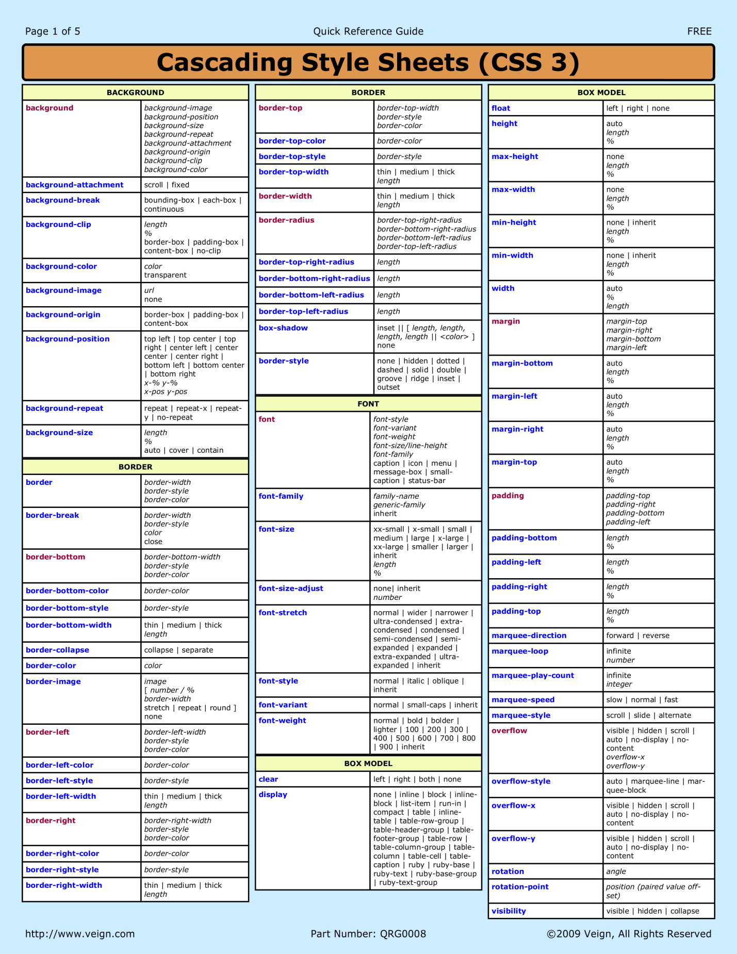

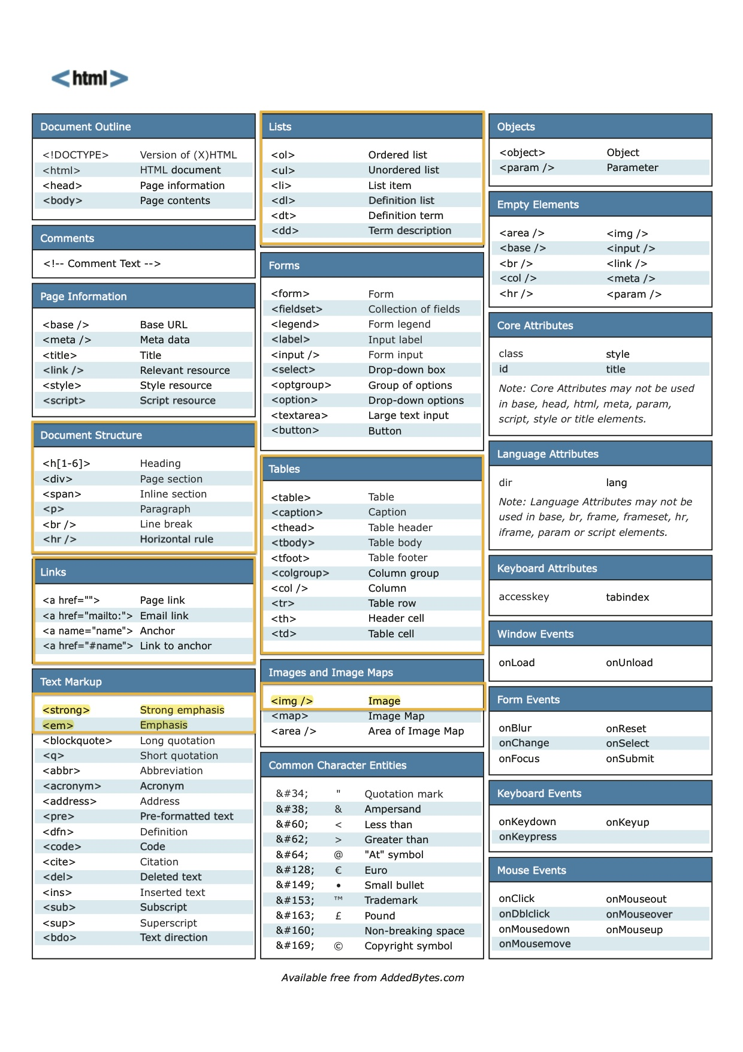

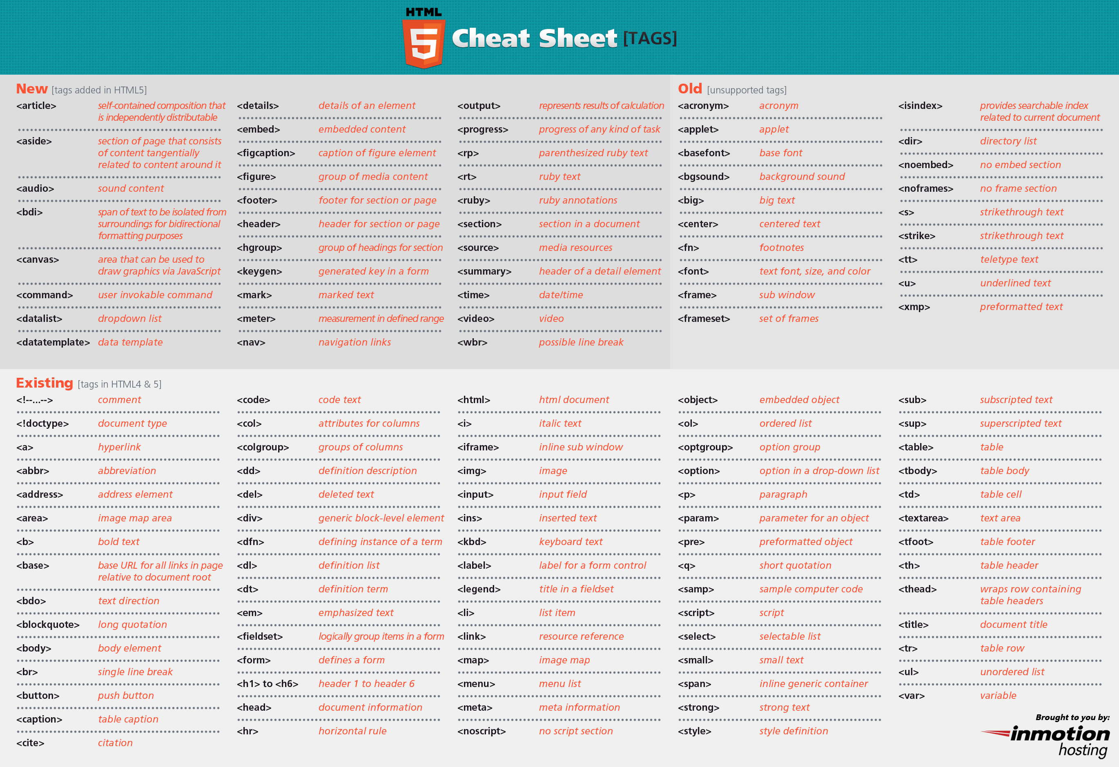

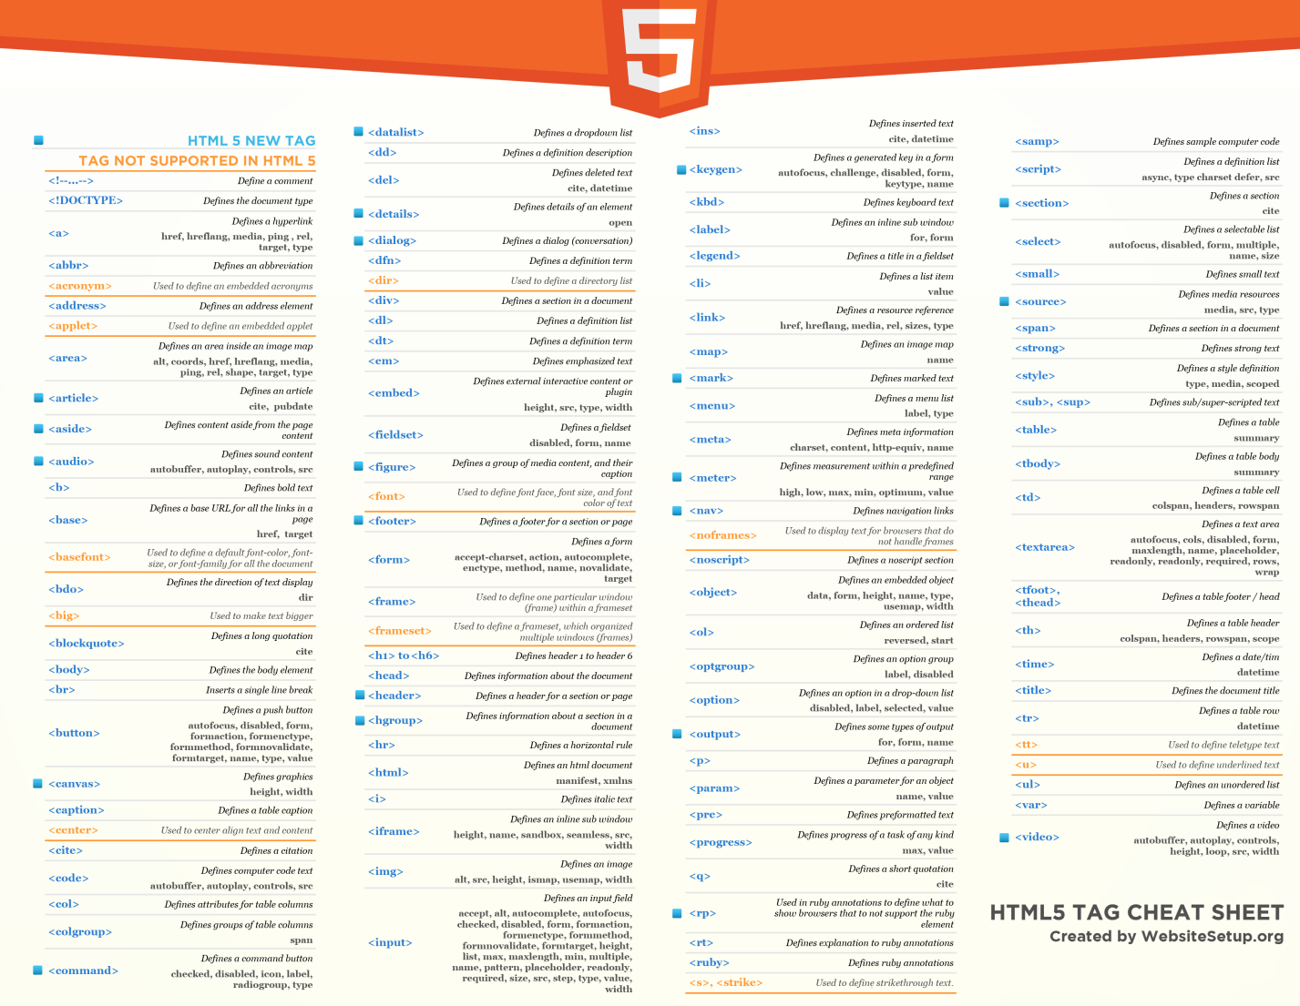

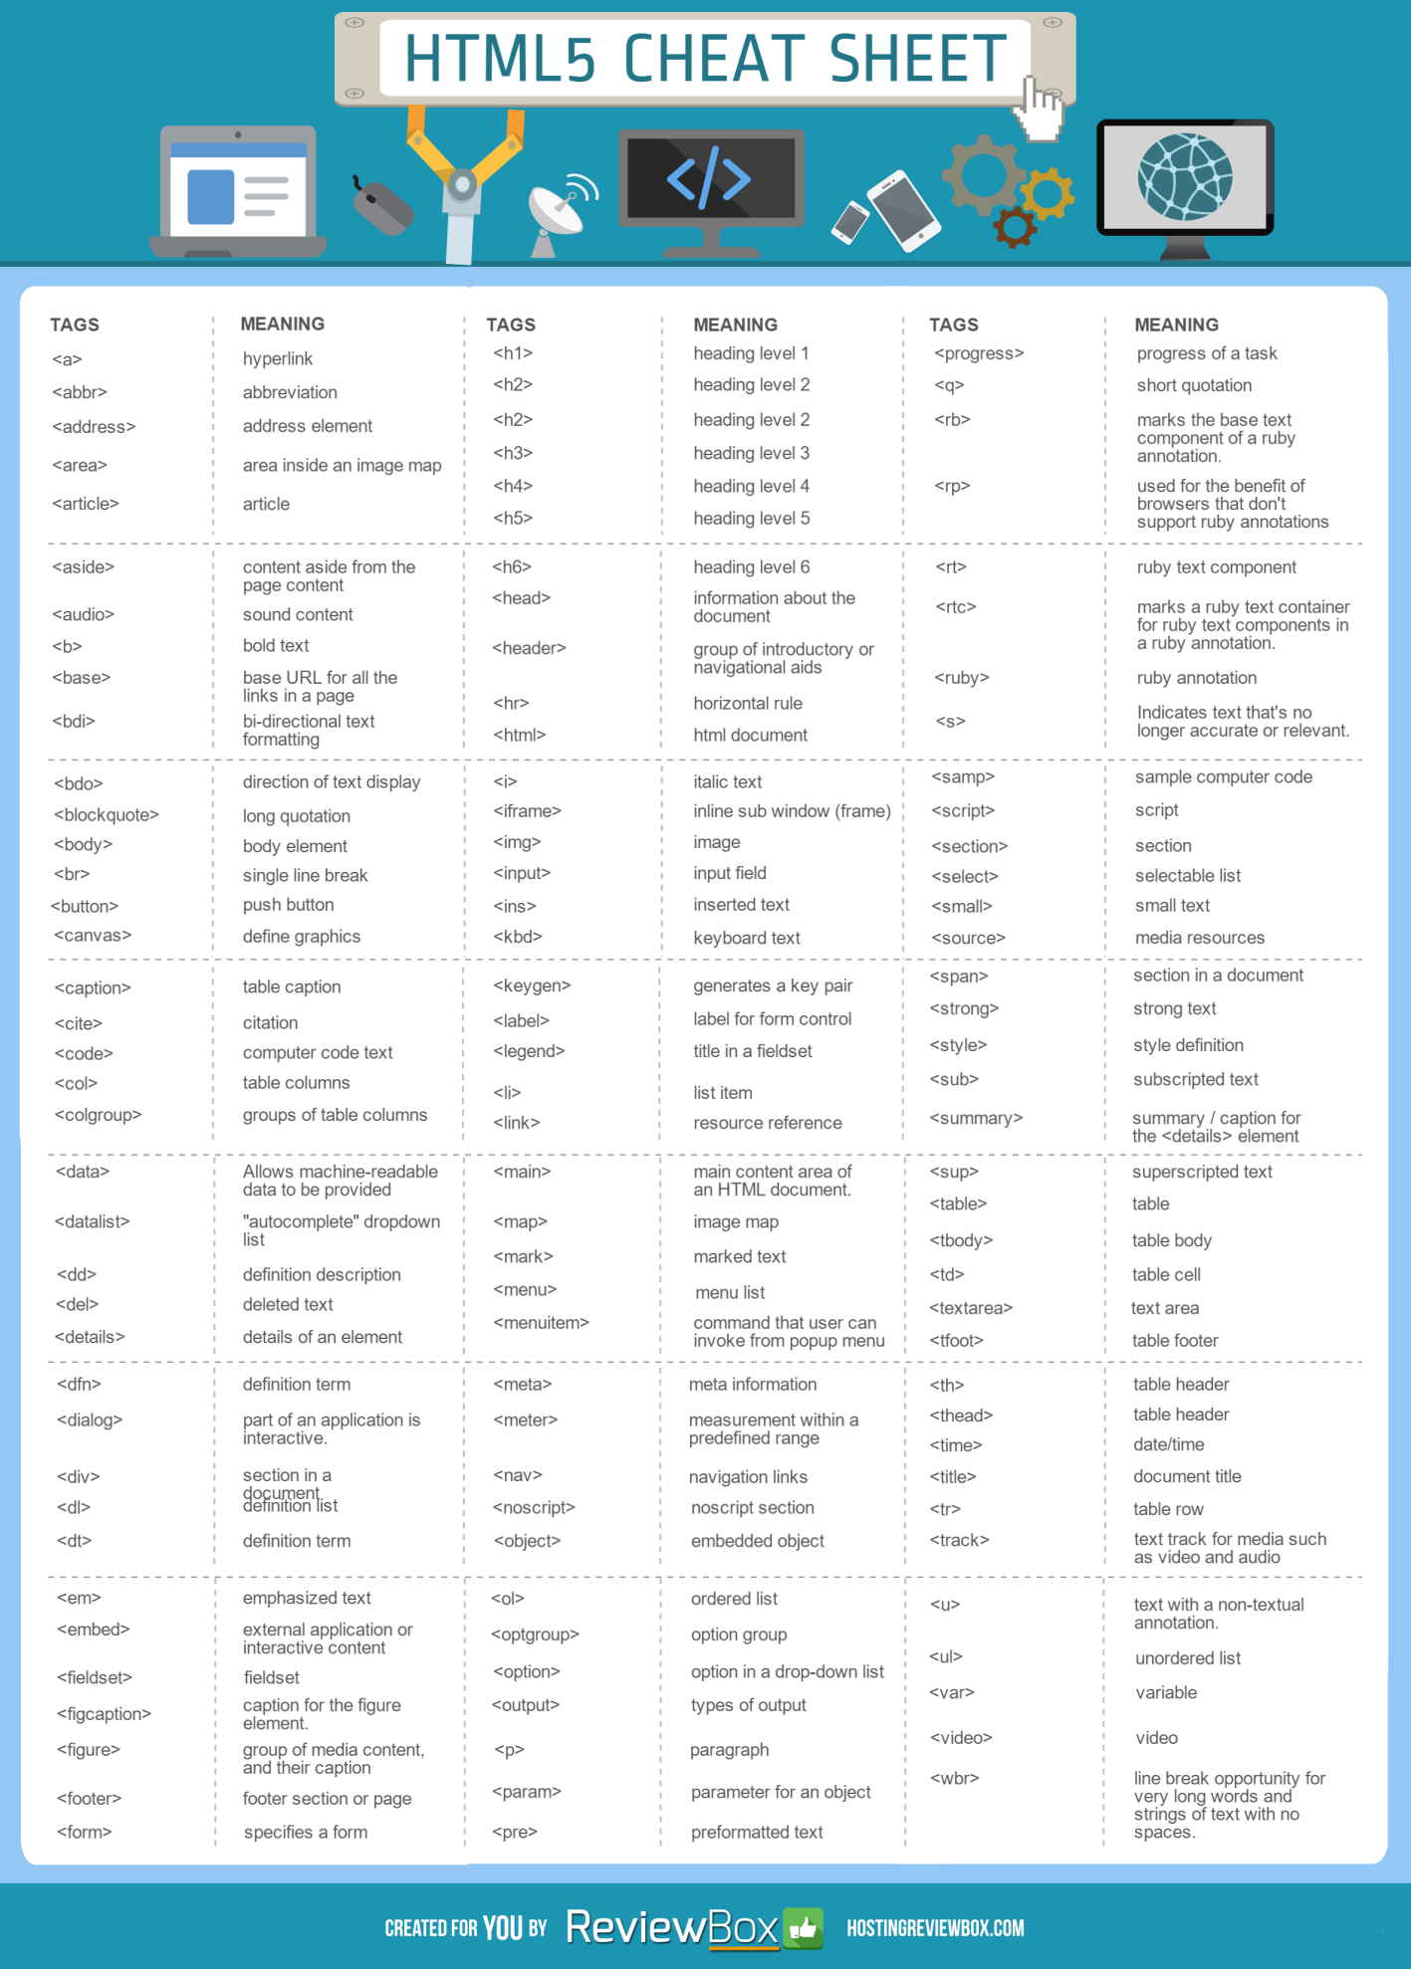

5) What are the advantages of CSS?

* Bandwidth
* Site-wide consistency
* Page reformatting
* Accessibility
* Content separated from presentation

6) What are the limitations of CSS?

* Ascending by selectors is not possible
* Limitations of vertical control
* No expressions
* No column declaration
* Pseudo-class not controlled by dynamic behavior
* Rules, styles, targeting specific text not possible

10) What are the advantages of Embedded Style Sheets?

* You can create classes for use on multiple tag types in the document.
* You can use selector and grouping methods to apply styles in complex situations.
* No extra download is required to import the information.

11) What is a CSS selector?

It is a string that identifies the elements to which a particular declaration apply. It is also referred as a link between the HTML document and the style sheet. It is equivalent of HTML elements. There are several different types of selectors in CSS: -

* CSS Element Selector
* CSS Id Selector
* CSS Class Selector
* CSS Universal Selector
* CSS Group Selector

### 24) What is the difference between inline, embedded and external style sheets?

28) What is the CSS Box model and what are its elements?

The CSS box model is used to define the design and layout of elements of CSS.

The elements are:

* Margin - It removes the area around the border. It is transparent.
* Border - It represents the area around the padding
* Padding - It removes the area around the content. It is transparent.
* Content - It represents the content like text, images, etc.

31) What is the purpose of the z-index and how is it used?

The z-index helps to specify the stack order of positioned elements that may overlap one another. The z-index default value is zero and can take on either a positive or negative number.

An element with a higher z-index is always stacked above than a lower index.

Z-Index can take the following values:

* **Auto:** Sets the stack order equal to its parents.
* **Number:** Orders the stack order.
* **Initial:** Sets this property to its default value (0).
* **Inherit:** Inherits this property from its parent element.

### 32) Explain the difference between visibility: hidden and display: none?

**visibility: hidden** hides the element, but it occupies space and affects the layout of the document.

**display: none** also hides the element but not occupy space. It will not affect the layout of the document.

### 33) What do you understand by W3C?

W3C stands for World Wide Web Consortium. Its purpose is to deliver the information of the World Wide Web. It also develops rules and guidelines for the Web.

### 34) What is tweening?

It is the process of generating intermediate frames between two images.

It gives the impression that the first image has smoothly evolved into the second one.

It is an important method used in all types of animations.

In CSS3, Transforms (matrix, translate, rotate, scale) module can be used to achieve tweening.

7) Which HTML tag is used to display the data in the tabular form?

The **HTML table tag** is used to display data in tabular form (row * column). It also manages the layout of the page, e.g., header section, navigation bar, body content, footer section. Here is the list of tags used while displaying the data in the tabular form:

|  |  |
| --- | --- |
| **Tag** | **Description** |
| <table> | It defines a table. |
| <tr> | It defines a row in a table. |
| <th> | It defines a header cell in a table. |
| <td> | It defines a cell in a table. |
| <caption> | It defines the table caption. |
| <colgroup> | It specifies a group of one or more columns in a table for formatting. |
| <col> | It is used with <colgroup> element to specify column properties for each column. |
| <tbody> | It is used to group the body content in a table. |
| <thead> | It is used to group the header content in a table. |
| <tfooter> | It is used to group the footer content in a table. |

### 10) What is semantic HTML?

Semantic HTML is a coding style. It is the use of HTML markup to reinforce the semantics or meaning of the content. For example: In semantic HTML <b> </b> tag is not used for bold statement as well as <i> </i> tag is used for italic. Instead of these we use <strong></strong> and <em></em> tags.

### 11) What is an image map?

Image map facilitates you to link many different web pages using a single image. It is represented by <map> tag. You can define shapes in images that you want to make part of an image mapping.

### 13) How to create a nested webpage in HTML?

The HTML iframe tag is used to display a nested webpage. In other words, it represents a webpage within a webpage. The HTML <iframe> tag defines an inline frame. For example:

22) How to make a picture of a background image of a web page?

To make a picture a background image on a web page, you should put the following tag code after the </head> tag.

1. **<body** background = "image.gif"**>**

Here, replace the "image.gif" with the name of your image file which you want to display on your web page.

### 23) What are empty elements?

HTML elements with no content are called empty elements. For example: <br>, <hr> etc.

1. **<iframe** src="demo_iframe.html" width="200px" height="200px"**></iframe>**

### 26) What are the entities in HTML?

The HTML character entities are used as a replacement for reserved characters in HTML. You can also replace characters that are not present on your keyboard by entities. These characters are replaced because some characters are reserved in HTML.

### 27) Why is a URL encoded in HTML?

An URL is encoded to convert non-ASCII characters into a format that can be used over the Internet because a URL is sent over the Internet by using the ASCII character-set only. If a URL contains characters outside the ASCII set, the URL has to be converted. The non-ASCII characters are replaced with a "%" followed by hexadecimal digits.

29) What is the canvas element in HTML5?

The <canvas> element is a container that is used to draw graphics on the web page using scripting language like JavaScript. It allows for dynamic and scriptable rendering of 2D shapes and bitmap images. There are several methods in canvas to draw paths, boxes, circles, text and add images. For Example:

1. **<canvas** id="myCanvas1" width="300" height="100" style="border:2px solid;"**>**
2. Your browser does not support the HTML5 canvas tag.
3. **</canvas>**

30) What is SVG?

HTML SVG is used to describe the two-dimensional vector and vector/raster graphics. SVG images and their behaviors are defined in XML text files. So as XML files, you can create and edit an SVG image with the text editor. It is mostly used for vector type diagrams like pie charts, 2-Dimensional graphs in an X, Y coordinate system.

1. **<svg** width="100" height="100"**>**
2. **<circle** cx="50" cy="50" r="40" stroke="yellow" stroke-width="4" fill="red" **/>**
3. **</svg>**

36) What is the use of figure tag in HTML 5?

The figure tag is used to add a photo in the document on the web page. It is used to handle the group of diagrams, photos, code listing with some embedded content.

1. **<p>**The Taj Mahal is widely recognized as "the jewel of Muslim art in India and one of the universally admired masterpieces of the world's heritage."**</p>**
2. **<figure>**
3. **<img** src="htmlpages/images/tajmahal.jpg" alt="Taj Mahal"**/>**
4. **</figure>**

37) What is the use of figcaption tag in HTML 5?

The <figcaption> element is used to provide a caption to an image. It is an optional tag and can appear before or after the content within the <figure> tag. The <figcaption> element is used with <figure> element and it can be placed as the first or last child of the <figure> element.

1. **<figure>**
2. **<img** src="htmlpages/images/tajmahal.jpg" alt="Taj Mahal"**/>**
3. **<figcaption>**Fig.1.1 - A front view of the great Taj Mahal in Agra.**</figcaption>**
4. **</figure>**

### 42) If I do not put <!DOCTYPE html> will HTML 5 work?

No, the browser will not be able to identify that it is an HTML document and HTML 5 tags do not function properly..